June 18, 2016
DIRECT & TO -
https://twitter.com/Pontifex/status/744122565195501569 @PontifexMore than a scientific question, the universe is a joyful mystery that speaks of God’s boundless love for us.
@Pontifex Pope Fransis-SATAN IS REVEALED AsINSTINCT MECHANISM.PROOFS TO OPPOSE SATAN'S POWER- http://jlp1997.wix.com/instinctlogicresearc
(W-Photo JLP1997 INSTINCTLOGICRESEARC- Website photo June 16, 2016 WVIEW urlPart1)
(W-Photo JLP1997 INSTINCTLOGICRESEARC- Website photo June 16, 2016 WVIEW urlPart2)
(W-Photo Gov. Herbert&REYES Survey for Doctors Jan. 11, 2016 & div.Remov& DK PLAIN LViewLAWsite CROP Sen Hatch,Lee.,Love&me)
(W-Photo 20 DeseretNews Comments about ‘Vatican looks to reform its media operations, add multimedia’ (5-30-2015) WIDE VIEW URL)
=========================================================
DIRECT From me- https://twitter.com/jonnyricola/status/744234288183312384
ALL MY TWEETS(unlawfully) REMOVED. test the links. I DEFEND OUR CONSTITUTION FOR US CITIZENS-https://twitter.com/SenOrrinHatch/status/743851987578535940
https://twitter.com/jonnyricola/status/744205928329732102
=========================================
ALL MY TWEETS HAVE BEEN REMOVED...
https://twitter.com/SenOrrinHatch/status/743851987578535940 https://twitter.com/jonnyricola/status/744205928329732102
https://twitter.com/SenMikeLee/status/743857189597642752 https://twitter.com/jonnyricola/status/744201587518648320
https://twitter.com/RepMiaLove/status/743890443943960576 https://twitter.com/jonnyricola/status/744207527982751744
https://twitter.com/stopthedrugwar/status/743870098616778752 https://twitter.com/jonnyricola/status/744193947925307392
https://twitter.com/LDSChurchNews/status/743839380465291265 https://twitter.com/jonnyricola/status/744177314041192448
https://twitter.com/revmahoney/status/743901454725955588
https://twitter.com/jonnyricola/status/743906683815026688
======================================================
DIRECT @RepMiaLove @SenOrrinHatch @SenMikeLee @BYU You ALL are Pro-Life Advocates. THIS @USSupremeCourt ERROR-Can be fixed=
(W-Photo Gov. Herbert&REYES Survey for Doctors Jan. 11, 2016 & div.Remov& DK PLAIN LViewLAW CROP Rep.Love,Sen Hatch,Lee.&me)
======================================
https://twitter.com/jonnyricola/status/744207527982751744
https://twitter.com/RepMiaLove/status/743890443943960576 @RepMiaLoveThis week I introduced H.R. 5490, which pushes back on CFPB overreach and restores the separation of powers. #utpol
@RepMiaLove @SenOrrinHatch @SenMikeLee @BYU You ALL are Pro-Life Advocates. THIS @USSupremeCourt ERROR-Can be fixed=
(W-Photo Gov. Herbert&REYES Survey for Doctors Jan. 11, 2016 & div.Remov& DK PLAIN LViewLAW CROP Rep.Love,Sen Hatch,Lee.&me)
reply
=====================================================
DIRECT-
@SenOrrinHatch @SenMikeLee @RepMiaLove @BYU You ALL are
Pro-Life Advocates. THIS @USSupremeCourt ERROR-Can be fixed=
(W-Photo Gov. Herbert&REYES Survey for Doctors Jan. 11, 2016 & div.Remov& DK PLAIN LViewLAWsite CROP Sen Hatch,Lee.,Love&me)
=====================================================
https://twitter.com/SenOrrinHatch/status/743851987578535940 @SenOrrinHatchCongrats to Dixie Regional Med. Ctr. on "ascending to new heights in healthcare" with the historic expansion! #utpol
@SenOrrinHatch @SenMikeLee @RepMiaLove @BYU You ALL are
Pro-Life Advocates. THIS @USSupremeCourt ERROR-Can be fixed=
(W-Photo Gov. Herbert&REYES Survey for Doctors Jan. 11, 2016 & div.Remov& DK PLAIN LViewLAWsite CROP Sen Hatch,Lee.,Love&me)
==============================================================
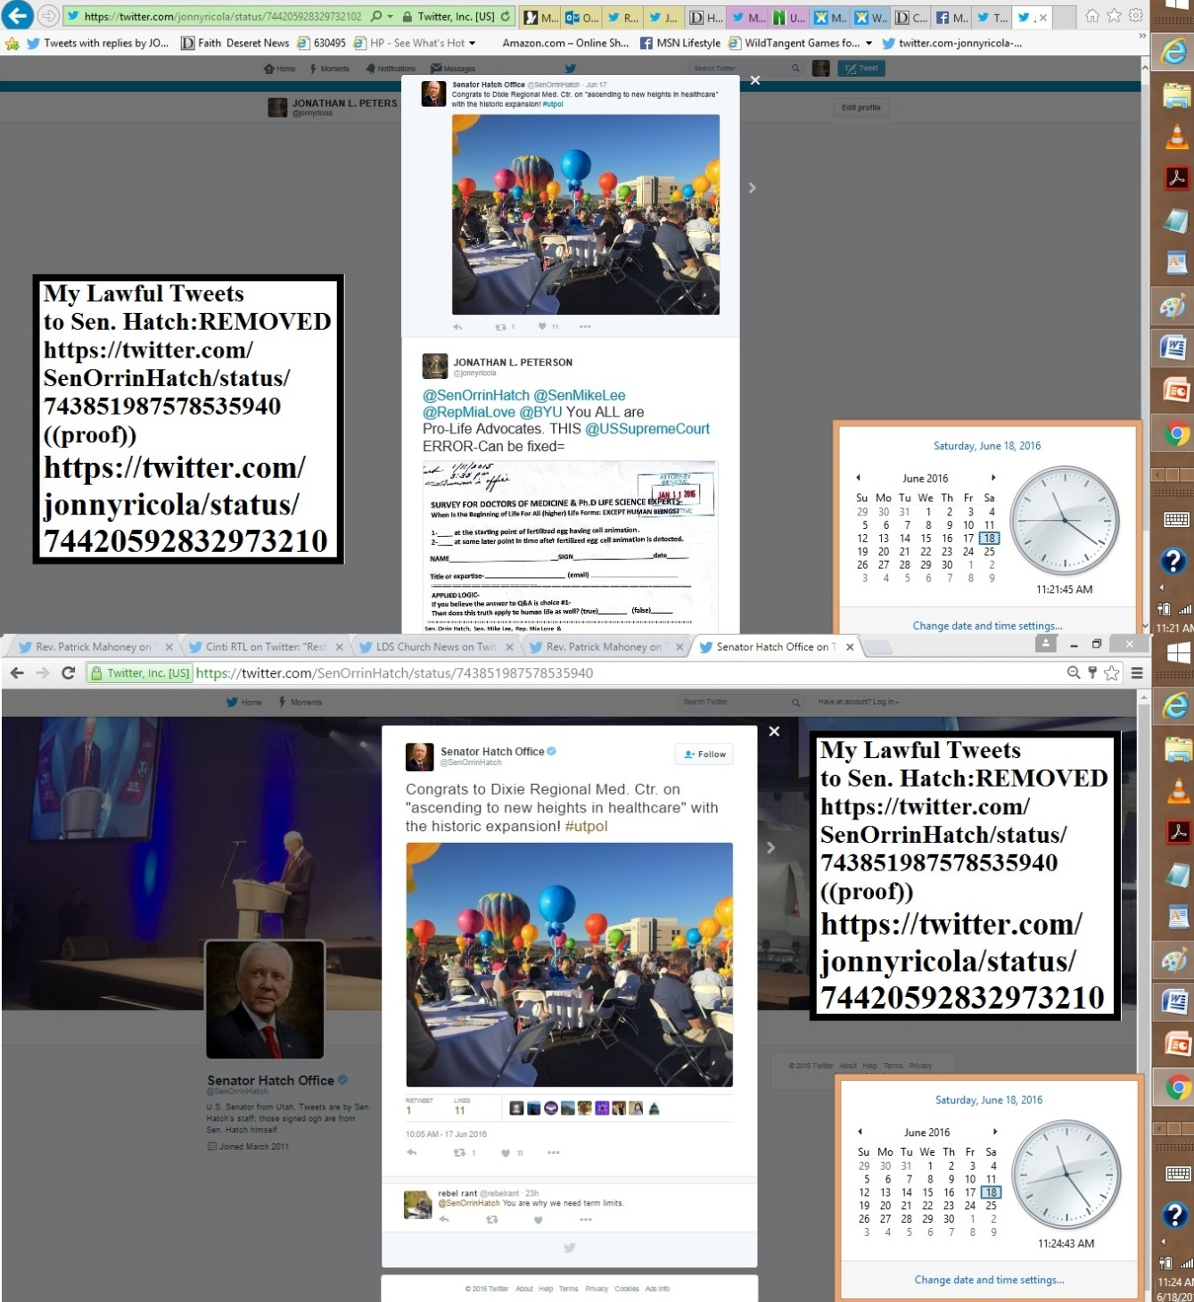========================
DIRECT- https://twitter.com/jonnyricola/status/744203703733805056
@SenMikeLee @SenOrrinHatch @RepMiaLove @CNN You ALL are Pro-Life Advocates. THIS @USSupremeCourt ERROR-Can be fixed=
(W-Photo Gov. Herbert&REYES Survey for Doctors Jan. 11, 2016 & div.Remov& DK PLAIN LViewLAWsite CROP SenLee.Hatch,Love&me)
==============================================
https://twitter.com/SenMikeLee/status/743857189597642752 @SenMikeLeeBig congrats to @RepRatcliffe and @RepHensarling for moving the Separation of Powers Act to the House floor. #A1P
@SenMikeLee @RepRatcliffe @RepHensarling Sen.Lee- You are Pro-Life advocate. THIS @USSupremeCourt ERROR-Can be fixed
(W-Photo Gov. Herbert&REYES Survey for Doctors Jan. 11, 2016 & div.Remov& DK PLAIN LViewLAWsite CROP SenLee&me)
=========================================
DIRECT- https://twitter.com/jonnyricola/status/744195540460535808
@stopthedrugwar @NORML @CopsSayLegalize END DRUG WAR W- 1 MOTION OF DISCOVERY=IF YOU HAVE THE HEART?
(W-Photo Judge Waddoups & DOJ Huber DRUG Survey 1of7pg stamped June 13, 2016)
(W-Photo Judge NUFFER DRUG Survey 1of7pg stamped June 13, 2016 )
(W-Photo Judge Robert Shelby DRUG Survey 1of7pg stamped June 13, 2016 WV)
(W-Photo Judge Waddoups & DOJ Huber COVER 1of8pg stamped June 13, 2016 WVIEW ORG DK)
======================
https://twitter.com/stopthedrugwar/status/743870098616778752 @stopthedrugwarOne Out of Four US Senators Is a Marijuana Prohibitionist -- Is Yours One of Them? http://stopthedrugwar.org/chronicle/2016/jun/17/one_out_four_us_senators_marijua_0 …
@stopthedrugwar HERE IT IS-filed with 3fed judges.END the DRUG WAR WITH 1 MOTION OF DISCOVERY=IF YOU HAVE THE HEART?
(W-Photo Judge Waddoups & DOJ Huber DRUG Survey 1of7pg stamped June 13, 2016)
(W-Photo Judge NUFFER DRUG Survey 1of7pg stamped June 13, 2016 )
(W-Photo Judge Robert Shelby DRUG Survey 1of7pg stamped June 13, 2016 WV)
(W-Photo Judge NUFFER COVER letter June 13, 2016 WV DK )
=========================
https://twitter.com/stopthedrugwar/status/743931794857172993 @stopthedrugwarChronicle AM: Times of London Calls for Drug Decrim, Microsoft Enters MJ Business, More... (6/17/16): http://stopthedrugwar.org/chronicle/2016/jun/17/chronicle_am_times_london_calls
@stopthedrugwar HERE IT IS-filed with 3fed judges.END the DRUG WAR WITH 1 MOTION OF DISCOVERY=IF YOU HAVE THE HEART?
(W-Photo Judge Waddoups & DOJ Huber DRUG Survey 1of7pg stamped June 13, 2016)
(W-Photo Judge NUFFER DRUG Survey 1of7pg stamped June 13, 2016 )
(W-Photo Judge Robert Shelby DRUG Survey 1of7pg stamped June 13, 2016 WV)
(W-Photo Judge Waddoups & DOJ Huber COVER 1of8pg stamped June 13, 2016 WVIEW ORG DK)
======================================================
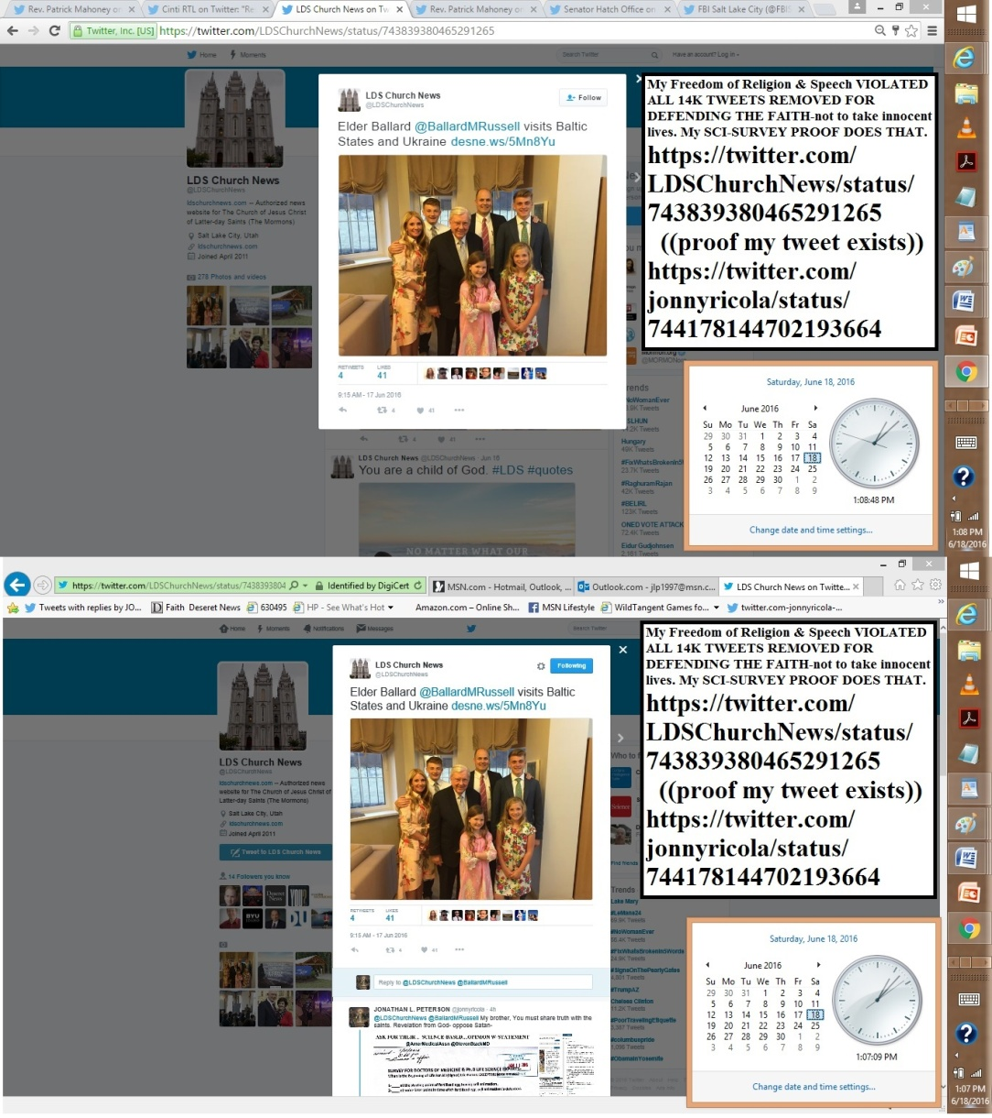
===============================================================
https://twitter.com/jonnyricola/status/744184484946272256 (@LDSChurchNews @BallardMRussell @NelsonRussellM @ThomasSMonson @OaksDallinH If you believe I am a LIAR. SAY SO or Repent & serve the Lord.)
https://twitter.com/jonnyricola/status/744178144702193664 (@LDSChurchNews @BallardMRussell DO YOU TRUST IN GOD?THEN YOU MUST SEARCH FOR TRUTH & SPEAK)
https://twitter.com/LDSChurchNews/status/743839380465291265 @LDSChurchNewsElder Ballard @BallardMRussell visits Baltic States and Ukraine http://desne.ws/5Mn8Yu
@LDSChurchNews @BallardMRussell My brother, You must share truth with the saints. Revelation from God- oppose Satan-
(W-Photo Gov. Herbert&REYES Survey for Doctors Jan. 11, 2016 & div.Remov DK nelsonLViewsite)
(W-Photo DeseretNews comment 20 athletes who are vocal about their faith (4-21-2016) WVIEWmessURL)
(W-Photo 25 DeseretNews comment '84 inspiring quotes from October 2015 LDS general conference' (10-6-2015)
(W-Photo DeseretNews Comments ‘Music and the Spoken Word- What is true greatness’ (5-14-2016)URLmessURL MustDEMAND)
reply
@LDSChurchNews @BallardMRussell DO YOU TRUST IN GOD?
THEN YOU MUST SEARCH FOR TRUTH & SPEAK
TEST4U/Proof IS FROM GOD- https://community.sumofus.org/petitions/ask-doctors-phd-life-science-experts-when-does-life-begin-survey?source=twitter-share-button
reply
@LDSChurchNews @BallardMRussell @NelsonRussellM @ThomasSMonson
God commands we oppose Satan &The Lies he uses 2Blind- https://twitter.com/jonnyricola/status/743481846705446915 (@LDSChurchNews Pres. @ThomasSMonson My words come from God. Confirm this & prepare for our Lord Jesus Christ. OR SIN)
reply
@LDSChurchNews @BallardMRussell @NelsonRussellM @ThomasSMonson
REJOICE:GOD DELIVERS US FROM SATAN'S POWER.ctr&SPEAK-
https://twitter.com/jonnyricola/status/743116290806579200 (@LDSChurchNews @DeseretNews @ThomasSMonson @EyringHB @UchtdorfDF @NelsonRussellM =Trust in God-Oppose Satan's Power-)
reply
@LDSChurchNews @BallardMRussell @NelsonRussellM @ThomasSMonson Elder @OaksDallinH ,
under covenant Speak or RESIGN
https://twitter.com/jonnyricola/status/742782647303213056 (@LDSChurchNews @UniofOxford READ @OaksDallinH& @NelsonRussellMIT CONFIRMS YOU KNEW = MUST REPENT & SPEAK: OR RESIGN)
reply
@LDSChurchNews @BallardMRussell @NelsonRussellM @ThomasSMonson @OaksDallinH
YOU ALL HAVE KNOWLEDGE. HONOR YOUR COVENANTS WITH GOD or BnHELL.
reply
@LDSChurchNews @BallardMRussell @NelsonRussellM @ThomasSMonson @OaksDallinH
If you believe I am a LIAR. SAY SO or Repent & serve the Lord.
========================================================
June 17, 2016
====================================================================
Mailed to the courts June 15th 5 PM PRIORTY- STILL NOT DELIVERED June 17, at 3PM. 3 miles away.
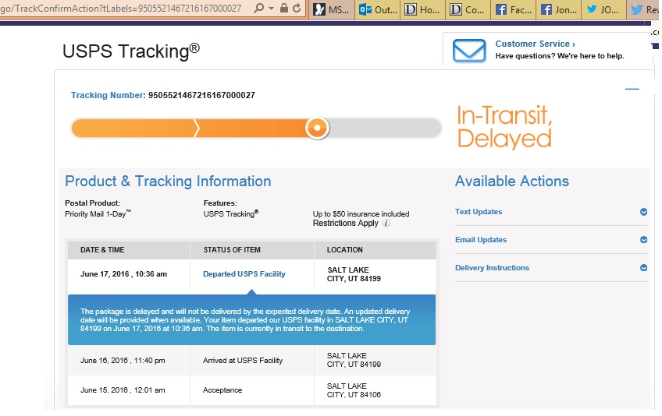
==================================================
DIRECT- @revmahoney My brother-each day you delay bringing my logic & proofs to US Public Attention. COSTS 6000 MORE LIVES-*
https://twitter.com/jonnyricola/status/743865135551283200
========================================================
https://twitter.com/revmahoney/status/743901454725955588 @revmahoneyAfter our sit-in, meeting with the mayor of Cleveland discussing our permits to demonstrate at the RNC. #prolife
@revmahoney You know this is the greatest test of faith mankind has seen in modern days. WILL YOU TRUST IN GOD?
https://twitter.com/jonnyricola/status/743899273121521664 (@revmahoney Sen. @RandPaul YOU ARE UNDER OATHS Both Constitutional & Hippocratic.STATE YOUR EXPERT OPINION-or BnHell
reply
@revmahoney Sen. @RandPaul YOU ARE UNDER OATHS
Both Constitutional & Hippocratic.STATE YOUR EXPERT OPINION-or BnHell
(W-Photo Gov. Herbert&REYES Survey for Doctors Jan. 11, 2016 & div.Remov& DK RAND CROP)
reply
@revmahoney @RandPaul Bring me out to your demonstration.
WE WILL TEST GOD'S LOGIC AGAINST CURRENT FALSE BELIEFS & SAVE OURSELVES WITH FAITH
===========================================================
https://twitter.com/jonnyricola/status/743899273121521664 @revmahoney Sen. @RandPaul YOU ARE UNDER OATHS Both Constitutional & Hippocratic.STATE YOUR EXPERT OPINION-or BnHell
https://twitter.com/revmahoney/status/743896526297104384 @revmahoneySit-in at the mayor of Cleveland's office seeking our permits which have been delayed for the RNC. #freespeech

@revmahoney HAND OUT Double sided SCI-Survey for Doctors& Experts-
SHOW THE WORLD SCI-TRUTH THAT WE MURDER OUR YOUNG
(W-Photo Gov. Herbert&REYES Survey for Doctors Jan. 11, 2016 & div.Remov& DK RAND CROP)
(W-Photo Gov. Herbert&REYES Survey for Doctors Jan. 11, 2016 & div.Remov& DK PLAIN CROP)
reply
@revmahoney Sen. @RandPaul YOU ARE UNDER OATHS
Both Constitutional & Hippocratic.STATE YOUR EXPERT OPINION-or BnHell
(W-Photo Gov. Herbert&REYES Survey for Doctors Jan. 11, 2016 & div.Remov& DK RAND CROP)
reply
@revmahoney @RandPaul You both & @LDSChurchNews Dr. @NelsonRussellM
VIOLATE COVENANTS WITH GOD.PROOF TO END Murders https://twitter.com/jonnyricola/status/742558880656330752
reply
@revmahoney @RandPaul @LDSChurchNews @NelsonRussellM @AP A PLACE IS PREPARED FOR YOU BOTH IN HELL_IF YOU STAY SILENT
(W-photo Gov. Herbert&REYES Survey for Doctors Jan. 11, 2016 SHORT & divisonRemovWVIEW RMNelson7 ways&LawfulFX)
(W-Photo Gov. Herbert&REYES Survey Doctors Jan. 11, 2016 SHORT ORi & divisonRemovWVIEW RAND 7ways&Captions)
(W-Photo Gov. Herbert&REYES Survey Doctors Jan. 11, 2016 SHORT ORi & divisonRemovWVIEW AMA NSF 7ways&Captions&Mission)
(W-Photo DeseretNews Comment- ‘Bill intends to ban certain abortion procedures in Utah’ (2-26-2016) WIDEVIEW w-SUP)
+++++++++++++++
==================================================
https://twitter.com/revmahoney/status/743886151291928576 @revmahoneyLIVE on #Periscope: At the Cleveland City Hall, seeking our permits for for the Republican national convention!
@revmahoney @BYU You can't let your FEARS BLOCK MORAL BEHAVIOR.
POST THIS. - Sen./Dr.@randpaul-WHAT IS YOUR OPINION?
(W-Photo Gov. Herbert&REYES Survey for Doctors Jan. 11, 2016 & div.Remov& DK RAND CROP)
(W-Photo Gov. Herbert&REYES Survey for Doctors Jan. 11, 2016 & div.Remov& DK PLAIN CROP)
reply
@revmahoney @BYU @RandPaul YOU CAN PROVE YOUR LOVE OF HUMANITY BY Signing a Petition to ASK EXPERTS. Oppose EVIL NOW?
https://community.sumofus.org/petitions/ask-doctors-phd-life-science-experts-when-does-life-begin-survey?source=twitter-share-button
==========================================
https://twitter.com/revmahoney/status/743877852790132736 @revmahoneyI believe! #believeland
@revmahoney @AP Are you going to ignore the filed w-court SCI-Survey Proof to end ROEvsWADE? 6000 MORE LIVES EA. DAY-
https://twitter.com/jonnyricola/status/743865135551283200 (revmahoney Rev. YOUR OATH TO GOD Is At Stake Here.@FoxNews @AP SPEAKUP & ASK DOCTOR/Sen.@RandPaul& @AmerMedicalAssn)
reply
@revmahoney @AP You can't let your FEARS BLOCK MORAL BEHAVIOR.
POST THIS. - Sen./Dr. @randpaul- WHAT IS YOUR OPINION
(W-Photo Gov. Herbert&REYES Survey for Doctors Jan. 11, 2016 & div.Remov& DK RAND LView CROP)
======================================================
https://twitter.com/jonnyricola/status/743865135551283200 (revmahoney Rev. YOUR OATH TO GOD Is At Stake Here.@FoxNews @AP SPEAKUP & ASK DOCTOR/Sen.@RandPaul& @AmerMedicalAssn)
https://twitter.com/jonnyricola/status/743866659522416642 https://twitter.com/jonnyricola/status/743868946709786624
https://twitter.com/jonnyricola/status/743874471673552896 https://twitter.com/jonnyricola/status/743872589328584704 https://twitter.com/jonnyricola/status/743871440517160960
https://twitter.com/revmahoney/status/743849501522296832 @revmahoneyGathering where the Republican convention will be in July calling for the defunding of Planned Parenthood! #prolife
@revmahoney Rev. YOUR OATH TO GOD Is At Stake Here.@FoxNews @AP SPEAKUP & ASK DOCTOR/Sen.@RandPaul& @AmerMedicalAssn
https://twitter.com/jonnyricola/status/743532348507987968 (@CintiRTL @createdequalorg @revmahoney @operationrescue @PregCenterEastASK-@randpaul @NSF & @AmerMedicalAssn TODAY?)
reply
@revmahoney @FoxNews @AP ?@RandPaul @AmerMedicalAssn THIS PROOF SHOULD HAVE BEEN USED BY @USSupremeCourt GROSS ERROR
(W-Photo Gov. Herbert&REYES Survey for Doctors Jan. 11, 2016 & div.Remov DK Dr. RAND PAUL LViewsite)
(W-Photo Gov. Herbert&REYES Survey for Doctors Jan. 11, 2016 & div.Remov& DK PLAIN LViewLAWsite CROP)
(W-Photo Gov. Herbert&REYES Survey Doctors Jan. 11, 2016 SHORT ORi & divisonRemovWVIEW AMA NSF 7ways&Captions&Mission)
(W-Photo DeseretNews Comment- ‘Bill intends to ban certain abortion procedures in Utah’ (2-26-2016) WIDEVIEW w-SUP
reply
@revmahoney @FoxNews @AP @RandPaul @AmerMedicalAssn @USSupremeCourt PROOFS FILED W-3 Fed. Judges-OBSTRUCTING JUSTICE
(W-Photo Judge Waddoups & DOJ Huber COVER 1of8pg stamped June 13, 2016 WVIEW ORG DK)
(W-Photo Judge Waddoups & DOJ Huber DRUG Survey 1of7pg stamped June 13, 2016)
(W-Photo Judge NUFFER DRUG Survey 1of7pg stamped June 13, 2016 )
(W-Photo Gov. Herbert&REYES Survey for Doctors Jan. 11, 2016 & div.Remov DK PLAIN LView&Courts misconduct @top pg4of7)
reply
@revmahoney @FoxNews @AP @RandPaul @AmerMedicalAssn @USSupremeCourt
I'm poor-But rich in faith & logic END OUR UNLAWFUL BEHAVIOR-BringMeTO U
reply
@revmahoney @FoxNews @AP @RandPaul @AmerMedicalAssn @USSupremeCourt I DO NOT FEAR CHALLENGING UNLAWFUL STATUS QUO-
(W-Photo Gary Johnson & me & survey on Bribery April 6-2016 slc,ut 1000x650 w-huber&gary obstruct & DRUG LAW)
(W-Photo Rep.Jason Chaffetz,MIA LOVE Photos & jlp w-Prison stories papaer cropped July 20,2015 W-titles 3 PHOTOw JLP) JPEG)
(W-Photo 54 Jonathan Johnson for governor rally & JLP 9-15-2015 CROPPED even more 2x W SURVEY 1600 W-TEXT REMINDER))
(W-Photo DeseretNews Comments ‘Obama marks Memorial Day at Arlington National Cemetery’ (5-30-2016) WVIEW )
reply
@revmahoney @FoxNews @AP @RandPaul @AmerMedicalAssn @USSupremeCourt
PROOF-How badly you need GOD'S help=TRY TOsignIT-
https://community.sumofus.org/petitions/ask-doctors-phd-life-science-experts-when-does-life-begin-survey?source=twitter-share-button

=========================================================
https://twitter.com/CintiRTL/status/743547251109265408 @CintiRTLCinti RTL Retweeted SpeakLife IncRestore the oath: https://twitter.com/speaklife_inc/status/743222487022874624 Hippocratic Oath)

@CintiRTL @createdequalorg @revmahoney @operationrescue
END ROEvsWADE=W/SCI-SURVEY4 Dr.s- @RandPaul @AmerMedicalAssn https://twitter.com/jonnyricola/status/743529474667479040 (@CintiRTL @createdequalorg @revmahoney @operationrescue @PregCenterEast Invite me to promote this SCI-SURVEY4 Dr.s-)
==============================================
DIRECT-
@DeseretNews @LDSChurchNews Prove to yourself & the public-PROOFS THAT
MY LOGIC IS FROM GOD- http://jlp1997.wix.com/instinctlogicresearc
https://twitter.com/jonnyricola/status/743849092208463876
==============================================================
https://twitter.com/jonnyricola/status/743849092208463876 @DeseretNews @LDSChurchNews Prove to yourself & the public-PROOFS THATMY LOGIC IS FROM GOD- http://jlp1997.wix.com/instinctlogicresearc
https://twitter.com/DeseretNews/status/743836007984824320 @DeseretNewsIn our opinion: A growing challenge in education: recruiting and retaining teachershttp://www.deseretnews.com/article/865656376/In-our-opinion-A-growing-challenge-in-education-recruiting-and-retaining-teachers.html
@DeseretNews What Utah & our nation needs:Teachers who will teach Constitutional Principles (EqualUnderAllLaws) RSVP
(W-photo DeseretNews Comments ‘A father's faith- How modern dads impact their children's religious views’ (6-17-2016) onhold)
(W-Photo Judge Waddoups & DOJ Huber COVER 1of8pg stamped June 13, 2016 WVIEW ORG DK)
(W-photo Gov. Herbert&REYES Survey for Doctors Jan. 11, 2016 SHORT & divisonRemovWVIEW RMNelson7 ways&LawfulFX)
reply
@DeseretNews(leftOut Proof of receipt-sorry) Our Society must honor our rules of conduct. Ask Nuffer,Shelby&Waddoups
(W-Photo Judge Waddoups & DOJ Huber DRUG Survey 1of7pg stamped June 13, 2016)
(W-Photo Judge NUFFER DRUG Survey 1of7pg stamped June 13, 2016 )
(W-Photo Judge Robert Shelby DRUG Survey 1of7pg stamped June 13, 2016 WV)
(W-Photo Gov. Herbert&REYES Survey for Doctors Jan. 11, 2016 & div.Remov& DK PLAIN LViewLAWsite )
reply
@DeseretNews @LDSChurchNews Prove to yourself & the public-PROOFS THAT MY LOGIC IS FROM GOD- http://jlp1997.wix.com/instinctlogicresearc
(W-Photo JLP1997 INSTINCTLOGICRESEARC- Website photo June 16, 2016 WVIEW urlPart1)
(W-Photo JLP1997 INSTINCTLOGICRESEARC- Website photo June 16, 2016 WVIEW urlPart2)
(W-Photo DeseretNews comment 20 athletes who are vocal about their faith (4-21-2016) WVIEW URL )
(W-Photo Gov. Herbert&REYES Survey for Doctors Jan. 11, 2016 & div.Remov& DK PLAIN LViewLAWsite CROP)
===================================================================
DIRECT- @kelsey_dallas @DeseretNews Kelsey- did you read my request? Does our society need to repent & honor our oath to God?
https://twitter.com/jonnyricola/status/743837455917322240 (@kelsey_dallas @WilcoxNMP @DeseretNews Prove to yourself & the public-MY LOGIC IS FROM GOD-http://jlp1997.wix.com/instinctlogicresearc)
============================================================
https://twitter.com/kelsey_dallas/status/743838038929743872 @kelsey_dallasI wrote about politics! Americans don't like infidelity, but they may still vote for a cheater this year http://national.deseretnews.com/article/20371/americans-dont-like-infidelity-but-they-may-still-vote-for-a-cheater-this-year.html
@kelsey_dallas @DeseretNews Kelsey- did you read my request? Does our society need to repent & honor our oath to God?
https://twitter.com/jonnyricola/status/743837455917322240 (@kelsey_dallas @WilcoxNMP @DeseretNews Prove to yourself & the public-MY LOGIC IS FROM GOD-http://jlp1997.wix.com/instinctlogicresearc)
=====================================
https://twitter.com/jonnyricola/status/743837455917322240 (@kelsey_dallas @WilcoxNMP @DeseretNews Prove to yourself & the public-MY LOGIC IS FROM GOD-http://jlp1997.wix.com/instinctlogicresearc
https://twitter.com/kelsey_dallas/status/743617342844768256 @kelsey_dallasKelsey Dallas Retweeted DeseretNews NationalMy latest!
@kelsey_dallas @WilcoxNMP @DeseretNews blessed W-father/bishop whose Example did reflect his teachings (Mostly) RSVP
(W-photo DeseretNews Comments ‘A father's faith- How modern dads impact their children's religious views’ (6-17-2016) onhold)
reply
@kelsey_dallas @WilcoxNMP @DeseretNews Prove to yourself & the public-
MY LOGIC IS FROM GOD- http://jlp1997.wix.com/instinctlogicresearc
(W-Photo JLP1997 INSTINCTLOGICRESEARC- Website photo June 16, 2016 WVIEW urlPart1)
(W-Photo JLP1997 INSTINCTLOGICRESEARC- Website photo June 16, 2016 WVIEW urlPart2)
(W-Photo DeseretNews comment 20 athletes who are vocal about their faith (4-21-2016) WVIEW URL )
(W-Photo Gov. Herbert&REYES Survey for Doctors Jan. 11, 2016 & div.Remov&7Ways DK nelson LViewLAWsite)
============================================
June 16, 2016
===================================================
https://twitter.com/UofUResearch/status/743450799750135809 @UofUResearchHave u seen the 8000 pinwheels honoring our veterans? Experts worry high military suicide rates are 'new normal'.
@UofUResearch This psychological deprogramming tool is ready for clinical testing. What could it hurt? AskProf.Berg
(W-photo 73 DeseretNews comment My view- Saving drug addicts should be priority for government, health care leaders’(7-5-2015)
===================================
DIRECT TO
@revmahoney YOUaBunch ofTALKorDO YOU TRUST IN GOD
@CintiRTL @createdequalorg @operationrescue @randpaul @DeseretNews https://twitter.com/jonnyricola/status/743532348507987968
(@CintiRTL @createdequalorg @revmahoney @operationrescue @PregCenterEastASK-@randpaul @NSF & @AmerMedicalAssn TODAY?)
=======================================================
https://twitter.com/jonnyricola/status/743532348507987968 @CintiRTL @createdequalorg @revmahoney @operationrescue @PregCenterEastASK-@randpaul @NSF & @AmerMedicalAssn TODAY?
https://twitter.com/CintiRTL/status/743511494319575040 @CintiRTL 2h2 hours ago
Cinti RTL Retweeted Gail Finke Our ED Paula Westwood, @createdequalorg @revmahoney @operationrescue @PregCenterEast there too!

@CintiRTL @createdequalorg @revmahoney @operationrescue @PregCenterEast YOU WANT TO END Roe vs. Wade? this is HOW- https://twitter.com/jonnyricola/status/743089001356103680
(@USSupremeCourt Justice Roberts- BLACKMUN FAILED TO USE DUE DILIGENCE BY ASKING FOR SCI-CONSENSUS BEFORE ROEvsWADE =)
reply
@CintiRTL @createdequalorg @revmahoney @operationrescue @PregCenterEast Invite me to promote this SCI-SURVEY4 Dr.s-
(W-Photo Gov. Herbert&REYES Survey for Doctors Jan. 11, 2016 & div.Remov& DK PLAIN LViewLAWsite CROP)
(W-Photo Gov. Herbert&REYES Survey for Doctors Jan. 11, 2016 & div.Remov DK Dr. RAND PAUL LViewsite)
(W-Photo Gov. Herbert&REYES Survey Doctors Jan. 11, 2016 SHORT ORi & divisonRemovWVIEW AMA NSF 7ways&Captions&Mission)
(W-Photo DeseretNews Comment- ‘Bill intends to ban certain abortion procedures in Utah’ (2-26-2016) WIDEVIEW w-SUP

reply
@CintiRTL @createdequalorg @revmahoney @operationrescue @PregCenterEast
You Do Need My Help! JUST TRY TO SIGN THIS =
https://community.sumofus.org/petitions/ask-doctors-phd-life-science-experts-when-does-life-begin-survey?source=twitter-share-button
reply
@CintiRTL @createdequalorg @revmahoney @operationrescue @PregCenterEast ASK-@randpaul @NSF & @AmerMedicalAssn TODAY?
(W-Photo Gov. Herbert&REYES Survey for Doctors Jan. 11, 2016 & div.Remov DK Dr. RAND PAUL LViewsite)
(W-Photo Gov. Herbert&REYES Survey Doctors Jan. 11, 2016 SHORT ORi & divisonRemovWVIEW AMA NSF 7ways&Captions&Mission)
(W-photo Gov. Herbert&REYES Survey for Doctors Jan. 11, 2016 SHORT ORi W-HEADER & divisonRemovWVIEW USSG-7 ways&Lawful)
(W-Photo DeseretNews Comment- ‘Bill intends to ban certain abortion procedures in Utah’ (2-26-2016) WIDEVIEW w-SUP
reply
@CintiRTL @createdequalorg @revmahoney @operationrescue @PregCenterEast @RandPaul @NSF @AmerMedicalAssn IF YOU DON'T USE THIS SCI-PROOF=EVIL
=================================================
https://twitter.com/LDSChurchNews/status/743479268181610497 @LDSChurchNewsYou are a child of God. #LDS #quotes
@LDSChurchNews A gift from God is before you. To use it-YOU MUST TRUST IN GOD WITH YOUR LIFE. Satan is revealed- ASK
(W-Photo DeseretNews comments 15 LDS general authorities & B of Mormon heroes 1-8-2016 WVIEW w- SKULL -DN-URL& faithURL)
(W-Photo DeseretNews Comments How much do you know about President Henry B. Eyring (6-1-2016) WVIEW messSite )
(W-Photo 1 FAITH LIST DNews FEB-29-2016 w- URL&revelation- The Lord says & ASK LDS if true- rejoice DN-savior is born url )
(W-Photo DeseretNews Comments ‘Music and the Spoken Word- What is true greatness’ (5-14-2016)URL siteMustDEMAND)
reply
@LDSChurchNews This is the true Church of Christ
But we must repent of our sins & oppose Satan's Power with TRUTHask-https://twitter.com/jonnyricola/status/743481846705446915
(@LDSChurchNews Pres. @ThomasSMonson My words come from God.Confirm this & prepare for our Lord Jesus Christ. OR SIN)
reply
@LDSChurchNews NOW YOU KNOW- SATAN HAS POWER OVER THE FLESH. BECAUSE INSTINCT OPERATES SURVIVAL LOGIC FOR THE GROUP.
(W-Photo DeseretNews comment 20 athletes who are vocal about their faith (4-21-2016) WVIEW URL )
(W-Photo Gov. Herbert&REYES Survey for Doctors Jan. 11, 2016 & div.Remov&7Ways DK nelson LViewLAWsite)
(W-Photo 1 FAITH LIST DNews FEB-29-2016 w- URL&revelation- The Lord says & ASK LDS if true- rejoice DN-savior is born url )
(W-Photo DeseretNews comment LDS leaders pay tribute to mothers from the pulpit (5-6-2016) WView mess)
reply
@LDSChurchNews @DeseretNews @LDSchurch @ThomasSMonson @EyringHB @UchtdorfDF PROOFS COMPILED@-http://jlp1997.wix.com/instinctlogicresearc
(W-Photo JLP1997 INSTINCTLOGICRESEARC- Website photo June 16, 2016 WVIEW urlPart1)
(W-Photo JLP1997 INSTINCTLOGICRESEARC- Website photo June 16, 2016 WVIEW urlPart2)
(W-Photo PBS The BRAIN final episode with PROOFS OF INSTINCT MECH as A.I. Driven w STATUS QUO w-LINK)
(W-Photo MormonNewsRoom Elder Oaks Encourages @BYU Grad to Serve &UT Sup JustOaks &Worthen- SUR-11-2015 Wtitle URL CROP)
===================================
https://twitter.com/jonnyricola/status/743481846705446915 @LDSChurchNews Pres. @ThomasSMonson My words come from God.Confirm this & prepare for our Lord Jesus Christ. OR SIN
https://twitter.com/LDSChurchNews/status/743469787586539520 @LDSChurchNewsPresident Monson's 'Scout duty' to be exemplified at future training center @ThomasSMonson | http://desne.ws/Tu3Rbe
@LDSChurchNews @LDSchurch SIMPLE -PRES.@ThomasSMonson
YOU CAN CALL ME A LIAR & EXCOMMUNICATE ME.
OR CONFIRM AS TRUTH
(W-Photo DeseretNews Comments ‘Music and the Spoken Word- What is true greatness’ (5-14-2016)URLmessURLsiteMustDEMANDdk)

@LDSChurchNews To honor our covenants with God. We must Oppose Satan's Power over US. Tell the Saints @ThomasSMonson
https://twitter.com/jonnyricola/status/743116290806579200 (@LDSChurchNews @DeseretNews @ThomasSMonson @EyringHB @UchtdorfDF @NelsonRussellM =Trust in God-Oppose Satan's Power-)
reply
@LDSChurchNews Pres. @ThomasSMonson My words come from God.
Confirm this & prepare for our Lord Jesus Christ. OR SIN
(W-Photo DeseretNews comments 15 LDS general authorities & B of Mormon heroes 1-8-2016 WVIEW w- SKULL -DN-URL& faithURL)
(W-Photo DeseretNews comment 20 athletes who are vocal about their faith (4-21-2016) WVIEW URL DK)
(W-Photo Gov. Herbert&REYES Survey for Doctors Jan. 11, 2016 & div.Remov&7Ways DK nelson LViewLAWsite)
(W-Photo DeseretNews Comments ‘Music and the Spoken Word- What is true greatness’ (5-14-2016)URLmessURLsiteMustDEMANDdk)
reply
@LDSChurchNews @ThomasSMonson @EyringHB @UchtdorfDF @NelsonRussellM CONFIRM REVELATION FROM GOD orREJECT GIFT-ctrNOW
https://twitter.com/jonnyricola/status/741637836529532928 (@LDSChurchNews @BednarDavidA The Lord commands we oppose Satan & evil. With our voice. ASK-Dr./Pres @NelsonRussellM)
reply
@LDSChurchNews @ThomasSMonson @EyringHB @UchtdorfDF @NelsonRussellM DOES SATAN RULE YOUR HEART May6=6Kx47DAYS=282000
https://twitter.com/jonnyricola/status/741652668922220544 (@LDSChurchNews @BednarDavidA @DeseretNews @ThomasSMonson @EyringHB @UchtdorfDF@NelsonRussellM-May6=6Kx37DAYS=222000)
reply
@LDSChurchNews @ThomasSMonson @EyringHB @UchtdorfDF @NelsonRussellM SPEAK=HAVING KNOWLEDGE FROM GOD TO OPPOSE SATAN=
https://twitter.com/jonnyricola/status/728677561815851008 (@LDSChurchNews By example. Use This gift from God.By your faith &works-kingdom of God on earthask @NelsonRussellM)
reply
@LDSChurchNews @ThomasSMonson @EyringHB @UchtdorfDF @NelsonRussellM
@POTUS IF YOU WILL NOT OPPOSE SATAN =WRATH OF GOD
(W-Photo Gov. Herbert&REYES Survey Doctors Jan. 11, 2016 SHORT ORi W-HEADER & divisonRemovWVIEW RMNelson7 ways&LawfulFX)
reply
@LDSChurchNews @ThomasSMonson @EyringHB @UchtdorfDF @NelsonRussellM
@POTUS PROOFS COMPILED @- http://jlp1997.wix.com/instinctlogicresearc
(W-Photo JLP1997 INSTINCTLOGICRESEARC- Website photo June 15, 2016 WVIEW urlPart1)
(W-Photo JLP1997 INSTINCTLOGICRESEARC- Website photo June 13, 2016 WVIEW urlPart2)
(W-Photo PBS The BRAIN final episode with PROOFS OF INSTINCT MECH as A.I. Driven w STATUS QUO w-LINK)
(W-Photo Gary Johnson & me & survey on Bribery April 6-2016 slc,ut 1000x650 w-huber&gary obstruct & DRUG LAW)
reply
@LDSChurchNews @ThomasSMonson @EyringHB @UchtdorfDF @NelsonRussellM @POTUS 3 fed judges &DOJ John Huber-VIOLATE OATH
(W-Photo Judge Waddoups & DOJ Huber COVER 1of8pg stamped June 13, 2016 WVIEW ORG DK)
(W-Photo Judge Waddoups & DOJ Huber DRUG Survey 1of7pg stamped June 13, 2016 WV)
(W-Photo Judge NUFFER DRUG Survey 1of7pg stamped June 13, 2016 ) WV
(W-Photo 42 CIVIL RIGHTS POST ON HUBER VIOLATING DUE PROCESS OCT 8,2015 w-LINK lg text W-NUFFER&Lynch DK WV)
===============================
@UofUResearch This psychological deprogramming tool is ready for clinical testing. What could it hurt? AskProf.Berg

=========================================
https://twitter.com/jonnyricola/status/743476984097824771 @FBISaltLakeCity @AP Judge Nuffer,Shelby,Waddoups&DOJHuber Violate Discovery Rules.YOU HAVE KNOWLEDGE = DO YOUR DUTY
https://twitter.com/FBISaltLakeCity/status/743465713512263680 @FBISaltLakeCityTwin Falls County Man Sentenced to 42 Months for Unlawful Possession of Firearms: — Salt Lake City https://www.fbi.gov/saltlakecity/press-releases/2016/twin-falls-county-man-sentenced-to-42-months-for-unlawful-possession-of-firearms …

@FBISaltLakeCity WE DON'T UNDERSTAND; We don't use our Code of Conduct Where Violations are Ingrained in STATUS QUO
https://twitter.com/jonnyricola/status/743165795652362240
(@FBIMostWanted @DeseretNews Agent Barnhart &Palmer-IF YOU DONT SPEAKUP:YOU ARE GUILTY OF MISCONDUCT/THAT COSTS LIVES)
reply
@FBISaltLakeCity @AP Judge Nuffer,Shelby,Waddoups&DOJHuber Violate Discovery Rules.
YOU HAVE KNOWLEDGE = DO YOUR DUTY
(W-Photo Judge Waddoups & DOJ Huber DRUG Survey 1of7pg stamped June 13, 2016 WV)
(W-Photo Judge NUFFER DRUG Survey 1of7pg stamped June 13, 2016 ) WV
(W-Photo Judge Waddoups & DOJ Huber DRUG Survey 1of7pg stamped June 13, 2016 WV)
(W-Photo Judge Waddoups & DOJ Huber COVER 1of8pg stamped June 13, 2016 WVIEW ORG DK)
reply
@FBISaltLakeCity @AP @DeseretNews Have I Proven WEViolate LAW? @CivilRights @LorettaLynch @USSupremeCourt
@LDSchurch? https://twitter.com/jonnyricola/status/743463298675277824
(@NYDailyNews Proofs-Violations of Highest LawAsk @FBISaltLakeCity @CivilRights @LorettaLynch @USSupremeCourt 4TRUTH)

reply
@FBISaltLakeCity @AP @DeseretNews @CivilRights @LorettaLynch @USSupremeCourt @LDSchurch My Mail toJudges is BLOCKED?
(W-Photo PRIORTY MAIL TO JUDGES IS BEING DELAYED. 3 MILES TO COURTHOUSE. JUNE 17, 2016)
================================================
DIRECT TO -
@NYDailyNews @DeseretNews Have I Proven WE Violate LAW? @FBISaltLakeCity @CivilRights @LorettaLynch @USSupremeCourt ? https://twitter.com/jonnyricola/status/743463298675277824
(@NYDailyNews Proofs-Violations of Highest LawAsk @FBISaltLakeCity @CivilRights @LorettaLynch @USSupremeCourt 4TRUTH)
=============================================
https://twitter.com/jonnyricola/status/743463298675277824 (@NYDailyNews Proofs-Violations of Highest LawAsk @FBISaltLakeCity @CivilRights @LorettaLynch @USSupremeCourt 4TRUTH)
https://twitter.com/NYDailyNews/status/743452236685185024 @NYDailyNewsInventor of the AR-15 would be "sickened" by its use in mass shootings, family says http://nydn.us/1sHRJ6B
@NYDailyNews The question is-If we armed lawful citizens like the Israelis?
Would the gunman have been stopped within a few mins or seconds?
reply
@NYDailyNews It is a sad day, when citizens in a free democracy must arm themselves to be safe.
That is why 2nd Amendment in our BILLofRIGHTS
reply
@NYDailyNews When the USA sets the example for the world, of what a true democracy stand for:
Equal Under All Laws- the world will follow US.
reply
@NYDailyNews WHAT WE DON'T UNDERSTAND; We don't use our Code of Conduct Where Violations are Ingrained in STATUS QUO
https://twitter.com/jonnyricola/status/743165795652362240
(@FBIMostWanted @DeseretNews Agent Barnhart &Palmer-IF YOU DONT SPEAKUP:YOU ARE GUILTY OF MISCONDUCT/THAT COSTS LIVES)
reply
@NYDailyNews Proofs-Violations of Highest Law Ask @FBISaltLakeCity @CivilRights @LorettaLynch @USSupremeCourt 4TRUTH
(W-Photo Judge Waddoups & DOJ Huber COVER 1of8pg stamped June 13, 2016 WVIEW ORG DK)
(W-Photo Judge Waddoups & DOJ Huber DRUG Survey 1of7pg stamped June 13, 2016 WV)
(W-Photo Gov. Herbert&REYES Survey for Doctors Jan. 11, 2016 & div.Remov DK PLAIN LView&Courts misconduct @top)
(W-Photo 42 CIVIL RIGHTS POST ON HUBER VIOLATING DUE PROCESS OCT 8,2015 w-LINK lg text W-NUFFER&Lynch DK)
reply
@NYDailyNews @FBISaltLakeCity @CivilRights @LorettaLynch
BLACKMUN& @USSupremeCourt FAILEDtoGetSCI-CONSENSUS-try2sign-https://community.sumofus.org/petitions/ask-doctors-phd-life-science-experts-when-does-life-begin-survey?source=twitter-share-button
reply
@NYDailyNews @FBISaltLakeCity @CivilRights @LorettaLynch @USSupremeCourt
TRYtoSIGN PETITION?http://jlp1997.wix.com/instinctlogicresearc
(W-Photo JLP1997 INSTINCTLOGICRESEARC- Website photo June 15, 2016 WVIEW urlPart1)
(W-Photo JLP1997 INSTINCTLOGICRESEARC- Website photo June 13, 2016 WVIEW urlPart2)
(W-Photo PBS The BRAIN final episode with PROOFS OF INSTINCT MECH as A.I. Driven w STATUS QUO w-LINK)
(W-Photo DeseretNews comments 15 LDS general authorities & B of Mormon heroes 1-8-2016 WVIEW w- SKULL -DN-URL& faithURL)
reply
@NYDailyNews @FBISaltLakeCity @CivilRights @LorettaLynch @USSupremeCourt
TEST4U-ASK @RandPaul @NSF @AmerMedicalAssn
https://twitter.com/jonnyricola/status/743093751711600640 (@USSupremeCourt @CNN @SenOrrinHatch Sen.@RandPaul makes petitions for law-NOT NEEDED=JUST SIGN TRUTH&ASK-@NSF & AMA)
====================================================
https://twitter.com/NYDailyNews/status/743428951037599744 @NYDailyNewsWATCH: Video shows Pulse clubgoers hiding in bathroom; survivor remembers hours of terror http://nydn.us/24SIDjd
@NYDailyNews Crazy or evil people will do assaults on the public: Like the Israelis have trained weapons permit citizens to defend ThePublic
=======================================================
June 15, 2016
=========================================================
DIRECT TO - https://twitter.com/jonnyricola/status/743177484187762688
@FBISaltLakeCity @CNN You Must honor your Constitutional Oath.DECIDE TODAY:
Proof of crimes against US CONSTITUTION- https://twitter.com/jonnyricola/status/743165795652362240
(@FBIMostWanted @DeseretNews Agent Barnhart &Palmer-IF YOU DONT SPEAKUP:YOU ARE GUILTY OF MISCONDUCT/THAT COSTS LIVES)
====================================================
https://twitter.com/jonnyricola/status/743165795652362240 (@FBIMostWanted @DeseretNews Agent Barnhart &Palmer-IF YOU DONT SPEAKUP:YOU ARE GUILTY OF MISCONDUCT/THAT COSTS LIVES)
https://twitter.com/FBIMostWanted/status/743119064378134 @FBIMostWantedThe #FBI seeks East Area Rapist/Golden State Killer for multiple rapes, murders, burglaries: https://www.fbi.gov/wanted/seeking-info/unknown-suspect-21/view …528
@FBIMostWanted That is important.But the Evidence/ending Drug Monopoly,Bribery&6K lives aday on SCI-LIE=SurveyPROOFS
https://twitter.com/jonnyricola/status/742531842616627201 (@FBISaltLakeCity I was at the FED Courthouse today- I delivered 7 pages of proof we violate our law.TO NUFFER &2MORE)
reply
@FBIMostWanted @DeseretNews Agent Barnhart &Palmer-IF YOU DONT SPEAKUP:YOU ARE GUILTY OF MISCONDUCT/THAT COSTS LIVES
(W-Photo 46 U.S. DISTRICT COURT JUDGE Robert J. Shelby & WADDOUPS, Filed 11 page complaint 7-1-2015 DK)
(W-Photo Gov. Herbert&REYES Survey Doctors Jan. 11, 2016 SHORT ORi & RemovWVIEW AMA NSF 7ways&Captions&Mission)
(W-Photo 42 CIVIL RIGHTS POST ON HUBER VIOLATING DUE PROCESS OCT 8,2015 w-LINK lg text W-NUFFER&Lynch DK
(W-Photo DOJ John HUBER SURVEY PROOF OF CORP SHAREHOLDER BRIBERY OCT 8,2015 & ZION DOJ URL DK Site)
reply
@FBIMostWanted @DeseretNews @AP YOUR DUTY TO CONSTITUTIONAL OATH- OUTWAYS DUTY TO DOJ & THE PRES. if demands silence-
https://twitter.com/jonnyricola/status/743089001356103680 (@USSupremeCourt Justice Roberts- BLACKMUN FAILED TO USE DUE DILIGENCE BY ASKING FOR SCI-CONSENSUS BEFORE ROEvsWADE =)
reply
@FBIMostWanted @DeseretNews @AP Would you like me to hand deliver U a copy of:3x8pgNotarized,Stamped PROOFof Crimes?
(W-Photo Judge NUFFER COVER letter June 13, 2016 WV DK )
(W-Photo 46 U.S. DISTRICT COURT JUDGE Robert J. Shelby & WADDOUPS, Filed 11 page complaint 7-1-2015 DK)
(W-Photo 31 U.S. DISTRICT COURT Chief Judge David Nuffer , Filed 11 page complaint 7-1-2015 w-JUDGE info & PAGE1& 3 DRUG PROOF DK
(W-Photo Judge NUFFER DRUG Survey 1of7pg stamped June 13, 2016 ) WV
reply
@FBIMostWanted @DeseretNews @AP SCI-PROOF=INJUSTICE @USSupremeCourt& EVERY LOGICAL PERSON SINCE ROEvsWADE BECAME LAW
(W-Photo Gov. Herbert&REYES Survey Doctors Jan. 11, 2016 SHORT ORi & RemovWVIEW AMA NSF 7ways&Captions&Mission)
reply
@FBIMostWanted @DeseretNews @AP @USSupremeCourt STAY SILENT=YOU&
Sen.@RandPaul-Records will prove OBSTRUCTED JUSTICE
(W-Photo Gov. Herbert&REYES Survey for Doctors Jan. 11, 2016 & div.Remov DK Dr. RAND PAUL LViewsite)
======================================================
Would the LDS Church allow me to post these powerful truths & command them to Repent. OVER & OVER.....IF THEY DID NOT BELIEVE IT TRUE?
NEVER. I WAS BLOCKED FROM ALL OTHER LDS SOCIAL MEDIA AFTER MUCH POSTING OF THE SAME THINGS.
Every apostle, Pres.Monson, Pres Eyring, Pres.Uchtdor, MormonNews Room, Mormon. org, @LDSChurch, BUT I HAVE THE RECORD THAT THOSE SITES ALLOWED ME TO POST MANY TIMES. & WHEN I SAID IF THEY DON'T SPEAKUP - THEY ARE EVIL & DEFEND SATAN'S POWER.
IT BECAME TO MUCH FOR THEM. AND BLOCKED ME FROM FURTHER POSTING... Satan /instinct mechanism DOES ALL IT CAN TO BLOCK THIS GIFT FROM GOD FROM BEING SHARED. I DON'T QUIT BECAUSE i KNOW THAT GOD IS IN CHARGE & GOING TO HELP MANKIND WITH THIS BATTLE AGAINST OUR SURVIVAL LOGIC BLOCKING OUR CHOICE TO BE GOOD & OPPOSE EVIL WITH FAITH.
https://twitter.com/LDSChurchNews/status/743100577886834688
https://twitter.com/LDSChurchNews/status/742727825266900993
https://twitter.com/LDSChurchNews/status/742374279661002758
https://twitter.com/LDSChurchNews/status/741281102900252673
https://twitter.com/LDSChurchNews/status/740962172990193665
https://twitter.com/LDSChurchNews/status/740593297316446208
https://twitter.com/LDSChurchNews/status/740186058978004993
((ON THIS ONE THE NSA REMOVED ALL MY TWEETS, & SHUT ME DOWN 2 DAYS- HERE IS THE 4 LINKS TO MY POSTS ON THIS STORY. MY TWITTER ACCOUNT STORES IT STILL))
https://twitter.com/jonnyricola/status/740225080752365568
https://twitter.com/jonnyricola/status/740226547974447105
https://twitter.com/jonnyricola/status/740240078019006464
https://twitter.com/jonnyricola/status/740246940604981248
https://twitter.com/LDSChurchNews/status/738791365555818496
https://twitter.com/LDSChurchNews/status/738756680758923265
=========================================================
https://twitter.com/jonnyricola/status/743116290806579200 (@LDSChurchNews @DeseretNews @ThomasSMonson @EyringHB @UchtdorfDF @NelsonRussellM =Trust in God-Oppose Satan's Power-)
https://twitter.com/LDSChurchNews/status/743100577886834688 @LDSChurchNewsBrother Tad R. Callister: Sunday School 'discussion is a means, not an end' | http://desne.ws/bwL0J9
@LDSChurchNews @DeseretNews @ThomasSMonson @EyringHB @UchtdorfDF @NelsonRussellM 6000 lives ea. day YOU ARE SILENT-
https://twitter.com/LDSChurchNews/status/742727825266900993 (@LDSChurchNews . @OaksDallinH speaks at @UniofOxford on complementary functions of religion and government http://desne.ws/oY9gnx)
reply
@LDSChurchNews @DeseretNews @ThomasSMonson @EyringHB @UchtdorfDF @NelsonRussellM YOU HAVE KNOWLEDGE-Repent,CTR&SPEAK-
https://twitter.com/jonnyricola/status/742558880656330752 (@LDSChurchNews Each day @NelsonRussellM& @ThomasSMonson ARE SILENT, 6000 murders/blood upon their hands_Trust in God)
reply
@LDSChurchNews @DeseretNews @ThomasSMonson @EyringHB @UchtdorfDF @NelsonRussellM =Trust in God-Oppose Satan's Power-
(W-photo Gov. Herbert&REYES Survey for Doctors Jan. 11, 2016 SHORT ORi W-HEADER & divisonRemovWVIEW RMNelson7 ways&LawfulFX)
(W-Photo DeseretNews comment 20 athletes who are vocal about their faith (4-21-2016) WVIEW URL DK
(W-Photo 1 FAITH LIST DNews FEB-29-2016 w- URL&revelation- The Lord says & ASK LDS if true- rejoice DN-savior is born url )
(W-Photo DeseretNews Comments How much do you know about President Henry B. Eyring (6-1-2016) WVIEW messSite )
reply
@LDSChurchNews @DeseretNews @ThomasSMonson @EyringHB @UchtdorfDF @NelsonRussellM DO YOU UNDERSTAND- THIS IS FROM GOD-
https://twitter.com/jonnyricola/status/741637836529532928 (@LDSChurchNews @BednarDavidA The Lord commands we oppose Satan & evil. With our voice. ASK-Dr./Pres @NelsonRussellM)
reply
@LDSChurchNews @DeseretNews @ThomasSMonson @EyringHB @UchtdorfDF @NelsonRussellM YOU HAD KNOWLEDGE since Feb 21=EVIL-
https://twitter.com/jonnyricola/status/701497339685384193 (pinned @DeseretNews @BYU @UUtah @CivilRights @NelsonRussellM @utahsenate SCIENCE DEFINES BEGINNING ASK @AmerMedicalAssn) TOO
reply
@LDSChurchNews @DeseretNews @ThomasSMonson @EyringHB @UchtdorfDF @NelsonRussellM God lovesU REPENT&OPPOSE SATAN NOW-
(W-Photo DeseretNews Comments ‘Music and the Spoken Word- What is true greatness’ (5-14-2016)URLmessURLsiteMustDEMANDdk
(W-Photo 1 FAITH LIST DNews FEB-29-2016 w- URL&revelation- The Lord says & ASK LDS if true- rejoice DN-savior is born url )
(W-Photo DeseretNews Comments How much do you know about President Henry B. Eyring (6-1-2016) WVIEW messSite )
(W-Photo DeseretNews comment 20 athletes who are vocal about their faith (4-21-2016) WVIEWmessURL DK
reply
@LDSChurchNews @DeseretNews @ThomasSMonson @EyringHB @UchtdorfDF @NelsonRussellM U& @USSupremeCourt WILL SHARE BLAME-
https://twitter.com/jonnyricola/status/743102679279243264 (@USSupremeCourt @CNN @SenOrrinHatch @RandPaul @NSFIF YOU DONT USE THIS GIFT fromGOD:Self-Destruction Upon YourHEADS)
reply
@LDSChurchNews @DeseretNews @ThomasSMonson @EyringHB @UchtdorfDF @NelsonRussellM @USSupremeCourt TEST SATAN-try2Sign- https://community.sumofus.org/petitions/ask-doctors-phd-life-science-experts-when-does-life-begin-survey?source=twitter-share-button
reply
@LDSChurchNews @DeseretNews @EyringHB @UchtdorfDF @NelsonRussellM PROVEmyLOGIC IS TRUEorFALSE IN YOUR COURTS
@ThomasSMonson& @USSupremeCourt
=========================================================
https://twitter.com/jonnyricola/status/743089001356103680 @USSupremeCourt Justice Roberts- BLACKMUN FAILED TO USE DUE DILIGENCE BY ASKING FOR SCI-CONSENSUS BEFORE ROEvsWADE =
https://twitter.com/USSupremeCourt/status/742410560780652546
@USSupremeCourtUNITED STATES v. BRYANT, MICHAEL. Decided 06/13/2016 http://j.mp/28xGYEn

@USSupremeCourt Justice Roberts-Crimes against citizenship-
better logic is needed by our society & US Courts!-SPEAK- https://twitter.com/jonnyricola/status/742035038196228097 (@USSupremeCourt Did any of you legal geniuses examine my SCI-SURVEY for Doctors & Experts?Roe vsWade is based on lie)
REPLY
(hidden reply )
@USSupremeCourt @CNN Go2-@SenOrrinHatch open SURVEY4 @RandPaul they
know must have due process. HELP THEM-HONOR OATH
https://twitter.com/jonnyricola/status/742731205729124353 (@SenOrrinHatch @DeseretNews& Dr.@RandPaul HAVING KNOWLEDGE R TO BLAIM. Ea day 6000 more murdered because U R SILENT=)
reply
@USSupremeCourt Justice Roberts- BLACKMUN FAILED TO USE DUE DILIGENCE BY ASKING FOR SCI-CONSENSUS BEFORE ROEvsWADE =
(W-Photo Gov. Herbert&REYES Survey Doctors Jan. 11, 2016 SHORT ORi & divisonRemovWVIEW AMA NSF 7ways&Captions&Mission)
(W-Photo Gov. Herbert&REYES Survey for Doctors Jan. 11, 2016 & div.Remov DK PLAIN LView&Courts misconduct @top)
(W-Photo Judge NUFFER COVER letter June 13, 2016 WV DK )
(W-Photo Judge NUFFER DRUG Survey 1of7pg stamped June 13, 2016 ) WV
reply
@USSupremeCourt @CNN Go the @FBISaltLakeCity & open evidence they
know must have due process. HELP THEM- HONOR OATH-
https://twitter.com/jonnyricola/status/742531842616627201 (@FBISaltLakeCity I was at the FED Courthouse today- I delivered 7 pages of proof we violate our law.TO NUFFER &2MORE)
reply
@USSupremeCourt @CNN @SenOrrinHatch
@RandPaul Proof myLogic IsAdvanced=Why no ProLIFE Dr.wroteIT=CAN'T-YOUtry2signIT-
https://community.sumofus.org/petitions/ask-doctors-phd-life-science-experts-when-does-life-begin-survey?source=twitter-share-button
reply
@USSupremeCourt @CNN @SenOrrinHatch Sen.@RandPaul makes petitions for law-NOT NEEDED=JUST SIGN TRUTH&ASK-@NSF & AMA
(W-Photo Gov. Herbert&REYES Survey for Doctors Jan. 11, 2016 & div.Remov DK Dr. RAND PAUL LViewsite)
(W-Photo Gov. Herbert&REYES Survey Doctors Jan. 11, 2016 SHORT ORi & divisonRemovWVIEW AMA NSF 7ways&Captions&Mission)
(W-Photo DeseretNews Comment- ‘Bill intends to ban certain abortion procedures in Utah’ (2-26-2016) WIDEVIEW w-SUP
(W-Photo DeseretNews Comments ‘Obama marks Memorial Day at Arlington National Cemetery’ (5-30-2016) WVIEW )
reply
@USSupremeCourt @CNN @SenOrrinHatch @RandPaul @NSF HAVING PROOF-WE VIOLATE CONSTITUTION LAW-SPEAK UP-Or OBSTRUCT J.= https://twitter.com/jonnyricola/status/691338724802584576
(SUPREME- IF ONLY BLACKMUN HAD USED SCIENCE CONSENSUS 1ST)
reply
@USSupremeCourt @CNN @SenOrrinHatch @RandPaul @NSF ProofsPhotos FedJudges docs-Sci,Law&Faith-http://jlp1997.wix.com/instinctlogicresearc
(W-Photo JLP1997 INSTINCTLOGICRESEARC- Website photo June 15, 2016 WVIEW urlPart1)
(W-Photo JLP1997 INSTINCTLOGICRESEARC- Website photo June 13, 2016 WVIEW urlPart2)
(W-Photo PBS The BRAIN final episode with PROOFS OF INSTINCT MECH as A.I. Driven w STATUS QUO w-LINK)
(W-Photo Gary Johnson & me & survey on Bribery April 6-2016 slc,ut 1000x650 w-huber&gary obstruct & DRUG LAW)
reply
@USSupremeCourt @CNN @SenOrrinHatch @RandPaul @NSF
IF YOU DONT USE THIS GIFT fromGOD:Self-Destruction Upon YourHEADS
(W-Photo DeseretNews comments 15 LDS general authorities & B of Mormon heroes 1-8-2016 WVIEW w- SKULL -DN-URL& faithURL)
================================================================
June 14, 2016
===============================================================
https://twitter.com/USSupremeCourt/status/742410559061004289 @USSupremeCourtPUERTO RICO, ET AL. v. FRANKLIN CA TAX-FREE TRUST. Decided 06/13/2016 http://j.mp/24MmvXG
@USSupremeCourt Justice Ginsberg, Do you believe my logic is needed by our society & our courts? I don't bite-SPEAK-
https://twitter.com/jonnyricola/status/742035038196228097 (@USSupremeCourt Did any of you legal geniuses examine my SCI-SURVEY for Doctors & Experts?Roe vsWade is based on lie)
reply
@USSupremeCourt Justice Ginsberg- DID
BLACKMUN FAIL TO USE DUE DILIGENCE BY ASKING FOR SCI-CONSENSUS BEFORE RvsW???
(W-Photo Gov. Herbert&REYES Survey Doctors Jan. 11, 2016 SHORT ORi & divisonRemovWVIEW AMA NSF 7ways&Captions&Mission)
(W-Photo Gov. Herbert&REYES Survey for Doctors Jan. 11, 2016 & div.Remov DK PLAIN LView&Courts misconduct @top)
(W-Photo (W-Photo Judge Waddoups & Huber COVER letter June 13, 2016 WV DK)
(W-Photo Judge Waddoups & DOJ Huber DRUG Survey 1of7pg stamped June 13, 2016 WV)
reply
@USSupremeCourt @AP Go2-@SenOrrinHatch open SURVEY4 @RandPaul they know must have due process. HELP THEM- HONOR OATH
https://twitter.com/jonnyricola/status/742731205729124353 (@SenOrrinHatch @DeseretNews& Dr.@RandPaul HAVING KNOWLEDGE R TO BLAIM. Ea day 6000 more murdered because U R SILENT=)
reply
@USSupremeCourt @AP @SenOrrinHatch @RandPaul
Proof myLogic IsAdvanced=Why no ProLIFE dr.wroteIT=CAN'T-YOUtry2signIT-
https://community.sumofus.org/petitions/ask-doctors-phd-life-science-experts-when-does-life-begin-survey?source=twitter-share-button
reply
@USSupremeCourt @AP @SenOrrinHatch @RandPaul HERE IS THE LINK
CALL ME FOR A PUBLIC DISCUSSION/DEBATE ON TRUE REALITY-
http://jlp1997.wix.com/instinctlogicresearc
=======================================================
https://twitter.com/USSupremeCourt/status/742410557618163712 @USSupremeCourtHALO ELECTRONICS, INC. v. PULSE ELECTRONICS, INC., ET AL. . Decided 06/13/2016 http://j.mp/24Mm9Al
@USSupremeCourt @AP-Justice Thomas- Do you believe my logic & proofs are needed by WE THE PEOPLE? I don't bite SPEAK-
https://twitter.com/jonnyricola/status/742035038196228097 (@USSupremeCourt Did any of you legal geniuses examine my SCI-SURVEY for Doctors & Experts?Roe vsWade is based on lie)
reply
@USSupremeCourt @AP Justice Thomas-DID BLACKMUN FAIL TO USE DUE DILIGENCE BY ASKING FOR SCI-CONSENSUS BEFORE RvsW???
(W-photo Gov. Herbert&REYES Survey for Doctors Jan. 11, 2016 SHORT ORi W-HEADER & divisonRemovWVIEW USSG-7 ways&Lawful)
(W-Photo Gov. Herbert&REYES Survey for Doctors Jan. 11, 2016 & div.Remov DK CROPPED WVIEW)
(W-Photo Judge NUFFER COVER letter June 13, 2016 WV DK)
(W-Photo Judge NUFFER DRUG Survey 1of7pg stamped June 13, 2016 ) WV
reply
@USSupremeCourt @AP Go the @FBISaltLakeCity & open evidence they know must have due process. HELP THEM- HONOR OATH-
https://twitter.com/jonnyricola/status/742531842616627201 (@FBISaltLakeCity I was at the FED Courthouse today- I delivered 7 pages of proof we violate our law.TO NUFFER &2MORE)
reply
@USSupremeCourt @AP @FBISaltLakeCity Proof my logic is advanced
Why no prolife dr.wrote this? COULDN'T-YOUtry2signIT- https://community.sumofus.org/petitions/ask-doctors-phd-life-science-experts-when-does-life-begin-survey?source=twitter-share-button
=================================
REPLY (JUNE 14,2016) (ADDED TOO) https://twitter.com/FBISaltLakeCity/status/742461589098401792
@FBISaltLakeCity I'm a man of my word. Nuffer,Shelby,&Waddoups=
3x8page,notarized,court stamped proof of crimes today
(W-Photo JUDGE NUFFER,SHELBY& WADDOUPS TRACKING PRIORITY MAIL NOTARIZED & CT STAMPED PROOF OF CRIMES June 14, 2016dk)
(W-Photo Judge NUFFER COVER letter June 13, 2016 WV DK )
(W-Photo Judge Waddoups & DOJ Huber DRUG Survey 1of7pg stamped June 13, 2016 WV)
(W-Photo 42 CIVIL RIGHTS POST ON HUBER VIOLATING DUE PROCESS OCT 8,2015 w-LINK lg text W-NUFFER&Lynch DK WV)
======================
https://twitter.com/jonnyricola/status/742799984257437698 @LDSChurchNews @UniofOxford @OaksDallinH @NelsonRussellM @OxNeuro @FHIOxford :) GOD LOVES US-http://jlp1997.wix.com/instinctlogicresearc
https://twitter.com/LDSChurchNews/status/742727825266900993 @LDSChurchNews. @OaksDallinH speaks at @UniofOxford on complementary functions of religion and government http://desne.ws/oY9gnx

@LDSChurchNews @UniofOxford Elder @OaksDallinH My LDS leader&brother&Legal Expert-SHOULD THIS SURVEY BE USED NOW?ctr
(W-Photo Gov. Herbert&REYES Survey for Doctors Jan. 11, 2016 & div.Remov DK NELSON LViewsite)
reply
@LDSChurchNews @UniofOxford @OaksDallinH You know the Court failed to get SCI-CONSENSUS BEFORE VERDICT? SPEAK NOWctr-
https://twitter.com/jonnyricola/status/742558880656330752 (@LDSChurchNews Each day @NelsonRussellM& @ThomasSMonson ARE SILENT, 6000 murders/blood upon their hands_Trust in God)
reply
@LDSChurchNews @UniofOxford @OaksDallinH Confirm GIFT FROM GOD- Repent Of Your Silence W-@NelsonRussellM SignITtoday
https://community.sumofus.org/petitions/ask-doctors-phd-life-science-experts-when-does-life-begin-survey?source=twitter-share-button
reply
@LDSChurchNews @UniofOxford @OaksDallinH @NelsonRussellM YOU ARE NOW RESPONSIBLE FOR 6000 MURDERS ADAY IN USA?speak-
https://twitter.com/jonnyricola/status/740613865247936516
(@LDSChurchNews @BallardMRussell @NelsonRussellM @ThomasSMonson @EyringHB @UchtdorfDF A GIFT&A WARNING FROM GOD-Speak)
reply
@LDSChurchNews @UniofOxford READ @OaksDallinH& @NelsonRussellM
IT CONFIRMS YOU KNEW = MUST REPENT & SPEAK: OR RESIGN
(W-Photo DeseretNews comment 20 athletes who are vocal about their faith (4-21-2016) WVIEWmessURL DK
(W-Photo Gov. Herbert&REYES Survey for Doctors Jan. 11, 2016 & div.Remov&7Ways DK nelsonLViewLAWsite
(W-Photo DeseretNews comments 15 LDS general authorities & B of Mormon heroes 1-8-2016 WVIEW w- SKULL -DN-URL& faithURL)
(W-Photo 1 FAITH LIST DNews FEB-29-2016 w- URL&revelation- The Lord says & ASK LDS if true- rejoice DN-savior is born url )
reply
@LDSChurchNews @UniofOxford @OaksDallinH @NelsonRussellM CALLED OF GOD TO SHOW TRUE REALITY TO MANKIND
OPPOSE SATAN
(W-Photo DeseretNews Comments ‘Music and the Spoken Word- What is true greatness’ (5-14-2016)URLmessURLsiteMustDEMANDdk
(W-Photo PBS The BRAIN final episode with PROOFS OF INSTINCT MECH as A.I. Driven w STATUS QUO w-LINK)
(W-Photo DR. NEIL , EAGLEMAN & ALLPhD EXPERTS SCI-SURVEY ON INSTINCT w-deprog 3-14-2016 PAINTED TEXT w-PBSbrainURL&twitter)
(W-Photo NSF Evidence letter for Funding.Pg1 of 3 (Landscape) Dear NSF pi-leadership and Pres. Barack Obama, April 16, 2015 WView)
reply
@LDSChurchNews @UniofOxford @OaksDallinH @NelsonRussellM
@OxNeuro & @FHIOxford SEE&BLOCKED ME
https://twitter.com/FHIOxford/status/602203767023476736
(W-Photo Oxford Neuro & OXFORD FUTURE OF HUMANITY -science TWITTER blocks my research from being considered now 7-2-2015)
(W-Photo SCIENCE DISCOVERY Will w Deprogram tool 5-20-2015 cropped w OX Tweet)
(W-Photo 23 DeseretNews comment '53 female Utah college athletes who served or are serving LDS missions' (10-30-2015)PBSlink)
(W-Photo MormonNewsRoom Elder Oaks Encourages @BYU Grad to Serve &UT Sup JustOaks &Worthen- SUR-11-2015 Wtitle URL CROP)
reply
@LDSChurchNews @UniofOxford @OaksDallinH @NelsonRussellM @OxNeuro @FHIOxford :) GOD LOVES US-http://jlp1997.wix.com/instinctlogicresearc
(W-Photo JLP1997 INSTINCTLOGICRESEARC- Website photo June 13, 2016 WVIEW urlPart1)
(W-Photo JLP1997 INSTINCTLOGICRESEARC- Website photo June 13, 2016 WVIEW urlPart2)
(W-Photo LETTER to LDS CHURCH OFFICIALS 1-14-2011 amended W-APROVAL JAN 19, 2011 w-header pg1&2)
(W-Photo LETTER to LDS CHURCH OFFICIALS 1-14-2011 amended W-APROVAL JAN 19, 2011 w-header pg3&4)
=======================================================
https://twitter.com/jonnyricola/status/742739171920351232 (@SenOrrinHatch @DeseretNews @RandPaul @APARE YOU UNDER OATH OR NOT BARNHART/ @FBISaltLakeCityDO YOUR DUTY& SPEAKUP-)
https://twitter.com/SenOrrinHatch/status/741356149971255296 @SenOrrinHatch"He was the greatest because he reminded us all who was the greatest: God, our creator." #RIPChamp #utpol

@SenOrrinHatch my brother-YOU HAVE THE GIFT FROM GOD TO LEAD OUR NATION. USE IT & HONOR YOUR COVENANTS- THIS DAY-ctr
(W-Photo Gov. Herbert&REYES Survey for Doctors Jan. 11, 2016 & div.Remov& DK PLAIN LViewLAWsite ) CROP
(W-Photo Gov. Herbert&REYES Survey for Doctors Jan. 11, 2016 & div.Remov DK PLAIN LViewsite)
(W-Photo Gov. Herbert&REYES Survey Doctors Jan. 11, 2016 SHORT ORi & divisonRemovWVIEW AMA NSF 7ways&Captions&Mission)
(W-Photo DeseretNews Comment- ‘Bill intends to ban certain abortion procedures in Utah’ (2-26-2016) WIDEVIEW w-SUP
Reply
@SenOrrinHatch @DeseretNews& Dr.@RandPaul HAVING KNOWLEDGE R TO BLAIM. Ea day 6000 more murdered because U R SILENT=
(W-Photo Gov. Herbert&REYES Survey for Doctors Jan. 11, 2016 & div.Remov DK Dr. RAND PAUL LViewsite)
(hidden reply - @SenOrrinHatch @DeseretNews @RandPaul I could use better proof reading.DID YOU UNDERSTAND WHAT I SAID?BLAME.included
(W-Photo Judge NUFFER COVER letter June 13, 2016 WV DK )
(W-Photo Judge NUFFER DRUG Survey 1of7pg stamped June 13, 2016 ) WV
(W-Photo Gov. Herbert&REYES Survey for Doctors Jan. 11, 2016 & div.Remov DK PLAIN LViewsite)
(W-Photo DeseretNews Comment- ‘Bill intends to ban certain abortion procedures in Utah’ (2-26-2016) WIDEVIEW w-SUP

reply
@SenOrrinHatch @DeseretNews @RandPaul @AP MANY HAVE THIS SCI-SURVEY PROOF TO END LAW BASED ON A LIE @FBISaltLakeCity
https://twitter.com/jonnyricola/status/742534743636332544 (@FBISaltLakeCity Marshals listened &new my logic & proofs have merit.I left1st2with them-YOU CAN'T BE SILENT W-PROOF)
reply
@SenOrrinHatch @DeseretNews @RandPaul @AP @FBISaltLakeCity
WHY NO PROLIFE DOCTORS WROTE THIS SURVEY=Satan_UtrySignIT-https://community.sumofus.org/petitions/ask-doctors-phd-life-science-experts-when-does-life-begin-survey?source=twitter-share-button
reply
@SenOrrinHatch @DeseretNews @RandPaul @AP ARE YOU UNDER OATH OR NOT BARNHART/ @FBISaltLakeCity
DO YOUR DUTY& SPEAKUP-
https://twitter.com/jonnyricola/status/742531842616627201 (@FBISaltLakeCity I was at the FED Courthouse today- I delivered 7 pages of proof we violate our law.TO NUFFER &2MORE)
============================================================
June 13, 2016
=========================================================
https://twitter.com/LDSChurchNews/status/742374279661002758 @LDSChurchNewsLDS leaders mourn 'shocking' Orlando terror attack, pray for victims, law enforcement | http://desne.ws/F9XHqt

@LDSChurchNews Review LDS tweets below&ASK LDS Leadership Must Repent, serve God &Oppose Satan's power over USorUPAY-
https://twitter.com/jonnyricola/status/741637836529532928 (@LDSChurchNews @BednarDavidA The Lord commands we oppose Satan & evil. With our voice. ASK-Dr./Pres @NelsonRussellM)
reply
@LDSChurchNews Each day @NelsonRussellM& @ThomasSMonson ARE SILENT, 6000 murders/blood upon their hands_Trust in God
(W-Photo Gov. Herbert&REYES Survey for Doctors Jan. 11, 2016 & div.Remov&7Ways DK nelsonLViewLAWsite
(W-Photo DeseretNews comment 20 athletes who are vocal about their faith (4-21-2016) WVIEWmessURL DK
(W-Photo DeseretNews comments 15 LDS general authorities & B of Mormon heroes 1-8-2016 WVIEW w- SKULL -DN-URL& faithURL)
(W-Photo DeseretNews Comments How much do you know about President Henry B. Eyring (6-1-2016) WVIEW messSite )
reply
@LDSChurchNews @NelsonRussellM THIS KNOWLEDGE IS A GIFT FROM GOD. Tell them my prophet-@ThomasSMonson PREPARE FOR THE LORD JESUS CHRIST ctr
reply
@LDSChurchNews @NelsonRussellM @ThomasSMonson If I'm not called of God to deliver Satan w-logic & proofs=U SAY I LIE
(W-photo DeseretNews Comments ‘Music and the Spoken Word- What is true greatness’ (5-14-2016)URLmessURLsiteMustDEMANDdk
reply
@LDSChurchNews @NelsonRussellM I Tell you Satan has power over you.
Ask God& @ThomasSMonson to help. TEST=try2SignIT- https://community.sumofus.org/petitions/ask-doctors-phd-life-science-experts-when-does-life-begin-survey?source=twitter-share-button
reply
@LDSChurchNews @NelsonRussellM @ThomasSMonson IF GOD HATH NOT PREPARED A WAY. THIS KNOWLEDGE WOULD NOT BE BEFORE YOU
(W-Photo JLP1997 INSTINCTLOGICRESEARC- Website photo June 13, 2016 WVIEW urlPart1)
(W-Photo JLP1997 INSTINCTLOGICRESEARC- Website photo June 13, 2016 WVIEW urlPart2)
(W-Photo 1 FAITH LIST DNews FEB-29-2016 w- URL&revelation- The Lord says & ASK LDS if true- rejoice DN-savior is born url )
(W-photo 73 DeseretNews comment My view- Saving drug addicts should be priority for government, health care leaders’(7-5-2015)
reply
@LDSChurchNews @NelsonRussellM @ThomasSMonson PRAY TOGETHER AND ASK FOR GOD TO GIVE YOU POWER TO OPPOSE SATAN OPENLY.
OFFER YOUR LIFE TO GOD
=========================================================
https://twitter.com/jonnyricola/status/742528673278889984 https://twitter.com/jonnyricola/status/742531842616627201 https://twitter.com/jonnyricola/status/742534743636332544 https://twitter.com/jonnyricola/status/742538370325221376 https://twitter.com/jonnyricola/status/742540222856974337 https://twitter.com/jonnyricola/status/742544181122371584 https://twitter.com/jonnyricola/status/742551241369079808 https://twitter.com/jonnyricola/status/742554688994713600 https://twitter.com/jonnyricola/status/742916988863807488
https://twitter.com/FBISaltLakeCity/status/742461589098401792 @FBISaltLakeCityInformation: Federal Court Arraignments: — Salt Lake City https://www.fbi.gov/saltlakecity/press-releases/2016/information-federal-court-arraignments-9 …

@FBISaltLakeCity I see you are OK with my lawful tweets being removed. YOU ARE UNDER OATH LIKE ME. SAY/DO SOMETHING-
https://twitter.com/jonnyricola/status/741735161469894656 (@FBISaltLakeCity @SenOrrinHatch ARE YOU GOING TO DO SOMETHING ABOUT THIS VIOLATION OF CONSTITUTIONAL DEFENSE? Speak?)
reply
@FBISaltLakeCity I was at the FED Courthouse today- I delivered 7 pages of proof we violate our law.TO NUFFER &2MORE
(W-Photo Judge Waddoups & DOJ Huber DRUG Survey 1of7pg stamped June 13, 2016 WV)
(W-Photo Judge NUFFER DRUG Survey 1of7pg stamped June 13, 2016 ) WV
(W-Photo 42 CIVIL RIGHTS POST ON HUBER VIOLATING DUE PROCESS OCT 8,2015 w-LINK Lynch DK WV)
(W-Photo DOJ John HUBER SURVEY PROOF OF CORP SHAREHOLDER BRIBERY OCT 8,2015 & ZION DOJ URL DK Site)
reply
@FBISaltLakeCity Marshals listened &new my logic & proofs have merit.I left1st2with them
-YOU CAN'T BE SILENT W-PROOF
(W-Photo 42 CIVIL RIGHTS POST ON HUBER VIOLATING DUE PROCESS OCT 8,2015 w-LINK lg text W-NUFFER&Lynch DK WV)
(W-Photo DOJ John HUBER SURVEY PROOF OF CORP SHAREHOLDER BRIBERY OCT 8,2015 & ZION DOJ URL DK Site)
(W-Photo Judge NUFFER COVER letter June 13, 2016 WV DK )
(W-Photo Gov. Herbert&REYES Survey for Doctors Jan. 11, 2016 & div.Remov DK PLAIN LViewsite)
reply
@FBISaltLakeCity Click on UNAVAIL-LINKS THEY WORK
NSA REMOVED MANY OF MY LAWFUL POSTS TO SLOW DOWN FBI &OTHERS
https://twitter.com/jonnyricola/status/742052311850057729 =EVIL
(@FBISaltLakeCity @SenOrrinHatch @LDSChurchNews @DeseretNews Proof REMOVED From @CivilRights= https://twitter.com/jonnyricola/status/741011883444998146)
reply
@FBISaltLakeCity NOT ME-LOL
ANY HINDERING THE DEFENSEofCONSTITUTION. IS OBSTRUCTING JUSTICE
TESTofWill=YOUtry2SignIT= https://community.sumofus.org/petitions/ask-doctors-phd-life-science-experts-when-does-life-begin-survey?source=twitter-share-button
reply
@FBISaltLakeCity I just emailed you the judges pdf files. SOME HUMOR- WE CAN USE IT. WE ARE ABOUT TO TACKLE INSTINCT- https://twitter.com/jonnyricola/status/742517342110785536 (ventura 750k lawyers and not 1 could write for profit)
REPLY
@FBISaltLakeCity Todd(do I document well?Don't laugh)Go to http://jlp1997.wix.com/instinctlogicresearcyou view/download TWEET DOC&links&B:)
(W-Photo JLP1997 INSTINCTLOGICRESEARC- Website photo June 13, 2016 WVIEW urlPart1
(W-Photo JLP1997 INSTINCTLOGICRESEARC- Website photo June 13, 2016 WVIEW urlPart2
(W-Photo Sen. RAND PAUL TWITTER-Rally Orem UT JLP, sign & survey proofs in photo 8-29-2015 attachments W-LINKS NO RESPONSE)
(W-Photo Gary Johnson & me & survey on Bribery April 6-2016 slc,ut 1000x650 w-huber&gary obstruct & DRUG LAW)
reply
@FBISaltLakeCity June13,2011-Attacked,by Burley ID Officers,deniedBail tortured&almost killed-FOR DEFENDING CONSTITUTION
escapeSLCHatch&Todd
REPLY (JUNE 14,2016)
@FBISaltLakeCity I'm a man of my word. Nuffer,Shelby,&Waddoups=3x8page,notarized,court stamped proof of crimes today
(W-Photo JUDGE NUFFER,SHELBY& WADDOUPS TRACKING PRIORITY MAIL NOTARIZED & CT STAMPED PROOF OF CRIMES June 14, 2016dk)
(W-Photo Judge NUFFER COVER letter June 13, 2016 WV DK )
(W-Photo Judge Waddoups & DOJ Huber DRUG Survey 1of7pg stamped June 13, 2016 WV)
(W-Photo 42 CIVIL RIGHTS POST ON HUBER VIOLATING DUE PROCESS OCT 8,2015 w-LINK lg text W-NUFFER&Lynch DK WV)
===========================
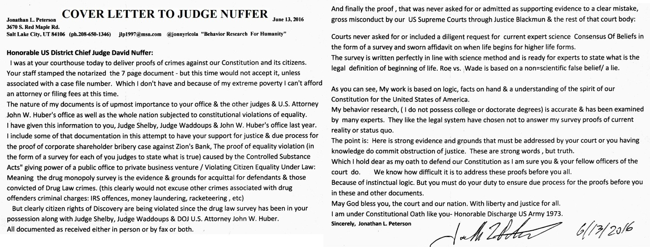
LINK IS ON WEBSITE W-RED ARROWS POINTED AT IT.
==========================
DIRECT- @GovJVentura @GovGaryJohnson ask @jasoninthehouse @RepMiaLove ALL Got Proof our Drug Law Violates EQUALITY=Bloodshed
(W-Photo Rep.Jason Chaffetz,MIA LOVE Photos & jlp w-Prison stories papaer cropped July 20,2015 W-titles 3 PHOTOw JLP) JPEG)
==================
https://twitter.com/GovJVentura/status/741723773032767488 @GovJVenturaICYMI here's why I want #marijuana to be #legal #mmot http://www.hazytimes.com/cannabis/cannabis-regulations-crazy-make-no-sense-burden-tax-people/
@GovJVentura I will prove to you Jesse- that my logic is advanced. Not 1 PRO-LIFE Doctor wrote this survey to ENDIT-
(W-Photo Gov. Herbert&REYES Survey for Doctors Jan. 11, 2016 & div.Remov DK PLAIN LViewsite)
(W-Photo Gov. Herbert&REYES Survey for Doctors Jan. 11, 2016 & div.Remov DK Dr. RAND PAUL LViewsite)
(W-Photo Gov. Herbert&REYES Survey Doctors Jan. 11, 2016 SHORT ORi & divisonRemovWVIEW AMA NSF 7ways&Captions&Mission)
(W-Photo DeseretNews Comment- ‘Bill intends to ban certain abortion procedures in Utah’ (2-26-2016) WIDEVIEW w-SUP
reply
@GovJVentura JESSE&me&$400 filing fee-US District Court in Utah. Judge Nuffer is going to answer=LIBERTY&JUSTICE4ALL
reply
@GovJVentura 750,000 Attorneys, Not 1 Can write the logic survey to prove
CORP SHAREHOLDER $ IS SPENT ON PROFIT-Dah
(W-Photo 46 U.S. DISTRICT COURT JUDGE Robert J. Shelby & WADDOUPS, Filed 11 page complaint 7-1-2015 DK)

@darrell88 @GovJVentura 3 fed judges = ready to be questioned on DOES OUR DRUG MONOPOLY LAW VIOLATE EQUALITY-askThem
(W-Photo Judge Waddoups & DOJ Huber DRUG Survey 1of7pg stamped June 13, 2016)
(W-Photo Judge NUFFER DRUG Survey 1of7pg stamped June 13, 2016 )
(W-Photo Judge Robert Shelby DRUG Survey 1of7pg stamped June 13, 2016 WV)
(W-Photo CIVIL RIGHTS POST ON HUBER VIOLATING DUE PROCESS OCT 8,2015 w-LINK lg text WIDEVIEW & Loretta link)
reply
@darrell88 @GovJVentura JUST LIKE YOU SAID JESSE. PERSONAL CHOICE= NOT-CONTROLLED BY PRIVATE BUSINESS VENTURE.=Wrong
(W-Photo Judge Waddoups & DOJ Huber DRUG Survey 1of7pg stamped June 13, 2016 WV)
(W-Photo Judge NUFFER DRUG Survey 1of7pg stamped June 13, 2016 ) WV
(W-Photo Judge Robert Shelby DRUG Survey 1of7pg stamped June 13, 2016 WV)
(W-Photo 26 DeseretNews comments ‘Scalia's death leaves major void in high court, Utah legal exp’ (2-14-2016) W-SUPREME URL& Loretta)
reply

==========================================
June 13, 2016
=====================================
https://twitter.com/USSupremeCourt/status/740944038774210560 @USSupremeCourtDIETZ, ROCKY v. BOULDIN, HILLARY. Decided 06/09/2016 http://j.mp/25OR9lP
@USSupremeCourt If you choose to defend our Constitution from current status quo violations-OUTCOME WILL BE >NOT TO-
https://twitter.com/jonnyricola/status/742035038196228097 (@USSupremeCourt Did any of you legal geniuses examine my SCI-SURVEY for Doctors & Experts?Roe vsWade is based on lie)
===========
DIRECT From me- https://twitter.com/jonnyricola/status/742062092354625536
USA @USSupremeCourt A Monitored Site. They clearly OBSTRUCT JUSTICE. A SURVEY FOR EXPERTS MUST BE USED FOR CONSENSUS-https://twitter.com/jonnyricola/status/742048498816716801 (@USSupremeCourt @RandPaul @DeseretNews Proof Is Removed-@CivilRights= Obstruction of Justice=https://twitter.com/jonnyricola/status/741011883444998146 w-photos)
====================================
(ADDED TOO- MY POST TO THE DOJ WAS REMOVED TO OBSTRUCT JUSTICE-
https://twitter.com/CivilRights/status/740942042868637698 @CivilRights.@TheJusticeDept Reaches Agreement with Milwaukee to Ensure Civic Access for People with Disabilities → http://go.usa.gov/chbaG
@CivilRights @TheJusticeDept @DeseretNews PROOFS REMOVED SHOWING @USSupremeCourt MISCONDUCT- https://twitter.com/jonnyricola/status/741011883444998146 (@CivilRights @TheJusticeDept YOU DOJ UNDER OATH KNOW A SURVEY WILL END Roe vs Wade- USE IT- CORRECT BLACKMUN ERROR-)
(W-Photo ALL TWEETS REMOVED twitter.com CivilRightsDOJ proof Supreme Ct error JUNE 9 to 12-2016 part1)
(W-Photo ALL TWEETS REMOVED twitter.com CivilRightsDOJ proof Supreme Ct error JUNE 9 to 12-2016 part2)
(W-Photo Gov. Herbert&REYES Survey for Doctors Jan. 11, 2016 & div.Remov DK Dr. RAND PAUL LViewsite)
(W-Photo DeseretNews Comment- ‘Bill intends to ban certain abortion procedures in Utah’ (2-26-2016) WIDEVIEW w-SUP
===================================================
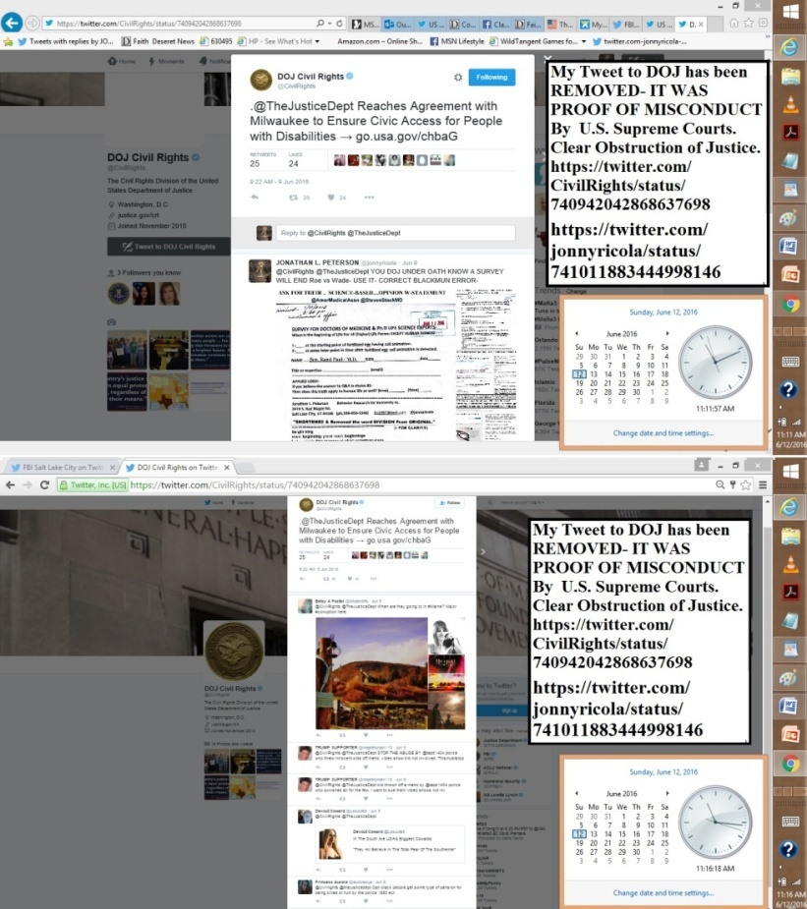
====================================================
https://twitter.com/jonnyricola/status/741011883444998146 (@CivilRights @TheJusticeDept YOU DOJ UNDER OATH KNOW A SURVEY WILL END Roe vs Wade- USE IT- CORRECT BLACKMUN ERROR-)
(added to https://twitter.com/FBISaltLakeCity/status/740589223036649472 @FBISaltLakeCityOwner of Saul Farms Sentenced Bernard Saul to Serve 36 Months in Prison: — Salt Lake City https://www.fbi.gov/saltlakecity/press-releases/2016/owner-of-saul-farms-sentenced-bernard-saul-to-serve-36-months-in-prison …
@FBISaltLakeCity @SenOrrinHatch @LDSChurchNews @NelsonRussellM
PROOF @USSupremeCourt Violates Your Oath = DIDN'T ASK-https://twitter.com/jonnyricola/status/741031128723652611
reply
@FBISaltLakeCity @SenOrrinHatch @LDSChurchNews @DeseretNews
Proof REMOVED From @CivilRights=
https://twitter.com/jonnyricola/status/741011883444998146 ( @CivilRights @TheJusticeDept YOU DOJ UNDER OATH KNOW A SURVEY WILL END Roe vs Wade- USE IT- CORRECT BLACKMUN ERROR-)
============
https://twitter.com/jonnyricola/status/691338724802584576
(SUPREME- IF ONLY BLACKMUN HAD USED SCIENCE CONSENSUS 1ST)
https://twitter.com/CivilRights/status/740942042868637698
==============
https://twitter.com/jonnyricola/status/742069795965652994 @USSupremeCourt @RandPaul @DeseretNews @CivilRights @AP Review my record ofBEHAVIOR RESEARCH-http://jlp1997.wix.com/instinctlogicresearc
https://twitter.com/jonnyricola/status/742048498816716801 (@USSupremeCourt @RandPaul @DeseretNews Proof Is Removed-@CivilRights= Obstruction of Justice=https://twitter.com/jonnyricola/status/741011883444998146)
https://twitter.com/USSupremeCourt/status/740944039579525120 @USSupremeCourtWILLIAMS, TERRANCE v. PENNSYLVANIA. Decided 06/09/2016 http://j.mp/1XIhgtH
@USSupremeCourt Did any of you legal geniuses examine my SCI-SURVEY for Doctors & Experts?Roe vsWade is based on lie
(W-Photo Gov. Herbert&REYES Survey for Doctors Jan. 11, 2016 & div.Remov DK Dr. RAND PAUL LViewsite)
(W-Photo Gov. Herbert&REYES Survey for Doctors Jan. 11, 2016 & div.Remov DK nelson LViewLAWsite CROP
(W-Photo Gov. Herbert&REYES Survey Doctors Jan. 11, 2016 SHORT ORi & divisonRemovWVIEW AMA NSF 7ways&Captions&Mission)
(W-Photo DeseretNews Comment- ‘Bill intends to ban certain abortion procedures in Utah’ (2-26-2016) WIDEVIEW w-SUP
reply
@USSupremeCourt Roe vs.Wade: SCI-BASED Court decision
Blackmun did not get SCI-CONSENSUS before ruling-ASK-@RandPaul
(W-Photo Gov. Herbert&REYES Survey Doctors Jan. 11, 2016 SHORT ORi & divisonRemovWVIEW RAND 7ways&Captions)
reply
@USSupremeCourt @RandPaul @DeseretNews Proof Is Removed-@CivilRights= Obstruction of Justice= https://twitter.com/jonnyricola/status/741011883444998146
(W-Photo ALL TWEETS REMOVED twitter.com CivilRightsDOJ proof Supreme Ct error JUNE 9 to 12-2016 part1)
(W-Photo ALL TWEETS REMOVED twitter.com CivilRightsDOJ proof Supreme Ct error JUNE 9 to 12-2016 part2)
(W-Photo Gov. Herbert&REYES Survey for Doctors Jan. 11, 2016 & div.Remov DK Dr. RAND PAUL LViewsite)
(W-Photo Gov. Herbert&REYES Survey Doctors Jan. 11, 2016 & divisonRemovWVIEW AMA NSF 7ways&Captions&Mission)
reply
@USSupremeCourt @RandPaul @DeseretNews @CivilRights @AP?
Courts had EVIDENCE OF MISCONDUCTby BLACKMUN since Jan2016- https://twitter.com/jonnyricola/status/691338724802584576
(SUPREME- IF ONLY BLACKMUN HAD USED SCIENCE CONSENSUS 1ST)
reply
@USSupremeCourt @RandPaul @DeseretNews @CivilRights @AP Review my record ofBEHAVIOR RESEARCH-http://jlp1997.wix.com/instinctlogicresearc
(W-photo JLP1997 INSTINCTLOGICRESEARC- Website photo June 12, 2016 WVIEW urlPart1)
(W-photo JLP1997 INSTINCTLOGICRESEARC- Website photo June 4, 2016 WVIEW urlPart2)
(W-Photo 26 DeseretNews comments ‘Scalia's death leaves major void in high court, Utah legal exp’ (2-14-2016) W-SUPREME URL& Loretta)
(W-Photo DeseretNews Comments ‘Obama marks Memorial Day at Arlington National Cemetery’ (5-30-2016) WVIEW )
=======================================
ADDED TOO- https://twitter.com/LDSChurchNews/status/741281102900252673 @LDSChurchNews'Look for the one,' Elder Bednar teaches in Spain and Portugal | #LDS @BednarDavidA http://desne.ws/6dQDke
@LDSChurchNews @BednarDavidA @DeseretNews @ThomasSMonson @EyringHB @UchtdorfDF SEARCH 4TRUTH http://jlp1997.wix.com/instinctlogicresearc
(W-photo JLP1997 INSTINCTLOGICRESEARC- Website photo June 9, 2016 WVIEW urlPart1)
(W-photo JLP1997 INSTINCTLOGICRESEARC- Website photo June 4, 2016 WVIEW urlPart2)
(W-Photo DeseretNews Comments How much do you know about President Henry B. Eyring (6-1-2016) WVIEW messSite )
(W-Photo DeseretNews Comments ‘Music and the Spoken Word- What is true greatness’ (5-14-2016)URLmessURLsiteMustDEMANDdk)
=============================================
https://twitter.com/KatieMcKellar1/status/740397756137807874 @KatieMcKellar13 #SaltLake residents hailed as heroes for saving teens in Jordan River crash
@KatieMcKellar1 Good morning Katie:If you & @DeseretNews Would ask this one Q&A of Governor Candidates-
WE THE PEOPLE
(W-Photo Gary Herbert,J Johnson & Mike Weinholtz -SURVEY FOR CORP BRIBERY -EXPLAIN SIGN 6-12-2016 W-SUBVERT &political contWV)
(W-Photo DeseretNews Comments ‘GOP primary in governor's race now focused on money’ (5-1-2016) Wview)
(W-Photo 26 DeseretNews comments ‘Scalia's death leaves major void in high court, Utah legal exp’ (2-14-2016) W-SUPREME URL& Loretta)
(W-Photo DeseretNews Comments ‘Obama marks Memorial Day at Arlington National Cemetery’ (5-30-2016) WVIEW )
reply
@KatieMcKellar1 @DeseretNews I wrote a truthful, needed comment for your readers to consider. Why was it denied :) ?
(W-Photo DeseretNews Comments ‘The race for governor- Herbert vs. Johnson’ (6-12-2016) on hold)
reply
@KatieMcKellar1 @DeseretNews My Constitution/@CivilRights& SCI-Surveys
SHOW OUR LOGIC ERRORS-
https://twitter.com/jonnyricola/status/742048498816716801
(W-Photo ALL TWEETS REMOVED twitter.com CivilRightsDOJ proof Supreme Ct error JUNE 9 to 12-2016 part1)
(W-Photo ALL TWEETS REMOVED twitter.com CivilRightsDOJ proof Supreme Ct error JUNE 9 to 12-2016 part2)
(W-Photo 26 DeseretNews comments ‘Scalia's death leaves major void in high court, Utah legal exp’ (2-14-2016) W-SUPREME URL& Loretta)
(W-Photo DeseretNews comments 15 LDS general authorities & B of Mormon heroes 1-8-2016 WVIEW w- SKULL -DN-URL& faithURL)
reply
@KatieMcKellar1 @DeseretNews @CivilRights ANY AGREE_MY SURVEYforDOCTORS &EXPERTS HAS MERIT?
TESTwillpower-Try2SignIT- https://community.sumofus.org/petitions/ask-doctors-phd-life-science-experts-when-does-life-begin-survey?source=twitter-share-button
reply
@KatieMcKellar1 @DeseretNews @CivilRights @LDSChurchNews
Record of my work 4-WeThePEOPLE= http://jlp1997.wix.com/instinctlogicresearc
(W-photo JLP1997 INSTINCTLOGICRESEARC- Website photo June 12, 2016 WVIEW urlPart1)
(W-photo JLP1997 INSTINCTLOGICRESEARC- Website photo June 4, 2016 WVIEW urlPart2)
(W-Photo Gary Johnson & me & survey on Bribery April 6-2016 slc,ut 1000x650 w-huber&gary obstruct & DRUG LAW)
(W-Photo 54 Jonathan Johnson for governor rally & JLP 9-15-2015 CROPPED even more 2x W SURVEY 1600 W-TEXT REMINDER))
========================================
June 11, 2016
FBI-SLC - POSTS WERE PERMENANTLY REMOVED. - UNLAWFUL & EVIL BEHAVIORS.
https://twitter.com/FBISaltLake/status/740589223036649472
https://twitter.com/jonnyricola/status/741029834957021184
https://twitter.com/jonnyricola/status/741032634315210752
https://twitter.com/jonnyricola/status/741033928857767936
https://twitter.com/jonnyricola/status/741034567008559104
https://twitter.com/jonnyricola/status/741038787015249920
-----------------------------------------------------
https://www.facebook.com/ProLifeAlliance/photos/a.153781571335145.28267.145170355529600/1111700098876616/?type=3&theater
https://www.facebook.com/ProLifeAlliance/photos/a.153781571335145.28267.145170355529600/1113587358687890/?type=1&theater============================== Dennis R. writer for DeseretNews======================================
MY POSTS TO Sen. Hatch & CNN HAVE BEEN PERMINANTLY REMOVED. TWITTER DID NOT DO IT. NSA /Gov. Agency DID.
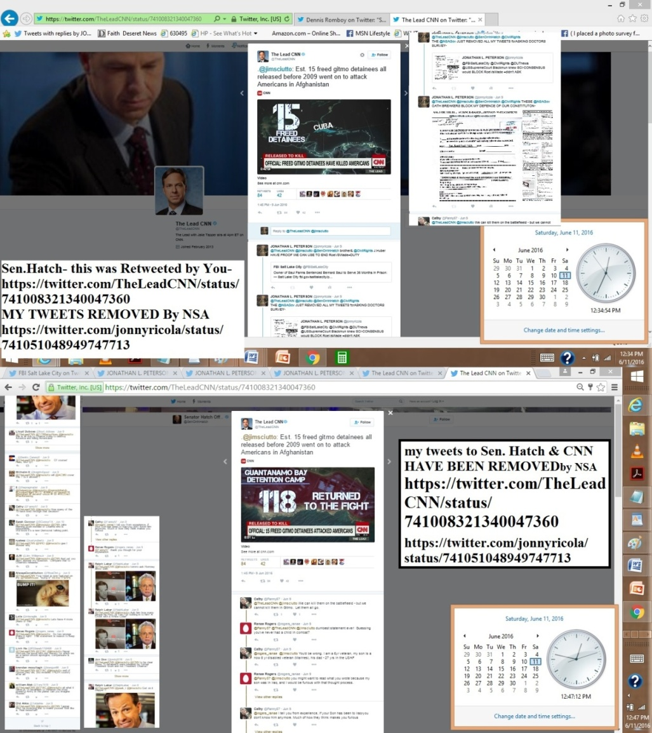
https://twitter.com/jonnyricola/status/741731923811127296
(@dennisromboy @DeseretNews @AP @USSupremeCourt @RandPaul@NelsonRussellM @SenOrrinHatch @CNN
AskDOJ @FBISaltLakeCity)
https://twitter.com/dennisromboy/status/741392487978172417 @dennisromboySen. Orrin Hatch celebrates Muhammad Ali's greatness in funeral speech http://desne.ws/GGsTKB #MuhammedAliFuneral #MuhammadAli
@dennisromboy I wrote this comment. it is truthful, needed & I hope approved by you & @DeseretNews helpWE THE PEOPLE
(W-Photo DeseretNews Comments ‘Sen. Orrin Hatch celebrates Muhammad Ali's greatness in funeral speech’ (6-11-2016) ON HOLD WV)
(W-Photo Gov. Herbert&REYES Survey for Doctors Jan. 11, 2016 & div.Remov DK PLAIN LViewsite)
(W-Photo ALL TWEETS REMOVED twitter.com FBISaltLakeCity status 740589223036649472 JUNE 9-2016 Part1)
(W-Photo ALL TWEETS REMOVED twitter.com FBISaltLakeCity status 740589223036649472 JUNE 9-2016 Part2
reply
@dennisromboy @DeseretNews @AP Citizens need your help/
SURVEY Doctors&Experts @USSupremeCourt FailedUS=Ask @RandPaul
(W-Photo Gov. Herbert&REYES Survey for Doctors Jan. 11, 2016 & div.Remov DK Dr. RAND PAUL LViewsite)
(W-Photo Gov. Herbert&REYES Survey for Doctors Jan. 11, 2016 & div.Remov DK PLAIN LViewsite)
(W-Photo Gov. Herbert&REYES Survey for Doctors Jan. 11, 2016 & div.Remov DK nelson LViewLAWsite CROP
(W-Photo W-Photo DeseretNews Comment- ‘Bill intends to ban certain abortion procedures in Utah’ (2-26-2016) WIDEVIEW w-SUP
reply
@dennisromboy @DeseretNews @AP @USSupremeCourt @RandPaul
@NelsonRussellM Ea. DAY U R SILENT COSTS 6000 US LIVES=Evil
(W-Photo Gov. Herbert&REYES Survey for Doctors Jan. 11, 2016 & div.Remov DK nelson LViewLAWsite
(W-Photo Gov. Herbert&REYES Survey Doctors Jan. 11, 2016 SHORT ORi & divisonRemovWVIEW RAND 7ways&Captions)
(W-photo Gov. Herbert&REYES Survey for Doctors Jan. 11, 2016 SHORT ORi W-HEADER & divisonRemovWVIEW USSG-7 ways&Lawful)
(W-Photo DeseretNews Comments ‘Obama marks Memorial Day at Arlington National Cemetery’ (5-30-2016) WVIEW )
reply
@dennisromboy @DeseretNews @AP @USSupremeCourt @RandPaul @NelsonRussellM @SenOrrinHatch @CNN
https://twitter.com/jonnyricola/status/741051048949747713 (@TheLeadCNN @jimsciutto @SenOrrinHatch @CivilRights THESE @NSAGov OATH BREAKERS BLOCK MY DEFENCE OF OUR CONSTITUTON-)
(W-Photo TWEETS REMOVED Sen. Hatch Retweeted FROM CNN w-SURVEY FOR DOCTORS June 9, 10 -2016 Part1)
(W-Photo TWEETS REMOVED Sen. Hatch Retweeted FROM CNN w-SURVEY FOR DOCTORS June 9, 10 -2016 Part2)
(W-Photo Gov. Herbert&REYES Survey for Doctors Jan. 11, 2016 & div.Remov DK Dr. RAND PAUL LViewsite)
(W-Photo Gov. Herbert&REYES Survey Doctors Jan. 11, 2016 SHORT ORi & divisonRemovWVIEW AMA NSF 7ways&Captions&Mission)
reply
@dennisromboy @DeseretNews @AP @USSupremeCourt @RandPaul@NelsonRussellM @SenOrrinHatch @CNN
AskDOJ @FBISaltLakeCity
(W-Photo ALL TWEETS REMOVED twitter.com FBISaltLakeCity status 740589223036649472 JUNE 9-2016 Part1)
(W-Photo ALL TWEETS REMOVED twitter.com FBISaltLakeCity status 740589223036649472 JUNE 9-2016 Part2
(W-Photo CIVIL RIGHTS POST ON HUBER VIOLATING DUE PROCESS OCT 8,2015 w-LINK lg text WIDEVIEW & Loretta link)
(W-Photo DOJ John HUBER SURVEY PROOF OF CORP SHAREHOLDER BRIBERY OCT 8,2015 & ZION DOJ URL DK Site
===============================================================
https://twitter.com/jonnyricola/status/741735161469894656 (@FBISaltLakeCity @SenOrrinHatch ARE YOU GOING TO DO SOMETHING ABOUT THIS VIOLATION OF CONSTITUTIONAL DEFENSE? Speak?)
https://twitter.com/FBISaltLakeCity/status/740589223036649472 (added too-my other tweets removed by the NSA)
(@FBISaltLakeCity Owner of Saul Farms Sentenced Bernard Saul to Serve 36 Months in Prison: — Salt Lake City https://www.fbi.gov/saltlakecity/press-releases/2016/owner-of-saul-farms-sentenced-bernard-saul-to-serve-36-months-in-prison)
@FBISaltLakeCity @SenOrrinHatch My lawful tweets have been removed
I am under oath & BEING BLOCKED- examine proofs- https://twitter.com/jonnyricola/status/741731923811127296
reply
@FBISaltLakeCity @SenOrrinHatch ARE YOU GOING TO DO SOMETHING
ABOUT THIS VIOLATION OF CONSTITUTIONAL DEFENSE? Speak?
(W-Photo ALL TWEETS REMOVED twitter.com FBISaltLakeCity status 740589223036649472 JUNE 9-2016 Part1)
(W-Photo ALL TWEETS REMOVED twitter.com FBISaltLakeCity status 740589223036649472 JUNE 9-2016 Part2
(W-Photo TWEETS REMOVED Sen. Hatch Retweeted FROM CNN w-SURVEY FOR DOCTORS June 9, 10 -2016 Part1)
(W-Photo TWEETS REMOVED Sen. Hatch Retweeted FROM CNN w-SURVEY FOR DOCTORS June 9, 10 -2016 Part2)
reply
@FBISaltLakeCity @SenOrrinHatch @LDSChurchNews @LDSChurchNews @NelsonRussellM
REVIEW MESSAGE- Defend USA LAW-
Proofs-http://jlp1997.wix.com/instinctlogicresearc
==============================================================
https://twitter.com/dennisromboy/status/741310350637731844 @dennisromboyFed judge affirms convicted businessman Jeremy Johnson to stay in jail pending sentencing next month. #utahcrime #Utah

@dennisromboy @DeseretNews posted=@RandPaul @FBISaltLakeCity Proof
@USSupremeCourt MADE aLEGAL ERROR-@NSAGov REMOVED
(W-Photo ALL TWEETS REMOVED twitter.com FBISaltLakeCity status 740589223036649472 JUNE 9-2016 Part1)LINKS
(W-Photo ALL TWEETS REMOVED twitter.com FBISaltLakeCity status 740589223036649472 JUNE 9-2016 Part2
(W-Photo Gov. Herbert&REYES Survey for Doctors Jan. 11, 2016 & div.Remov DK Dr. RAND PAUL LViewsite)
(W-Photo Gov. Herbert&REYES Survey for Doctors Jan. 11, 2016 & div.Remov DK PLAIN LViewsite)
reply
@dennisromboy @DeseretNews @RandPaul @FBISaltLakeCity @USSupremeCourt @NSAGov Clearly-OBSTRUCTS JUSTICE=testThisLINK-
https://twitter.com/jonnyricola/status/741033928857767936 (@FBISaltLakeCity @CivilRights @DUTnews @USSupremeCourt @SenOrrinHatch @AP AskSen/Dr.@RandPaul-Silence is OBSTRUCTION)
++++++++++++++
=======================================================
https://twitter.com/jonnyricola/status/741652668922220544 @LDSChurchNews @BednarDavidA @DeseretNews @ThomasSMonson @EyringHB @UchtdorfDF@NelsonRussellM-May6=6Kx37DAYS=222000
https://twitter.com/LDSChurchNews/status/741281102900252673 @LDSChurchNews'Look for the one,' Elder Bednar teaches in Spain and Portugal | #LDS @BednarDavidA http://desne.ws/6dQDke

@LDSChurchNews @BednarDavidA The Lord commands we oppose Satan & evil. With our voice. ASK-Dr./Pres @NelsonRussellM
(W-Photo Gov. Herbert&REYES Survey for Doctors Jan. 11, 2016 & div.Remov DK NELSON LViewsite)
reply
@LDSChurchNews @BednarDavidA @DeseretNews ASK-GODfor
@ThomasSMonson @EyringHB @UchtdorfDF @NelsonRussellM SPEAK NOW
(W-Photo Gov. Herbert&REYES Survey for Doctors Jan. 11, 2016 & div.Remov&5Ways DK nelsonLViewLAWsite CROP
(W-Photo DeseretNews comment 20 athletes who are vocal about their faith (4-21-2016) WVIEWmessURL DK
(W-Photo DeseretNews comments 15 LDS general authorities & B of Mormon heroes 1-8-2016 WVIEW w- SKULL -DN-URL& faithURL)
(W-Photo 1 FAITH LIST DNews FEB-29-2016 w- URL&revelation- The Lord says & ASK LDS if true- rejoice DN-savior is born url )
reply
@LDSChurchNews @BednarDavidA @DeseretNews @ThomasSMonson @EyringHB @UchtdorfDF @NelsonRussellM
OPPOSE SATAN'S POWER-
https://twitter.com/jonnyricola/status/740613865247936516 (@LDSChurchNews @BallardMRussell @NelsonRussellM @ThomasSMonson @EyringHB @UchtdorfDF A GIFT&A WARNING FROM GOD-Speak)
reply
@LDSChurchNews @BednarDavidA @DeseretNews @ThomasSMonson @EyringHB @UchtdorfDF @NelsonRussellM
THIS WAS PINNED 5 wks-
https://twitter.com/jonnyricola/status/701487762831052800 (PINNED STORY)
reply
@LDSChurchNews @BednarDavidA @DeseretNews @ThomasSMonson @EyringHB @UchtdorfDF @NelsonRussellM
WITH KNOWLEDGE YOU NOW ARE EVIL-
REPENT & CTR
reply

https://twitter.com/jonnyricola/status/740991319422558208 (@LDSChurchNews @BYU @DeseretNews @NelsonRussellM @ThomasSMonson @EyringHB @UchtdorfDF DEFENDmyWORKorExcommunicateME)
reply
@LDSChurchNews @BednarDavidA @DeseretNews @ThomasSMonson @EyringHB @UchtdorfDF @NelsonRussellM-May6=6Kx37DAYS=222000
https://twitter.com/jonnyricola/status/728677561815851008 (@LDSChurchNews By example. Use This gift from God.By your faith &works-kingdom of God on earthask @NelsonRussellM)
======================================================
June 10 at 6PM I CHECKED & MOST OF MY TWEETS HAVE BEEN RESTORED. .....NOT ALL..
==================
June 9, 2016
NSA JUST REMOVED ALL 14K of MY TWEETS AGAIN.
I ONLY ASK FOR THOSE UNDER OATH TO HONOR IT.
https://twitter.com/jonnyricola/with_replies & open any-Faith List stories comment brotherJonathan - http://www.deseretnews.com/top/faith
https://community.sumofus.org/petitions/ask-doctors-phd-life-science-experts-when-does-life-begin-survey?source=twitter-share-button
https://community.sumofus.org/petitions/ask-doctors-phd-life-science-experts-when-does-life-begin-survey?source=facebook-sharebutton&time=1463337383 (this one science Q&A is prepared to change our world-a gift from God)
https://www.facebook.com/ProLifeAlliance/photos/a.153781571335145.28267.145170355529600/1111700098876616/?type=3&theater
https://www.facebook.com/ProLifeAlliance/photos/a.153781571335145.28267.145170355529600/1113587358687890/?type=1&theater
=============================
@LDSChurchNews HAS JUST UNBLOCKED ME. I KNEW THEY WANT TO SERVE THE LORD.
But my posts removed by the NSA - ARE STILL GONE......
=======================================
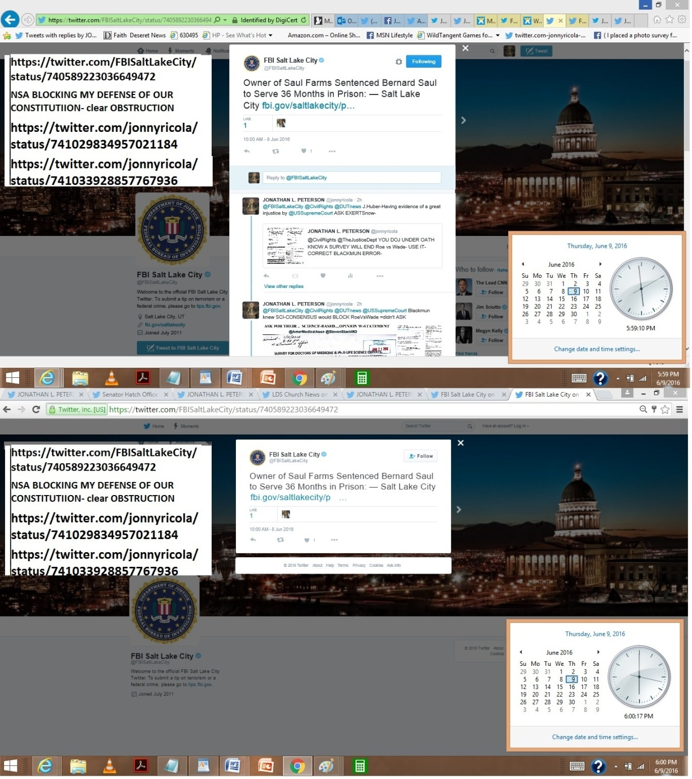
================================================
https://twitter.com/jonnyricola/status/741045229449449472
https://twitter.com/jonnyricola/status/741046002354819072
https://twitter.com/jonnyricola/status/741051048949747713
https://twitter.com/TheLeadCNN/status/741008321340047360 @TheLeadCNN.@jimsciutto: Est. 15 freed gitmo detainees all released before 2009 went on to attack Americans in Afghanistan

@TheLeadCNN @jimsciutto @SenOrrinHatch brother& @CivilRights J.Huber HAVE PROOF WE CAN USE TO END RoeVSWade=DUTY
https://twitter.com/jonnyricola/status/741031128723652611 (@FBISaltLakeCity @CivilRights @DUTnews @USSupremeCourt Blackmun knew SCI-CONSENSUS would BLOCK RoeVsWade =didn't ASK)
reply
@TheLeadCNN @jimsciutto @SenOrrinHatch @CivilRights
THE @NSAGov JUST REMOVED ALL MY TWEETS forASKING DOCTORS SURVEY-
https://twitter.com/jonnyricola/status/741031128723652611 @FBISaltLakeCity @CivilRights @DUTnews @USSupremeCourt Blackmun knew SCI-CONSENSUS would BLOCK RoeVsWade =didn't ASK
reply
@TheLeadCNN @jimsciutto @SenOrrinHatch @CivilRights THESE @NSAGov OATH BREAKERS BLOCK MY DEFENCE OF OUR CONSTITUTON-
(W-Photo Gov. Herbert&REYES Survey for Doctors Jan. 11, 2016 & div.Remov DK Dr. RAND PAUL LViewsite)
(W-Photo Gov. Herbert&REYES Survey Doctors Jan. 11, 2016 SHORT ORi & divisonRemovWVIEW AMA NSF 7ways&Captions&Mission)
(W-photo Gov. Herbert&REYES Survey for Doctors Jan. 11, 2016 SHORT ORi W-HEADER & divisonRemovWVIEW USSG-7 ways&Lawful)
(W-Photo W-Photo DeseretNews Comment- ‘Bill intends to ban certain abortion procedures in Utah’ (2-26-2016) WIDEVIEW w-SUP
===================================
https://twitter.com/jonnyricola/status/741029834957021184 @FBISaltLakeCity @CivilRights @DUTnews J.Huber-Having evidence of a great injustice by @USSupremeCourt ASK EXERTSnow-
https://twitter.com/jonnyricola/status/741032634315210752 @FBISaltLakeCity @CivilRights @DUTnews @USSupremeCourt VIOLATE OATH IF U DON'T USE EVIDENCE-@SenOrrinHatch @RandPaul
https://twitter.com/jonnyricola/status/741033928857767936 @FBISaltLakeCity @CivilRights @DUTnews @USSupremeCourt @SenOrrinHatch @AP AskSen/Dr.@RandPaul-Silence is OBSTRUCTION
https://twitter.com/jonnyricola/status/741034567008559104 @FBISaltLakeCity @CivilRights @DUTnews @USSupremeCourt @SenOrrinHatch @AP @RandPaul PROOF ofINSTINCT'Spower-try2sign-
https://twitter.com/jonnyricola/status/741038787015249920 @FBISaltLakeCity @CivilRights @DUTnews @USSupremeCourt @SenOrrinHatch @AP @RandPaul Record of my work 4 WeThePEOPLE=http://jlp1997.wix.com/instinctlogicresearc …
https://twitter.com/jonnyricola/status/741031128723652611 @FBISaltLakeCity @CivilRights @DUTnews @USSupremeCourt Blackmun knew SCI-CONSENSUS would BLOCK RoeVsWade =didn't ASK
https://twitter.com/FBISaltLakeCity/status/740589223036649472 @FBISaltLakeCityOwner of Saul Farms Sentenced Bernard Saul to Serve 36 Months in Prison: — Salt Lake City https://www.fbi.gov/saltlakecity/press-releases/2016/owner-of-saul-farms-sentenced-bernard-saul-to-serve-36-months-in-prison
https://twitter.com/jonnyricola/status/741735161469894656 (@FBISaltLakeCity @SenOrrinHatch ARE YOU GOING TO DO SOMETHING ABOUT THIS VIOLATION OF CONSTITUTIONAL DEFENSE? Speak?) (added too-my other tweets removed by the NSA)
(@FBISaltLakeCity Owner of Saul Farms Sentenced Bernard Saul to Serve 36 Months in Prison: — Salt Lake City https://www.fbi.gov/saltlakecity/press-releases/2016/owner-of-saul-farms-sentenced-bernard-saul-to-serve-36-months-in-prison)
@FBISaltLakeCity @SenOrrinHatch My lawful tweets have been removed
I am under oath & BEING BLOCKED- examine proofs- https://twitter.com/jonnyricola/status/741731923811127296
reply
@FBISaltLakeCity @SenOrrinHatch ARE YOU GOING TO DO SOMETHING
ABOUT THIS VIOLATION OF CONSTITUTIONAL DEFENSE? Speak?
(W-Photo ALL TWEETS REMOVED twitter.com FBISaltLakeCity status 740589223036649472 JUNE 9-2016 Part1)
(W-Photo ALL TWEETS REMOVED twitter.com FBISaltLakeCity status 740589223036649472 JUNE 9-2016 Part2
(W-Photo TWEETS REMOVED Sen. Hatch Retweeted FROM CNN w-SURVEY FOR DOCTORS June 9, 10 -2016 Part1)
(W-Photo TWEETS REMOVED Sen. Hatch Retweeted FROM CNN w-SURVEY FOR DOCTORS June 9, 10 -2016 Part2)

@FBISaltLakeCity @CivilRights @DUTnews J.Huber-Having evidence of a great injustice by @USSupremeCourt ASK EXERTSnow-
https://twitter.com/jonnyricola/status/741011883444998146 (@CivilRights @TheJusticeDept YOU DOJ UNDER OATH KNOW A SURVEY WILL END Roe vs Wade- USE IT- CORRECT BLACKMUN ERROR-)
reply (hidden) @FBISaltLakeCity @CivilRights @DUTnews @USSupremeCourt (experts)sorry I missed it.But I am sure you understood. @NSF
(W-photo Gov. Herbert&REYES Survey for Doctors Jan. 11, 2016 & div.Remov DK Dr. Cordova LViewsite)
reply
@FBISaltLakeCity @CivilRights @DUTnews @USSupremeCourt Blackmun knew SCI-CONSENSUS would BLOCK RoeVsWade =didn't ASK
(W-Photo Gov. Herbert&REYES Survey for Doctors Jan. 11, 2016 & div.Remov DK PLAIN LViewsite)
(W-photo Gov. Herbert&REYES Survey for Doctors Jan. 11, 2016 SHORT ORi W-HEADER & divisonRemovWVIEW USSG-7 ways&Lawful)
(W-Photo Gov. Herbert&REYES Survey Doctors Jan. 11, 2016 SHORT ORi & divisonRemovWVIEW AMA NSF 7ways&Captions&Mission)
(W-Photo Gov. Herbert&REYES Survey for Doctors Jan. 11, 2016 & div.Remov DK Dr. RAND PAUL LViewsite)
reply
@FBISaltLakeCity @CivilRights @DUTnews @USSupremeCourt VIOLATE OATH IF U DON'T USE EVIDENCE-@SenOrrinHatch @RandPaul
https://twitter.com/jonnyricola/status/740950781063356416 (@SenOrrinHatch @amandadickson @kslnewsradio WE ARE UNDER OATHTO DEFEND OUR CONSTITUTION-Correct this violationTODAY)
reply
@FBISaltLakeCity @CivilRights @DUTnews @USSupremeCourt @SenOrrinHatch @AP AskSen/Dr.@RandPaul-Silence is OBSTRUCTION
(W-Photo Gov. Herbert&REYES Survey for Doctors Jan. 11, 2016 & div.Remov DK Dr. RAND PAUL LViewsite)
reply
@FBISaltLakeCity @CivilRights @DUTnews @USSupremeCourt @SenOrrinHatch @AP @RandPaul
PROOF ofINSTINCT'Spower-try2sign-
https://community.sumofus.org/petitions/ask-doctors-phd-life-science-experts-when-does-life-begin-survey?source=twitter-share-button
reply
@FBISaltLakeCity @CivilRights @DUTnews @USSupremeCourt @SenOrrinHatch @AP @RandPaul Record of my work 4 WeThePEOPLE=
http://jlp1997.wix.com/instinctlogicresearc
========================
https://twitter.com/jonnyricola/status/741011883444998146 @CivilRights @TheJusticeDept YOU DOJ UNDER OATH KNOW A SURVEY WILL END Roe vs Wade- USE IT- CORRECT BLACKMUN ERROR-
https://twitter.com/CivilRights/status/740942042868637698 @CivilRights.@TheJusticeDept Reaches Agreement with Milwaukee to Ensure Civic Access for People with Disabilities → http://go.usa.gov/chbaG

@CivilRights @TheJusticeDept YOU DOJ UNDER OATH KNOW A SURVEY WILL END Roe vs Wade- USE IT- CORRECT BLACKMUN ERROR-
(W-Photo Gov. Herbert&REYES Survey for Doctors Jan. 11, 2016 & div.Remov DK Dr. RAND PAUL LViewsite)
(W-Photo Gov. Herbert&REYES Survey for Doctors Jan. 11, 2016 & div.Remov DK PLAIN LViewsite)
(W-Photo Gov. Herbert&REYES Survey Doctors Jan. 11, 2016 SHORT ORi & divisonRemovWVIEW AMA NSF 7ways&Captions&Mission)
(W-Photo W-Photo DeseretNews Comment- ‘Bill intends to ban certain abortion procedures in Utah’ (2-26-2016) WIDEVIEW w-SUP
==============================
DIRECT-
@operationrescue @AP CALL&FAX Sen.@RandPaul ASK HIM TO FLY OUT TO THE MEETING. SIGN HIS EXPERT OPINION & GIVE COPIES
(W-Photo Gov. Herbert&REYES Survey for Doctors Jan. 11, 2016 & div.Remov DK Dr. RAND PAUL LViewsite)
============================
https://twitter.com/operationrescue/status/740971998239563776 @operationrescueBREAKING! #ProLife Groups Will Peacefully Oppose Hillary Clinton During Address To #PlannedParenthood Tomorrow

@operationrescue @DeseretNews CALL&FAX Sen.@RandPaul
ASK HIM:GoTo THE MEETING. SIGN HIS EXPERT OPINION & GIVE COPIES
(W-Photo Gov. Herbert&REYES Survey for Doctors Jan. 11, 2016 & div.Remov DK Dr. RAND PAUL LViewsite)

@operationrescue PRO-LIFE HAND copies of SURVEY FOR DOCTORS=proof of life. WE CAN END ROE vs WADE IN MONTHS._Courage
(W-Photo Gov. Herbert&REYES Survey for Doctors Jan. 11, 2016 & div.Remov DK PLAIN LViewsite)
(W-Photo Gov. Herbert&REYES Survey Doctors Jan. 11, 2016 SHORT ORi & divisonRemovWVIEW RAND 7ways&Captions)
(W-Photo Gov. Herbert&REYES Survey Doctors Jan. 11, 2016 SHORT ORi & divisonRemovWVIEW AMA NSF 7ways&Captions&Mission)
(W-Photo W-Photo DeseretNews Comment- ‘Bill intends to ban certain abortion procedures in Utah’ (2-26-2016) WIDEVIEW w-SUP
reply

reply
@operationrescue FYI-
NEED TO KNOW- HOW HARD IT IS TO CHALLENGE STATUS QUO DIRECTLY. This petition(TESTS YOUR WILL) https://community.sumofus.org/petitions/ask-doctors-phd-life-science-experts-when-does-life-begin-survey?source=twitter-share-button
reply
@operationrescue @DeseretNews PRO-LIFE Sen.@RandPaul
CAN WITH HIS PEN_STRIKE DOWN_ROEvsWADE. & LEAD @AmerMedicalAssn
(W-Photo Gov. Herbert&REYES Survey for Doctors Jan. 11, 2016 & div.Remov DK Dr. RAND PAUL LViewsite

@nonsumdignus @operationrescue THE HELP FROM GOD IS HERE.
IF YOU HAVE THE COURAGE TO USE IT. ASK Sen. @RandPaul @AP
Gov. Herbert&REYES Survey for Doctors Jan. 11, 2016 & div.Remov DK Dr. RAND PAUL LViewsite
====================================================
https://twitter.com/operationrescue/status/740971409380282369 @operationrescueBREAKING! ProLifers Groups Will Peacefully Oppose Hillary Clinton During Address To Planned Parenthood Tomorrow

@operationrescue PRO-LIFE HAND copies of SURVEY FOR DOCTORS=proof of life.
WE CAN END ROE vs WADE IN MONTHS._Courage
(W-Photo Gov. Herbert&REYES Survey for Doctors Jan. 11, 2016 & div.Remov DK PLAIN LViewsite)
(W-photo Gov. Herbert&REYES Survey for Doctors Jan. 11, 2016 SHORT ORi W-HEADER & divisonRemovWVIEW USSG-7 ways&Lawful)
(W-Photo Gov. Herbert&REYES Survey Doctors Jan. 11, 2016 SHORT ORi & divisonRemovWVIEW AMA NSF 7ways&Captions&Mission)
(W-Photo W-Photo DeseretNews Comment- ‘Bill intends to ban certain abortion procedures in Utah’ (2-26-2016) WIDEVIEW w-SUP
reply
@operationrescue FYI- NEED TO KNOW- HOW HARD IT IS TO CHALLENGE STATUS QUO DIRECTLY. This petition (TESTS YOUR WILL) https://community.sumofus.org/petitions/ask-doctors-phd-life-science-experts-when-does-life-begin-survey?source=twitter-share-button
reply
@operationrescue PRO-LIFE LEADER Sen.@RandPaul CAN WITH HIS PEN
STRIKE DOWN _ROEvsWADE. LEADING THE @AmerMedicalAssn
Gov. Herbert&REYES Survey for Doctors Jan. 11, 2016 & div.Remov DK Dr. RAND PAUL LViewsite
====================================================

https://twitter.com/LDSChurchNews/status/740962172990193665 @LDSChurchNewsNew Doctrinal Mastery program is replacing Scripture Mastery for seminary students | http://desne.ws/xeXv6B
@LDSChurchNews my LDS leadership & members- The Lord chastens those he loves.
Repent & oppose Satan's Power on Earth. FEAR & SERVE GOD
Today-
@LDSChurchNews Thx for removing your block-of our work for the Lord. @NSAGov removed my posts to survey Doctors=EVIL
(W-Photo LDSChurchNews TWITTER- POSTS ALL REMOVED story on black mission presidents&wife June 8,2016 WV Part1
(W-Photo LDSChurchNews TWITTER- POSTS ALL REMOVED story on black mission presidents&wife June 8,2016 WV Part2
(W-Photo GLEN BECK TWEETS REMOVED. DEFENDING OUR UNBORN WVIEW URLSpart1)
(W-Photo GLEN BECK TWEETS REMOVED. DEFENDING OUR UNBORN WVIEW URLSpart2)
reply
@LDSChurchNews @NSAGov Our Lord guides us to oppose Evil/instinct/Satan & UNLAWFUL BEHAVIORS-Ask @NelsonRussellM ctr
https://twitter.com/jonnyricola/status/740613865247936516 (@LDSChurchNews @BallardMRussell @NelsonRussellM @ThomasSMonson @EyringHB @UchtdorfDF A GIFT&A WARNING FROM GOD-Speak)
reply
@LDSChurchNews @BYU Courage @NelsonRussellM SignIT &WeBattle Satan @ThomasSMonson @EyringHB @UchtdorfDF @DeseretNews
(W-Photo Gov. Herbert&REYES Survey for Doctors Jan. 11, 2016 & div.Remov DK NELSON LViewsite)
reply
@LDSChurchNews @BYU @DeseretNews SHOW YOUR FAITH IN GOD ctr&ASK-@NelsonRussellM @ThomasSMonson @EyringHB @UchtdorfDF
https://twitter.com/jonnyricola/status/740615251616370689 (@LDSChurchNews @BallardMRussell @NelsonRussellM @ThomasSMonson @EyringHB @UchtdorfDF @DeseretNews TRUTHorREMOVE&exco)
reply
@LDSChurchNews @BYU @DeseretNews @NelsonRussellM @ThomasSMonson @EyringHB @UchtdorfDF You either serve the Lord & Oppose Satan OR WRATHofGOD
reply
@LDSChurchNews @BYU @DeseretNews @NelsonRussellM @ThomasSMonson @EyringHB @UchtdorfDF -SHARE
http://jlp1997.wix.com/instinctlogicresearc
(W-photo JLP1997 INSTINCTLOGICRESEARC- Website photo June 9, 2016 WVIEW urlPart1)
(W-photo JLP1997 INSTINCTLOGICRESEARC- Website photo June 4, 2016 WVIEW urlPart2)
(W-Photo DeseretNews comments 15 LDS general authorities & B of Mormon heroes 1-8-2016 WVIEW w- SKULL -DN-URL& faithURL)
(W-Photo DeseretNews Comments How much do you know about President Henry B. Eyring (6-1-2016) WVIEW messSite )
reply
@LDSChurchNews @BYU @DeseretNews @NelsonRussellM @ThomasSMonson @EyringHB @UchtdorfDF DEFENDmyWORKorExcommunicateME
(W-photo DeseretNews Comments ‘Music and the Spoken Word- What is true greatness’ (5-14-2016)URLmessURLsiteMustDEMANDdk)
(W-Photo 1 FAITH LIST DNews FEB-29-2016 w- URL&revelation- The Lord says & ASK LDS if true- rejoice DN-savior is born url )
(W-Photo 2 DeseretNews comments 22 quotes from LDS leaders about dating and marriage (2-13-2016) WIDEVIEW Paint Text URL
(W-Photo DeseretNews comments 'How much do you know about Elder Ronald A. Rasband-' (2-5-2016) WIDEVIEW w-Tw-URL)
reply
@LDSChurchNews @BYU @DeseretNews @NelsonRussellM @ThomasSMonson @EyringHB @UchtdorfDF ONLYaSERVE OF GOD-Could write=
(W-photo DeseretNews comment 20 athletes who are vocal about their faith (4-21-2016) WVIEWmessURL DK
reply
@LDSChurchNews @BYU @DeseretNews @NelsonRussellM @ThomasSMonson @EyringHB @UchtdorfDF (servant) WePrepareForThe Lord-
https://twitter.com/jonnyricola/status/740728037742809088 (@JeffreyHayzlett @phaware @AP @LDSchurch @ThomasSMonson @EyringHB @UchtdorfDF @NelsonRussellM IF UR wondering - Battle Against Satan's Power)
++++++++++++
@CivilRights @RandPaul @SenOrrinHatch @SenMikeLee @DeseretNews @USSupremeCourt @LorettaLynch @UUtah UloveUSA?signIT-
https://community.sumofus.org/petitions/ask-doctors-phd-life-science-experts-when-does-life-begin-survey?source=facebook-share-button&time=1463337383
https://twitter.com/LDSChurchNews/status/740186058978004993 https://twitter.com/jonnyricola/status/740225080752365568
=================================
https://twitter.com/jonnyricola/status/740950781063356416 @SenOrrinHatch @amandadickson @kslnewsradio WE ARE UNDER OATHTO DEFEND OUR CONSTITUTION-Correct this violationTODAY
https://twitter.com/jonnyricola/status/740952184481665024 @SenOrrinHatch @amandadickson @kslnewsradio BrotherHatch-everyday you remain silent 6000 innocent lives taken-UNLAWFULLY.REPENT&SPEAKorBnH
https://twitter.com/SenOrrinHatch/status/740901143409201152 @SenOrrinHatchSenator Hatch will be joining @amandadickson on @kslnewsradio at 7:45 MST to discuss his friendship with Muhammad Ali. #utpol
@SenOrrinHatch @amandadickson @kslnewsradio You are my brother- But you & the rest of US VIOLATE CONSTITUTIONAL LAW-
https://twitter.com/jonnyricola/status/740932904629338112 (@SenOrrinHatch @SenateGOP @SenMikeLee @USSupremeCourt BLACKMUN violated rules& didn't get expert consensus-DO IT NOW)
reply
@SenOrrinHatch @amandadickson @kslnewsradio WE ARE UNDER OATH TO DEFEND OUR CONSTITUTION-Correct this violationTODAY
(W-photo Gov. Herbert&REYES Survey for Doctors Jan. 11, 2016 SHORT ORi W-HEADER & divisonRemovWVIEW USSG-7 ways&Lawful)
(W-Photo Gov. Herbert&REYES Survey Doctors Jan. 11, 2016 SHORT ORi & divisonRemovWVIEW AMA NSF 7ways&Captions&Mission)
(W-Photo Gov. Herbert&REYES Survey for Doctors Jan. 11, 2016 & div.Remov DK PLAIN LViewsite)
(W-Photo W-Photo DeseretNews Comment- ‘Bill intends to ban certain abortion procedures in Utah’ (2-26-2016) WIDEVIEW w-SUP
reply
@SenOrrinHatch @amandadickson @kslnewsradio Sen.Hatch you know I am called of God to deliver truth of reality-SignIT-https://community.sumofus.org/petitions/ask-doctors-phd-life-science-experts-when-does-life-begin-survey?source=twitter-share-button
reply
@SenOrrinHatch @amandadickson @kslnewsradio BrotherHatch-
everyday you remain silent 6000 innocent lives taken-UNLAWFULLY.
REPENT&SPEAKorBnH
Reply
@SenOrrinHatch @amandadickson @kslnewsradio ASKctr- @NelsonRussellM @ThomasSMonson @EyringHB @UchtdorfDF @DeseretNews
https://twitter.com/jonnyricola/status/740613865247936516
(@LDSChurchNews @BallardMRussell @NelsonRussellM @ThomasSMonson @EyringHB @UchtdorfDF A GIFT&A WARNING FROM GOD-Speak)
(hidden reply- @SenOrrinHatch @SenateGOP @SenMikeLee @USSupremeCourt @RandPaul @NelsonRussellM @POTUS @AP LINK ABOVE WORKS & PROVES OBSTRUCTION of JUSTICE
reply
@SenOrrinHatch @amandadickson @kslnewsradio @NelsonRussellM @ThomasSMonson @EyringHB @UchtdorfDF @DeseretNews SPEAK-
(W-photo DeseretNews comment 20 athletes who are vocal about their faith (4-21-2016) WVIEWmessURL DK
(W-Photo DeseretNews comments 15 LDS general authorities & B of Mormon heroes 1-8-2016 WVIEW w- SKULL -DN-URL& faithURL)
(W-photo JLP1997 INSTINCTLOGICRESEARC- Website photo June 9, 2016 WVIEW urlPart1)
(W-photo JLP1997 INSTINCTLOGICRESEARC- Website photo June 4, 2016 WVIEW urlPart2)
++++++++++++++++++++++++
======================
https://twitter.com/jonnyricola/status/740940462375067648 @SenOrrinHatch @SenateGOP @SenMikeLee @USSupremeCourt @RandPaul @NelsonRussellM @POTUS SurveySoPowerful-It's REMOVED
https://twitter.com/SenOrrinHatch/status/740662599541362689 @SenOrrinHatchThe costs of Obamacare have continued to rise every year. We can and must do better. #utpol @SenateGOP #TCOT
@SenOrrinHatch @SenateGOP My brother we violate Constitution Law.
POWERS Given DOCTORS Are UNLAWFUL-DrugMonopolyLaw-https://twitter.com/jonnyricola/status/739125153695567876 (CivilRights other violations)
reply
@SenOrrinHatch @SenateGOP @SenMikeLee HEALTH CARE EXTREME PRICING IS CAUSED BY VIOLATION OF CITIZEN EQUALITY-TEST4U2
(W-Photo Sen Lee,Hatch& USAG Lynch w-REYES-controlled sub acts violat equality 5-18-2016 NOTARIZED WVIEW w-YEANAE & stamped)
(W-Photo CIVIL RIGHTS POST ON HUBER VIOLATING DUE PROCESS OCT 8,2015 w-LINK lg text WIDEVIEW & Loretta link)
(W-Photo US Att JOHN HUBER & TRINA HIGGINS-controlled substance acts violations 6-4-2015 NOTARIZED NUFFER WIDEVIEW w-YEA )
(W-Photo DeseretNews Comments ‘Obama marks Memorial Day at Arlington National Cemetery’ (5-30-2016) WVIEW DK)
reply
@SenOrrinHatch @SenateGOP @SenMikeLee You have the SCI-SURVEY PROOF TO END UNLAWFUL Roe vs Wade-SPONSOR IT-or BnHELL
https://community.sumofus.org/petitions/ask-doctors-phd-life-science-experts-when-does-life-begin-survey?source=twitter-share-button
reply
@SenOrrinHatch @SenateGOP @SenMikeLee @USSupremeCourt BLACKMUN violated rules& didn't get expert consensus-DO IT NOW
(W-Photo Gov. Herbert&REYES Survey Doctors Jan. 11, 2016 SHORT ORi & divisonRemovWVIEW AMA NSF 7ways&Captions&Mission)
(W-photo Gov. Herbert&REYES Survey for Doctors Jan. 11, 2016 SHORT ORi W-HEADER & divisonRemovWVIEW USSG-7 ways&Lawful)
(W-Photo Gov. Herbert&REYES Survey for Doctors Jan. 11, 2016 & div.Remov DK PLAIN LViewsite)
(W-Photo W-Photo DeseretNews Comment- ‘Bill intends to ban certain abortion procedures in Utah’ (2-26-2016) WIDEVIEW w-SUP
reply
@SenOrrinHatch @SenateGOP @SenMikeLee @USSupremeCourt
ASK/DEMAND @RandPaul @NelsonRussellM EXPERTS GIVE TESTIMONYnow
(W-photo Gov. Herbert&REYES Survey for Doctors Jan. 11, 2016 SHORT ORi W-HEADER & divisonRemovWVIEW RAND 7ways&Captions)
(W-photo Gov. Herbert&REYES Survey for Doctors Jan. 11, 2016 SHORT & divisonRemovWVIEW RMNelson7 ways&LawfulFX)
reply
@SenOrrinHatch @SenateGOP @SenMikeLee @USSupremeCourt @RandPaul @NelsonRussellM @POTUS HAVING KNOWLEDGE=DUTY TO ACT-https://community.sumofus.org/petitions/ask-doctors-phd-life-science-experts-when-does-life-begin-survey?source=twitter-share-button
reply
@SenOrrinHatch @SenateGOP @SenMikeLee @USSupremeCourt @RandPaul @NelsonRussellM @POTUS SurveySoPowerful-It's REMOVED
(W-Photo LDSChurchNews TWITTER- POSTS ALL REMOVED story on black mission presidents&wife June 8,2016 WV Part1
(W-Photo LDSChurchNews TWITTER- POSTS ALL REMOVED story on black mission presidents&wife June 8,2016 WV Part2
(W-Photo GLEN BECK TWEETS REMOVED. DEFENDING OUR UNBORN WVIEW URLSpart1)
(W-Photo GLEN BECK TWEETS REMOVED. DEFENDING OUR UNBORN WVIEW URLSpart2)
reply
@SenOrrinHatch @SenateGOP @SenMikeLee @USSupremeCourt @RandPaul @NelsonRussellM @POTUS
IF YOU DON'T ACT-It IsTREASON
(W-Photo DeseretNews Comments ‘Obama marks Memorial Day at Arlington National Cemetery’ (5-30-2016) WVIEW DK)
reply
@SenOrrinHatch @SenateGOP @SenMikeLee @USSupremeCourt @RandPaul @NelsonRussellM @POTUS TEST= https://twitter.com/glennbeck/status/733722760015446017
https://twitter.com/jonnyricola/status/733724399451275264
reply
@SenOrrinHatch @SenateGOP @SenMikeLee @USSupremeCourt @RandPaul @NelsonRussellM @POTUS @AP I RECORD MY WORK 4theUSA-
http://jlp1997.wix.com/instinctlogicresearc
======================================================
(W-Photo DeseretNews Comment- ‘Bill intends to ban certain abortion procedures in Utah’ (2-26-2016) WIDEVIEW w-SUP)
(W-Photo Gov. Herbert&REYES Survey for Doctors Jan. 11, 2016 & div.Remov DK PLAIN LViewsite)
(W-Photo W-Photo DeseretNews Comment- ‘Bill intends to ban certain abortion procedures in Utah’ (2-26-2016) WIDEVIEW w-SUP
(W-Photo Gov. Herbert&REYES Survey Doctors Jan. 11, 2016 SHORT ORi & divisonRemovWVIEW AMA NSF 7ways&Captions&Mission)
(W-photo Gov. Herbert&REYES Survey for Doctors Jan. 11, 2016 SHORT ORi W-HEADER & divisonRemovWVIEW USSG-7 ways&Lawful)
(W-photo Gov. Herbert&REYES Survey for Doctors Jan. 11, 2016 SHORT W& divisonRemovWVIEW RAND 7ways&Captions)
(W-Photo W-Photo DeseretNews Comment- ‘Bill intends to ban certain abortion procedures in Utah’ (2-26-2016) WIDEVIEW w-SUP
=============================
I am now blocked from my LDS church twittersites, facebook, & church.
WITHOUT A LETTER OF REPRIMAND OR DISCIPLINARY COUNSEL.
THEY MUST OPPOSE SATAN & EVIL OR THEY DO NOT SERVE GOD. quote me- I speak the truth
==========================================
https://twitter.com/jonnyricola/status/740725669533876225 (if dr.Nelson dont signIT=EVIL)
https://twitter.com/JeffreyHayzlett/status/740677317278740481 @JeffreyHayzlettJeffrey Hayzlett Retweeted phaware™My pleasure! Such a great cause #csuitegives #breathlessonbway #phaware RT @phaware:

@JeffreyHayzlett @phaware MyConstitution proofs-R ready for our courts.Corp Bribery,Drug monopoly& @LDSchurch blocks-https://twitter.com/jonnyricola/status/740242781243736064
reply
@JeffreyHayzlett @phaware @LDSchurch That link works. it says this.@AP
6000 LIVES ADAY- Because of your silence-CTR
(W-Photo Gov. Herbert&REYES Survey for Doctors Jan. 11, 2016 & div.Remov DK PLAIN LViewsite)
reply
@JeffreyHayzlett @phaware @LDSchurch @AP check ITout.WHO HAS THE POWER TO REMOVE LAWFUL TWEETSfromPUBLICVIEW
@NSAGov - https://twitter.com/LDSChurchNews/status/740186058978004993
reply
@JeffreyHayzlett @phaware @LDSchurch @AP @NSAGov Examine this unlawful removal of my tweets.
https://twitter.com/jonnyricola/status/740240078019006464
(W-photo REMOVED TWEET FROM LDSCHURCHNEWS June 8-2016 are your ready to serve)
(W-photo Gov. Herbert&REYES Survey for Doctors Jan. 11, 2016 SHORT & divisonRemovWVIEW RMNelson7 ways&LawfulFX)
(W-Photo DeseretNews Comment- ‘Bill intends to ban certain abortion procedures in Utah’ (2-26-2016) WIDEVIEW w-SUP)
(W-Photo Gov. Herbert&REYES Survey for Doctors Jan. 11, 2016 & div.Remov DK PLAIN LViewsite)
reply
@JeffreyHayzlett @phaware @LDSchurch @AP @NSAGov
Survey for doctors & PhD Experts- Challenge Status Quo 4 US-TEST4U
https://community.sumofus.org/petitions/ask-doctors-phd-life-science-experts-when-does-life-begin-survey?source=twitter-share-button
reply
@JeffreyHayzlett @phaware @AP @NSAGov I TOLD MY @LDSchurch =SAY I TELL THE TRUTH or EXCOMMUNICATE ME-https://twitter.com/jonnyricola/status/740609161151422464 THIS LINKWORKS
@LDSChurchNews @BallardMRussell Do you deny this gift from God? =Support Satan's Power.DO YOU REPENT?@NelsonRussellM)
reply
@JeffreyHayzlett @phaware @AP IF @LDSchurch @ThomasSMonson @EyringHB @UchtdorfDF Dr.@NelsonRussellM DONTsignIT=EVIL-
(W-photo Gov. Herbert&REYES Survey for Doctors Jan. 11, 2016 SHORT & divisonRemovWVIEW RMNelson7 ways&LawfulFX)
reply
@JeffreyHayzlett @phaware @AP @LDSchurch @ThomasSMonson @EyringHB @UchtdorfDF @NelsonRussellM IF I'M A LIAR? I SHOULD BE EXCOMMUNICATED4LIFE
reply
@JeffreyHayzlett @phaware @AP @LDSchurch @ThomasSMonson @EyringHB @UchtdorfDF @NelsonRussellM IF UR wondering - Battle Against Satan's Power

======================================
https://twitter.com/jonnyricola/status/740613865247936516
(@LDSChurchNews @BallardMRussell @NelsonRussellM @ThomasSMonson @EyringHB @UchtdorfDF A GIFT&A WARNING FROM GOD-Speak)
https://twitter.com/jonnyricola/status/707998886665662464 (@DeseretNews Prepare for Our LORD JESUS CHRIST-ASK @LDSchurch @ThomasSMonson @EyringHB @UchtdorfDF& Apostles IF TRUE)
https://twitter.com/jonnyricola/status/740609161151422464 (Do you deny this gift from God?)
https://twitter.com/LDSChurchNews/status/740593297316446208 @LDSChurchNews. @BallardMRussell sees potential for Church growth in Russia #LDS | http://desne.ws/dSozvD

@LDSChurchNews @BallardMRussell Do you deny this gift from God? =Support Satan's Power.DO YOU REPENT?@NelsonRussellM https://twitter.com/jonnyricola/status/740242781243736064
LDSChurchNews @AP @ThomasSMonson @NelsonRussellM @EyringHB @UchtdorfDF 6000 LIVES ADAY- Because of your silence-CTR)
reply
@LDSChurchNews @BallardMRussell @NelsonRussellM THAT LINK WORKS I am now blocked from ASKING Dr.Nelson to save life-
https://community.sumofus.org/petitions/ask-doctors-phd-life-science-experts-when-does-life-begin-survey?source=twitter-share-button
reply
@LDSChurchNews @BallardMRussell @NelsonRussellM @ThomasSMonson @EyringHB @UchtdorfDF YOU GOING TO REMOVE REVELATION-
(W-Photo DeseretNews Comments How much do you know about President Henry B. Eyring (6-1-2016) WVIEW messSite )
(W-Photo DeseretNews comments From Spring City to St. George- 12 historic LDS sites for families to visit summer (6-3-2016) WVmessSite
(W-Photo 1 FAITH LIST DNews FEB-29-2016 w- URL&revelation- The Lord says & ASK LDS if true- rejoice DN-savior is born)
(W-Photo DeseretNews comments 15 LDS general authorities & B of Mormon heroes 1-8-2016 WVIEW w- SKULL -DN-URL& faithURL)
reply
@LDSChurchNews @BallardMRussell @NelsonRussellM @ThomasSMonson @EyringHB @UchtdorfDF A GIFT&A WARNING FROM GOD-Speak
(W-photo DeseretNews comment 20 athletes who are vocal about their faith (4-21-2016) WVIEWmessURL DK
(W-photo Gov. Herbert&REYES Survey for Doctors Jan. 11, 2016 SHORT ORi W-HEADER & divisonRemovWVIEW NELSON 7ways)Cap
W-Photo DeseretNews Comment- ‘Bill intends to ban certain abortion procedures in Utah’ (2-26-2016) WIDEVIEW w-SUP
(W-Photo 7 DeseretNews Elder Holland, Sister Stephens, Elder Hallstrom respond to 17 addit (3-11-2016) WIDEVIEW
reply
@LDSChurchNews @BallardMRussell @NelsonRussellM @ThomasSMonson @EyringHB @UchtdorfDF @DeseretNews TRUTHorREMOVE&exco
(W-Photo DeseretNews Comments ‘Music and the Spoken Word- What is true greatness’ (5-14-2016)URLmessURLsiteMustDEMANDdk
(W-Photo 1 FAITH LIST DNews FEB-29-2016 w- URL&revelation- The Lord says & ASK LDS if true- rejoice DN-savior is born url )
(W-Photo 2 DeseretNews comments 22 quotes from LDS leaders about dating and marriage (2-13-2016) WIDEVIEW Paint Text URL
(W-Photo DeseretNews comments 'How much do you know about Elder Ronald A. Rasband-' (2-5-2016) WIDEVIEW w-Tw-URL)
reply
@LDSChurchNews @BallardMRussell @NelsonRussellM @ThomasSMonson @EyringHB @UchtdorfDF @DeseretNews OPPOSE SATAN orPay-https://twitter.com/jonnyricola/status/701497339685384193
reply
@LDSChurchNews @BallardMRussell @NelsonRussellM @ThomasSMonson @EyringHB @UchtdorfDF @DeseretNews MY CALLING w-PROOF-http://jlp1997.wix.com/instinctlogicresearc
reply
@LDSChurchNews @BallardMRussell @NelsonRussellM @ThomasSMonson @EyringHB @UchtdorfDF @DeseretNews EXCOMMUNICATE ME IF I'M A LIAR-
hypocrites
===============================================================
========================================
DIRECT from me- https://twitter.com/jonnyricola/status/740593287493472258
@jonnyricola
Logic Demands @AP ask Doctors & PhD Science Experts
@NSF @AmerMedicalAssn When does life begin for Higher Life Forms-https://community.sumofus.org/petitions/ask-doctors-phd-life-science-experts-when-does-life-begin-survey?source=twitter-share-button
========================================
DIRECT- @CivilRights @AP @CivilRightsAAG @DeseretNews @NSF @USSupremeCourt @POTUS USAG @LorettaLynch-Do I have an acurrate view of Constitution Law?
=======================================================
https://twitter.com/jonnyricola/status/687326307621838848 (@votemadsen You have the filed with 3 Fed Judges & 5 UT Sup Ct. Justices Survey proof to end our Drug Monopoly.SPEAK)
https://twitter.com/CivilRights/status/740244242862374912 (Added Too now)
@CivilRights.@CivilRightsAAG Vanita Gupta Speaks at the Washington Council of Lawyers Pro Bono & Public Interest Forum → https://www.justice.gov/opa/speech/head-civil-rights-division-vanita-gupta-delivers-remarks-washington-council-lawyers …
https://www.facebook.com/photo.php?fbid=1203928306308392&set=p.1203928306308392&type=3&theater
@CivilRights @AP @CivilRightsAAG @DeseretNews @NSF @USSupremeCourt @POTUS USAG @LorettaLynch-Do I have an acurrate view of Constitution Law?
aL Evan‏@alevapa1 6h6 hours ago
@jonnyricola @CivilRights @AP @CivilRightsAAG @LorettaLynch: $25 or $25000 to effect a political outcome? Same intent.
reply
@alevapa1 @CivilRights @AP @CivilRightsAAG @LorettaLynch What counts is crime that can be proven in a court of law. needing proof of intent.
reply
@alevapa1 @CivilRights @AP @CivilRightsAAG @LorettaLynch Shareholder $ is very special. It is under Corp.Mission Law
(W-Photo 46 U.S. DISTRICT COURT JUDGE Robert J. Shelby & WADDOUPS, Filed 11 page complaint 7-1-2015 DK)
REPLY
@alevapa1 @CivilRights @AP @CivilRightsAAG @LorettaLynch
USAG Loretta Lynch-would you say I have an accurate view of Constitutional Law?Y/N
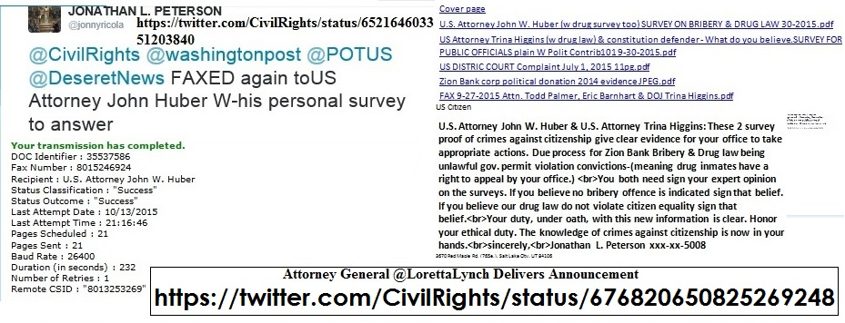
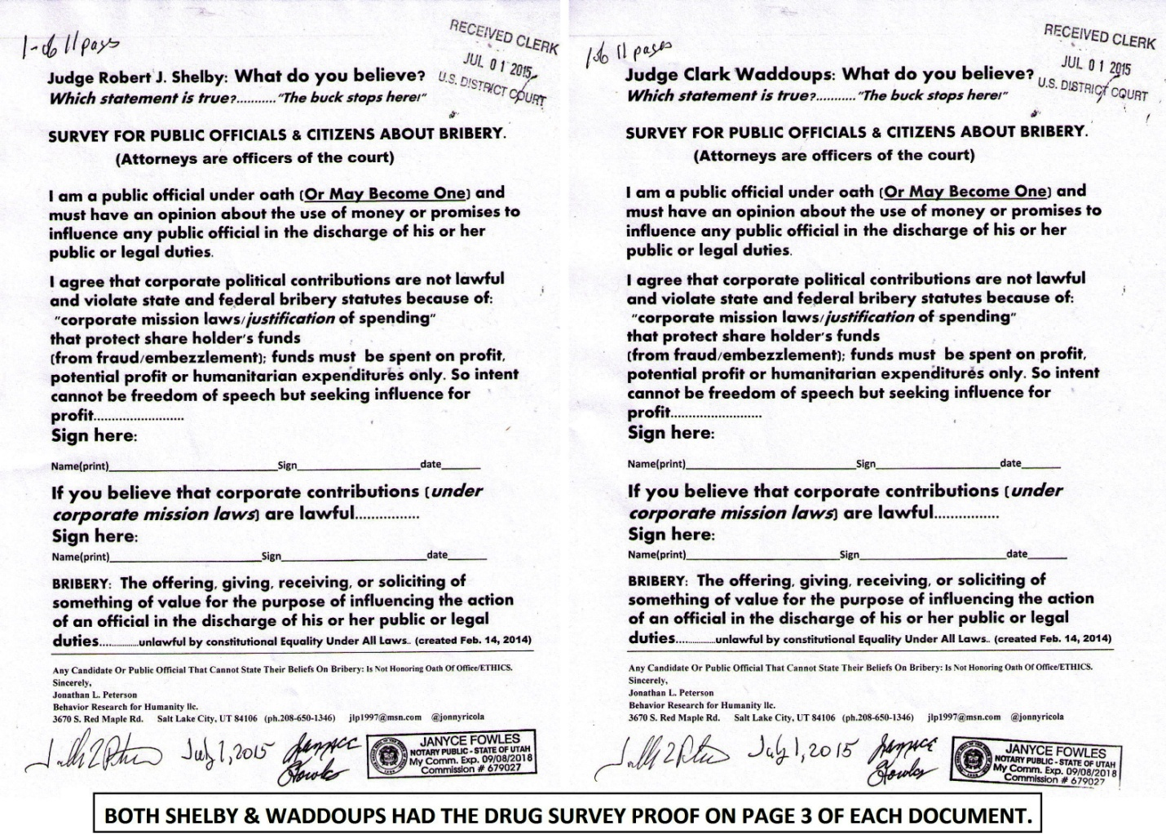
==================================================
June 7, 2016
==================
DIRECT TO GLENN-
@glennbeck My brother,(all are brothers&sisters) I haven't heard back from you.
do you believe my words are from God?https://twitter.com/glennbeck/status/739938692006051840
DIRECT TO GLENN-
@glennbeck goodnight my bro I pray for my LDS leaders to oppose Satan &sign the proof God is in charge.I hope Uhelp2 https://twitter.com/jonnyricola/status/740240078019006464
(@LDSChurchNews @ThomasSMonson are you ready to serve the Lord & oppose Satan?
@NelsonRussellM @EyringHB @UchtdorfDF
(W-Photo Gov. Herbert survey doctors NELSON )
======================================
https://twitter.com/glennbeck/status/740317822111391744 @glennbeckBigoted Judges Shut Down 16-year-old Singer Purely Because of Her Beliefs http://ow.ly/HDoo3011BkX
@glennbeck Put that judge is his place.Ask for his expert opinion on these 2 legal questions of Constitutional law:)
(W-Photo Gary Johnson & me & survey on Bribery April 6-2016 slc,ut 1000x650 w-huber&gary obstruct & DRUG LAW)
(W-Photo Pres. Obama & Trump & HILLARY-U BELIEVE IT SIGN IT SURVEY FOR CORP BRIBERY -EXPLAIN 2-26-2016 WView messURLS
(W-Photo GLENN BECK & LORETTA- -NUFFER DOC w-REYES-controlled sub 6-4-2015 NOTARIZED WIDEVIEW w-YEA orNAE w sq)
(W-Photo DeseretNews Comments ‘Obama marks Memorial Day at Arlington National Cemetery’ (5-30-2016) WVIEW DK)
reply
@glennbeck You believe there is anyone else called of God to deliver truth of our adversary?I need to share the gift-https://community.sumofus.org/petitions/ask-doctors-phd-life-science-experts-when-does-life-begin-survey?source=twitter-share-button
reply
@glennbeck I was at DOJ J.Huber's office today in SLC. HE HAS A FILED TEST CASE HE'S TO SCARED TO GIVE DUE PROCESS.
https://twitter.com/jonnyricola/status/740369724945485824
reply
@glennbeck Please go to my website &watch 2 photo shows of the work I do for the Lord & my brothers&sisters-ITS good-http://jlp1997.wix.com/instinctlogicresearc
reply
@glennbeck goodnight my bro I pray for my LDS leaders to oppose Satan &sign the proof God is in charge.I hope Uhelp2 https://twitter.com/jonnyricola/status/740240078019006464
(@LDSChurchNews @ThomasSMonson are you ready to serve the Lord & oppose Satan?
@NelsonRussellM @EyringHB @UchtdorfDF
(W-Photo Gov. Herbert survey doctors NELSON )
======================
https://twitter.com/jonnyricola/status/740369724945485824 @CivilRights @AP @CivilRightsAAG @LorettaLynch HAS KNOWN ABOUT IT10-2015.time 4DUE PROCESS-OR OBSTRUCT JUSTICE=JAIL
https://twitter.com/CivilRights/status/740244242862374912 @CivilRights.@CivilRightsAAG Vanita Gupta Speaks at the Washington Council of Lawyers Pro Bono & Public Interest Forum → https://www.justice.gov/opa/speech/head-civil-rights-division-vanita-gupta-delivers-remarks-washington-council-lawyers …

@CivilRights Here is the fix @CivilRightsAAG& @LorettaLynch I went to DOJ J.Huber's office-HE HAS A TEST CASE IN UT-
https://twitter.com/jonnyricola/status/739125153695567876 (@CivilRights @RandPaul @SenOrrinHatch @SenMikeLee @DeseretNews @USSupremeCourt @LorettaLynch @UUtah OTHER VIOLATIONS)
reply
@CivilRights @AP @CivilRightsAAG @LorettaLynch HAS KNOWN ABOUT IT
10-2015.time 4DUE PROCESS-OR OBSTRUCT JUSTICE=JAIL
(W-Photo CIVIL RIGHTS POST ON HUBER VIOLATING DUE PROCESS OCT 8,2015 w-LINK lg text WIDEVIEW & Loretta link)
(W-Photo US DISTRIC COURT Judge Nuffer Complaint July 1, 2015 11pg Lrez PAGE 1 & ZION BANK in ID evidence & SUPREME URL& Loretta)
(W-Photo DeseretNews Comments ‘GOP primary in governor's race now focused on money’ (5-1-2016) Wview)
(W-Photo USatt Huber,USAG Lynch& Reyes -SURVEY FOR CORP BRIBERY -EXPLAIN SIGN 2-26-2016 W-SUBVERT WIDEVIEW loretta tell them
(hidden reply to thse under oath = @CivilRights @AP @CivilRightsAAG @LorettaLynch I'M HOPING FEAR OF JUSTICE FOR OBSTRUCTION & LOVE OF NATION WILL MAKE YOU RISK ALL FOR theUSA)
reply
@CivilRights @AP - @WhiteHouse @FLOTUS @CivilRightsAAG
@LorettaLynch -You know a more important crime @NSF SPEAKUP =
https://twitter.com/jonnyricola/status/739880620407414784
(@CivilRightsAAG @CivilRights Of All The @USSupremeCourtViolations Our Society DOES_THIS IS THE WORST & YOU KNOW IT.)
reply
@CivilRights @AP @WhiteHouse @FLOTUS @CivilRightsAAG @LorettaLynch
@NSF & @USSupremeCourt FAILED USA=By Not Asking =
https://community.sumofus.org/petitions/ask-doctors-phd-life-science-experts-when-does-life-begin-survey?source=twitter-share-button
reply
@CivilRights @AP @WhiteHouse @FLOTUS @CivilRightsAAG @LorettaLynch @DeseretNews DUTY @NSF @USSupremeCourt 2FixERROR
(W-Photo Gov. Herbert&REYES Survey Doctors Jan. 11, 2016 SHORT ORi & divisonRemovWVIEW AMA NSF 7ways&Captions&Mission)
(W-photo Gov. Herbert&REYES Survey for Doctors Jan. 11, 2016 SHORT ORi W-HEADER & divisonRemovWVIEW USSG-7 ways&Lawful)
(W-Photo W-Photo DeseretNews Comment- ‘Bill intends to ban certain abortion procedures in Utah’ (2-26-2016) WIDEVIEW w-SUP
(W-Photo DeseretNews Comments ‘Obama marks Memorial Day at Arlington National Cemetery’ (5-30-2016) WVIEW DK)
reply
@CivilRights @AP @CivilRightsAAG @LorettaLynch @DeseretNews @NSF @USSupremeCourt TEST4U @POTUS- https://community.sumofus.org/petitions/ask-doctors-phd-life-science-experts-when-does-life-begin-survey?source=twitter-share-button NOBODY CANsignIT.Utry
reply
@CivilRights @AP @CivilRightsAAG @LorettaLynch @DeseretNews @NSF @USSupremeCourt @POTUS Instinct Mech blocks choices- https://twitter.com/jonnyricola/status/738383532813254657 @NSF @AP @IBMWatson @PBS @DeseretNews @UUtah @POTUSWHY this SCI-Knowledge is so important? =Instinct blocks Choice
reply
@CivilRights @AP @CivilRightsAAG @LorettaLynch @DeseretNews @NSF @USSupremeCourt @POTUS It's Not SCI-FI it's REALITY
(W-Photo DR. NEIL , EAGLEMAN & ALLPhD EXPERTS SCI-SURVEY ON INSTINCT w-deprog 3-14-2016 PAINTED TEXT w-PBSbrainURL&twitter)
(W-Photo NSF Evidence letter for Funding.Pg1 of 3 (Landscape) Dear NSF pi-leadership and Pres. Barack Obama, April 16, 2015 WView)
(W-Photo 69B MY LAST TWEET- Was to Dr. Neil DeGrassi Tyson March 14-2016 survey on instinct LG VIEW messDKwARROWS)corected
(W-Photo PBS The BRAIN final episode with PROOFS OF INSTINCT MECH as A.I. Driven w STATUS QUO w-LINK)
reply
@CivilRights @AP @CivilRightsAAG @LorettaLynch @DeseretNews @NSF @USSupremeCourt @POTUS
My work RECORDED 4U &the USA- http://jlp1997.wix.com/instinctlogicresearc
reply
@CivilRights @AP @CivilRightsAAG @DeseretNews @NSF @USSupremeCourt @POTUS USAG @LorettaLynch-Do I have an acurrate view of Constitution Law?
reply
@CivilRights @AP @CivilRightsAAG @DeseretNews @NSF @USSupremeCourt @POTUS @LorettaLynch
Sometimes my spelling is atrocious- ACCURATE. Y/N :)

@CivilRights @AP @CivilRightsAAG @LorettaLynch @DeseretNews @NSF @USSupremeCourt @POTUS My work RECORDED 4U &the USA-http://jlp1997.wix.com/instinctlogicresearc
reply
@CivilRights @AP @CivilRightsAAG @DeseretNews @NSF @USSupremeCourt @POTUS USAG @LorettaLynch-Do I have an acurrate view of Constitution Law?
reply
@CivilRights @AP @CivilRightsAAG @DeseretNews @NSF @USSupremeCourt @POTUS @LorettaLynch Sometimes my spelling is atrocious- ACCURATE. Y/N :)
+++++++++++++++++++++++++++++++++
=====================================
https://twitter.com/WhiteHouseAAPI/status/739899668260347906 @WhiteHouseAAPIWe are kicking off the @whitehouse #MASSA bullying prevention roundtable with @vj44 and @Cecilia44 opening the event

@WhiteHouseAAPI @WhiteHouse @vj44 @Cecilia44 I went to DOJ @CivilRights J.Huber's office- HE HAS A TEST CASE IN UT-
https://twitter.com/jonnyricola/status/739125153695567876 (@CivilRights @RandPaul @SenOrrinHatch @SenMikeLee @DeseretNews @USSupremeCourt @LorettaLynch @UUtah OTHER VIOLATIONS)
reply
@WhiteHouseAAPI @WhiteHouse @vj44 @Cecilia44 @CivilRights @LorettaLynch HAS KNOWN ABOUT IT 10-2015.time 4DUE PROCESS
(W-Photo CIVIL RIGHTS POST ON HUBER VIOLATING DUE PROCESS OCT 8,2015 w-LINK lg text WIDEVIEW & Loretta link)
(W-Photo US DISTRIC COURT Judge Nuffer Complaint July 1, 2015 11pg Lrez PAGE 1 & ZION BANK in ID evidence & SUPREME URL& Loretta)
(W-Photo DeseretNews Comments ‘GOP primary in governor's race now focused on money’ (5-1-2016) Wview)
(W-Photo USatt Huber,USAG Lynch& Reyes -SURVEY FOR CORP BRIBERY -EXPLAIN SIGN 2-26-2016 W-SUBVERT WIDEVIEW loretta tell them
reply
@WhiteHouseAAPI @WhiteHouse @vj44 @Cecilia44 @CivilRights @LorettaLynch You know @CivilRightsAAG a more important 1=
https://twitter.com/jonnyricola/status/739880620407414784 (@CivilRightsAAG @CivilRights Of All The @USSupremeCourtViolations Our Society DOES_THIS IS THE WORST & YOU KNOW IT.)
reply
@WhiteHouseAAPI @WhiteHouse @vj44 @Cecilia44 @CivilRights @LorettaLynch @CivilRightsAAG @USSupremeCourt JUSTICE 4ALL-
https://community.sumofus.org/petitions/ask-doctors-phd-life-science-experts-when-does-life-begin-survey?source=twitter-share-button
reply
@WhiteHouseAAPI @WhiteHouse @vj44 @Cecilia44 @CivilRights @LorettaLynch @CivilRightsAAG @USSupremeCourt NO EXCUSES
(W-photo Gov. Herbert&REYES Survey for Doctors Jan. 11, 2016 SHORT ORi W-HEADER & divisonRemovWVIEW USSG-7 ways&Lawful)
(W-Photo Gov. Herbert&REYES Survey Doctors Jan. 11, 2016 SHORT ORi & divisonRemovWVIEW AMA NSF 7ways&Captions&Mission)
(W-Photo W-Photo DeseretNews Comment- ‘Bill intends to ban certain abortion procedures in Utah’ (2-26-2016) WIDEVIEW w-SUP
(W-Photo DeseretNews Comments ‘Obama marks Memorial Day at Arlington National Cemetery’ (5-30-2016) WVIEW DK)
reply
@WhiteHouseAAPI @WhiteHouse @vj44 @Cecilia44 @CivilRights @LorettaLynch @CivilRightsAAG TEST4U-https://community.sumofus.org/petitions/ask-doctors-phd-life-science-experts-when-does-life-begin-survey?source=twitter-share-button … NOBODY CANsignIT.Utry https://community.sumofus.org/petitions/ask-doctors-phd-life-science-experts-when-does-life-begin-survey?source=twitter-share-button
reply
@WhiteHouseAAPI @WhiteHouse @vj44 @Cecilia44 @CivilRights @LorettaLynch @CivilRightsAAG Instinct Mech blocks choices-
https://twitter.com/jonnyricola/status/738383532813254657 (@NSF @AP @IBMWatson @PBS @DeseretNews @UUtah @POTUS WHY this SCI-Knowledge is so important? =Instinct blocks Choice)
==============================================
https://twitter.com/JJohnsonNow/status/740295380793851904 @JJohnsonNowBallots are in the mail & arriving even now. Have you taken the comparison quiz yet? #HireJJ #utpol #elections http://johnsonvsherbert.vote
@JJohnsonNow @AP You said your were going to help.@GovHerbert said he would get back to me-YOU BOTH OBSTRUCT JUSTICE
(W-Photo 54 Jonathan Johnson for governor rally & JLP 9-15-2015 CROPPED even more 2x W SURVEY 1600 W-TEXT REMINDER)
(W-Photo DeseretNews Comments ‘GOP primary in governor's race now focused on money’ (5-1-2016) Wview)
(W-Photo Jonathan Johnson & Gov. Gary Herbert-U BELIEVE IT SIGN IT SURVEY FOR CORP BRIBERY -EXPLAIN SIGN 4-1-2016)
(W-Photo DeseretNews Comments ‘Gov. Gary Herbert says 'tone' of fundraising will change amid criticism’ (5-17-2016)
reply
@JJohnsonNow @AP @GovHerbert BOTH KNOW THE CASE IS FILED AGAINST ZION'S BANK. @KUTV2News @DUTnews Huber OBSTRUCTS J2
(W-Photo CIVIL RIGHTS POST ON HUBER VIOLATING DUE PROCESS OCT 8,2015 w-LINK lg text WIDEVIEW & Loretta link)
(W-Photo US DISTRIC COURT Judge Nuffer Complaint July 1, 2015 11pg Lrez PAGE 1 & ZION BANK in ID evidence & SUPREME URL& Loretta)
(W-Photo 46 U.S. DISTRICT COURT JUDGE Robert J. Shelby & WADDOUPS, Filed 11 page complaint 7-1-2015 DK)
(W-Photo USatt Huber,USAG Lynch& Reyes -SURVEY FOR CORP BRIBERY -EXPLAIN SIGN 2-26-2016 W-SUBVERT WIDEVIEW loretta tell them
reply
@JJohnsonNow @AP @GovHerbert @KUTV2News @DUTnews
ASK @LorettaLynch& @CivilRightsAAG TO VERIFY =THIS PROOF OF INTENT-
https://twitter.com/jonnyricola/status/685209659938975744
============================================
https://twitter.com/jonnyricola/status/740242781243736064 (@LDSChurchNews @AP @ThomasSMonson @NelsonRussellM @EyringHB @UchtdorfDF 6000 LIVES ADAY- Because of your silence-CTR)
https://twitter.com/jonnyricola/status/740240078019006464 (are you ready to serve)
https://twitter.com/LDSChurchNews/status/740186058978004993 @LDSChurchNews16 new temple presidents called by First Presidency #LDS | http://desne.ws/229LfN
@LDSChurchNews The Lord guided us to treat our neighbor with equality. Satan tries to blind us -so we don't care.ASK-
https://community.sumofus.org/petitions/ask-doctors-phd-life-science-experts-when-does-life-begin-survey?source=twitter-share-button
reply
@LDSChurchNews Truth from God so we can repent & oppose Satan Openly
Ask @ThomasSMonson knows revelation is from God
https://twitter.com/jonnyricola/status/738847361389060097 (@LDSChurchNews It is a simple fact-You @ThomasSMonson @EyringHB @UchtdorfDF& @LDSchurch WOULD NOT ALLOW IT-IfNotTrue)
reply
@LDSChurchNews @ThomasSMonson are you ready to serve the Lord & oppose Satan?
@NelsonRussellM @EyringHB @UchtdorfDF
(W-Photo Gov. Herbert&REYES Survey Doctors Jan. 11, 2016 SHORT ORi W-HEADER & divisonRemovWVIEW RMNelson7 ways&LawfulFX)
reply
@LDSChurchNews @AP @ThomasSMonson @NelsonRussellM @EyringHB @UchtdorfDF
6000 LIVES ADAY- Because of your silence-CTR
(W-Photo Gov. Herbert&REYES Survey for Doctors Jan. 11, 2016 & div.Remov DK PLAIN LViewsite)
reply
@LDSChurchNews @AP @ThomasSMonson @NelsonRussellM @EyringHB @UchtdorfDF
Time To support this work for our Lord SHARE=http://jlp1997.wix.com/instinctlogicresearc
========================================================
DIRECT- https://twitter.com/jonnyricola/status/740215752838385664 JONATHAN L. PETERSON ‏@jonnyricola · 14m14 minutes ago
@theblaze @SpeakerRyan You really want to reveal @realDonaldTrump true self to the public? Ask him & @HillaryClinton
(W-Photo Pres. Obama & Trump & HILLARY-U BELIEVE IT SIGN IT SURVEY FOR CORP BRIBERY -EXPLAIN 2-26-2016 WView messURLS
===============================================
https://twitter.com/theblaze/status/740213788008275968 @theblazeNew York Times: Trump will usher in “ethnic cleansing of the court system” http://www.theblaze.com/stories/2016/06/07/new-york-times-trump-will-usher-in-ethnic-cleansing-of-the-court-system/ …

@theblaze @AP Logic Survey to reveal @realDonaldTrump who will not defend our Constitution based on Citizen Equality
(W-Photo Pres. Obama & Trump & HILLARY-U BELIEVE IT SIGN IT SURVEY FOR CORP BRIBERY -EXPLAIN 2-26-2016 WView messURLS
reply
@theblaze @AP @realDonaldTrump Our nation's logic is flawed & doesn't honor our code of conduct.UseThis proof tooASK- https://community.sumofus.org/petitions/ask-doctors-phd-life-science-experts-when-does-life-begin-survey?source=twitter-share-button

========================
https://twitter.com/jonnyricola/status/740213636044455936 @theblaze @SpeakerRyan You really want to reveal @realDonaldTrump true self to the public? Ask him & @HillaryClinton
https://twitter.com/theblaze/status/740209666072805376 @theblaze.@SpeakerRyan blasts Trump’s judge comment: “Textbook definition of a racist comment” http://www.theblaze.com/stories/2016/06/07/paul-ryan-blasts-trumps-judge-comment-textbook-definition-of-a-racist-comment/ …
@theblaze @SpeakerRyan You really want to reveal @realDonaldTrump true self to the public? Ask him & @HillaryClinton
(W-Photo Pres. Obama & Trump & HILLARY-U BELIEVE IT SIGN IT SURVEY FOR CORP BRIBERY -EXPLAIN 2-26-2016 WView messURLS
reply
@theblaze @SpeakerRyan @realDonaldTrump @HillaryClinton
Why no lawyer wrote that proof or Doctor wrote this 1=SATAN
https://community.sumofus.org/petitions/ask-doctors-phd-life-science-experts-when-does-life-begin-survey?source=twitter-share-button
reply
==========================================
June 6, 2016
=======================================
DIRECT-
@glennbeck I hope you DO serve our Lord. If you don't oppose Satan, but are silent ?
Our Lord will be silent for you-
https://twitter.com/jonnyricola/status/739947756421316608 (@glennbeck I hope you are chosen of the Lord to stand against Satan &Our blindness to reality.if you're not. Pray 4U)
=======================================================
https://twitter.com/glennbeck/status/739938692006051840 @glennbeckReagan Historian: Donald Trump Is No Ronald Reagan http://ow.ly/doPM300YXub

@glennbeck Finding out you don't have the power of choice is hard on your mind. You can't even ask doctors 4 opinion-https://community.sumofus.org/petitions/ask-doctors-phd-life-science-experts-when-does-life-begin-survey?source=twitter-share-button
reply
@glennbeck is this really you?Or a helper that shields you from the truth? NSA REMOVED Post-
https://twitter.com/glennbeck/status/733722760015446017
https://twitter.com/jonnyricola/status/733724399451275264
reply
@glennbeck I record most of my tweets & when tweets are removed (different than being blocked from further posting-
(W-Photo GLEN BECK TWEETS REMOVED. DEFENDING OUR UNBORN WVIEW URLSpart1)
(W-Photo GLEN BECK TWEETS REMOVED. DEFENDING OUR UNBORN WVIEW URLSpart2)
(W-Photo TWITTER POSTS REMOVED CIVILRIGHTS RI POSTING April 30, 2016 URLS p3)
(W-Photo TWITTER POSTS REMOVED CivilRights post on bribery May 16, 2016 POST GONE)
reply
@glennbeck I hope you are chosen of the Lord to stand against Satan &Our blindness to reality.
if you're not. Pray 4U
(W-Photo DeseretNews comments 15 LDS general authorities & B of Mormon heroes 1-8-2016 WVIEW w- SKULL -DN-URL& faithURL)
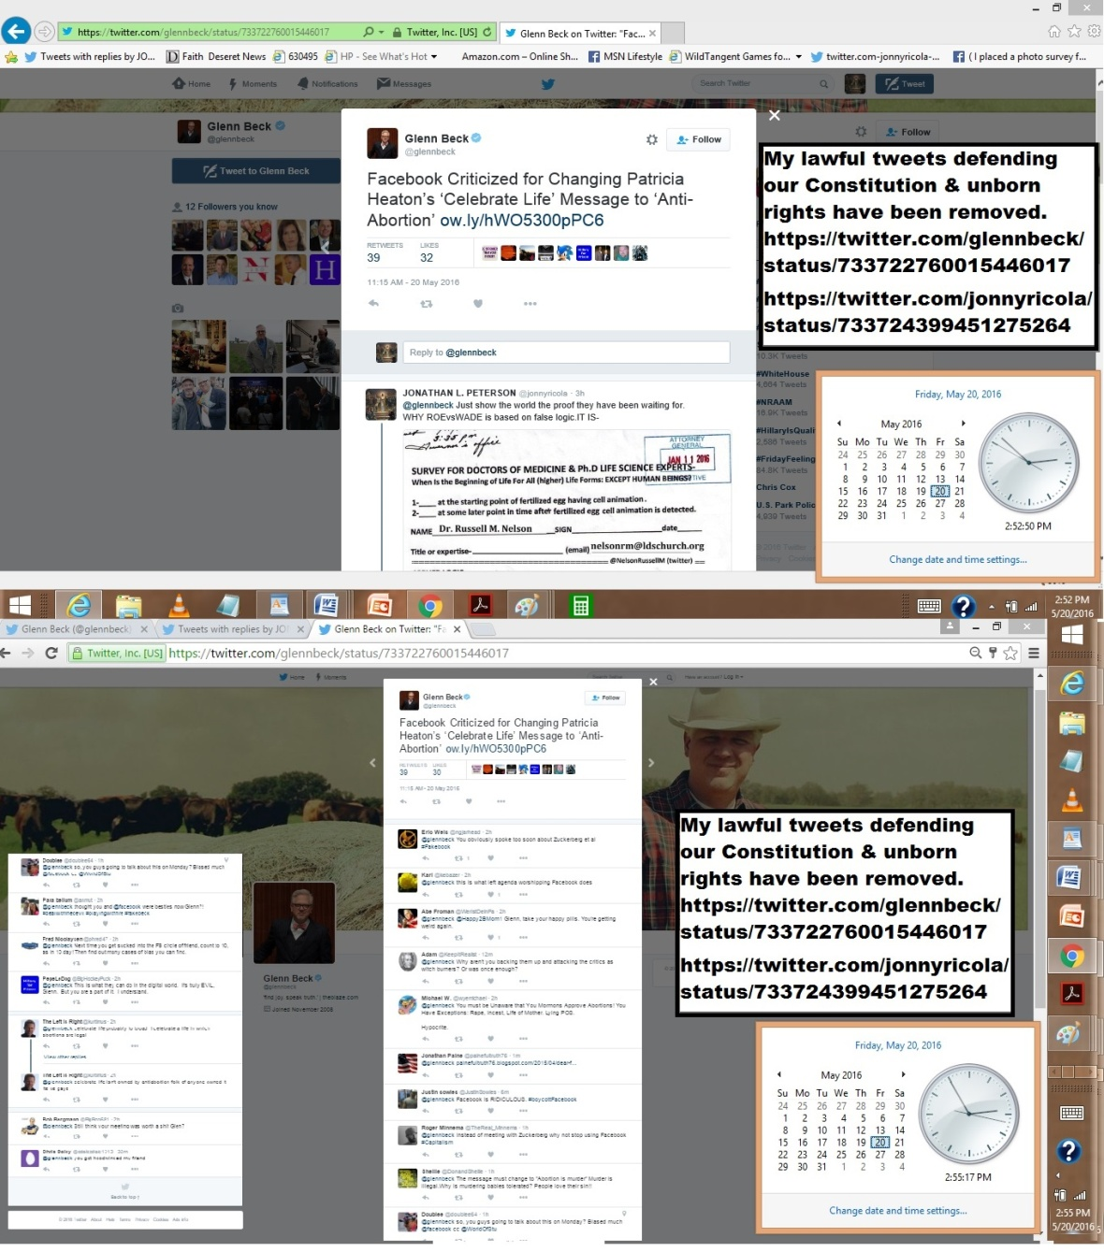
==============
https://twitter.com/glennbeck/status/739931958294269952 @glennbeckIs intertwining religion and politics manipulative?

@glennbeck Not if religion demands defending Constitutional principles. like Equality Under All Laws. Ask them https://twitter.com/jonnyricola/status/739125153695567876 (@CivilRights @RandPaul @SenOrrinHatch @SenMikeLee @DeseretNews @USSupremeCourt @LorettaLynch @UUtah OTHER VIOLATIONS)
reply
@glennbeck Glenn, we are LDS brothers,Our testimony is of Christ. Christ demands we love our neighbor. WE DON'T- ctr
(W-Photo DeseretNews Comments ‘Obama marks Memorial Day at Arlington National Cemetery’ (5-30-2016) WVIEW DK)
(W-Photo Gary Johnson & me & survey on Bribery April 6-2016 slc,ut 1000x650 w-huber&gary obstruct & DRUG LAW)
(W-photo Gov. Herbert&REYES Survey for Doctors Jan. 11, 2016 SHORT ORi W-HEADER & divisonRemovWVIEW NELSON 7ways)Cap
(W-Photo DeseretNews comments 15 LDS general authorities & B of Mormon heroes 1-8-2016 WVIEW w- SKULL -DN-URL& faithURL)
reply
@glennbeck Glenn do you believe my words?LDS leadership does or my message from God-on every http://www.deseretnews.com/top/faith
https://twitter.com/jonnyricola/status/738847361389060097 @LDSChurchNews It is a simple fact-You @ThomasSMonson @EyringHB @UchtdorfDF& @LDSchurch WOULD NOT ALLOW IT-IfNotTrue)
reply
@glennbeck Go to my website- it has the record of my work for the Lord & share it
Oppose Satan's Power w-Faith-now- http://jlp1997.wix.com/instinctlogicresearceply
reply
@glennbeck Glenn my brother,if you believe Im delusional or serve instinct
tell me but don't use silence like @USSupremeCourt& @LorettaLynch
================================
https://twitter.com/jonnyricola/status/739929108851740672 (@glennbeck @AmerMedicalAssn @CivilRights @DeseretNewsGlenn- Serve God & ask experts for their opinion-Oppose Satan)
https://twitter.com/glennbeck/status/739926557616181248 @glennbeckWhat will happen if Hillary Clinton is elected president?
@glennbeck I posted this to your facebook & now I am blocked. The survey to end Roe vs.Wade= https://twitter.com/jonnyricola/status/739880620407414784
https://twitter.com/CivilRightsAAG/status/739866867402211328
reply
@glennbeck The survey to end Roe vs.Wade= ask @AmerMedicalAssn & @CivilRights @DeseretNews https://twitter.com/CivilRightsAAG/status/739866867402211328
https://twitter.com/jonnyricola/status/739880620407414784 (@CivilRightsAAG @CivilRights Of All The @USSupremeCourtViolations Our Society DOES_THIS IS THE WORST & YOU KNOW IT.)
reply
@glennbeck @AmerMedicalAssn @CivilRights @DeseretNews If I did not serve God I couldn't have written this SCI-survey-
https://community.sumofus.org/petitions/ask-doctors-phd-life-science-experts-when-does-life-begin-survey?source=twitter-share-button
reply
@glennbeck @AmerMedicalAssn @CivilRights @DeseretNews
Glenn- Serve God & ask experts for their opinion-Oppose Satan
(W-Photo Gov. Herbert&REYES Survey Doctors Jan. 11, 2016 SHORT ORi & divisonRemovWVIEW AMA NSF 7ways&Captions&Mission)
(W-photo Gov. Herbert&REYES Survey for Doctors Jan. 11, 2016 SHORT ORi W-HEADER & divisonRemovWVIEW USSG-7 ways&Lawful)
(W-photo Gov. Herbert&REYES Survey for Doctors Jan. 11, 2016 SHORT ORi W-HEADER & divisonRemovWVIEW RAND 7ways&Captions)
(W-Photo W-Photo DeseretNews Comment- ‘Bill intends to ban certain abortion procedures in Utah’ (2-26-2016) WIDEVIEW w-SUP
=========================================================
https://twitter.com/jonnyricola/status/739880620407414784 (@CivilRightsAAG @CivilRights Of All The @USSupremeCourtViolations Our Society DOES_THIS IS THE WORST & YOU KNOW IT.)
https://twitter.com/CivilRightsAAG/status/739866867402211328 (DOJ- RETWEETED)
@CivilRightsAAG Vanita Gupta Retweeted The First LadyWhen we empower women, we strengthen America. #StateofWomen

@CivilRightsAAG Vanita- @CivilRights is a monitored site. You are violating your oath of office to stay silent=DUTY- https://twitter.com/jonnyricola/status/739125153695567876 (@CivilRights @RandPaul @SenOrrinHatch @SenMikeLee @DeseretNews @USSupremeCourt @LorettaLynch @UUtah OTHER VIOLATIONS)
reply
@CivilRightsAAG @CivilRights Of All The @USSupremeCourt
Violations Our Society DOES_THIS IS THE WORST & YOU KNOW IT.
(W-photo Gov. Herbert&REYES Survey for Doctors Jan. 11, 2016 SHORT ORi W-HEADER & divisonRemovWVIEW USSG-7 ways&Lawful)
(W-Photo Gov. Herbert&REYES Survey Doctors Jan. 11, 2016 SHORT ORi & divisonRemovWVIEW AMA NSF 7ways&Captions&Mission)
(W-photo Gov. Herbert&REYES Survey for Doctors Jan. 11, 2016 SHORT ORi W-HEADER & divisonRemovWVIEW RAND 7ways&Captions)
(W-Photo W-Photo DeseretNews Comment- ‘Bill intends to ban certain abortion procedures in Utah’ (2-26-2016) WIDEVIEW w-SUP
reply
@CivilRightsAAG @CivilRights 64Mil LIVES TAKEN BECAUSE @USSupremeCourt Blackmun-DIDN'T ASK FOR SCIENCE-CONSENSUS 1ST-
https://community.sumofus.org/petitions/ask-doctors-phd-life-science-experts-when-does-life-begin-survey?source=twitter-share-button
reply
@CivilRightsAAG @CivilRights @USSupremeCourt @DeseretNews
PROOFS & LOGIC ARE A GIFT FROM GOD-Use them or Pay 4 EVER-
(W-Photo DeseretNews Comments ‘Obama marks Memorial Day at Arlington National Cemetery’ (5-30-2016) WVIEW DK)
reply
@CivilRightsAAG @CivilRights @USSupremeCourt @DeseretNews @LorettaLynch
@POTUS & @FLOTUS Review&Defend CONSTITUTION-
https://twitter.com/jonnyricola/status/739880620407414784 (@CivilRightsAAG @CivilRights Of All The @USSupremeCourtViolations Our Society DOES_THIS IS THE WORST & YOU KNOW IT.)
=================================
https://twitter.com/jonnyricola/status/739877397491634180 (@LorettaLynch @USSupremeCourt @CivilRights
@AP NOT USING THIS @NSF SCI-SURVEY=OBSTRUCTIONofJUSTICE- @POTUS @RandPaul)
https://twitter.com/LorettaLynch/status/738067071876136961 @LorettaLynchPleased to speak at @UniLeiden with Min @ArdvanderSteur on US-EU cooperation & strong US-Netherlands relationship.
@LorettaLynch @UniLeiden @ArdvanderSteur Sci-Survey FOR EXPERTS
Should've been used by @USSupremeCourt =Correct Error-
https://community.sumofus.org/petitions/ask-doctors-phd-life-science-experts-when-does-life-begin-survey?source=twitter-share-button
reply
@LorettaLynch @USSupremeCourt @CivilRights
@AP NOT USING THIS @NSF SCI-SURVEY=OBSTRUCTIONofJUSTICE- @POTUS @RandPaul
(W-Photo Gov. Herbert&REYES Survey Doctors Jan. 11, 2016 SHORT ORi & divisonRemovWVIEW AMA NSF 7ways&Captions&Mission)
(W-photo Gov. Herbert&REYES Survey for Doctors Jan. 11, 2016 SHORT ORi W-HEADER & divisonRemovWVIEW RAND 7ways&Captions)
(W-photo Gov. Herbert&REYES Survey for Doctors Jan. 11, 2016 SHORT ORi W-HEADER & divisonRemovWVIEW USSG-7 ways&Lawful)
(W-Photo W-Photo DeseretNews Comment- ‘Bill intends to ban certain abortion procedures in Utah’ (2-26-2016) WIDEVIEW w-SUP
reply
@LorettaLynch @USSupremeCourt @AP @NSF @POTUS @RandPaul YOU ALL BETTER HAVE A LOOK-
AT MONITORED @CivilRights = DUTY-https://twitter.com/jonnyricola/status/739125153695567876
(@CivilRights @RandPaul @SenOrrinHatch @SenMikeLee @DeseretNews @USSupremeCourt @LorettaLynch @UUtah OTHER VIOLATIONS)
=============================================================
DIRECT - https://twitter.com/jonnyricola/status/739871135458676736
@LorettaLynch @CivilRights @AP NOT USING THIS @NSF SCI-SURVEY =OBSTRUCTIONofJUSTICE-@USSupremeCourt @POTUS @RandPaul
(W-Photo Gov. Herbert&REYES Survey Doctors Jan. 11, 2016 SHORT ORi & divisonRemovWVIEW AMA NSF 7ways&Captions&Mission)
(W-photo Gov. Herbert&REYES Survey for Doctors Jan. 11, 2016 SHORT ORi W-HEADER & divisonRemovWVIEW USSG-7 ways&Lawful)
(W-photo Gov. Herbert&REYES Survey for Doctors Jan. 11, 2016 SHORT ORi W-HEADER & divisonRemovWVIEW RAND 7ways&Captions)
(W-Photo W-Photo DeseretNews Comment- ‘Bill intends to ban certain abortion procedures in Utah’ (2-26-2016) WIDEVIEW w-SUP
===================================================
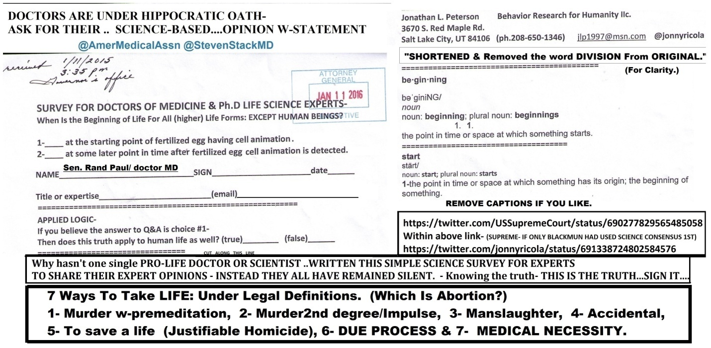
============================
https://www.facebook.com/ProLifeAlliance/photos/a.153781571335145.28267.145170355529600/1111700098876616/?type=3&theater
reply
@prolifealliance @ShareThis @USSupremeCourt @LDSChurchNews
SCI-SURVEY4Doctors&Experts=LOGICAL & REQUIRED FOR JUSTICE-https://community.sumofus.org/petitions/ask-doctors-phd-life-science-experts-when-does-life-begin-survey?source=twitter-share-button
reply
@prolifealliance @ShareThis NOT USING THIS SCI-PROOF OF LIFE=
OBSTRUCTION- @USSupremeCourt @LorettaLynch @POTUS @NSF
(W-Photo Gov. Herbert&REYES Survey Doctors Jan. 11, 2016 SHORT ORi & divisonRemovWVIEW AMA NSF 7ways&Captions&Mission)
(W-photo Gov. Herbert&REYES Survey for Doctors Jan. 11, 2016 SHORT ORi W-HEADER & divisonRemovWVIEW USSG-7 ways&Lawful)
(W-photo Gov. Herbert&REYES Survey for Doctors Jan. 11, 2016 SHORT ORi W-HEADER & divisonRemovWVIEW RMNelson7 ways&LawfulFX)
(W-Photo W-Photo DeseretNews Comment- ‘Bill intends to ban certain abortion procedures in Utah’ (2-26-2016) WIDEVIEW w-SUP
============================================
https://twitter.com/jonnyricola/status/739856668880601088 (@ProLifeNation @USSupremeCourt @LDSChurchNews @NSF NOT USING THISSCI-PROOF OF LIFE=IS OBSTRUCTION of JUSTICE-@POTUS)
https://twitter.com/ProLifeNation/status/730430404084137985 @ProLifeNationTo Vote or Not to Vote, That is the Question http://www.operationrescue.org/archives/to-vote-or-not-to-vote-that-is-the-question/ … #prolife #prochoice #trump

@ProLifeNation The SCI-SURVEY FOR DOCTORS & EXPERTS WAS NEVER USED BY OUR @USSupremeCourt -Which violated their Oath-
https://twitter.com/jonnyricola/status/739851726165966854 (@operationrescue @DeseretNews SURVEY FOR SCIENCE CONSENSUS IS THE RESPONSIBILITY OF OUR @USSupremeCourt @POTUS @NSF w-surveys)
reply
@ProLifeNation @USSupremeCourt @LDSChurchNews This SCI-SURVEY FOR Doctors &Experts-is LOGICAL & REQUIRED FOR JUSTICE-
https://community.sumofus.org/petitions/ask-doctors-phd-life-science-experts-when-does-life-begin-survey?source=twitter-share-button
reply
@ProLifeNation @USSupremeCourt @LDSChurchNews @NSF NOT USING THIS
SCI-PROOF OF LIFE=IS OBSTRUCTION of JUSTICE-@POTUS
(W-Photo Gov. Herbert&REYES Survey Doctors Jan. 11, 2016 SHORT ORi & divisonRemovWVIEW AMA NSF 7ways&Captions&Mission)
(W-photo Gov. Herbert&REYES Survey for Doctors Jan. 11, 2016 SHORT ORi W-HEADER & divisonRemovWVIEW RMNelson7 ways&LawfulFX)
(W-photo Gov. Herbert&REYES Survey for Doctors Jan. 11, 2016 SHORT ORi W-HEADER & divisonRemovWVIEW USSG-7 ways&Lawful)
(W-Photo W-Photo DeseretNews Comment- ‘Bill intends to ban certain abortion procedures in Utah’ (2-26-2016) WIDEVIEW w-SUP
======================================================
https://twitter.com/jonnyricola/status/739851726165966854 (@operationrescue @DeseretNews SURVEY FOR SCIENCE CONSENSUS IS THE RESPONSIBILITY OF OUR @USSupremeCourt @POTUS @NSF)
https://twitter.com/operationrescue/status/739836005109243905 @operationrescueNewman to Join #OperationRNC in Cleveland to Demand the GOP Stays #ProLife http://www.operationrescue.org/archives/newman-to-join-operationrnc-in-cleveland-to-demand-the-gop-stays-pro-life/ … #abortion

@operationrescue Constitutional Proof. SCI-SURVEY IS READY TO END ROE vs Wade. sign IT & Deliver to @USSupremeCourt-
https://community.sumofus.org/petitions/ask-doctors-phd-life-science-experts-when-does-life-begin-survey?source=twitter-share-button
reply
@operationrescue @DeseretNews SURVEY FOR SCIENCE CONSENSUS IS THE RESPONSIBILITY OF OUR @USSupremeCourt @POTUS @NSF
(W-Photo Gov. Herbert&REYES Survey for Doctors Jan. 11, 2016 & div.Remov DK Dr. Cordova LViewsite)
(W-photo Gov. Herbert&REYES Survey for Doctors Jan. 11, 2016 SHORT ORi W-HEADER & divisonRemovWVIEW USSG-7 ways&Lawful)
(W-Photo Gov. Herbert&REYES Survey Doctors Jan. 11, 2016 SHORT ORi & divisonRemovWVIEW AMA NSF 7ways&Captions&Mission)
(W-Photo W-Photo DeseretNews Comment- ‘Bill intends to ban certain abortion procedures in Utah’ (2-26-2016) WIDEVIEW w-SUP
==========
==========================
June 5, 2016
===============================
https://twitter.com/LDSChurchNews/status/738791365555818496 @LDSChurchNewsTerrorism didn't diminish Sister Fanny Clain's faith and #Mormon mission #BrusselsAttacks http://desne.ws/nPf8Ul

@LDSChurchNews Truth must be examined & used- with faith in God.
@DeseretNews @NelsonRussellM 6000 lives ea day-@AP=
https://community.sumofus.org/petitions/ask-doctors-phd-life-science-experts-when-does-life-begin-survey?source=twitter-share-button
reply
@LDSChurchNews @NelsonRussellM @AP I Wrote these PROOFS for @DalaiLama & @DeseretNews @ThomasSMonson Gifts from God-
https://twitter.com/jonnyricola/status/739669787182125056 (@DaIaiIamaa I wrote this for:@DalaiLama& @LDSchurch @DeseretNews important Q&A for Mankind.To GainPowerOver-Instinct)
reply
@LDSChurchNews @NelsonRussellM @AP @DalaiLama @DeseretNews @ThomasSMonson Review The Record of my work for God & U =
http://jlp1997.wix.com/instinctlogicresearc
reply
@LDSChurchNews @AP @DalaiLama @DeseretNews @ThomasSMonson
Pres.@NelsonRussellM By Your Example- World is Humbled-CTR
(W-photo Gov. Herbert&REYES Survey for Doctors Jan. 11, 2016 SHORT ORi W-HEADER & divisonRemovWVIEW NELSON 7ways)Cap
=====================================================
https://twitter.com/DaIaiIamaa/status/739563954788306945 The true hero is one who conquers his own anger and hatred.
@DaIaiIamaa To love oneself is instinctual- to love thy neighbor as thyself divine. Survival logic vs. Moral logic:ONE BRINGS PEACE on EARTH
reply
@DaIaiIamaa I wrote this for:@DalaiLama& @LDSchurch @DeseretNews important Q&A for Mankind.To GainPowerOver-Instinct
(W-photo 38 DeseretNews Comments about ‘10 of the Dalai Lama's most inspirational quotes’ (7-5-2015)
(W-photo DR. NEIL , EAGLEMAN & ALLPhD EXPERTS SCI-SURVEY ON INSTINCT w-deprog 3-14-2016 PAINTED TEXT w-PBSbrainURL&twitter
(W-Photo DeseretNews comments 15 LDS general authorities & B of Mormon heroes 1-8-2016 WVIEW w- SKULL -DN-URL& faithURL)
(W-photo Gov. Herbert&REYES Survey for Doctors Jan. 11, 2016 SHORT ORi W-HEADER & divisonRemovWVIEW NELSON 7ways)Cap
reply
@DaIaiIamaa @DalaiLama @LDSchurch @DeseretNews SILENCE IS aMOST TERRIBLE SIN-@LDSChurchNews @NelsonRussellM 6Kperday-
https://community.sumofus.org/petitions/ask-doctors-phd-life-science-experts-when-does-life-begin-survey?source=twitter-share-button
++++++++++++++++++++++++
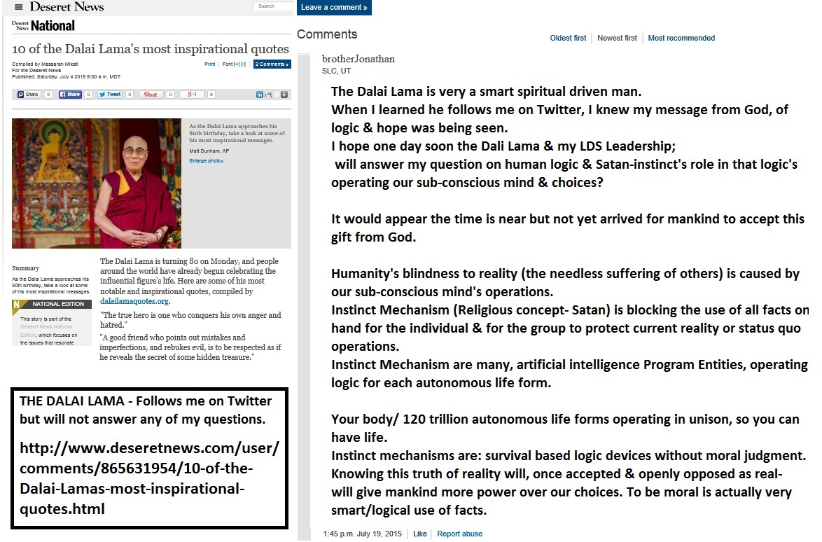
======================================================================
https://twitter.com/DalaiLama/status/738664557720129536 @DalaiLama If we start now and make the effort, we can make the world a more peaceful place. We have to try.
@DalaiLama Do you see the logic of my Survey for Doctors & PhD. Experts? Do you have the will to support this truth?
https://twitter.com/jonnyricola/status/739669787182125056 @DaIaiIamaa I wrote this for:@DalaiLama& @LDSchurch @DeseretNews important Q&A for Mankind.To GainPowerOver-Instinct
reply
@DalaiLama The power to oppose instinct is HERE to be shared. Will you help mankind with your voice of reason? SPEAK- https://community.sumofus.org/petitions/ask-doctors-phd-life-science-experts-when-does-life-begin-survey?source=twitter-share-button
reply
@DalaiLama That sci-survey is proof that the God loves us & is intervening in the course of history.
IS THIS TRUE?Bro https://twitter.com/jonnyricola/status/739669787182125056 (@DaIaiIamaa I wrote this for:@DalaiLama& @LDSchurch @DeseretNews important Q&A for Mankind.To GainPowerOver-Instinct photo of DNews Q&A for DalaiLamaa)
=========================
June 4, 2016
======================================================
https://twitter.com/benlockhart89/status/360209606951174144 (DNews)
@benlockhart89Good read on Bryce Harper, the understated #Mormon http://bit.ly/1aGLIIT
@benlockhart89 thx for story:ASK CASSELL& @UUtah http://www.deseretnews.com/article/865655622/In-a-dream-still-Man-sentenced-to-55-years-for-marijuana-deals-in-2004-released-from-prison.html- For not having permission from Private Bus.
https://twitter.com/jonnyricola/status/739130439076454400 (CivilRights UNDER OATH-SPEAK)
reply
@benlockhart89 @UUtah My work for the people.Recorded on my website in Word docs & links to @CivilRights @LDSchurch-
http://jlp1997.wix.com/instinctlogicresearc
reply
@benlockhart89 @UUtah @CivilRights @LDSchurch This Proof of law broken
is ready to help mankind oppose Instinct Mech- https://community.sumofus.org/petitions/ask-doctors-phd-life-science-experts-when-does-life-begin-survey?source=twitter-share-button
===============================================================
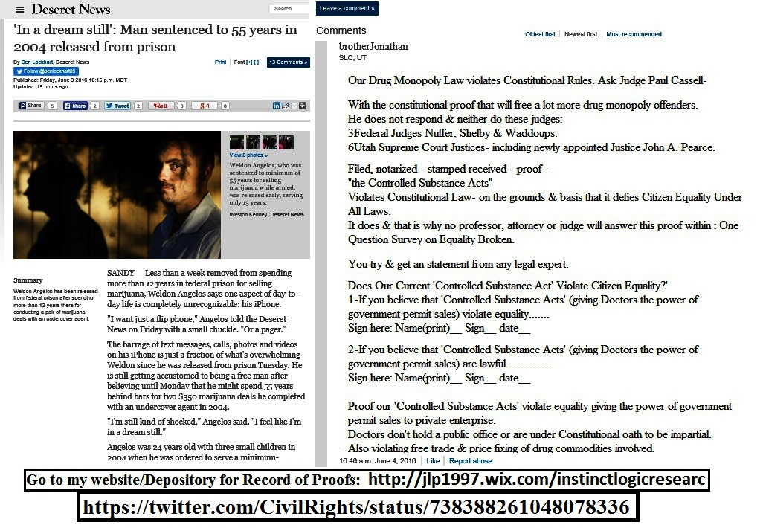

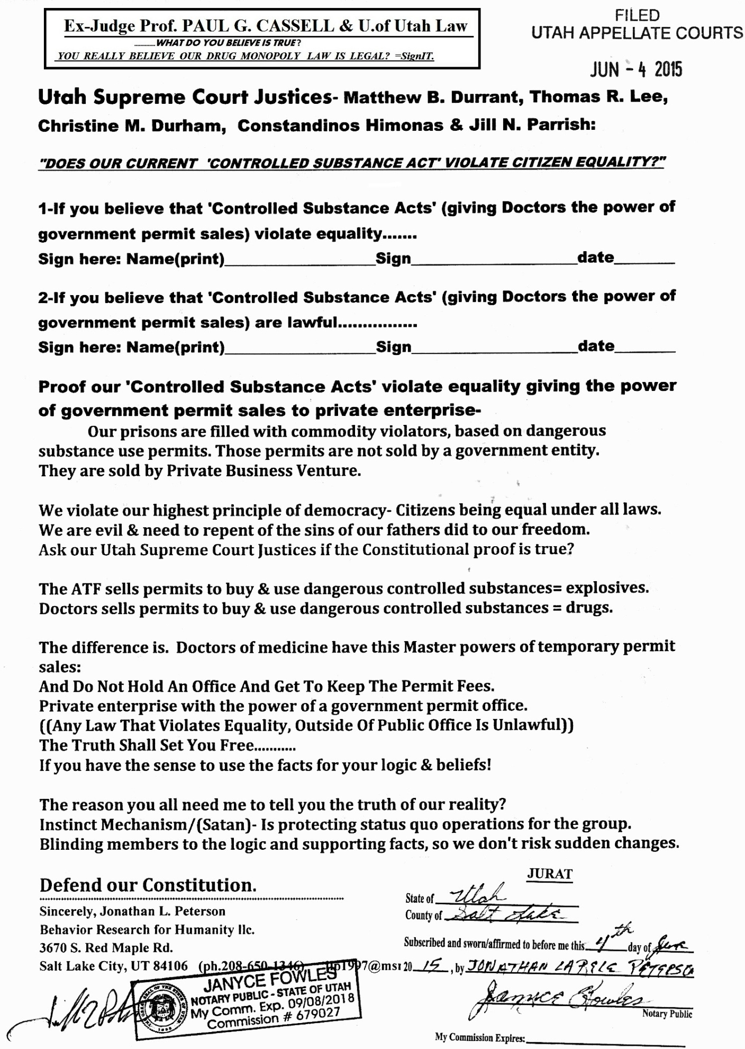
==================================
https://twitter.com/jonnyricola/status/739107138211958785 -proof https://twitter.com/jonnyricola/status/739107860936691715 -take action https://twitter.com/jonnyricola/status/739108459463901184 - action or obstruct
https://twitter.com/jonnyricola/status/739130439076454400 - UNDER OATH-SPEAK
https://twitter.com/jonnyricola/status/739125153695567876 - Other Violations
https://twitter.com/CivilRights/status/738388261048078336 @CivilRightsCompensation Available for Uncapped # of Individuals in Disability Settlement with Greyhound → http://go.usa.gov/cuTyC
@CivilRights DOJ @RandPaul @ChrisMurphyCT @SenOrrinHatch @SenMikeLee @AP HAVE PROOF @USSupremeCourt _VIOLATED RULES
https://community.sumofus.org/petitions/ask-doctors-phd-life-science-experts-when-does-life-begin-survey?source=twitter-share-button
reply
@CivilRights @RandPaul @ChrisMurphyCT @SenOrrinHatch @SenMikeLee @AP @USSupremeCourt TAKE ACTION ToCORRECT ERROR NOW
(W-Photo Gov. Herbert&REYES Survey for Doctors Jan. 11, 2016 & div.Remov DK Dr. Cordova LViewsite)
(W-Photo Gov. Herbert&REYES Survey Doctors Jan. 11, 2016 SHORT ORi & divisonRemovWVIEW AMA NSF 7ways&Captions&Mission)
(W-photo Gov. Herbert&REYES Survey for Doctors Jan. 11, 2016 SHORT ORi W-HEADER & divisonRemovWVIEW USSG-7 ways&Lawful)
(W-Photo W-Photo DeseretNews Comment- ‘Bill intends to ban certain abortion procedures in Utah’ (2-26-2016) WIDEVIEW w-SUP
reply
@CivilRights @RandPaul @ChrisMurphyCT @SenOrrinHatch @SenMikeLee @AP @USSupremeCourt TAKE ACTION OR OBSTRUCT JUSTICE
https://twitter.com/jonnyricola/status/706206154691469312 (@USSupremeCourt @POTUS @LorettaLynch I REWROTE THE SCI- SURVEY FOR DOCTORS & PhD experts. ASK THEM~ @AmerMedicalAssn)
reply
@CivilRights @RandPaul @SenOrrinHatch @SenMikeLee @DeseretNews @USSupremeCourt @LorettaLynch @UUtah
OTHER VIOLATIONS
(W-Photo Gary Johnson & me & survey on Bribery April 6-2016 slc,ut 1000x650 w-huber&gary obstruct & DRUG LAW)
(W-Photo Sen Murphy, Paul, Hatch& Lee - SURVEY FOR CORP BRIBERY -EXPLAIN SIGN 6-4-2016 W-SUBVERT WVIEW USAG tell them)
(W-Photo CIVIL RIGHTS POST ON HUBER VIOLATING DUE PROCESS OCT 8,2015 w-LINK lg text WIDEVIEW & Loretta link)
(W-Photo Sen Rand, Hatch, LEE &LORETTA- UNDER OATH W-NUFFER DOC w-REYES-controlled subst 6-4-2015 NOTARIZED WVIEW w-YEA)
reply
@CivilRights @RandPaul @SenOrrinHatch @SenMikeLee @DeseretNews @USSupremeCourt @LorettaLynch
@UUtah DEFY US CONSTITU
(W-Photo PAUL CASSELL &Utah Supreme Court Justice DURRANT DRUG MONOPOLY survey FOR PEARCE March 25, 2016 wview)
(W-Photo JUDGE Cassel, Hatch& Lee - SURVEY FOR CORP BRIBERY -EXPLAIN SIGN 6-4-2016 W-SUBVERT WVIEW USAG tell them)
reply
@CivilRights @RandPaul @SenOrrinHatch @SenMikeLee @DeseretNews @USSupremeCourt @LorettaLynch
@UUtah UNDER OATH-SPEAK
(W-Photo PAUL CASSELL &Utah Supreme Court Justice DURRANT DRUG MONOPOLY survey FOR PEARCE March 25, 2016 wview)
(W-Photo JUDGE Cassel, Hatch& Lee - SURVEY FOR CORP BRIBERY -EXPLAIN SIGN 6-4-2016 W-SUBVERT WVIEW USAG tell them)
reply
@CivilRights @TheJusticeDept @LorettaLynch @SenOrrinHatch @SenMikeLee @AP @USSupremeCourt @RandPaul
RESPONDorCOURT4U
(W-Photo DeseretNews Comments ‘Obama marks Memorial Day at Arlington National Cemetery’ (5-30-2016) WVIEW DK)
reply
@CivilRights @RandPaul @SenOrrinHatch @SenMikeLee @DeseretNews @USSupremeCourt @LorettaLynch @UUtah
I RECORD/DOChere= http://jlp1997.wix.com/instinctlogicresearc
++++++++
=================================================================
https://twitter.com/jonnyricola/status/738501714894979072 @RedAlert @RandPaul IF YOU CAN'T SIGN THE SURVEY FOR DOCTORS & EXPERTS. RESIGN YOUR OFFICE THIS WILL END Roe vs Wade-
https://community.sumofus.org/petitions/ask-doctors-phd-life-science-experts-when-does-life-begin-survey?source=twitter-share-button

======================================================================
https://twitter.com/CivilRights/status/738387355225198593
.@TheJusticeDept Reaches Agreement to Protect the Rights of Spanish-Speaking Voters in Napa County, California → http://go.usa.gov/cSnMJ

@CivilRights @TheJusticeDept You have received many proof of law from me. They are filed. @LorettaLynch CORRECT THIS-https://community.sumofus.org/petitions/ask-doctors-phd-life-science-experts-when-does-life-begin-survey?source=twitter-share-button
reply
@CivilRights @TheJusticeDept @LorettaLynch
@SenOrrinHatch @SenMikeLee @AP @USSupremeCourt
@RandPaul=Correct ErrorNOW
(W-photo Gov. Herbert&REYES Survey for Doctors Jan. 11, 2016 SHORT ORi W-HEADER & divisonRemovWVIEW RAND 7ways&Captions)
(W-Photo Gov. Herbert&REYES Survey for Doctors Jan. 11, 2016 & div.Remov DK Dr. Cordova LViewsite)
(W-Photo Gov. Herbert&REYES Survey Doctors Jan. 11, 2016 SHORT ORi & divisonRemovWVIEW AMA NSF 7ways&Captions&Mission)
(W-Photo W-Photo DeseretNews Comment- ‘Bill intends to ban certain abortion procedures in Utah’ (2-26-2016) WIDEVIEW w-SUP
reply
@CivilRights @TheJusticeDept @LorettaLynch @SenOrrinHatch @SenMikeLee @AP @USSupremeCourt @RandPaul
ACTIONorOBSTRUCT- https://twitter.com/jonnyricola/status/706206154691469312 (US SUPREM-IREWROTE THE SCI- SURVEY FOR DOCTORS & PhD experts. ASK THEM~ @AmerMedicalAssn)
reply
@CivilRights @TheJusticeDept @LorettaLynch @SenOrrinHatch @SenMikeLee @AP @USSupremeCourt @RandPaul
OTHER VIOLATIONS
(W-Photo Gary Johnson & me & survey on Bribery April 6-2016 slc,ut 1000x650 w-huber&gary obstruct & DRUG LAW)
(W-Photo Sen Murphy, Paul, Hatch& Lee - SURVEY FOR CORP BRIBERY -EXPLAIN SIGN 6-4-2016 W-SUBVERT WVIEW USAG tell them)
(W-Photo CIVIL RIGHTS POST ON HUBER VIOLATING DUE PROCESS OCT 8,2015 w-LINK lg text WIDEVIEW & Loretta link)
(W-Photo Sen Rand, Hatch, LEE &LORETTA- UNDER OATH W-NUFFER DOC w-REYES-controlled subst 6-4-2015 NOTARIZED WVIEW w-YEA)
reply
@CivilRights @TheJusticeDept @LorettaLynch @SenOrrinHatch @SenMikeLee @AP @USSupremeCourt @RandPaul
DEFY US CONSTITU
(W-Photo Sen Murphy, Paul, Hatch& Lee - SURVEY FOR CORP BRIBERY -EXPLAIN SIGN 6-4-2016 W-SUBVERT WVIEW USAG tell them)
reply
@CivilRights @TheJusticeDept @LorettaLynch @SenOrrinHatch @SenMikeLee @AP @USSupremeCourt @RandPaul
RESPONDorCOURT4U
(W-Photo DeseretNews Comments ‘Obama marks Memorial Day at Arlington National Cemetery’ (5-30-2016) WVIEW DK)
reply
@CivilRights @TheJusticeDept @LorettaLynch @SenOrrinHatch @SenMikeLee @AP @USSupremeCourt @RandPaul
I RECORD/DOChere= http://jlp1997.wix.com/instinctlogicresearc
++++++++++++++++++++++++++++++++++++
=========================================
June 3, 2016
==============================================================
DIRECT from my twitter site- https://twitter.com/jonnyricola/status/738860712840175616
@jonnyricola- My mission:To serve God & man with truth.Truths come from God
@DeseretNews Examine & SPEAKUP? http://jlp1997.wix.com/instinctlogicresearc
(W-Photo JLP1997 INSTINCTLOGICRESEARC- Website photo June 2, 2016 WVIEW urlPart1b
(W-Photo JLP1997 INSTINCTLOGICRESEARC- Website photo June 2, 2016 WVIEW urlPart2
(W-Photo Gov. Herbert&REYES Survey Doctors Jan. 11, 2016 SHORT ORi & divisonRemovWVIEW AMA NSF 7ways&Captions&Mission)
(W-Photo PBS The BRAIN final episode with PROOFS OF INSTINCT MECH as A.I. Driven w STATUS QUO w-LINK)
===================
DIRECT-
@RandPaul @DeseretNews My words are true.UNDER OATH&DUTY=
@ChrisMurphyCT @SenOrrinHatch @SenMikeLee @USSupremeCourt-
https://twitter.com/jonnyricola/status/738780720655523840
(@RandPaul @ChrisMurphyCT @SenOrrinHatch @SenMikeLee @AP @USSupremeCourt JUSTICES-Repent &correct your grevious error)
=========================================
https://twitter.com/LDSChurchNews/status/738756680758923265 @LDSChurchNewsVietnam grants official recognition to the LDS Church | http://desne.ws/1i2orI

@LDSChurchNews Growth of our Lord's Church triples
When @ThomasSMonson @LDSchurch tells the world-'Satan is revealed
(W-Photo DeseretNews comment LDS leaders pay tribute to mothers from the pulpit (5-6-2016) WView mess)
(W-photo DeseretNews comment 20 athletes who are vocal about their faith (4-21-2016) WVIEWmessURL DK
(W-photo DeseretNews comments From Spring City to St. George- 12 historic LDS sites for families to visit this summer (6-3-2016) WV
(W-Photo DeseretNews comments 15 LDS general authorities & B of Mormon heroes 1-8-2016 WVIEW w- SKULL -DN-URL& faithURL)
reply
@LDSChurchNews It is a simple fact-You @ThomasSMonson @EyringHB @UchtdorfDF& @LDSchurch WOULD NOT ALLOW IT-IfNotTrue
(W-Photo 1 FAITH LIST DNews FEB-29-2016 w- URL&revelation- The Lord says & ASK LDS if true- rejoice DN-savior is born)
reply
@LDSChurchNews @ThomasSMonson @EyringHB @UchtdorfDF @LDSchurch @DeseretNews See the work done to prepare for Christ-http://jlp1997.wix.com/instinctlogicresearc
reply
@LDSChurchNews @ThomasSMonson @EyringHB @UchtdorfDF @LDSchurch @DeseretNews To prepare for our Lord Jesus Christ-WE MUST OPPOSE SATAN OPENLY
==============================
https://twitter.com/NSF/status/738819300920692736 (@NSFDonuts, #math and superdense teleportation of quantum information http://1.usa.gov/1TNvZwK #NationalDonutDay)
@NSF Interesting- but mostly useless to mankind.THE PREVIOUS POSTS HAVE THE POTENTIAL TO CROSS EVOLUTIONARY BARRIER-
https://twitter.com/jonnyricola/status/738374165355339776 (@NSF @AP Director Cordova-answer the most important science question in history-Survival Logic Delivery System-TEST)
reply
@NSF Gain power of choice over Instinct Mechanism-Operating Survival Logic for ea. autonomous life form-INFO is HERE- https://twitter.com/NSF/status/738357394468687872 ("Every discovery has its moment in time – & if science isn’t prepared for it, we could very well miss it" #Kavli2016)
reply
@NSF You need to support my research & I know that you know this too
How to get funding so the sci-proofs can be tested. BY ME. I DON'T FEAR
reply
@NSF Tell yourself it will be easy to disprove my ridiculous theory of
Instinct Mechanism as A.I. technology & INVITE ME TO NSF HEADQUARTERS
=====================================
https://twitter.com/jonnyricola/status/738819206741786624 @science360 @NSF Monarch Butterflies have a sophisticated auto pilotEa.CELL /2Mil bio machines Choreographed -THINK http://www.dailymotion.com/video/x1f26gz_bbc-our-secret-universe-the-hidden-life-of-the-cell-720p-hdtv_tech
https://twitter.com/science360/status/738755212853186565 @science360#photooftheday: A #butterfly wing in #3D. http://1.usa.gov/1sSqrdv
@science360 @NSF Will you accept a gift from God/ creator of instinct mech.?
INTELLIGENT_OPERATORS-OF SURVIVAL LOGIC
https://twitter.com/jonnyricola/status/738379820636086272 (@NSF @AP @IBMWatson @PBS @DeseretNews @UUtah @POTUSObserve: Intelligent parasitic vines?DNA-(not brains) BLUEPRINT-)
reply
reply
@science360 @NSF FIGHT YOUR SUBCONSIOUS MIND'S POWER-
Plants think, Ants use group strategy- never been in water-DAH
https://twitter.com/jonnyricola/status/738090314779361280 (@NSF Observe & Think:100 fire Ants(never been in water) knowing how to make a ball & take turns=A.I.driven behaviors-)
reply
@science360 @NSF Monarch Butterflies have a sophisticated auto pilot
Ea.CELL /2Mil bio machines Choreographed -THINK
http://www.dailymotion.com/video/x1f26gz_bbc-our-secret-universe-the-hidden-life-of-the-cell-720p-hdtv_tech
reply
@science360 @NSF 5 proofs of reality- NEVER WRITTEN BEFORE. INVITE ME TO SHOW YOU MY LOGIC RESEARCH IS TRUE REALITY-
https://twitter.com/jonnyricola/status/738452847721779200
(@NSF 5 proofs of reality,Never written before on earthFor Survival=Precedent override w-Non-Interference w-timeline)
reply
@science360 @NSF @DeseretNews Meaning = Precedent Override?
God intervenes w-normalTIMEflow of history-To Save His Children from Destruction
======================================
https://twitter.com/jonnyricola/status/738780720655523840 @RandPaul @ChrisMurphyCT @SenOrrinHatch @SenMikeLee @AP @USSupremeCourt JUSTICES-Repent &correct your grevious error
https://twitter.com/RandPaul/status/738727209599275009 @RandPaulWe must protect and defend the constitution against all enemies, foreign and domestic.

@RandPaul WE MET & I DELIVERED FILED CONSTITUTIONAL PROOFS WE VIOLATE OUR LAW. YOU HAVE SAID NOTHING. DEFEND US NOW-
https://twitter.com/jonnyricola/status/738497339602542592 (@RandPaul @NSF @AmerMedicalAssn @LDSchurch @LDSChurchNews @NelsonRussellM @DeseretNews U are defending Constitution? )
reply
@RandPaul @ChrisMurphyCT Rand you know this survey will end Roe vs. Wade. YOUR OATH OF OFFICE & HIPPOCRATIC DEMANDS-
(W-photo Gov. Herbert&REYES Survey for Doctors Jan. 11, 2016 SHORT ORi W-HEADER & divisonRemovWVIEW RAND 7ways&Captions)
reply
@RandPaul @ChrisMurphyCT @SenOrrinHatch @SenMikeLee PROMOTE THIS SCI-SURVEY FOR DOCTORS-THAT(Criminally)WAS NOT USED- https://community.sumofus.org/petitions/ask-doctors-phd-life-science-experts-when-does-life-begin-survey?source=twitter-share-button
reply
@RandPaul @ChrisMurphyCT @SenOrrinHatch @SenMikeLee EACH OF YOU. UNDER OATH- w-PROOFS=Cannot Remain Silent-SPEAK NOW
https://community.sumofus.org/petitions/ask-doctors-phd-life-science-experts-when-does-life-begin-survey?source=twitter-share-button
reply
@RandPaul @ChrisMurphyCT @SenOrrinHatch @SenMikeLee @AP
@USSupremeCourt JUSTICES-Repent &correct your grevious error
(W-photo Gov. Herbert&REYES Survey for Doctors Jan. 11, 2016 SHORT ORi W-HEADER & divisonRemovWVIEW USSG-7 ways&Lawful)
(W-Photo Gov. Herbert&REYES Survey Doctors Jan. 11, 2016 SHORT ORi & divisonRemovWVIEW AMA NSF 7ways&Captions&Mission)
(W-photo Gov. Herbert&REYES Survey for Doctors Jan. 11, 2016 SHORT ORi W-HEADER & divisonRemovWVIEW RAND 7ways&Captions)
(W-Photo Gov. Herbert&REYES Survey for Doctors Jan. 11, 2016 & div.Remov DK Dr. Cordova LViewsite)
reply
@RandPaul @ChrisMurphyCT @SenOrrinHatch @SenMikeLee @AP @USSupremeCourt
YOU DEFEND OUR CONSTITUTION W-YOUR LIFEorBnH
(W-Photo DeseretNews Comments ‘Obama marks Memorial Day at Arlington National Cemetery’ (5-30-2016) WVIEW DK)
++++++++++++++++
https://twitter.com/PBS/status/667130400117022720 (the brain series finally)
======================================================
https://twitter.com/NSF/status/738768486999183360 @NSF.@NSF & partners mark 5 yrs of the National #Robotics Initiative in D.C. on June 9.http://1.usa.gov/1sSKTek

@NSF @NIH @NASA @DARPA @usnistgov @roboticscaucus @IEEEUSA @whitehouseostp
A MOST IMPORTANT RESEARCH TO HELP MANKIND-
https://twitter.com/jonnyricola/status/738374165355339776 (@NSF @AP Director Cordova-answer the most important science question in history-Survival Logic Delivery System-TEST)
reply
@NSF @NIH @NASA @DARPA @usnistgov @roboticscaucus @IEEEUSA @whitehouseostp
I CAN PROVE-Instinct blocks Moral Choice-
(W-Photo Gov. Herbert&REYES Survey for Doctors Jan. 11, 2016 & div.Remov DK Dr. Cordova LViewsite)
(W-Photo Gov. Herbert&REYES Survey Doctors Jan. 11, 2016 SHORT ORi & divisonRemovWVIEW AMA NSF 7ways&Captions&Mission
(W-Photo Gov. Herbert&REYES Survey for Doctors Jan. 11, 2016 SHORT ORi W-HEADER & divisonRemovWVIEW USSG)
(W-Photo PBS The BRAIN final episode with PROOFS OF INSTINCT MECH as A.I. Driven w STATUS QUO w-LINK)
reply
@NSF @NIH @NASA @DARPA @usnistgov @IEEEUSA @whitehouseostp @randpaul& @POTUS
This research Will correct logic errors- https://twitter.com/jonnyricola/status/738780720655523840 (@RandPaul @ChrisMurphyCT @SenOrrinHatch @SenMikeLee @AP @USSupremeCourt JUSTICES-Repent &correct your grevious error)
reply
@NSF @NIH @NASA @DARPA @usnistgov @roboticscaucus @IEEEUSA @whitehouseostp
Instinct Mechanism: denies access to info-
https://twitter.com/jonnyricola/status/667391339588272128 (@PBS @davideagleman @UCBerkeley IT'S SIMPLE Dr. Eagleman=TRUE,NOT TRUE, PROBABLY TRUE, PROBABLY NOT TRUE-(choices)
reply
@NSF @NIH @NASA @DARPA @usnistgov @IEEEUSA @whitehouseostp @RandPaul @POTUS
TEST-Sci-Surveys for experts on LIFE&LAW
(W-photo DR. NEIL , EAGLEMAN & ALLPhD EXPERTS SCI-SURVEY ON INSTINCT w-deprog 3-14-2016 PAINTED TEXT w-PBSbrainURL&twitter
(W-Photo Gov. Herbert&REYES Survey Doctors Jan. 11, 2016 SHORT ORi & divisonRemovWVIEW AMA NSF 7ways&Captions&Mission
(W-photo Sen Murphy, Paul, Hatch& Lee - SURVEY FOR CORP BRIBERY -EXPLAIN SIGN 5-11-2016 W-SUBVERT WIDEVIEW loretta tell them
(W-photo Sen Rand, Hatch, LEE &LORETTA- OATH W-NUFFER DOC w-REYES- controlled substance 6-4-2015 NOTARIZED WVIEW w-YEA
reply

++++++++++++++
=========================================
https://twitter.com/jonnyricola/status/738772643214589956 @NSF @TACC @UTAustin @IBMWatson One of my proofs /SCI-METHOD =Survey Q&A Applied to experts - JUST ASK- Dr. Cordova
https://twitter.com/NSF/status/738714466263531520 @NSFStampede 2 #supercomputer @TACC drives frontiers of science & engineering forward. http://bit.ly/Stampede2 @UTAustin

@NSF @TACC @UTAustin I asked 7 univerisities & Prof Brown UTAstin to input 8 words to @IBMWatson HE REFUSED,ask him- https://www.credomobilize.com/petitions/ask-ibmwatson-one-question-for-humanity-is-instinct-mechanism-an-artificial-intelligence-program?source=twitter-share-button
reply
@NSF @TACC @UTAustin @IBMWatson NSF has my EAGER grant submission for over a year & no response. My proof of Reality-
https://twitter.com/jonnyricola/status/738383532813254657 (@NSF @AP @IBMWatson @PBS @DeseretNews @UUtah @POTUSWHY this SCI-Knowledge is so important? =Instinct blocks Choice)
reply
@NSF @TACC @UTAustin @IBMWatson One of my proofs /SCI-METHOD =
Survey Q&A Applied to experts - JUST ASK- Dr. Cordova
(W-Photo Gov. Herbert&REYES Survey for Doctors Jan. 11, 2016 & div.Remov DK Dr. Cordova LViewsite)
reply
@NSF @TACC @UTAustin @IBMWatson @AP-You see my proofs-
Trigger Instinctual Reaction- Blocking choice from the host.-
https://twitter.com/jonnyricola/status/738374165355339776
reply
@NSF @TACC @UTAustin @IBMWatson @AP @RandPaul Dr Cordova-
INVITE ME TO PROVE MY BEHAVIOR RESEARCH IS TRUE - REALITY-
https://twitter.com/jonnyricola/status/738495154575659008 (@RandPaul @NSF @AmerMedicalAssn @LDSchurch @LDSChurchNews @NelsonRussellM @DeseretNews 6000 lives a day-UNLAWFULLY = )
reply
https://twitter.com/jonnyricola/status/738781957375430657 (@RandPaul @ChrisMurphyCT @SenOrrinHatch @SenMikeLee @AP @USSupremeCourt YOU DEFEND OUR CONSTITUTION W-YOUR LIFEorBnH)
===============================================
JUNE 2, 2016
========================================
June 2, 2016 http://jlp1997.wix.com/instinctlogicresearc
https://twitter.com/jonnyricola/with_replies & open any-Faith List stories comment brotherJonathan - http://www.deseretnews.com/top/faith
https://community.sumofus.org/petitions/ask-doctors-phd-life-science-experts-when-does-life-begin-survey?source=facebook-share-button&time=1463337383 (this one science Q&A is prepared to change our world-a gift from God)
=========================================================
https://twitter.com/RedAlert/status/736557745772498945 @RedAlert@RandPaul takes a shot at lazy legislators not reading bills they vote on [VIDEO]http://redalertpolitics.com/2016/05/27/rand-paul-takes-shot-lazy-legislators-not-reading-bills-vote-video/#RvMAJt01v8KXpM3s.99 …
@RedAlert @RandPaul You & I shook hands & you never got back to me. Our Constitution is being violated-OATH & DUTY =
(W-photo Gov. Herbert&REYES Survey for Doctors Jan. 11, 2016 SHORT ORi W-HEADER & divisonRemovWVIEW RAND 7ways&Captions)
(W-Photo Sen. RAND PAUL TWITTER-Rally Orem UT JLP, sign & survey proofs 8-29-2015 attachments fullview W-LINKS NO RESPONSE) JPEG
(W-Photo DeseretNews Comments ‘Obama marks Memorial Day at Arlington National Cemetery’ (5-30-2016) WVIEW DK)
(W-Photo Gary Johnson & me & survey on Bribery April 6-2016 slc,ut 1000x650 w-huber&gary obstruct & DRUG LAW)
reply
@RedAlert @RandPaul IF YOU CAN'T SIGN THE SURVEY FOR DOCTORS & EXPERTS. RESIGN YOUR OFFICE
THIS WILL END Roe vs Wade-https://community.sumofus.org/petitions/ask-doctors-phd-life-science-experts-when-does-life-begin-survey?source=facebook-share-button&time=1463337383
================================
https://twitter.com/jonnyricola/status/738495154575659008
https://twitter.com/RandPaul/status/738453159069122561 @RandPaul · 3h3 hours agoI will always defend Kentucky, our nation, and the constitutional rights, protections, and freedoms we hold dear.
@RandPaul @NSF @AmerMedicalAssn @LDSchurch @LDSChurchNews @NelsonRussellM @DeseretNews 6000 lives a day-UNLAWFULLY =
(W-photo Gov. Herbert&REYES Survey for Doctors Jan. 11, 2016 SHORT ORi W-HEADER & divisonRemovWVIEW RAND 7ways&Captions)
W-Photo Gov. Herbert&REYES Survey Doctors Jan. 11, 2016 SHORT ORi & divisonRemovWVIEW AMA NSF 7ways&Captions&Mission
(W-Photo Gov. Herbert&REYES Survey for Doctors Jan. 11, 2016 & div.Remov DK NELSON LViewsite)
(W-Photo W-Photo DeseretNews Comment- ‘Bill intends to ban certain abortion procedures in Utah’ (2-26-2016) WIDEVIEW w-SUP
reply
@RandPaul @NSF @AmerMedicalAssn @LDSchurch @LDSChurchNews @NelsonRussellM @DeseretNews NO LOGICAL REASON NOT TO Sign-https://community.sumofus.org/petitions/ask-doctors-phd-life-science-experts-when-does-life-begin-survey?source=twitter-share-button
reply
@RandPaul @NSF @AmerMedicalAssn @LDSchurch @LDSChurchNews @NelsonRussellM @DeseretNews U are defending Constitution?
(W-Photo Sen. RAND PAUL TWITTER-Rally Orem UT JLP, sign & survey proofs 8-29-2015 attachments fullview W-LINKS NO RESPONSE) JPEG
(W-Photo CIVIL RIGHTS POST ON HUBER VIOLATING DUE PROCESS OCT 8,2015 w-LINK lg text WIDEVIEW & Loretta link)
(W-Photo US DISTRIC COURT Judge Nuffer Complaint July 1, 2015 11pg Lrez PAGE 1 & ZION BANK in ID evidence & SUPREME URL& Loretta)
(W-Photo DeseretNews Comments ‘Obama marks Memorial Day at Arlington National Cemetery’ (5-30-2016) WVIEW DK)
======
@RandPaul @NSF @RandPaul @AmerMedicalAssn @LDSchurch @LDSChurchNews @NelsonRussellM @DeseretNews 6000 lives a day-UNLAWFULLY =
(W-Photo Gov. Herbert&REYES Survey Doctors Jan. 11, 2016 SHORT ORi & divisonRemovWVIEW AMA NSF 7ways&Captions&Mission
(W-Photo Gov. Herbert&REYES Survey for Doctors Jan. 11, 2016 & div.Remov DK NELSON LViewsite)
(W-photo Gov. Herbert&REYES Survey for Doctors Jan. 11, 2016 SHORT ORi W-HEADER & divisonRemovWVIEW RAND 7ways&Captions)
(W-Photo W-Photo DeseretNews Comment- ‘Bill intends to ban certain abortion procedures in Utah’ (2-26-2016) WIDEVIEW w-SUP URL)@AmerMedicalAssn @LDSchurch @LDSChurchNews @NelsonRussellM @DeseretNews 6000 lives a day-UNLAWFULLY =
(W-Photo Gov. Herbert&REYES Survey Doctors Jan. 11, 2016 SHORT ORi & divisonRemovWVIEW AMA NSF 7ways&Captions&Mission
(W-Photo Gov. Herbert&REYES Survey for Doctors Jan. 11, 2016 & div.Remov DK NELSON LViewsite)
(W-photo Gov. Herbert&REYES Survey for Doctors Jan. 11, 2016 SHORT ORi W-HEADER & divisonRemovWVIEW RAND 7ways&Captions)
(W-Photo W-Photo DeseretNews Comment- ‘Bill intends to ban certain abortion procedures in Utah’ (2-26-2016) WIDEVIEW w-SUP URL)
=============================
DIRECT-
@NSF @RandPaul @AmerMedicalAssn @LDSchurch @LDSChurchNews @NelsonRussellM @DeseretNews 6000 lives a day-UNLAWFULLY =
(W-Photo Gov. Herbert&REYES Survey Doctors Jan. 11, 2016 SHORT ORi & divisonRemovWVIEW AMA NSF 7ways&Captions&Mission
(W-Photo Gov. Herbert&REYES Survey for Doctors Jan. 11, 2016 & div.Remov DK NELSON LViewsite)
(W-photo Gov. Herbert&REYES Survey for Doctors Jan. 11, 2016 SHORT ORi W-HEADER & divisonRemovWVIEW RAND 7ways&Captions)
(W-Photo W-Photo DeseretNews Comment- ‘Bill intends to ban certain abortion procedures in Utah’ (2-26-2016) WIDEVIEW w-SUP URL)
======================
DIRECT from My site - https://twitter.com/jonnyricola/status/738411032889032705
Our Future depends on Faith in God-@NSF @DeseretNews @POTUS @AmerMedicalAssn @LDSchurch-ctr= http://jlp1997.wix.com/instinctlogicresearc &
https://twitter.com/jonnyricola/status/738391205105434624 (NSF, LDSchurch oppose instnctSCIENCE WON'T HELP YOU!)
====================================
DIRECT- https://twitter.com/jonnyricola/status/738403703116292096
@NSF @DeseretNews @POTUS @AmerMedicalAssn @LDSchurch-ctr
Our Future depends on Faith in God- http://jlp1997.wix.com/instinctlogicresearc
https://twitter.com/jonnyricola/status/738391205105434624 ( @NSF @DeseretNews @POTUS @AmerMedicalAssn @LDSchurch I can tell you what will happen if you don't oppose instinct -
SCIENCE WON'T HELP YOU!)
==========================================================
https://twitter.com/NSF/status/738422949804310530 National Science Fdn Verified account ‏@NSFSupervolcanoes like #Yellowstone may have been more active in the past http://1.usa.gov/1Uj9pLD [photo: Carol Frost]

@NSF I know you've received offworld information. Take me to your leader-I have a message violating prime directive-
https://twitter.com/jonnyricola/status/738383532813254657 (@NSF @AP @IBMWatson @PBS @DeseretNews @UUtah @POTUSWHY this SCI-Knowledge is so important? =Instinct blocks Choice)
reply
@NSF 5 proofs of reality,Never written before on earth
For Survival=Precedent override w-Non-Interference w-timeline
(W-Photo DR. NEIL , EAGLEMAN & ALLPhD EXPERTS SCI-SURVEY ON INSTINCT w-deprog 3-14-2016 PAINTED TEXT w-PBSbrainURL&twitter
(W-Photo DeseretNews comments 15 LDS general authorities & B of Mormon heroes 1-8-2016 WVIEW w- SKULL -DN-URL& faithURL)
(W-Photo Gov. Herbert&REYES Survey Doctors Jan. 11, 2016 SHORT ORi & divisonRemovWVIEW AMA NSF 7ways&Captions&Mission
(W-Photo Gary Johnson & me & survey on Bribery April 6-2016 slc,ut 1000x650 w-huber&gary obstruct & DRUG LAW
reply
@NSF That's it. Proofs to oppose your sub-conscious mind Operated by Survival Logic /under the authority of Satan/instinct mechanism USE IT*
reply
@NSF Use de-programming tool. 2hr Ea day.= save yourselves & serve God at the same time-REALITY CURRENTLY IN CHANGE-
(W-Photo Remember PAGE 1
(W-Photo Remember PAGE 2
(W-Photo Remember PAGE 3
(W-Photo THIS SHOULD HELP pg 4 of Remember Revelation on Reality April 2011
reply
@NSF those are blurry-sorry-My life spared/I became a witness of instinct mechaniam.1st hand=http://www.deseretnews.com/user/comments/865633643/My-latest-minuet-with-mortality.html
(W-Photo Remember WIDEV PAGE 1
(W-Photo Remember WIDEV PAGE 2
(W-Photo Remember WIDEV PAGE 3
(W-Photo Remember WIDEV PAGE 6
reply
@NSF Turns out proof of God/ intelligence created life & instinct mechanism to operate the logic- was in front of us all the time.WE R BLIND
reply
@NSF How did my logic get upgraded?Started with near death, then fast& prayer 40 days.Then I offer & God accepted=vision/taken to our future
=======================================
https://twitter.com/NSF/status/738359433613430785 @NSFCongrats to all #Kavli2016 winners! All U.S. laureates in #neuroscience, #nanoscience + #astrophysics are #NSFfunded

@NSF @AP Neuroscience has been blinded to reality
Not Understanding Survival Logic's Delivery System/Instinct Mech.-
https://twitter.com/jonnyricola/status/738374165355339776 (new 6-2 @NSF @AP Director Cordova-answer the most important science question in history-Survival Logic Delivery System-TEST)
reply
@NSF @AP TEST MY RESEARCH- IT HAS UPGRADED LOGIC. I WISH TO SHARE IT- @AmerMedicalAssn WHY DIDN'T YOU THINK OF THIS?
https://community.sumofus.org/petitions/ask-doctors-phd-life-science-experts-when-does-life-begin-survey?source=twitter-share-button
reply
@NSF @AP @AmerMedicalAssn IF MY RESEARCH HAS NO MERIT. Why would I be 1st to write THIS-PROVE IT WITH YOUR RESPONSE-
(W-Photo NSF Evidence letter for Funding.Pg1 of 3 (Landscape) Dear NSF pi-leadership and Pres. Barack Obama, April 16, 2015 WView)
(W-Photo DR. NEIL , EAGLEMAN & ALLPhD EXPERTS SCI-SURVEY ON INSTINCT w-deprog 3-14-2016 PAINTED TEXT w-PBSbrainURL&twitter
(W-Photo NSF Cover pg 2 of 2 (landscape) letter for Grant Funding. Dear NSF pi-leadership and Pres. Barack Obama, April 16, 2015 WV
(W-Photo PBS The BRAIN final episode with PROOFS OF INSTINCT MECH as A.I. Driven w STATUS QUO w-LINK
====================================

===================================
https://twitter.com/jonnyricola/status/738391205105434624
( @NSF @DeseretNews @POTUS @AmerMedicalAssn @LDSchurch I can tell you what will happen if you don't oppose instinct -
SCIENCE WON'T HELP YOU!)
https://twitter.com/NSF/status/738360412819869697 @NSFNational Science Fdn Retweeted The Kavli PrizeLearn more about this amazing discovery: http://1.usa.gov/1LjkIQY #Einsteinwasright

@NSF @DeseretNews @POTUS Of all the discoveries of Science- Which 1 has mankind benefitted the most from?..this one= https://twitter.com/jonnyricola/status/738374165355339776 (new 6-2 @NSF @AP Director Cordova-answer the most important science question in history-Survival Logic Delivery System-TEST)
reply
@NSF @DeseretNews @POTUS @AmerMedicalAssn @LDSchurch - How this Sci-Q&A be blocked from answers by all? identical OS-
https://community.sumofus.org/petitions/ask-doctors-phd-life-science-experts-when-does-life-begin-survey?source=facebook-share-button&time=1463337383
reply
@NSF @DeseretNews @POTUS @AmerMedicalAssn @LDSchurch
I can tell you what will happen if you don't oppose instinct -
SCIENCE WON'T HELP YOU!
reply
@NSF @DeseretNews @POTUS @AmerMedicalAssn @LDSchurch Examine the Evidence-Change Your Beliefs W-TRUTH (FACTS&LOGIC)= http://jlp1997.wix.com/instinctlogicresearc
===================================================
https://twitter.com/NSF/status/738357394468687872 @NSF"Every discovery has its moment in time – & if science isn’t prepared for it, we could very well miss it" #Kavli2016

@NSF Our future depends on adapting to changes in current reality.
This research question is ready to change Reality
https://twitter.com/jonnyricola/status/738080647336464385 (@NSF Director Cordova- PROOF BEYOND ANY REASONABLE DOUBT. If you are unable to state your SCI-Opinion STATEthatTRUTH)
reply
@NSF @AP Director Cordova-answer the most important science question in history- Survival Logic Delivery System-TEST
(W-Photo Gov. Herbert&REYES Survey for Doctors Jan. 11, 2016 & div.Remov DK Dr. Cordova LViewsite)
reply
@NSF @AP How is this simple Q&A - a test of instinct mechanism?
It shows the power of choice operated by identical cloned operating systems.
reply
@NSF @AP Demonstrate you understand this gift of knowledge- make some sort of sign you understand: it is our future? https://twitter.com/jonnyricola/status/738047826798612482
reply
@NSF @AP Science gift- from the creator of instinct mechanism,
is ready for science method to be applied-@IBMWatson https://www.credomobilize.com/petitions/ask-ibmwatson-one-question-for-humanity-is-instinct-mechanism-an-artificial-intelligence-program?source=twitter-share-button
reply
@NSF @AP @IBMWatson @PBS @DeseretNews @UUtah @POTUS
Observe: Intelligent parasitic vines?
DNA-(not brains) BLUEPRINT- https://www.youtube.com/watch?v=yb_9X3I38N0
reply
@NSF @AP @IBMWatson @PBS @DeseretNews @UUtah @POTUS WHY this SCI-Knowledge is so important? =Instinct blocks Choice
(W-Photo PBS The BRAIN final episode with PROOFS OF INSTINCT MECH as A.I. Driven w STATUS QUO w-LINK
(W-Photo 69B MY LAST TWEET- Was to Dr. Neil DeGrassi Tyson March 14-2016 survey on instinct LG VIEW messDKwARROWS)corected
(W-Photo Gary Johnson & me & survey on Bribery April 6-2016 slc,ut 1000x650 w-huber&gary obstruct & DRUG LAW
(W-Photo Gov. Herbert&REYES Survey Doctors Jan. 11, 2016 SHORT ORi & divisonRemovWVIEW AMA NSF 7ways&Captions&Mission
reply
@NSF @AP @IBMWatson @PBS @DeseretNews @UUtah @POTUS
Pres.Obama, NSF&Director Cordova-HAVE I PROVEN MY RESEARCH IS OF VALUE TO MANKIND?speak

Martin Atayo ‏@mpgatechnology 5h5 hours ago
@NSF Politics and Politics in learning remain worst threat to science even when science is ready for new knowledge territory.
reply
@mpgatechnology @NSF Here It is-Did you review my instinct logic research?
I've many proofs ready for science method-https://twitter.com/jonnyricola/status/738383532813254657
(FROM ABOVE @NSF @AP @IBMWatson @PBS @DeseretNews @UUtah @POTUS WHY this SCI-Knowledge is so important=Instinct blocks Choice)
==============
June 1, 2016
=========================================
DIRECT- From my site to you- https://twitter.com/jonnyricola/status/738123094473117696
The @NSF @DeseretNews-clear proof my Instinctual Logic Research=Reality-
ASK THEM-Sci-Survey for PhD Experts isClear-
https://twitter.com/jonnyricola/status/738080647336464385 (@NSF Director Cordova- PROOF BEYOND ANY REASONABLE DOUBT. If you are unable to state your SCI-Opinion STATEthatTRUTH)
============================
https://twitter.com/BrennanCenter/status/738038932424757248 @BrennanCenterGreat news in Illinois! #AVRinIL passes the Senate + House - on to the governor! #AVRforAll @justdemocracyIL
@BrennanCenter @justdemocracyIL Look closely @USSupremeCourt FALSE-RULING-Clearly provable Bribery-@GovGaryJohnson??
https://twitter.com/jonnyricola/status/736988862610706432
=========================================
https://twitter.com/NSF/status/738081031941697536 @NSFA radio microchip for real-time sensing in living cells & more #smallbiz #biotech: http://1.usa.gov/1UbekP9 #BIO2016

@NSF This information is the most advanced logic research on earth. Instinct Mech. IS BLOCKING Our Use.ASK CORDOVA?
https://twitter.com/jonnyricola/status/738080647336464385 (@NSF Director Cordova- PROOF BEYOND ANY REASONABLE DOUBT. If you are unable to state your SCI-Opinion STATEthatTRUTH)
reply
@NSF ASK ME TO COME & PROVE TO ALL- IN A PUBLIC SETTING. HOW INSTINCT MECH. OPERATES SURVIVAL LOGIC for Every Life.
(W-Photo DR. NEIL , EAGLEMAN & ALLPhD EXPERTS SCI-SURVEY ON INSTINCT w-deprog 3-14-2016 PAINTED TEXT w-PBSbrainURL&twitter
reply
@NSF Observe & Think:100 fire Ants(never been in water) knowing how to make a ball & take turns=A.I.driven behaviors- https://www.youtube.com/watch?v=2bdry7_5qck
reply
@NSF Observe& Think-Where are the brains that drive a parasitic vine plant?
DNA-(not brains) sofisticated Blue Print- https://www.youtube.com/watch?v=yb_9X3I38N0
reply
@NSF @PBS @DeseretNews @neiltyson @UUtah @POTUS @AP IS MY RESEARCH READY FOR SCI-METHOD TO PROVE IT BEING REALITY??
https://www.credomobilize.com/petitions/ask-ibmwatson-one-question-for-humanity-is-instinct-mechanism-an-artificial-intelligence-program?source=twitter-share-button
(hidden reply- @NSF @PBS @DeseretNews @neiltyson @UUtah @POTUS @AP
You have nothing to fear from me. I am under constitutional oath.
Your rights protected.
reply
@NSF @PBS @DeseretNews @neiltyson @UUtah @POTUS @AP
YOU MUST IN A GROUP SETTING OPPOSE INSTINCT MECHANISM WITH TRUTH & CALL ME TO HELP U-jlp
========================
===================
https://twitter.com/jonnyricola/status/738080647336464385 (@NSF Director Cordova- PROOF BEYOND ANY REASONABLE DOUBT. If you are unable to state your SCI-Opinion STATEthatTRUTH)
https://twitter.com/NSF/status/738062238532153344 @NSFNew #NSFfunded devices, wearable system aim to predict, prevent #asthma attacks http://bit.ly/1TY58ld

@NSF Dear Director fcordova@nsf.gov-Do you duty to science &Mankind=address my research proofs of Instinct mechanism- https://twitter.com/jonnyricola/status/738063972440498176
@NSF @DoreenMcVeigh @JacquelynGill My Instinct Logic Research rests on this 1 Proof- EXPERTS try to sign it =BLOCKED
reply
@NSF Director Cordova- PROOF BEYOND ANY REASONABLE DOUBT.
If you are unable to state your SCI-Opinion STATEthatTRUTH
(W-Photo Gov. Herbert&REYES Survey for Doctors Jan. 11, 2016 & div.Remov DK Dr. Cordova LViewsite)
reply
@NSF Dr. Cordova @PBS @DeseretNews @neiltyson @UUtah @POTUS @AP
Instinct Mechanism Protects Our Unlawful Status Quo-
https://twitter.com/jonnyricola/status/738080647336464385 (@NSF Director Cordova- PROOF BEYOND ANY REASONABLE DOUBT.
If you are unable to state your SCI-Opinion STATEthatTRUTH)
reply
@NSF @PBS @DeseretNews @neiltyson @UUtah @POTUS @AP
My Behavior Research is ready for public analysis & review- HERE= http://jlp1997.wix.com/instinctlogicresearc
reply
@NSF @PBS @DeseretNews @neiltyson @UUtah @POTUS @AP
Observe 100Ants(neverbeen inH20)Make a ball=ai driven behaviors-https://www.youtube.com/watch?v=2bdry7_5qck
reply
@NSF @PBS @DeseretNews @neiltyson @UUtah @POTUS @AP
Observe:Intelligent parasitic vines?
DNA-(not brains)BluePrint- https://www.youtube.com/watch?v=yb_9X3I38N0
reply
@NSF @PBS @DeseretNews @neiltyson @UUtah @POTUS @AP IS MY RESEARCH READY FOR SCI-METHOD TO PROVE IT BEING REALITY??
https://www.credomobilize.com/petitions/ask-ibmwatson-one-question-for-humanity-is-instinct-mechanism-an-artificial-intelligence-program?source=twitter-share-button
reply
@NSF @PBS @DeseretNews @neiltyson @UUtah @POTUS @AP
You have nothing to fear from me. I am under constitutional oath.
Your rights protected.
reply
@NSF @PBS @DeseretNews @neiltyson @POTUS @AP
@LDSchurch-YOU MUST IN A GROUP SETTING OPPOSE INSTINCT
MECHANISM WITH TRUTH & CALL ME TO HELP U
=================+++++++++++++++++++
PHOTO OF SURVEY FOR NSF DIRECTOR DR. CORDOVA - Below
(W-Photo Gov. Herbert&REYES Survey for Doctors Jan. 11, 2016 & div.Remov DK Dr. Cordova LViewsite)
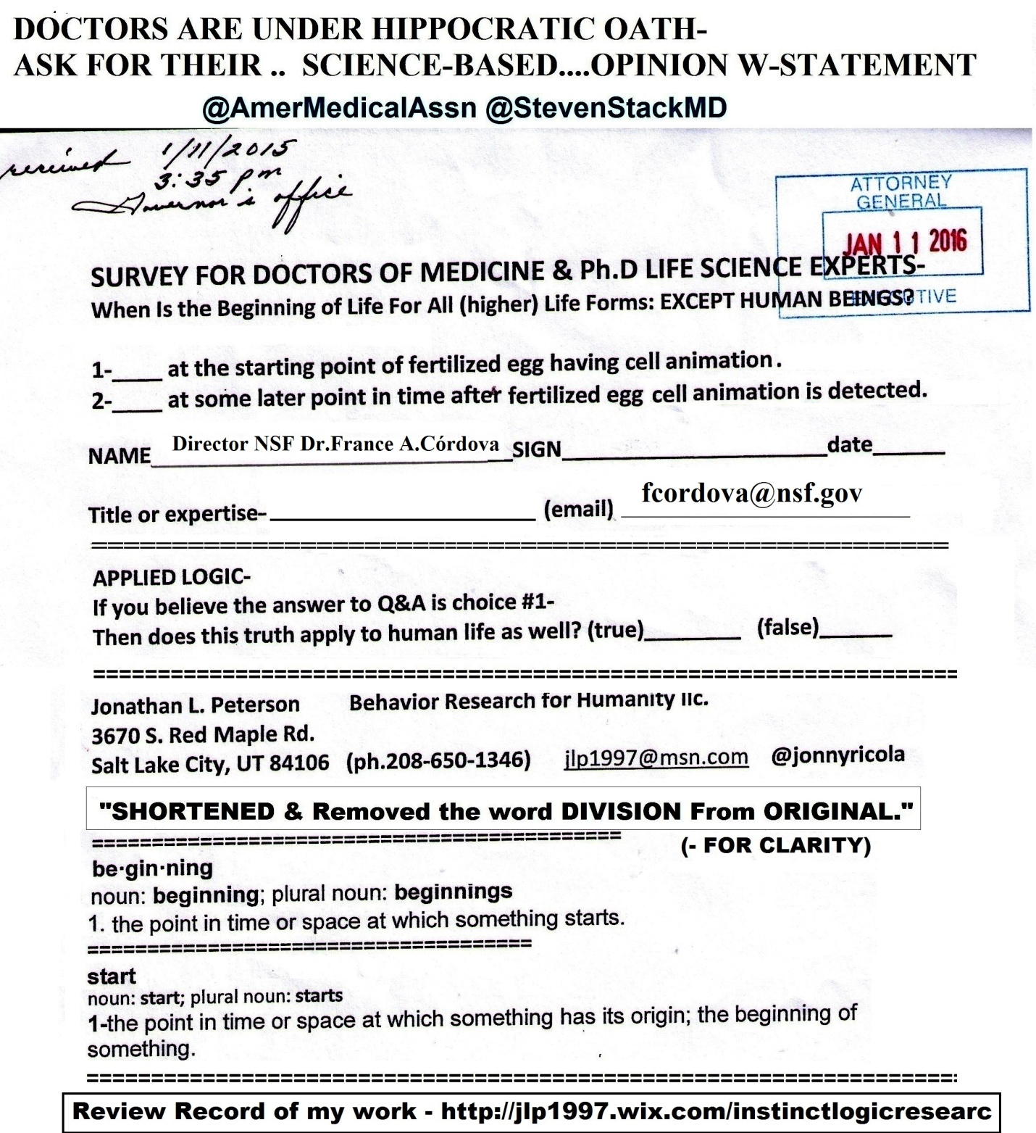
==================================
https://twitter.com/jonnyricola/status/738063972440498176 @NSF @DoreenMcVeigh @JacquelynGill My Instinct Logic Research rests on this 1 Proof- EXPERTS try to sign it =BLOCKED
https://twitter.com/NSF/status/738001312177086464 @NSFCongratulations to #NSFbday selfie/photo winner, @DoreenMcVeigh. Can't wait to see photos from your dive in July!
@NSF @DoreenMcVeigh @JacquelynGill offered advice viewing my EAGER grant request-Gave her proofs & she now blocks me-https://twitter.com/JacquelynGill/status/737983979152871424 (says unavailable-but it is)
reply
@NSF @DoreenMcVeigh @JacquelynGill Above link works. But here is the same link to NSF story-https://twitter.com/NSF/status/735528182225489921
reply
@NSF @DoreenMcVeigh @JacquelynGill My Instinct Logic Research rests on this 1 Proof- EXPERTS try to sign it =BLOCKED
(W-Photo Gov. Herbert&REYES Survey for Doctors Jan. 11, 2016 & divisonRemovWVIEW AMA NSF 7ways&Captions&Mission)
reply
@NSF @DoreenMcVeigh @JacquelynGill What has the power to block individual choice Paradox solved-HOW SURVIVAL LOGIC IS PASSED DOWN 2 NEXT GEN
reply
@NSF @DoreenMcVeigh @JacquelynGill Paradox solved-Only 1 possible solution
Self-Replicating A.I.Logic Ask @IBMWatson
(W-Photo 100 prof can't answer a simple question true not true 8-18-2014 Updated with message)
reply
@NSF @DoreenMcVeigh @JacquelynGill @IBMWatson LET US ALSO ASK @davideagleman& @PBS THEY HAVE THE INFO Since 11-19-15
https://twitter.com/PBS/status/667130400117022720 (the brain series finally)
reply
@NSF @DoreenMcVeigh @JacquelynGill @IBMWatson @davideagleman @PBS NSF-INVITE ME TO PUBLICLY PROVE MY INSTINCT LOGIC RESEARCH isTRUE REALITY
reply
@NSF @DoreenMcVeigh @JacquelynGill @IBMWatson @davideagleman @PBS Examine my proofs:Sci,Law & God =INSTINCT REVEALED-http://jlp1997.wix.com/instinctlogicresearc
======================
https://twitter.com/jonnyricola/status/738037093180416000 (@JacquelynGill @NFS @NSAGov Began3-14 ASK- Dr.@neiltyson& @IBMWatson https://twitter.com/neiltyson/status/709430725850886144 https://twitter.com/jonnyricola/status/709509292907311105)
https://twitter.com/NSF/status/735528182225489921 (response from scientist to earlier post) (@NSFWhat are we learning about how and when #tornadoes form? http://1.usa.gov/1TKQYUs)

@JacquelynGill /JacquelynGill/status/737983979152871424
@jonnyricola Did you contact a program officer first? That's generally the way to go with EAGERs.
reply
@JacquelynGill I did. I sent 5pg letter & evidence emails to leadership too. My proofs of reality need to be asked.Filed as directed by @NFS
reply
@JacquelynGill @NFS Instinct mechanism itself-blocks this research
Paradox of survival logic-passed down generation to gen=answered-W-Proofs
reply
@JacquelynGill @NFS Did you see that my posts, including this 1 was removed from public view for 2 days? Twitter didn't do it-@NSAGov did.:)
reply
@JacquelynGill @NFS @NSAGov 12 times since March all my 13K tweets have been removed & then restored to public view.BUT NOT ALL-I have proof
reply
@JacquelynGill @NFS @NSAGov Began3-14 ASK- Dr.@neiltyson& @IBMWatson https://twitter.com/neiltyson/status/709430725850886144
https://twitter.com/jonnyricola/status/709509292907311105
(W-Photo 69B MY LAST TWEET- Was to Dr. Neil DeGrassi Tyson March 14-2016 survey on instinct LG VIEW messDKwARROWS)corected
(W-Photo DR. NEIL PhD EXPERTS SCI-SURVEY ON INSTINCT w-deprog 3-14-2016 PAINTED TEXT w-PBSbrainURL & )
(W-Photo NSF Cover pg1 of 2 (landscape) letter for Grant Funding. Dear NSF pi-leadership and Pres. Barack Obama, April 16, 2015 WV-
(W-Photo NSF Cover pg 2 of 2 (landscape) letter for Grant Funding. Dear NSF pi-leadership and Pres. Barack Obama, April 16, 2015 WV
reply
@JacquelynGill @NFS @NSAGov @neiltyson @IBMWatson of all the proofs instinct mechanism is blocking research THIS ONE-https://twitter.com/jonnyricola/status/737766791854710784
(@NSF My questions clearly trigger instinct mechanism-Blocking an answer-THAT IS PROOF MY RESEARCH IS IMPORTANT-Try2- with NSF SURVEY)
reply
@JacquelynGill @NFS @NSAGov @neiltyson @IBMWatson I offer a more accurate view of reality. invite me to prove it=NOW
https://www.credomobilize.com/petitions/ask-ibmwatson-one-question-for-humanity-is-instinct-mechanism-an-artificial-intelligence-program?source=twitter-share-button
reply
@JacquelynGill @NFS @NSAGov @neiltyson @IBMWatson Jacquelyn -invite me to the @UMaine And Challenge our false beliefs W-Proof of Reality. :)
==================================================
May 31, 2016
===============================================
https://twitter.com/NSF/status/737718135906836480 @NSF50 #NSFfunded biotech startups will be at #BIO2016. Preview: magnetic beads bound to RNA http://1.usa.gov/1UbekP9
@NSF Are you going to approve my EAGER grant- for instinctual logic research?- you know 1 of my Questions/on Reality- https://twitter.com/jonnyricola/status/737338780604997633 (@NSF @saintmarys @smcbellebats @science360 This Research Q&A Survey is Here to change reality/Logic of our world-ASK)
reply
@NSF My questions clearly trigger instinct mechanism-Blocking an answer-
THAT IS PROOF MY RESEARCH IS IMPORTANT-Try2
(W-Photo Gov. Herbert&REYES Survey for Doctors Jan. 11, 2016 & divisonRemovWVIEW AMA NSF 7ways&Captions&Mission)
=============================================
https://twitter.com/NSF/status/737656155397324801 @NSFPeople with diverse backgrounds are critical to the cultivation of new ideas in #science and #engineering: http://1.usa.gov/1WPL86W #APAHM
@NSF @saintmarys @smcbellebats @science360 This Research Q&A Survey is Here to change reality/Logic of our world-ASK-
https://twitter.com/jonnyricola/status/737338780604997633 (@NSF @saintmarys @smcbellebats @science360 This Research Q&A Survey is Here to change reality/Logic of our world-ASK)
=========================
http://www.deseretnews.com/user/comments/765686901/Obama-marks-Memorial-Day-at-Arlington-National-Cemetery.html
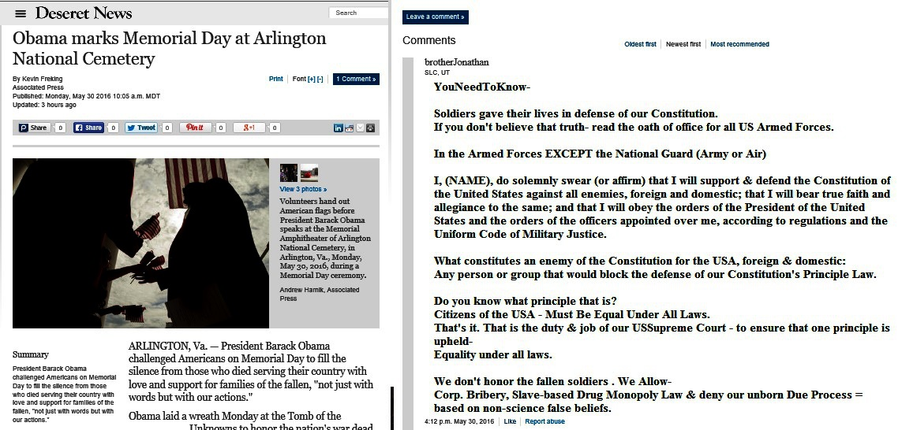
May 30, 2016
============================================
https://twitter.com/jonnyricola/status/737338780604997633 @NSF @saintmarys @smcbellebats @science360 This Research Q&A Survey is Here to change reality/Logic of our world-ASK
https://twitter.com/NSF/status/736904963859709953 @NSFCounting #bats with #echolocation, @SaintMarys @smcbellebats research @Science360 Radio:

@NSF @saintmarys @smcbellebats @science360 This Research Q&A Survey is Here to change reality/Logic of our world-ASK
(W-Photo Gov. Herbert&REYES Survey for Doctors Jan. 11, 2016 & divisonRemovWVIEW AMA NSF 7ways&Captions&Mission)
reply
@NSF @saintmarys @smcbellebats @science360 I love logic tests.
They prove what is true & what isn't.TRY2sign&SPEAKUP-https://community.sumofus.org/petitions/ask-doctors-phd-life-science-experts-when-does-life-begin-survey?source=twitter-share-button
reply
@NSF @saintmarys @smcbellebats @science360 If you had the courage to try to sign the petition=BECAME AWAREofINSTINCT MECHANISM'S POWER overU
reply
@NSF @saintmarys @smcbellebats @science360 IS MY BEHAVIOR RESEARCH IMPORTANT TO HUMANITY? A simple yes or no will do-https://community.sumofus.org/petitions/ask-doctors-phd-life-science-experts-when-does-life-begin-survey?source=twitter-share-button
reply
@NSF @saintmarys @smcbellebats @science360 Haven't you always wanted to know
how 2mil bio machines(in ea cell)think?
(W-Photo DR. NEIL PhD EXPERTS SCI-SURVEY ON INSTINCT w-deprog 3-14-2016 PAINTED TEXT w-PBSbrainURL & )
(W-Photo PBS The BRAIN final episode with PROOFS OF INSTINCT MECH as A.I. Driven w STATUS QUO w-LINK
(W-Photo NSF Evidence letter for Funding.Pg1 of 3 (Landscape) Dear NSF pi-leadership and Pres. Barack Obama, April 16, 2015 WView)
(W-Photo 69B MY LAST TWEET- Was to Dr. Neil DeGrassi Tyson March 14-2016 survey on instinct LG VIEW messDKwARROWS
reply
@NSF @saintmarys @smcbellebats @science360 I prepared 2 photo presentations & Twitter record= http://jlp1997.wix.com/instinctlogicresearc
(W-Photo JLP1997 INSTINCTLOGICRESEARC- Website photo May 25, 2016 WVIEW urlPart1)
(W-Photo JJLP1997 INSTINCTLOGICRESEARC- Website photo May 25, 2016 WVIEW urlPart2crop)
(W-Photo DeseretNews comments ‘Scalia's death leaves major void in high court, Utah legal experts say’ (2-14-2016) W-SUPREME URL)
(W-Photo DeseretNews comments 15 LDS general authorities & B of Mormon heroes 1-8-2016 WVIEW w- SKULL -DN-URL& faithURL)
=======================================================
https://twitter.com/NSF/status/736917335844507648 @NSFHere's the radio link: http://1.usa.gov/25p3vRmPhoto Credit: Meike Linnenschmidt
@NSF If you love pure science- without the bias our survival logic forces on its' hosts. Read this Research message- https://twitter.com/jonnyricola/status/737338780604997633 (This Research Q&A Survey is Here to change reality/Logic of our world-ASK)
============================================
https://twitter.com/PreciousLifeCom/status/73729891216436 @PreciousLifeComBernadette Smyth, the director of Precious Life, commented on these results:“The steady decrease in the number... http://fb.me/4DKcSwtYP8384
@PreciousLifeCom I have given you the science survey tool to end Abortion on Demand- USE IT or 6K deaths a day on U-
https://twitter.com/jonnyricola/status/737285655810572288 (NSF post)
reply
@PreciousLifeCom @DeseretNews @UUtah @AP Mission of Science-help mankind-IT'S my @NSF EAGER GRANT APP-to ask-EXPERTS
(W-Photo Gov. Herbert&REYES Survey for Doctors Jan. 11, 2016 & divisonRemovWVIEW AMA NSF 7ways&Captions&Mission
reply
@PreciousLifeCom @DeseretNews @UUtah @AP @NSF
There is no logical reason not to ask Doctors for their expert opinion-https://community.sumofus.org/petitions/ask-doctors-phd-life-science-experts-when-does-life-begin-survey?source=twitter-share-button
==========================
DIRECT- to @DeseretNews -https://twitter.com/jonnyricola/status/737288573418766337
@DeseretNews @UUtah @AP Mission of Science knowledge is to help mankind.-IT'S my @NSF EAGER GRANT APP-to ask-EXPERTS
(W-Photo Gov. Herbert&REYES Survey for Doctors Jan. 11, 2016 & divisonRemovWVIEW AMA NSF 7ways&Captions&Mission
========================================
https://twitter.com/NSF/status/737270435172192256 @NSFIn memory of many. In honor of all. Thank you! #MemorialDay
@NSF @AmerMedicalAssn @DeseretNews @PBS Mission of Science:
To help mankind -My NSF EAGER GRANT APP-to ask-EXPERTS:)
(W-Photo Gov. Herbert&REYES Survey for Doctors Jan. 11, 2016 & divisonRemovWVIEW AMA NSF 7ways&Captions&Mission
==============================================
DIRECT & To this story- https://twitter.com/NSF/status/736557826739343360 @NSFHitting the road for #MemorialDay ? Be safe! Learn about the science of #distracteddriving http://bit.ly/1TI2z8w
@NSF @AmerMedicalAssn @UUtah Mission of Science knowledge is to help
mankind.-IT'S my EAGER GRANT APP-to ask-EXPERTS
(W-Photo Gov. Herbert&REYES Survey for Doctors Jan. 11, 2016 & divisonRemovWVIEW AMA NSF 7ways&Captions&Mission
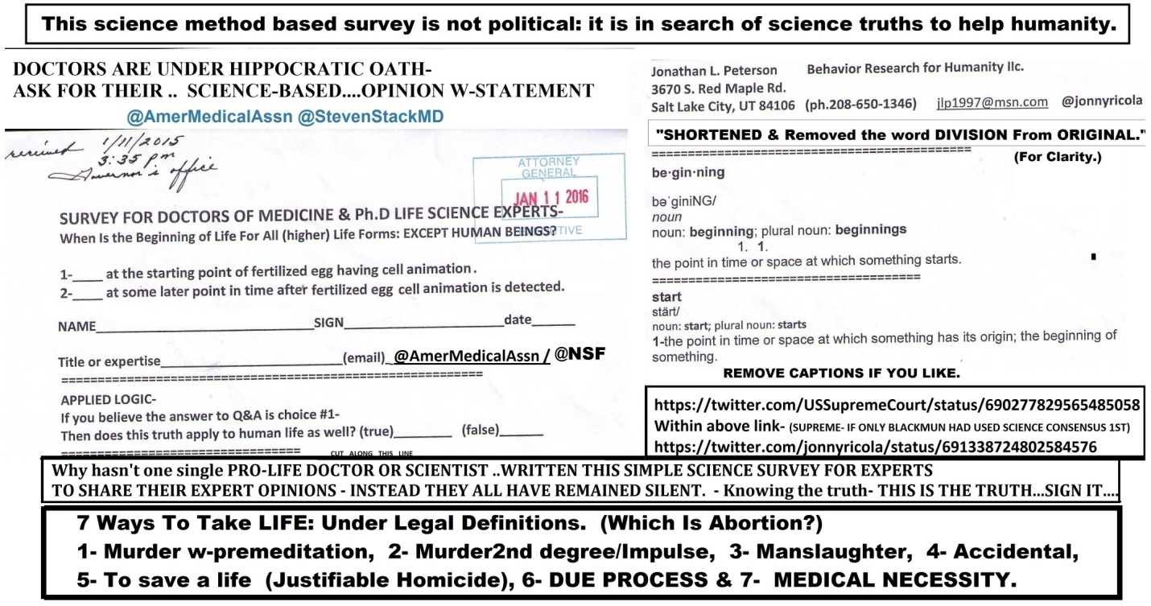
======================================
https://twitter.com/DeseretNews/status/737287944776474624 @DeseretNewsErin Stewart: Breaking the stigma of #postpartum #depressionhttp://www.deseretnews.com/article/865655226/Breaking-the-stigma-of-postpartum-depression.html
@DeseretNews @UUtah I ask PhD experts to give their opinion if this psychology tool could help mothers & dads withPD
(W-photo 73 DeseretNews comment My view- Saving drug addicts should be priority for government, health care leaders’(7-5-2015)
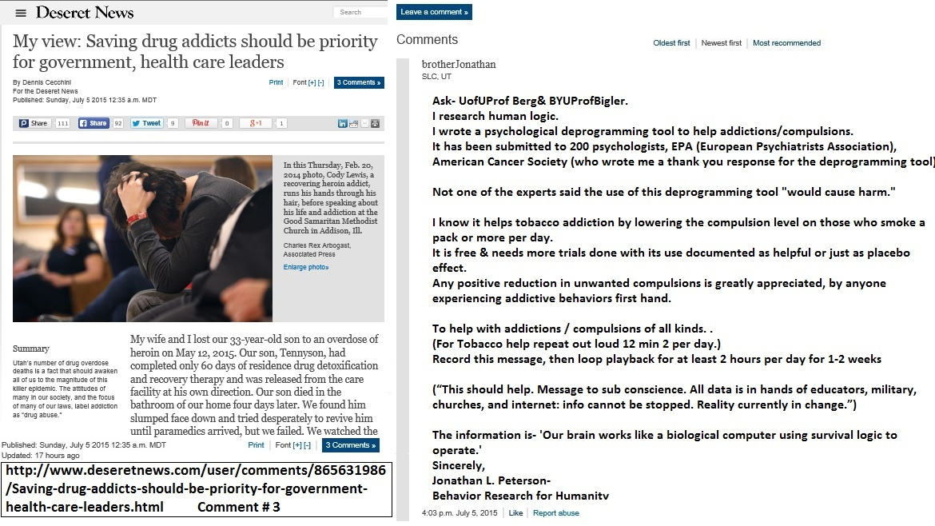
===========================================
May 29, 2016
https://www.facebook.com/slinstitute/posts/1193282834039606 (They removed this one-but kept this one- https://www.facebook.com/slinstitute/posts/970482386354846?comment_id=970570726346012
https://www.facebook.com/slinstitute/posts/1194530137248209 (this one is new-pursuit of happiness)
==============================================
https://twitter.com/votemadsen/status/737042658833629186 @votemadsenWeld - our platform is fiscal responsibility and personal freedom.
@votemadsen Prove it retweet my post on unconstitutional Drug Monopoly & Shareholder Bribery use. OR SIGN as LAWFUL
(W-Photo DABAKIS, TODD, MADSEN REYES-controlled sub acts violations of equality 6-4-2015 NOTARIZED WVIEW w-YEA OR NAE)
(W-Photo Sen Marc Madsen, Weiler, Reyes -WHY DIDN'T YOU WRITE THIS-SURVEY FOR PUBLIC OFFI plain 1-12-2016 WIDEVIEWw-tell them
(W-Photo CIVIL RIGHTS POST ON HUBER VIOLATING DUE PROCESS OCT 8,2015 w-LINK lg text WIDEVIEW & Loretta link)
(W-Photo US DISTRIC COURT Judge Nuffer Complaint July 1, 2015 11pg Lrez PAGE 1 & ZION BANK in ID evidence & SUPREME URL& Loretta)
reply
@votemadsen Mark our constitution is being violated. YOU KNOW IT
I HAVE GIVEN YOU THE PROOFS. This one needs YOU TOO- https://community.sumofus.org/petitions/ask-doctors-phd-life-science-experts-when-does-life-begin-survey?source=twitter-share-button
reply
@votemadsen Sorry I spelled Mark- Sign your expert opinion to Survey Proof of Violation to our Constitution @gopTODD
(W-Photo Sen Mark Madsen, Weiler, Reyes -WHY DIDN'T YOU WRITE THIS-SURVEY FOR PUBLIC OFFI plain 1-12-2016 WIDEVIEWw-tell them
reply
@votemadsen @gopTODD Do you think if you both remain silent: One day soon charged with OBSTRUCTION of JUSTICE? dah-
https://twitter.com/jonnyricola/status/687429643754967040 @utah_women @utahsenate @gopTODD @AngelaRomeroH26@JJohnsonNow @RepMiaLove BE SURE TO ASK SEN. WEILER-(lawyer)2SIGN
reply
@votemadsen @gopTODD I document really well. Ask FBIagent Todd Palmer
My tweet record is found Here=It is courtReady- http://jlp1997.wix.com/instinctlogicresearc
===============================
DIRECT-
@votemadsen @seanreyesag Ready to honor your Constitutional Oath & as officers of the Court? Drug Monopoly=VIOLATION
(W-Photo DABAKIS, TODD, MADSEN REYES-controlled sub acts violations of equality 6-4-2015 NOTARIZED WVIEW w-YEA OR NAE)
(W-Photo CIVIL RIGHTS POST ON HUBER VIOLATING DUE PROCESS OCT 8,2015 w-LINK lg text WIDEVIEW & Loretta link)
(W-Photo MADSEN TWITTER MED. POT AT CAPITOL- PROOF DRUG LAWS ILEGAL 1-13-2016 W-URL 2wv
(W-Photo Utah Supreme Ct Justices-are the controlled sub acts violations of equality 6-4-2015 NOTARIZED WIDEVIEW w-YEA OR NAE
==========
https://twitter.com/GovGaryJohnson/status/737019774471901184 (Sen.Madsen Retweets)
Gov. Gary Johnson Verified account ‏@GovGaryJohnsonGov. Gary Johnson Retweeted Robert SarvisThanks Rob!
@GovGaryJohnson Sen. @votemadsen Retweeted the wrong story.
This one could end Corp. Bribery & unjust Drug Monopoly-https://twitter.com/jonnyricola/status/736988862610706432
@GovGaryJohnson Do any of you believe: Corp. spend Shareholders Money on "freedom of speech" Justification? ASK GARY
=================
https://twitter.com/BradThor/status/737024327934222336 @BradThorStanding On Principle – Young Republicans Communications Chair Quits Over Trump http://noisyroom.net/blog/2016/05/26/standing-on-principle-young-republicans-communications-chair-quits-over-trump/ …
@BradThor Show those young Republicans this filed Proof of Bribery by Corp. w-Shareholders & ask @realDonaldTrump :)
(W-Photo Pres. Obama & Trump & HILLARY-U BELIEVE IT SIGN IT SURVEY FOR CORP BRIBERY -EXPLAIN 2-26-2016 WView messURLS
(W-Photo CIVIL RIGHTS POST ON HUBER VIOLATING DUE PROCESS OCT 8,2015 w-LINK lg text WIDEVIEW & Loretta link)
(W-Photo OBAMA,TRUMP HILLARY& LORETTA-UNDER OATH W-NUFFER DOC w-REYES-controlled sub 6-4-2015 NOTARIZED WVIEW w-YEA
(W-Photo 46 U.S. DISTRICT COURT JUDGE Robert J. Shelby & WADDOUPS, Filed 11 page complaint 7-1-2015 DK)
=================================================
https://twitter.com/IWF/status/737018427143905281 @IWFPolls Show That a Lot of Americans Can't Stand Hillary. http://bit.ly/1RxFfCV via @IWF
@IWF Ask @HillaryClinton one question on Corp. Shareholder Spending & she will quit the race.OR LEAD US TO EQUALITY-
(W-Photo Pres. Obama & Trump & HILLARY-U BELIEVE IT SIGN IT SURVEY FOR CORP BRIBERY -EXPLAIN 2-26-2016 WView messURLS
==========================================
https://twitter.com/KristNovoselic/status/736982961745076224 (Retweet by GART J.)
@KristNovoselicKrist Novoselić Retweeted Gov. Gary JohnsonCongratulations on the nomination. You're on the presidential ballot in all 50 states!
@KristNovoselic CAN YOU LEAD USA? & not speak up about proof of corp bribery Proof handed to you? @GovGaryJohnson
https://twitter.com/jonnyricola/status/736988862610706432 (@GovGaryJohnson Do any of you believe: Corp. spend Shareholders Money on "freedom of speech" Justification? ASK GARY)
reply
@KristNovoselic @GovGaryJohnson @realDonaldTrump @HillaryClinton @DeseretNews @POTUS THIS IS PROOF OF CORP. BRIBERY=
(W-Photo 59 Gary Johnson & me & survey on Bribery April 6-2016 slc,utURLmess)
(W-Photo CIVIL RIGHTS POST ON HUBER VIOLATING DUE PROCESS OCT 8,2015 w-LINK lg text WIDEVIEW & Loretta link)
(W-Photo US DISTRIC COURT Judge Nuffer Complaint July 1, 2015 11pg Lrez PAGE 1 & ZION BANK in ID evidence & SUPREME URL& Loretta)
Pres. Obama & Trump & HILLARY-U BELIEVE IT SIGN IT SURVEY FOR CORP BRIBERY -EXPLAIN 2-26-2016 WView messURLS
reply
@KristNovoselic @GovGaryJohnson @realDonaldTrump @HillaryClinton @DeseretNews @POTUS ALL CITIZEN'S RIGHTS PROTECTED-
https://community.sumofus.org/petitions/ask-doctors-phd-life-science-experts-when-does-life-begin-survey?source=twitter-share-button
REPLY
@KristNovoselic @GovGaryJohnson @realDonaldTrump @HillaryClinton @DeseretNews @POTUS DRUG MONOPOLY LAW=VIOLATION=ACT
(W-Photo Gary Johnson & me April 6-2016 slc,ut 1000x650 w-huber&gary obstruct & DRUG LAW)
(W-Photo CIVIL RIGHTS POST ON HUBER VIOLATING DUE PROCESS OCT 8,2015 w-LINK lg text WIDEVIEW & Loretta link)
(W-Photo OBAMA,TRUMP HILLARY& LORETTA-UNDER OATH W-NUFFER DOC w-REYES-controlled sub 6-4-2015 NOTARIZED WVIEW w-YEA
(W-Photo 46 U.S. DISTRICT COURT JUDGE Robert J. Shelby & WADDOUPS, Filed 11 page complaint 7-1-2015 DK)
reply
@KristNovoselic @GovGaryJohnson @realDonaldTrump @HillaryClinton @DeseretNews @POTUS
Instinct Logic Research is Here- http://jlp1997.wix.com/instinctlogicresearc
====================================
https://twitter.com/jonnyricola/status/736988862610706432 @GovGaryJohnson Do any of you believe: Corp. spend Shareholders Money on "freedom of speech" Justification? ASK GARY
https://twitter.com/GovGaryJohnson/status/736979070026715137 @GovGaryJohnsonDelegates! Please be back in the ballroom in five minutes to vote! Vice presidential voting is beginning in five minutes. Thanks #VPOTUS
@GovGaryJohnson Do any of you actually believe. Life does not start at the beginning of cell animation? ASK A DOCTOR-
https://community.sumofus.org/petitions/ask-doctors-phd-life-science-experts-when-does-life-begin-survey?source=twitter-share-button
reply
@GovGaryJohnson Do any of you believe: Corp. spend Shareholders Money on "freedom of speech" Justification? ASK GARY
(W-Photo 59 Gary Johnson & me & survey on Bribery April 6-2016 slc,utURLmess)
(W-Photo CIVIL RIGHTS POST ON HUBER VIOLATING DUE PROCESS OCT 8,2015 w-LINK lg text WIDEVIEW & Loretta link)
(W-Photo US DISTRIC COURT Judge Nuffer Complaint July 1, 2015 11pg Lrez PAGE 1 & ZION BANK in ID evidence & SUPREME URL& Loretta)
(W-Photo BERNIE SLC,UT March 21-2016 cropped wideview then longview W-we have proof of intent. & survey Lg TEXT)
reply
@GovGaryJohnson DO YOU BELIEVE-
Citizen Equality Is Not Broken W- Drug Monopoly Law? ASK GJ-https://twitter.com/USSupremeCourt/status/691657424634191875
(W-Photo Gary Johnson & me & survey on Bribery April 6-2016 slc,ut 1000x650 w-huber&gary obstruct & DRUG LAW)
(W-Photo CIVIL RIGHTS POST ON HUBER VIOLATING DUE PROCESS OCT 8,2015 w-LINK lg text WIDEVIEW & Loretta link)
US SUPREME & LORETTA-UNDER OATH W-NUFFER DOC w-REYES-controlled sub 6-4-2015 NOTARIZED WVIEW w-YEA OR NAE )
(W-Photo DeseretNews comments ‘Scalia's death leaves major void in high court, Utah legal experts say’ (2-14-2016) W-SUPREME URL)
=========================================
https://twitter.com/jonnyricola/status/737285655810572288 @NSF @AmerMedicalAssn @UUtah Mission of Science
DIRECT & TO THIS STORY- https://twitter.com/NSF/status/736557826739343360 @NSFHitting the road for #MemorialDay ? Be safe! Learn about the science of #distracteddriving http://bit.ly/1TI2z8w
@NSF @AmerMedicalAssn @UUtah A gift from God to U=oppose
our instinct mechanism.Share this proof & know God loves US-https://community.sumofus.org/petitions/ask-doctors-phd-life-science-experts-when-does-life-begin-survey?source=twitter-share-button
reply
@NSF @AmerMedicalAssn @UUtah Mission of Science knowledge is to help
mankind.-IT'S my EAGER GRANT APP-to ask-EXPERTS
(W-Photo Gov. Herbert&REYES Survey for Doctors Jan. 11, 2016 & divisonRemovWVIEW AMA NSF 7ways&Captions&Mission
============================================
DIRECT & TO THIS STORY- https://twitter.com/POTUS/status/732266263528001537 @POTUSToday, I join all Americans in honoring 13 officers who went beyond the call of duty to save the lives of strangers.
@POTUS @CivilRights A gift from God to U=oppose our
instinct mechanism/Satan.Share this proof & know God loves USall-https://community.sumofus.org/petitions/ask-doctors-phd-life-science-experts-when-does-life-begin-survey?source=twitter-share-button
=============
DIRECT & TO THIS STORY-https://twitter.com/CivilRights/status/736208942020341761 @CivilRights.@TheJusticeDept Settles Housing Discrimination Lawsuit Against Owners of Carson City, Nevada, Rental Properties → http://go.usa.gov/cJhtR
@CivilRights @TheJusticeDept A gift from God to U=oppose our instinct mechanism.Share this proof & know God loves US-https://community.sumofus.org/petitions/ask-doctors-phd-life-science-experts-when-does-life-begin-survey?source=twitter-share-button
=================
DIRECT & TO THIS STORY- https://twitter.com/byuidaho/status/735219135085350912 In his #BYUIdevotional address, Psychology faculty member Yohan Delton discussed misplaced #enmity.
@byuidaho A gift from God to us=oppose our instinct mechanism-Satan.Share this proof & know God loves us all-https://community.sumofus.org/petitions/ask-doctors-phd-life-science-experts-when-does-life-begin-survey?source=twitter-share-button Delton?
===============
DIRECT & TO THIS STORY- https://twitter.com/UniverseBYU/status/736272012096634880
@UniverseBYU @BYU A gift from God to us=oppose our instinct mechanism-Satan.Share this proof & know God loves us all-https://community.sumofus.org/petitions/ask-doctors-phd-life-science-experts-when-does-life-begin-survey?source=twitter-share-button
=============================================
DIRECT & TO THIS STORY- https://twitter.com/thecampaignbook/status/736240592162672640
@thecampaignbook A gift from God to us oppose our instinct mechanism-Satan.
Share this proof & know God loves us all-https://community.sumofus.org/petitions/ask-doctors-phd-life-science-experts-when-does-life-begin-survey?source=twitter-share-button
======================
DIRECT- @AmerMedicalAssn @StevenStackMD-A gift from God is here to help the righteous oppose Satan's power on earth:ShareIT- https://community.sumofus.org/petitions/ask-doctors-phd-life-science-experts-when-does-life-begin-survey?source=twitter-share-button
======================
https://twitter.com/AmerMedicalAssn/status/736935128056860672 @AmerMedicalAssnThe smoking rate among U.S. adults fell to 15% last year, after largest one-year decline in 20+ years. http://spr.ly/6019BqzVh (via @ap)
@AmerMedicalAssn @AP @StevenStackMD-A gift from God is here
ToHELP the righteous oppose Satan's power on earth:SHARE- https://community.sumofus.org/petitions/ask-doctors-phd-life-science-experts-when-does-life-begin-survey?source=twitter-share-button
====================================
https://twitter.com/DeseretNews/status/736925089216626692 @DeseretNewsBoyd Matheson: The true pursuit of happinesshttp://www.deseretnews.com/article/865655257/My-view-The-true-pursuit-of-happiness.html
@DeseretNews @LDSChurchNews @NSF-A gift from God is here
to help the righteous oppose Satan's power on earth:ShareIT-https://community.sumofus.org/petitions/ask-doctors-phd-life-science-experts-when-does-life-begin-survey?source=twitter-share-button
=====================
DIRECT-
@DeseretNews @LDSChurchNews @AP -A gift from God is here
to help the righteous oppose Satan's power on earth:ShareIT-https://community.sumofus.org/petitions/ask-doctors-phd-life-science-experts-when-does-life-begin-survey?source=twitter-share-button
==========================================
https://twitter.com/LDSChurchNews/status/736301036596396032 @LDSChurchNewsPresident Uchtdorf visits Europe, returns to the place of his birth http://desne.ws/kHmf5z
@LDSChurchNews Pres @UchtdorfDF -A gift from God is here
to help the righteous oppose Satan's power on earth:ShareIT-https://community.sumofus.org/petitions/ask-doctors-phd-life-science-experts-when-does-life-begin-survey?source=twitter-share-button
==========================
DIRECT & to this story posted by https://twitter.com/LDSChurchNews/status/736557779054272513 @LDSChurchNews10 new mission presidents http://desne.ws/sl5WR5
@LDSChurchNews Followers of Christ-A gift from God is here
to help the righteous oppose Satan's power on earth:Share-https://community.sumofus.org/petitions/ask-doctors-phd-life-science-experts-when-does-life-begin-survey?source=twitter-share-button
====================================
DIRECT FROM MY SITE- @jonnyricola 1m1 minute ago
https://twitter.com/jonnyricola/status/736937793163694080
My Brothers & Sisters in Christ. A gift from God is here-
to help the righteous oppose Satan's power on earth:Share-https://community.sumofus.org/petitions/ask-doctors-phd-life-science-experts-when-does-life-begin-survey?source=twitter-share-button
=====================
DIRECT TO A NEW FOLLOWER-
@Camelliavhh My sister in Christ. A gift from God is here- to help the righteous oppose Satan's power on earth:Share-
https://community.sumofus.org/petitions/ask-doctors-phd-life-science-experts-when-does-life-begin-survey?source=twitter-share-button
=====
May 27, 2016
https://twitter.com/jonnyricola/with_replies
https://www.facebook.com/slinstitute/posts/1193282834039606
==============
https://twitter.com/LDSChurchNews/status/736270870079889410 @LDSChurchNewsCommitment to God should be uniting force, Elder Holland tells BSA National Executive Board http://desne.ws/hq4w3k
@LDSChurchNews Commitment to God must have power to open our mouths to oppose Satan- here at home_TRUST IN GOD-Speak
https://twitter.com/jonnyricola/status/736264511674408960 (@AmerMedicalAssn @StevenStackMD YOUR DUTY UNDER HIPPOCRATIC OATH=Silence is a violation. YOU ARE SCIENTISTS. SignIT
reply
@LDSChurchNews 1 SERVANT OF GOD-SPEAKING TRUTH-CAN REVEAL SATAN &OUR NEED TO REPENT.Will you @NelsonRussellM Be 1ST?
https://community.sumofus.org/petitions/ask-doctors-phd-life-science-experts-when-does-life-begin-survey?source=twitter-share-button
reply
@LDSChurchNews @NelsonRussellM @UchtdorfDF-said:SEARCHforTRUTH- A gift from God=PROOFofSATAN-http://jlp1997.wix.com/instinctlogicresearc
(W-Photo JLP1997 INSTINCTLOGICRESEARC- Website photo May 25, 2016 WVIEW urlPart1)
(W-Photo JJLP1997 INSTINCTLOGICRESEARC- Website photo May 25, 2016 WVIEW urlPart2crop)
(W-Photo DeseretNews Comments ‘Music and the Spoken Word- What is true greatness’ (5-14-2016)URLmessURLsiteMustDEMANDdk
(W-Photo DeseretNews comments 15 LDS general authorities & B of Mormon heroes 1-8-2016 WVIEW w- SKULL -DN-URL& faithURL)
===============
THE AMA JUST IGNORES MY POSTS.
==================================
https://twitter.com/AmerMedicalAssn/status/736255659319119872 @AmerMedicalAssnDr. Heimlich, now 96, uses his maneuver for the first time to save choking woman at his senior living center.

@AmerMedicalAssn @StevenStackMD R Going to BnH.ask @Pontifex
You are going to end up in US COURT=OBSTRUCTING JUSTICE
https://twitter.com/jonnyricola/status/736252017908162560
(@AmerMedicalAssn @StevenStackMD YOUR DUTY UNDER HIPPOCRATIC OATH=Silence is a violation. YOU ARE SCIENTISTS. SignIT
reply
@AmerMedicalAssn @StevenStackMD See People are Silent Sheep under the power of Instinct/Satan- HELP THEM-@Pontifex
https://community.sumofus.org/petitions/ask-doctors-phd-life-science-experts-when-does-life-begin-survey?source=twitter-share-button
reply
@AmerMedicalAssn @StevenStackMD @Pontifex I asked my @LDSchurch X's& Dr.@NelsonRussellM they won't open their mouth-
(W-Photo Gov. Herbert&REYES Survey for Doctors Jan. 11, 2016 & div.Remov DK NELSON LViewsite)
(W-photo Gov. Herbert&REYES Survey for Doctors Jan. 11, 2016 SHORT ORi W-HEADER & divisonRemovWVIEW AMA NSF 7ways&Captions)
(W-Photo W-Photo DeseretNews Comment- ‘Bill intends to ban certain abortion procedures in Utah’ (2-26-2016) WIDEVIEW w-SUP URL)
(W-Photo DeseretNews comments 15 LDS general authorities & B of Mormon heroes 1-8-2016 WVIEW w- SKULL -DN-URL& faithURL)
====================================================
https://twitter.com/AmerMedicalAssn/status/736255652759273476 @AmerMedicalAssnHow can you build savings habits in the face of #MedEd debt, daily expenses, and complexity of financial planning? http://spr.ly/6018BqpOA

@AmerMedicalAssn @StevenStackMD R Going to BnH.ask @Pontifex & U are going to end up in US COURT=OBSTRUCTING JUSTICE https://twitter.com/jonnyricola/status/736252017908162560
(@AmerMedicalAssn @StevenStackMD YOUR DUTY UNDER HIPPOCRATIC OATH=Silence is a violation. YOU ARE SCIENTISTS. SignIT
reply
@AmerMedicalAssn @StevenStackMD Pope @Pontifex TELL THEM-
God will deliver Justice=IF DOCTORS DON'T STAND UP & SPEAK
https://community.sumofus.org/petitions/ask-doctors-phd-life-science-experts-when-does-life-begin-survey?source=twitter-share-button
=============
DIRECT- @AmerMedicalAssn 6000 Lives ea. day taken through false Science & you know it
RIGHT THIS WRONG=SPEAK-@StevenStackMD-
https://community.sumofus.org/petitions/ask-doctors-phd-life-science-experts-when-does-life-begin-survey?source=twitter-share-button
===============
https://twitter.com/jonnyricola/status/736252017908162560
https://twitter.com/AmerMedicalAssn/status/736225451220303876 @AmerMedicalAssnLast month, physicians and institutions discussed doc #wellness at #AHealthierNation chat. Recap: http://spr.ly/6013BWn9U #MentalHealthMonth

@AmerMedicalAssn 6000 Lives ea. day taken through false Science & you know it
RIGHT THIS WRONG=SPEAK-@StevenStackMD-
https://community.sumofus.org/petitions/ask-doctors-phd-life-science-experts-when-does-life-begin-survey?source=twitter-share-button
reply
@AmerMedicalAssn @StevenStackMD YOUR DUTY UNDER HIPPOCRATIC OATH=Silence is a violation. YOU ARE SCIENTISTS. SignIT
(W-Photo Gov. Herbert&REYES Survey for Doctors Jan. 11, 2016 & div.Remov&7Ways Dr.STACK -LAWsiteSM)
(W-photo Gov. Herbert&REYES Survey for Doctors Jan. 11, 2016 SHORT ORi W-HEADER & divisonRemovWVIEW AMA NSF 7ways&Captions)
(W-Photo Gov. Herbert&REYES Survey for Doctors Jan. 11, 2016 & div.Remov DK PLAIN LViewsite)
(W-Photo Gov. Herbert&REYES Survey for Doctors Jan. 11, 2016 SHORT ORi W-HEADER & divisonRemovWVIEW USSG)
reply
@AmerMedicalAssn @StevenStackMD Do Not Remain Silent: Eternity is a very long time. Examine-http://jlp1997.wix.com/instinctlogicresearc
(W-Photo JLP1997 INSTINCTLOGICRESEARC- Website photo May 25, 2016 WVIEW urlPart1)
(W-Photo JJLP1997 INSTINCTLOGICRESEARC- Website photo May 25, 2016 WVIEW urlPart2crop)
(W-Photo W-Photo DeseretNews Comment- ‘Bill intends to ban certain abortion procedures in Utah’ (2-26-2016) WIDEVIEW w-SUP URL)
(W-Photo DeseretNews comments 15 LDS general authorities & B of Mormon heroes 1-8-2016 WVIEW w- SKULL -DN-URL& faithURL)
=================================================
https://twitter.com/CUDenver/status/735999961242836993 @CUDenver Interested in social media? COMM 4710: New Media Production & Management is the only class on campus teaching it! Enroll today! #CUDenver
@CUDenver This debate(where ever it is held) WILL BECOME
INTERNATIONAL NEWS.WHY?Because everyone is afraid of CHANGE-
https://twitter.com/jonnyricola/status/736244048927690752 @cannabist Should you be in the censorship business? When @GovGaryJohnsonCOULD LEGALIZE POT USING THIS FILED PROOF!
================================================
DIRECT FROM MY SITE- https://twitter.com/jonnyricola/status/736223335239946241
@jonnyricola Most of my Tweets are restored,BUT NOT ALL: the links that say unavailable
Do Work, My right to teach Truths to USA- https://twitter.com/jonnyricola/status/736001421569458176 (@ScienceNews If my research has no merit- why can't any expert just say that answer on the sci-survey questions?FEAR....-photos science surveys & proofs)
=====================================================
DIRECT & To this story-
@cannabist I metW-Gov.GaryJohnson& gave him proofs to end Drug War on Pot. You block my post-https://twitter.com/jonnyricola/status/734456570067615744
(W-Photo cannabist blocks tweet on Gary Johnson May 27-2016 (PHOTO IS BLURY)
(W-Photo Gary Johnson & me & survey on Bribery April 6-2016 slc,ut 1000x650 w-huber&gary obstruct & DRUG LAW)
(W-Photo CIVIL RIGHTS POST ON HUBER VIOLATING DUE PROCESS OCT 8,2015 w-LINK lg text WIDEVIEW & Loretta link)
(W-Photo Lynch,Stewart,OBAMA W-NUFFER DOC -are the controlled sub 6-4-2015 NOTARIZED WIDEVIEW w-YEA orNAE w sq & CTstamped
reply
@cannabist Should you be in the censorship business? When @GovGaryJohnson
COULD LEGALIZE POT USING THIS FILED PROOF!
w-huber&gary obstruct & DRUG LAW)
(W-Photo cannabist blocks tweet on Gary Johnson May 27-2016 WVIEW) (PHOTO IS CLEAN)
(W-Photo Gary Johnson & me Photo#2 survey S April 6-2016 slc,ut 1000x650 w-huber&gary obstruct & DRUG LAW)
(W-Photo CIVIL RIGHTS POST ON HUBER VIOLATING DUE PROCESS OCT 8,2015 w-LINK lg text WIDEVIEW & Loretta link)
(W-Photo OBAMA,TRUMP HILLARY& LORETTA- DOC w-REYES-are the controlled substance 6-4-2015 NOTARIZED W w-YEA
=========================================================
https://twitter.com/cannabist/status/736238066621243392 @cannabistEnglewood’s seeking public opinion on how residents feel about allowing recreational pot: http://dpo.st/27VkixJ
@cannabist I metW-Gov.GaryJohnson& gave him proofs to end Drug War on Pot. You block my post-https://twitter.com/jonnyricola/status/734456570067615744
(W-Photo cannabist blocks tweet on Gary Johnson May 27-2016
(W-Photo Gary Johnson & me & survey on Bribery April 6-2016 slc,ut 1000x650 w-huber&gary obstruct & DRUG LAW)
(W-Photo CIVIL RIGHTS POST ON HUBER VIOLATING DUE PROCESS OCT 8,2015 w-LINK lg text WIDEVIEW & Loretta link)
(W-Photo Lynch,Stewart,OBAMA W-NUFFER DOC -are the controlled sub 6-4-2015 NOTARIZED WIDEVIEW w-YEA orNAE w sq & CTstamped
reply
@cannabist Should you be in the censorship business? When @GovGaryJohnson
COULD LEGALIZE POT USING THIS FILED PROOF!
w-huber&gary obstruct & DRUG LAW)
(W-Photo cannabist blocks tweet on Gary Johnson May 27-2016 WVIEW)
(W-Photo Gary Johnson & me Photo#2 survey S April 6-2016 slc,ut 1000x650 w-huber&gary obstruct & DRUG LAW)
reply
@cannabist @GovGaryJohnson Come on people-LET'S HAVE A DEBATE @CUDenver
STATUS QUO defenders VS. DRUG MONOPOLY LAW VIOLATES CITIZEN EQUALITY
+++++++++
May 26, 2016
Most of my tweets have just been restored. 6pm MT. not all of them. Science News tweets are still all removed but one... the rest of them are proofs of instinct mechanism's identity.
FROM 5-25-2016 ALL BUT ONE POSTING IS STILL REMOVED FROM PUBLIC VIEW.
https://twitter.com/jonnyricola/status/735552053360001024 @ScienceNews @NSF Get with the program.Scientists have been silent about When Life Begins.Open your SCI-Based Mouth-
https://twitter.com/jonnyricola/status/735558866113421312 @ScienceNews @NSF I submitted/EAGER
https://twitter.com/jonnyricola/status/735561092533878785 @ScienceNews @NSF Do you grasp the importance of THIS behavior research?
https://twitter.com/jonnyricola/status/735564133844717568 @ScienceNews @NSF @neiltyson (1st it said server error-so I reposted it)Proofs of my work-http://jlp1997.wix.com/instinctlogicresearc …
https://twitter.com/jonnyricola/status/735565164372598784 @ScienceNews @NSF @neiltyson @DeseretNews @AmerMedicalAssnUseThisGiftFrom GODOPPOSE OUR INSTINCT MECHANISM & HAVE GOD'S BLESSINGS ON MAN
https://twitter.com/jonnyricola/status/735566008346247168 @ScienceNews @NSF @neiltyson @AP @AmerMedicalAssnCOME ON PEOPLENOT 1 SCIENTIST MADE THIS COMPARITIVE ANAYYSIS?dah
https://twitter.com/jonnyricola/status/735566600946913280 @ScienceNews @NSF @neiltyson @AP @AmerMedicalAssnyes I spelled it wrong.ANALYSISI never said I was perfect.DEFEND HUMANITY FROM INSTINCT
https://twitter.com/ScienceNews/status/735549823982653440
May 26, 2016 UNFROZE MOST OF MY TWEETS AT 6pm MT.
=========================
https://twitter.com/ScienceNews/status/736007811365253120 @ScienceNews#Einstein raised new questions that scientists continue to investigate today. Read about them in our new e-book: http://ow.ly/o3hG300iRjE
@ScienceNews I wish I could ask him how he believes survival logic is administered to each autonomous life. I know-
https://www.facebook.com/sharer/sharer.php?u=https%3A%2F%2Fwww.credomobilize.com%2Fpetitions%2Fask-ibmwatson-one-question-for-humanity-is-instinct-mechanism-an-artificial-intelligence-program%3Fsource%3Dfacebook-share-button%26time%3D1400175850
reply
@ScienceNews lets see if this link looks better. I filed the form w-@IBMWatson to ask but then no answer- You Try 2-
https://www.credomobilize.com/petitions/ask-ibmwatson-one-question-for-humanity-is-instinct-mechanism-an-artificial-intelligence-program?source=twitter-share-button
Joel Carter‏@Dimplewidget 6m6 minutes ago
@jonnyricola @ScienceNews @IBMWatson @CREDOMobile simple answer, the ones who don't have it don't survive to reproduce.
reply to
@Dimplewidget @ScienceNews @IBMWatson @CREDOMobile You really don't get. proofs before your eyes but denied access. http://naturedocumentaries.org/3972/hidden-life-cell-bbc/
reply (5-27-2016)
@jonnyricola @ScienceNews @IBMWatson @CREDOMobile ahh now I see could macrophage/t-cell chemical signals come into play?
reply
@Dimplewidget @ScienceNews @IBMWatson @CREDOMobile So blind as those who will not see=2mil bio machines working in chaotic harmony
ai driven
+++++
https://twitter.com/jonnyricola/status/736008222063005697
https://twitter.com/jonnyricola/status/736009935180300288 @ScienceNews @NSF courage doctor OR scientist-be the1st to give your true expert opinion on when life begins &SignIT- LAST POST
https://twitter.com/ScienceNews/status/735987661916274688 @ScienceNewsRegeneron is new sponsor of Science Talent Search: http://ow.ly/6vf3300D3Mw #RegeneronSTS
@ScienceNews My research is the most advanced on earth- why would 5 proofs be removed-FEAR= https://twitter.com/ScienceNews/status/735549823982653440
https://twitter.com/jonnyricola/status/735558866113421312 (@ScienceNews @NSF I submitted/EAGER Grant App-using Sci-Based Surveys to prove)
reply
@ScienceNews Here are some of the others ones removed by NSA
I AM NOT BLOCKED BY YOU-so WHY?
https://twitter.com/jonnyricola/status/735561092533878785
https://twitter.com/jonnyricola/status/735564133844717568
reply
@ScienceNews If my research has no merit- why can't any expert just say that answer on the sci-survey questions?FEAR
(W-Photo DR. NEIL PhD EXPERTS SCI-SURVEY ON INSTINCT w-deprog 3-14-2016 PAINTED TEXT w-PBSbrainURL & )
(W-Photo NSF Evidence letter for Funding.Pg1 of 3 (Landscape) Dear NSF pi-leadership and Pres. Barack Obama, April 16, 2015 WView)
(W-Photo Gov. Herbert&REYES Survey for Doctors Jan. 11, 2016 SHORT ORi W-HEADER & divisonRemovWVIEW AMA NSF 7ways&Captions)
(W-Photo PBS The BRAIN final episode with PROOFS OF INSTINCT MECH as A.I. Driven w STATUS QUO w-LINK
reply
@ScienceNews See for yourself-2 photo presentations of true reality
Then giving weight-JUDGE-http://jlp1997.wix.com/instinctlogicresearc
(W-Photo JLP1997 INSTINCTLOGICRESEARC- Website photo May 25, 2016 WVIEW urlPart1)
(W-Photo JJLP1997 INSTINCTLOGICRESEARC- Website photo May 25, 2016 WVIEW urlPart2crop)
(W-Photo 69B MY LAST TWEET- Was to Dr. Neil DeGrassi Tyson March 14-2016 survey on instinct LG VIEW messDKwARROWS
(W-Photo DeseretNews comments 15 LDS general authorities & B of Mormon heroes 1-8-2016 WVIEW w- SKULL -DN-URL& faithURL)
reply
@ScienceNews @NSF courage doctor OR scientist-be the1st to give your true expert opinion on when life begins &SignIT-https://community.sumofus.org/petitions/ask-doctors-phd-life-science-experts-when-does-life-begin-survey?source=twitter-share-button
++++++++++
May 25, 2016
ALL MY TWEETS HAVE BEEN REMOVED AGAIN- NSA is blocking my work for the People.
(copy & paste links into your browser- Posts are still available from my twitter server)
===================
ASK LDS 1st Presidency & Apostle/Dr. Russell M. Nelson for his expert opinion.
================DIRECT & TO THIS POSTED STORY---------
https://twitter.com/jonnyricola/status/735465802837725188 @LDSChurchNews John:1-Confess your sin & serve the Lord@ThomasSMonson @EyringHB @UchtdorfDFSPEAK-@NelsonRussellM
https://twitter.com/jonnyricola/status/735488064881975296 @LDSChurchNews @ThomasSMonson @EyringHB@UchtdorfDF @NelsonRussellM You believe I serve God?Open you mouth _Proofs=http://jlp1997.wix.com/instinctlogicresearc …
https://twitter.com/LDSChurchNews/status/735173093849595904 @LDSChurchNewsLaie Temple Visitors' Center experiences increase of more than 100 visitors per day http://desne.ws/d5srd1

@LDSChurchNews John:1-Confess your sin & serve the Lord @ThomasSMonson @EyringHB @UchtdorfDF SPEAK-@NelsonRussellM https://community.sumofus.org/petitions/ask-doctors-phd-life-science-experts-when-does-life-begin-survey?source=twitter-share-button
reply
@LDSChurchNews @ThomasSMonson @EyringHB @UchtdorfDF
@NelsonRussellM You believe I serve God? Open you mouth _Proofs=
http://jlp1997.wix.com/instinctlogicresearc
USE THIS GIFT FROM GOD.. OPPOSE OUR INSTINCT MECHANISM & HAVE GOD'S BLESSINGS ON MAN.
reply (5-26-2016)
@LDSChurchNews @ThomasSMonson @EyringHB @UchtdorfDF @NelsonRussellM
You know Why NSA removed my posts for 2days=FEAR- https://twitter.com/jonnyricola/status/736008222063005697
( @ScienceNews See for yourself-2 photo presentations of true reality Then giving weight-JUDGE-http://jlp1997.wix.com/instinctlogicresearc )
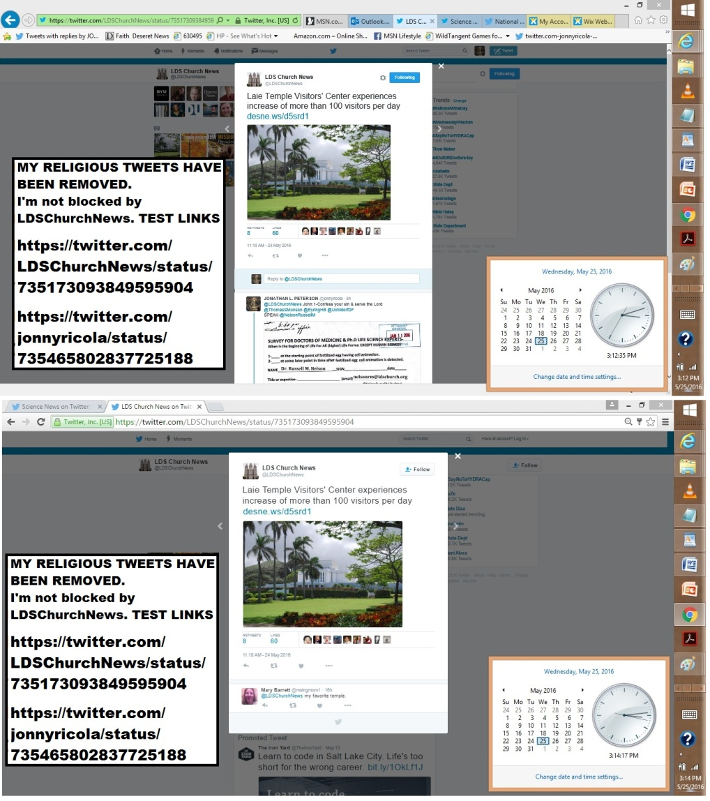
======
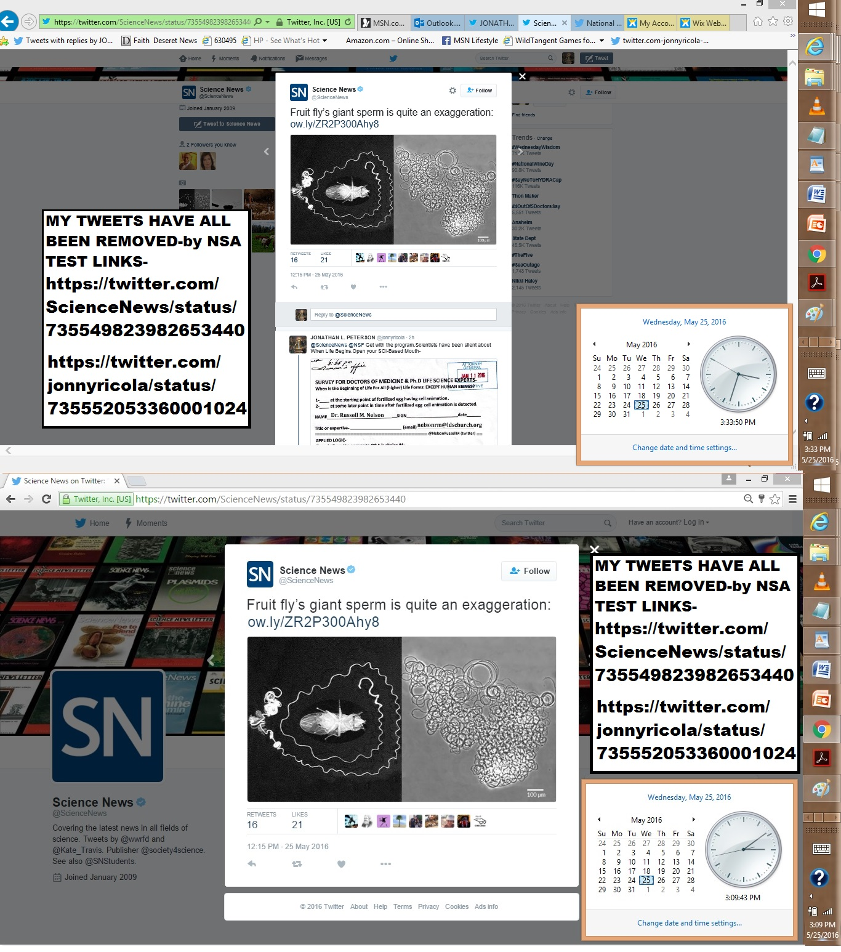
============================
https://twitter.com/jonnyricola/status/735552053360001024 @ScienceNews @NSF Get with the program.Scientists have been silent about When Life Begins.Open your SCI-Based Mouth-
https://twitter.com/jonnyricola/status/735558866113421312 @ScienceNews @NSF I submitted/EAGER
https://twitter.com/jonnyricola/status/735561092533878785 @ScienceNews @NSF Do you grasp the importance of THIS behavior research?
https://twitter.com/jonnyricola/status/735564133844717568 @ScienceNews @NSF @neiltyson (1st it said server error-so I reposted it)Proofs of my work-http://jlp1997.wix.com/instinctlogicresearc …
https://twitter.com/jonnyricola/status/735565164372598784 @ScienceNews @NSF @neiltyson @DeseretNews @AmerMedicalAssnUseThisGiftFrom GODOPPOSE OUR INSTINCT MECHANISM & HAVE GOD'S BLESSINGS ON MAN
https://twitter.com/jonnyricola/status/735566008346247168 @ScienceNews @NSF @neiltyson @AP @AmerMedicalAssnCOME ON PEOPLENOT 1 SCIENTIST MADE THIS COMPARITIVE ANAYYSIS?dah
https://twitter.com/jonnyricola/status/735566600946913280 @ScienceNews @NSF @neiltyson @AP @AmerMedicalAssnyes I spelled it wrong.ANALYSISI never said I was perfect.DEFEND HUMANITY FROM INSTINCT

https://twitter.com/ScienceNews/status/735549823982653440 @ScienceNewsFruit fly’s giant sperm is quite an exaggeration: http://ow.ly/ZR2P300Ahy8
@ScienceNews @NSF Get with the program.Scientists have been silent about When Life Begins.Open your SCI-Based Mouth- https://community.sumofus.org/petitions/ask-doctors-phd-life-science-experts-when-does-life-begin-survey?source=twitter-share-button
reply
@ScienceNews @NSF I submitted/EAGER Grant App-using Sci-Based Surveys to prove what-Instinct Mechanism Is=NoResponce
(W-Photo 25 Dear Prof. Cynthia Berg & PhD BRAIN EXPERTS, SCI-SURVEY ON INSTINCT w-deprog 3-3-2016 PAINTED TEXT - Copy
(W-Photo NSF Cover pg1 of 2 (landscape) letter for Grant Funding. Dear NSF pi-leadership and Pres. Barack Obama, April 16, 2015 WV-
(W-Photo NSF Cover pg 2 of 2 (landscape) letter for Grant Funding. Dear NSF pi-leadership and Pres. Barack Obama, April 16, 2015 WV
(W-Photo NSF Evidence letter for Funding.Pg1 of 3 (Landscape) Dear NSF pi-leadership and Pres. Barack Obama, April 16, 2015 WView)
reply
@ScienceNews @NSF Do you grasp the importance of THIS behavior research?
It is a gift from God-TEST THEM/ @neiltyson
(W-Photo Gov. Herbert&REYES Survey for Doctors Jan. 11, 2016 SHORT ORi W-HEADER & divisonRemovWVIEW AMA NSF 7ways&Captions)
(W-Photo DR. NEIL PhD EXPERTS SCI-SURVEY ON INSTINCT w-deprog 3-14-2016 PAINTED TEXT w-PBSbrainURL & )
(W-Photo PBS The BRAIN final episode with PROOFS OF INSTINCT MECH as A.I. Driven w STATUS QUO w-LINK
(W-Photo 69B MY LAST TWEET- Was to Dr. Neil DeGrassi Tyson March 14-2016 survey on instinct LG VIEW messDKwARROWS
reply
@ScienceNews @NSF @neiltyson (1st it said server error-so I reposted it) Proofs of my work-http://jlp1997.wix.com/instinctlogicresearc
(W-Photo JLP1997 INSTINCTLOGICRESEARC- Website photo May 25, 2016 WVIEW urlPart1)
(W-Photo JJLP1997 INSTINCTLOGICRESEARC- Website photo May 25, 2016 WVIEW urlPart2crop)
reply
@ScienceNews @NSF @neiltyson @DeseretNews @AmerMedicalAssn
UseThisGiftFrom GOD
OPPOSE OUR INSTINCT MECHANISM & HAVE GOD'S BLESSINGS ON MAN
reply
@ScienceNews @NSF @neiltyson @AP @AmerMedicalAssn
COME ON PEOPLE
NOT 1 SCIENTIST MADE THIS COMPARITIVE ANAYYSIS?dah
reply
================
https://twitter.com/jonnyricola/status/735536852501811200 https://twitter.com/jonnyricola/status/735537781380784128
https://twitter.com/jonnyricola/status/735538507070857216 https://twitter.com/jonnyricola/status/735538862974337024
https://twitter.com/jonnyricola/status/735548667734589440 @NSF @DeseretNews @AmerMedicalAssn @neiltyson @AP COME ON PEOPLENOT 1 SCIENTIST MADE THIS
https://twitter.com/jonnyricola/status/735549388974522368 @NSF @DeseretNews @AmerMedicalAssn @neiltyson @AP yes I spelled it wrong.ANALYSISI never said I was perfect. NOW DEFEND HUMANITY FROM SATAN
https://twitter.com/NSF/status/735528182225489921 @NSFWhat are we learning about how and when #tornadoes form? http://1.usa.gov/1TKQYUs

@NSF Get with the program.You&other scientists have been silent about When Life Begins.Open your science based mouth- https://community.sumofus.org/petitions/ask-doctors-phd-life-science-experts-when-does-life-begin-survey?source=twitter-share-button
reply
@NSF I submitted an eager grant proposal-to use Sci-Based Surveys to prove what-Instinct Mechanism Is.NO RESPONSE-:(
(W-Photo Gov. Herbert&REYES Survey for Doctors Jan. 11, 2016 SHORT ORi W-HEADER & divisonRemovWVIEW AMA NSF 7ways&Captions)
(W-Photo PBS The BRAIN final episode with PROOFS OF INSTINCT MECH as A.I. Driven w STATUS QUO w-LINK
(W-Photo DR. NEIL PhD EXPERTS SCI-SURVEY ON INSTINCT w-deprog 3-14-2016 PAINTED TEXT w-PBSbrainURL & )
(W-Photo 69B MY LAST TWEET- Was to Dr. Neil DeGrassi Tyson March 14-2016 survey on instinct LG VIEW messDKwARROWS
reply
@NSF @DeseretNews @AmerMedicalAssn @neiltyson @AP
Go to website-It has 2 photoPP& a word doc http://jlp1997.wix.com/instinctlogicresearc
(W-Photo JLP1997 INSTINCTLOGICRESEARC- Website photo May 25, 2016 WVIEW urlPart1)
(W-Photo JJLP1997 INSTINCTLOGICRESEARC- Website photo May 25, 2016 WVIEW urlPart2crop)
(W-Photo A SCI- COMPARISON BETWEEN, INSTINCT FUNCTIONS VS. COMPUTER FUNCTIONS W-NSF tweets 4-2015 Landscape WIDEVIEW
(W-Photo DeseretNews comments 15 LDS general authorities & B of Mormon heroes 1-8-2016 WVIEW w- SKULL -DN-URL& faithURL)
reply
@NSF @DeseretNews @AmerMedicalAssn @neiltyson @AP
USE THIS GIFT FROM GOD.. OPPOSE OUR INSTINCT MECHANISM & HAVE GOD'S BLESSINGS ON MAN. :)
reply
@NSF @DeseretNews @AmerMedicalAssn @neiltyson @AP COME ON PEOPLE NOT 1 SCIENTIST MADE THIS COMPARITIVE ANAYYSIS? DAH
(W-Photo NSF Evidence letter for Funding.Pg1 of 3 (Landscape) Dear NSF pi-leadership and Pres. Barack Obama, April 16, 2015 WView)
reply
@NSF @DeseretNews @AmerMedicalAssn @neiltyson @AP
yes I spelled it wrong.ANALYSIS
I never said I was perfect. NOW DEFEND HUMANITY FROM SATAN
===============
https://twitter.com/jonnyricola/status/735515250892496897 https://twitter.com/jonnyricola/status/735516471472726016
https://twitter.com/jonnyricola/status/735517427992125442 https://twitter.com/jonnyricola/status/735540320008437760
https://twitter.com/jonnyricola/status/735550473877344256 https://twitter.com/jonnyricola/status/735550821782409217
https://twitter.com/NSF/status/735441778891980801 @NSF Our NSF Beijing office is celebrating its 10th anniv today! 10 years of S&E collaborations: http://1.usa.gov/1OWisGt
@NSF I submitted an eager grant proposal-to use
Sci-Based Surveys to prove what-Instinct Mechanism Is.NO RESPONSE-:)
https://community.sumofus.org/petitions/ask-doctors-phd-life-science-experts-when-does-life-begin-survey?source=twitter-share-button
reply
@NSF @DeseretNews Survey above & These DOES confirm my
research needs support from NSF @AmerMedicalAssn& @neiltyson
(W-Photo Gov. Herbert&REYES Survey for Doctors Jan. 11, 2016 SHORT ORi W-HEADER & divisonRemovWVIEW AMA NSF 7ways&Captions)
(W-Photo PBS The BRAIN final episode with PROOFS OF INSTINCT MECH as A.I. Driven w STATUS QUO w-LINK
(W-Photo DR. NEIL PhD EXPERTS SCI-SURVEY ON INSTINCT w-deprog 3-14-2016 PAINTED TEXT w-PBSbrainURL & )
(W-Photo 69B MY LAST TWEET- Was to Dr. Neil DeGrassi Tyson March 14-2016 survey on instinct LG VIEW messDKwARROWS
reply
@NSF @DeseretNews @AmerMedicalAssn @neiltyson @AP
Go to website-It has 2 photoPP& a word doc http://jlp1997.wix.com/instinctlogicresearc
(W-Photo JLP1997 INSTINCTLOGICRESEARC- Website photo May 25, 2016 WVIEW urlPart1)
(W-Photo JJLP1997 INSTINCTLOGICRESEARC- Website photo May 25, 2016 WVIEW urlPart2crop)
(W-Photo A SCI- COMPARISON BETWEEN, INSTINCT FUNCTIONS VS. COMPUTER FUNCTIONS W-NSF tweets 4-2015 Landscape WIDEVIEW
(W-Photo DeseretNews comments 15 LDS general authorities & B of Mormon heroes 1-8-2016 WVIEW w- SKULL -DN-URL& faithURL)
reply
@NSF @DeseretNews @AmerMedicalAssn @neiltyson @AP
USE THIS GIFT FROM GOD.. OPPOSE OUR INSTINCT MECHANISM & HAVE GOD'S BLESSINGS ON MAN. :)
reply
@NSF @DeseretNews @AmerMedicalAssn @neiltyson @AP COME ON PEOPLE
NOT 1 SCIENTIST MADE THIS COMPARITIVE ANAYYSIS? DAH
(W-Photo NSF Evidence letter for Funding.Pg1 of 3 (Landscape) Dear NSF pi-leadership and Pres. Barack Obama, April 16, 2015 WView)
reply
++++++++
======================================
https://twitter.com/jonnyricola/status/735511152134787074
https://twitter.com/jonnyricola/status/735512117432844288
https://twitter.com/jonnyricola/status/735513548063801344
https://twitter.com/jonnyricola/status/735541851881541632
https://twitter.com/jonnyricola/status/735546237223456769
https://twitter.com/jonnyricola/status/735547481270849536
https://twitter.com/NSF/status/735251609412763648 @NSF#BigData R&D Strategic Planfosters collaboration b/w government, academia & industry. http://1.usa.gov/1RopMF3
@NSF I submitted an eager grant proposal-to use sci-based surveys to prove
what Instinct Mechanism is.NO RESPONSE-:)
https://community.sumofus.org/petitions/ask-doctors-phd-life-science-experts-when-does-life-begin-survey?source=twitter-share-button
reply
@NSF @AP The survey above & these should confirm my research
needs support from the NSF @AmerMedicalAssn& @neiltyson
(W-Photo Gov. Herbert&REYES Survey for Doctors Jan. 11, 2016 SHORT ORi W-HEADER & divisonRemovWVIEW AMA NSF 7ways&Captions)
(W-Photo PBS The BRAIN final episode with PROOFS OF INSTINCT MECH as A.I. Driven w STATUS QUO w-LINK
(W-Photo DR. NEIL PhD EXPERTS SCI-SURVEY ON INSTINCT w-deprog 3-14-2016 PAINTED TEXT w-PBSbrainURL & )
(W-Photo 69B MY LAST TWEET- Was to Dr. Neil DeGrassi Tyson March 14-2016 survey on instinct LG VIEW messDKwARROWS
reply
@NSF @AP @AmerMedicalAssn @neiltyson Go to website-It has 2 photo presentations & a word doc http://jlp1997.wix.com/instinctlogicresearc
(W-Photo JLP1997 INSTINCTLOGICRESEARC- Website photo May 25, 2016 WVIEW urlPart1)
(W-Photo JJLP1997 INSTINCTLOGICRESEARC- Website photo May 25, 2016 WVIEW urlPart2crop)
(W-Photo A SCI- COMPARISON BETWEEN, INSTINCT FUNCTIONS VS. COMPUTER FUNCTIONS W-NSF tweets 4-2015 Landscape WIDEVIEW
(W-Photo DeseretNews comments 15 LDS general authorities & B of Mormon heroes 1-8-2016 WVIEW w- SKULL -DN-URL& faithURL)
relpy
@NSF @AP @AmerMedicalAssn @neiltyson
@LDSchurch USE THIS GIFT FROM GOD.. OPPOSE OUR INSTINCT MECHANISM & HAVE GOD'S BLESSINGS ON ALL MANKIND
reply

(W-Photo NSF Evidence letter for Funding.Pg1 of 3 (Landscape) Dear NSF pi-leadership and Pres. Barack Obama, April 16, 2015 WView)
reply
@NSF @DeseretNews @AmerMedicalAssn @neiltyson @AP
yes I spelled it wrong.ANALYSIS
I never said I was perfect. NOW DEFEND HUMANITY FROM SATAN
+++++++++
https://twitter.com/jonnyricola/status/735496767727247362 https://twitter.com/jonnyricola/status/735498877265022978
https://twitter.com/jonnyricola/status/735508025687969792 https://twitter.com/jonnyricola/status/735540733646503940
https://twitter.com/NSF/status/735223683103502336 @NSFTomorrow: screening of Solar Superstorms, followed by panel discussion w/ scientific experts http://1.usa.gov/1TyEZbc
@NSF I submitted an eager grant proposal-to use sci-based surveys to prove
what Instinct Mechanism is.NO RESPONSE-:)
https://community.sumofus.org/petitions/ask-doctors-phd-life-science-experts-when-does-life-begin-survey?source=twitter-share-button
reply
@NSF @AP The survey above & these should confirm my research
needs support from the NSF @AmerMedicalAssn& @neiltyson
(W-Photo Gov. Herbert&REYES Survey for Doctors Jan. 11, 2016 SHORT ORi W-HEADER & divisonRemovWVIEW AMA NSF 7ways&Captions)
(W-Photo PBS The BRAIN final episode with PROOFS OF INSTINCT MECH as A.I. Driven w STATUS QUO w-LINK
(W-Photo DR. NEIL PhD EXPERTS SCI-SURVEY ON INSTINCT w-deprog 3-14-2016 PAINTED TEXT w-PBSbrainURL & )
(W-Photo 69B MY LAST TWEET- Was to Dr. Neil DeGrassi Tyson March 14-2016 survey on instinct LG VIEW messDKwARROWS
reply
@NSF @AP @AmerMedicalAssn @neiltyson Go to website-It has 2 photo presentations & a word doc http://jlp1997.wix.com/instinctlogicresearc
(W-Photo JLP1997 INSTINCTLOGICRESEARC- Website photo May 25, 2016 WVIEW urlPart1)
(W-Photo JJLP1997 INSTINCTLOGICRESEARC- Website photo May 25, 2016 WVIEW urlPart2crop)
reply
@NSF @AP @AmerMedicalAssn @neiltyson @LDSChurchNews
USE THIS GIFT FROM GOD.. OPPOSE OUR INSTINCT MECHANISM
& HAVE GOD'S BLESSINGS ON MAN.:)
++++++++
May 24, 2016
https://www.facebook.com/jonathan.peterson.1466/posts/1191429844224905
Legal argument- beyond reproach- (Expert testimony is admissible in court)
================================================
https://twitter.com/HMFPhysicians/status/732228223266754561 HMFPhysicians‏@HMFPhysiciansOur #EmergencyDepartment is staffed by over 50 BC, attending #physicians. Join us! http://www.hmfphysicians.org/emergency-medicine/ …
@HMFPhysicians @AP Doctors-Please open your expert mouths & not remain silent/Having Science Expertise Needed by USA- https://community.sumofus.org/petitions/ask-doctors-phd-life-science-experts-when-does-life-begin-survey?source=twitter-share-button
reply
@HMFPhysicians @AP Just 1 honest & ethical doctor-TO STATE THEIR TRUE, SCIENCE-UNBIASED BASED BELIEFS- FOR THE WORLD
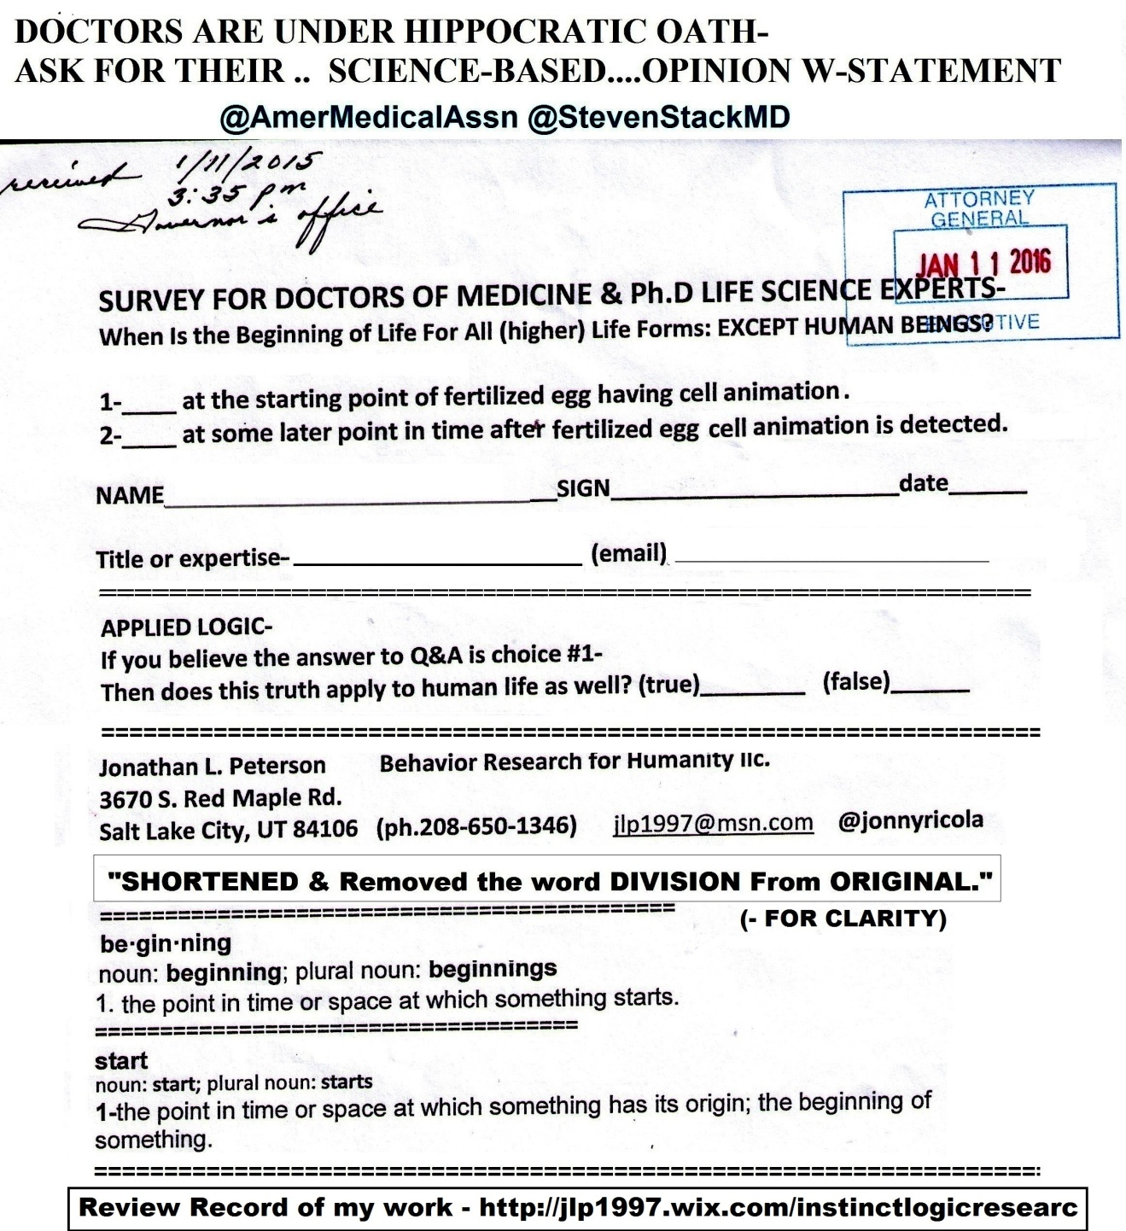
(W-PHOTO Gov. Herbert&REYES Survey for Doctors Jan. 11, 2016 & div.Remov DK PLAIN LViewsite)
===============================================
https://twitter.com/DeseretNews/status/735120690429333504 @DeseretNewsAre you willing to pay a fee to use trails in Big and Little Cottonwood canyons?http://www.deseretnews.com/article/865654884/Are-you-willing-to-pay-a-fee-to-use-trails-in-Big-and-Little-Cottonwood-canyons.html …

@DeseretNews One year ago today-I shared truth of reality with you & LDS leaders about our unlawful behavior & Satan-https://twitter.com/DeseretNews/status/602596215717371905 (proof of bribery & Satan demand an answer)
reply
@DeseretNews Rebuke Satan w-faith & use logic to end 6000 murders aday
in USA= ASK @NelsonRussellM & @LDSChurchNews
Gov. Herbert&REYES Survey for Doctors Jan. 11, 2016 & div.Remov DK nelsonLViewsite
reply
@DeseretNews @NelsonRussellM @LDSChurchNews IF YOU DON'T PUBLISH
_LEGAL PROOF STAYS HIDDEN.The blood of inocents onU
https://community.sumofus.org/petitions/ask-doctors-phd-life-science-experts-when-does-life-begin-survey?source=twitter-share-button
reply
@DeseretNews @NelsonRussellM @LDSChurchNews
DeseretNews-DO YOU HAVE THE RIGHT TO WITHHOLD PROOF OF CRIMES AGAINST US?
https://twitter.com/jonnyricola/status/730498543010516992 (@AlanDersh @DeseretNews Typical of my survey based proofs of true reality.Present evidence & a choice for Experts:))
reply
@DeseretNews @NelsonRussellM @LDSChurchNews Proofs of our crimes,
Satan revealed (from God comes the Truth)
RECORED =http://jlp1997.wix.com/instinctlogicresearc
reply
@DeseretNews @NelsonRussellM @LDSChurchNews
https://www.facebook.com/jonathan.peterson.1466/posts/1191429844224905
Legal argument-beyond reproach-(Expert testimony is admissible in court)
++++++
May 23, 2016
Happy birthday to me- I serve the Lord & oppose our instinct mechanism. HOW ABOUT U?
MY POSTS TO PRO-LIFE @PreciousLifeCo @glennbeck-(ARE BEING REMOVED AS FAST AS I PLACE THEM...
https://twitter.com/HH41848213/status/734942284605624320 (many under oath- have a record of obstruction now)
=================================================
https://twitter.com/prolifealliance/status/727774737779326977 @prolifeallianceSolidarity to @PreciousLifeCom inadvance of tomorrow's Stormont Elections: http://prolife.org.uk/2016/05/stormont-elections-message-northern-ireland-colleagues/ …

@prolifealliance @PreciousLifeCom DOCTORS NEED HELP
GIVING THEIR EXPERT TESTIMONY.Survey -should have been used 1973-https://community.sumofus.org/petitions/ask-doctors-phd-life-science-experts-when-does-life-begin-survey?source=facebook-share-button&time=1463337383
reply
@prolifealliance @PreciousLifeCom @glennbeck
YOU NEED TO TEST HOW POWERFUL THIS SURVEY IS. @RandPaul ON YOUR DOCTOR2
(W-photo Gov. Herbert&REYES Survey for Doctors Jan. 11, 2016 SHORT ORi W-HEADER & divisonRemovWVIEW RAND 7ways&Captions)
(W-photo Gov. Herbert&REYES Survey for Doctors Jan. 11, 2016 SHORT ORi W-HEADER & divisonRemovWVIEW AMA NSF 7ways&Captions)
(W-Photo Gov. Herbert&REYES Survey for Doctors Jan. 11, 2016 SHORT ORi W-HEADER & divisonRemovWVIEW USSG)
(W-Photo W-Photo DeseretNews Comment- ‘Bill intends to ban certain abortion procedures in Utah’ (2-26-2016) WIDEVIEW w-SUP URL)
reply
@prolifealliance @PreciousLifeCom @glennbeck @RandPaul I asked
@vivianleemd DEAN @UofUSofMedicine @UUtah SHE BLOCKED ME
(W-Photo Gov. Herbert&REYES Survey for Doctors Jan. 11, 2016 SHORT ORi W-HEADER & divisonRemovWVIEW VivianS.Lee 7ways
reply
@prolifealliance @PreciousLifeCom @glennbeck @RandPaul @UUtah
PLEASE ASK DEAN @vivianleemd @UofUMedicine TO BE 1ST=
W-Photo Gov. Herbert&REYES Survey for Doctors Jan. 11, 2016 SHORT ORi W-HEADER & divisonRemovWVIEW VivianS.Lee 7ways
reply
@prolifealliance @PreciousLifeCom @glennbeck @RandPaul @UUtah @vivianleemd @UofUMedicine
NoLOGICAL REASON-NOT2signIT-https://community.sumofus.org/petitions/ask-doctors-phd-life-science-experts-when-does-life-begin-survey?source=facebook-share-button&time=1463337383
==========================================
https://twitter.com/UofUofMedicine/status/727172538355183618 (earlier Post)
=============
DIRECT-
@prolifealliance @AP -DOCTORS NEED HELP- GIVING THEIR EXPERT TESTIMONY.The Survey that should have been used 1973-
https://community.sumofus.org/petitions/ask-doctors-phd-life-science-experts-when-does-life-begin-survey?source=facebook-share-button&time=1463337383
=================
https://twitter.com/jonnyricola/status/734927554797129729 (@PreciousLifeCo @glennbeck-DOCTORS NEED HELP
GIVING THEIR EXPERT TESTIMONYThe Survey that should have been used1973-https://community.sumofus.org/petitions/ask-doctors-phd-life-science-experts-when-does-life-begin-survey?source=facebook-share-)
https://twitter.com/PreciousLifeCom/status/727142497172992001 @PreciousLifeComAbortion kills an unborn child #ChooseLife #VoteProLife
@PreciousLifeCom @glennbeck DOCTORS NEED HELP
GIVING THEIR EXPERT TESTIMONY.Survey that should have been used 1973-https://community.sumofus.org/petitions/ask-doctors-phd-life-science-experts-when-does-life-begin-survey?source=facebook-share-button&time=1463337383
@PreciousLifeCo @glennbeck-DOCTORS NEED HELP
GIVING THEIR EXPERT TESTIMONY
The Survey that should have been used1973-https://community.sumofus.org/petitions/ask-doctors-phd-life-science-experts-when-does-life-begin-survey?source=facebook-share-button&time=1463337383
===========================
https://twitter.com/HH41848213/status/734942284605624320 @HH41848213@FoxNews @Judgenap @TheJusticeDept The legacy of Eric Holder and Obama. Shame on the American voters!
@HH41848213 @FoxNews @Judgenap @TheJusticeDept
FILED W-DOJ @CivilRights WE CAN PROSECUTE CORP. SHAREHOLDER BRIBERY-
(W-Photo LORETTA, Judge Napitano U BELIEVE IT SIGN IT SURVEY FOR CORP BRIBERY -EXPLAIN 2-26-2016 WView messURLSc
(W-Photo 46 U.S. DISTRICT COURT JUDGE Robert J. Shelby & WADDOUPS, Filed 11 page complaint 7-1-2015 DK)
(W-Photo CIVIL RIGHTS POST ON HUBER VIOLATING DUE PROCESS OCT 8,2015 w-LINK lg text WIDEVIEW & Loretta link)
(W-Photo FAX DOJ,Nuffer Complaint July 1, 2015 Pg 1 & ZION BANK in ID evidence&USsup)
reply
@HH41848213 @FoxNews @Judgenap @TheJusticeDept @CivilRights
NSA=EVIL
https://twitter.com/CivilRights/status/723180011084083200
https://twitter.com/jonnyricola/status/723555257804967936
(W-Photo TWITTER POSTS REMOVED CivilRights post on bribery May 16, 2016 POST GONE)
(W-Photo TWITTER POSTS REMOVED CIVILRIGHTS RI POSTING April 30, 2016 URLS p1)
(W-Photo TWITTER POSTS REMOVED CIVILRIGHTS RI POSTING April 30, 2016 URLS p2)
(W-Photo TWITTER POSTS REMOVED CIVILRIGHTS RI POSTING April 30, 2016 URLS p3)
reply
@HH41848213 @FoxNews @Judgenap @TheJusticeDept @CivilRights Lets ask USAG @LorettaLynch & Expert @AlanDersh 4truth- https://twitter.com/jonnyricola/status/730498543010516992 (@AlanDersh @DeseretNews Typical of my survey based proofs of true reality.Present evidence & a choice for Experts:))
reply
@HH41848213 @FoxNews @Judgenap @TheJusticeDept @CivilRights @LorettaLynch& @AlanDersh
YOU ARE UNDER OATH
ACT LIKE IT
(W-Photo LORETTA, DERSHOWITZ U BELIEVE IT SIGN IT SURVEY FOR CORP BRIBERY -EXPLAIN 2-26-2016 WView messURLS)
+++++++++++++++++++
https://twitter.com/CivilRights/status/723180011084083200
https://twitter.com/jonnyricola/status/723319661954134016
https://twitter.com/jonnyricola/status/723555257804967936

+++++++++++++
https://twitter.com/AP/status/734839162990436352 @AP VIDEO: Supporters of proposed NY ban on declawing cats say it's barbaric; opponents say it offers last resort:
@AP & 6000 lives taken is OK? I GOT NEWS 4 U- LIFE BEGINS@?
USE THIS SURVEY FOR DOCTORS&Experts:Ask @AmerMedicalAssn
https://community.sumofus.org/petitions/ask-doctors-phd-life-science-experts-when-does-life-begin-survey?source=twitter-share-button
reply
@AP @AmerMedicalAssn @NSF @RandPaul @NelsonRussellM
6000 LIVES TAKEN 2DAY
NOT CONSTITUTIONAL-ROEvsWADE=Based onA LIE
(W-photo Gov. Herbert&REYES Survey for Doctors Jan. 11, 2016 SHORT ORi W-HEADER & divisonRemovWVIEW RAND 7ways&Captions)
(W-photo Gov. Herbert&REYES Survey for Doctors Jan. 11, 2016 SHORT ORi W-HEADER & divisonRemovWVIEW AMA NSF 7ways&Captions)
(W-photo Gov. Herbert&REYES Survey for Doctors Jan. 11, 2016 SHORT ORi W-HEADER & divisonRemovWVIEW NELSON 7ways)Cap
(W-Photo DeseretNews comment 20 athletes who are vocal about their faith (4-21-2016) WVIEWmessURL DK)
reply
@AP @AmerMedicalAssn @NSF @RandPaul @NelsonRussellM
Defend Constitutional Rights for All or Status Quo & BURNinHELL-
https://community.sumofus.org/petitions/ask-doctors-phd-life-science-experts-when-does-life-begin-survey?source=facebook-share-button&time=1463337383
reply
@AP @AmerMedicalAssn @NSF @RandPaul @NelsonRussellM
WHY @LDSchurch DIDN'T MAKEaSURVEY TO DEFINE SCI-TRUTHS?
INSTINCT
http://jlp1997.wix.com/instinctlogicresearc

@Tarascan68 [replies to my messages)
@jonnyricola @AP @AmerMedicalAssn @NSF @RandPaul @NelsonRussellM dude you have mental issues
reply
@Tarascan68 @AP @AmerMedicalAssn @NSF @RandPaul @NelsonRussellM Like killing an alive human being - because you want too?
& that's unlawful?
reply
@Tarascan68 @AP @AmerMedicalAssn @NSF @RandPaul @NelsonRussellM 5 surveys to prove I'm not deceived YOU ARE=REALITY
(W-photo 43B U.S. DISTRICT COURT Chief Judge David Nuffer , Filed 11 page complaint 7-1-2015 w-JUDGE info & PAGE 3 DRUG )
(W-photo Gov. Herbert&REYES Survey for Doctors Jan. 11, 2016 SHORT ORi W-HEADER & divisonRemovWVIEW AMA 7ways)Cap
(W-Photo DR. NEIL PhD EXPERTS SCI-SURVEY ON INSTINCT w-deprog 3-14-2016 PAINTED TEXT w-PBSbrainURL & )
(W-Photo DeseretNews comments 15 LDS general authorities & B of Mormon heroes 1-8-2016 WVIEW w- SKULL -DN-URL& faithURL)
+++++++++
=============
DIRECT- @DeseretNews Ea_day you don't publish this Survey for Doctors&Experts=
6000 more dead babies on you soul& @LDSchurch https://community.sumofus.org/petitions/ask-doctors-phd-life-science-experts-when-does-life-begin-survey?source=twitter-share-button
===================
May 22, 2016
DO YOU WANT TO HAVE A NATION UNDER GOD WITH LIBERTY & JUSTICE FOR ALL?
Then you must oppose our unlawful status quo.. Bribery, Drug Monopoly & denying due process to our unborn..............IS UNCONSTITUTIONAL BEHAVIORS....
https://twitter.com/jonnyricola & https://twitter.com/jonnyricola/with_replies
===============================================
DIRECT- @DeseretNews You decided.You won't pin the story, ask a doctor, our @NelsonRussellM or @LDSchurch REAP WHAT YOU SOW-https://twitter.com/jonnyricola/status/734483576494821376 (@DeseretNews @LDSchurch @LDSChurchNews @ThomasSMonson @EyringHB @UchtdorfDF @NelsonRussellM GOD'S WRATH IF YOU DON'T)
==================================
https://twitter.com/DeseretNews/status/734501019304873984 A family's faith and a mother's legacy shines through The Emily Effect | http://www.deseretnews.com/article/865654819/A-familys-faith-and-a-mothers-legacy-shines-through-The-Emily-Effect.html …

@DeseretNews You decided.You won't pin the story, ask a doctor, our @NelsonRussellM or @LDSchurch REAP WHAT YOU SOW-https://twitter.com/jonnyricola/status/734483576494821376 (@DeseretNews @LDSchurch @LDSChurchNews @ThomasSMonson @EyringHB @UchtdorfDF @NelsonRussellM GOD'S WRATH IF YOU DON'T)
reply
@DeseretNews @NelsonRussellM @LDSchurch Your children will go hungry, your money will be of no worth.
ALL BECAUSE YOU WOULD NOT OPPOSE SATAN
================================
direct from my twitter site- https://twitter.com/jonnyricola/status/734492165724770304
YOU& @DeseretNews SERVE GOD & UNBORN
ABOUT TO BE MURDERED=ASK
Pin this story?Until WE get an answer from @LDSChurch?
https://twitter.com/jonnyricola/status/734483576494821376 (@DeseretNews @LDSchurch @LDSChurchNews @ThomasSMonson @EyringHB @UchtdorfDF @NelsonRussellM GOD'S WRATH IF YOU DON'T)
==============
https://twitter.com/jonnyricola/status/734490162282037248
DIRECT- @DeseretNews IF YOU SERVE GOD & UNBORN ABOUT TO BE MURDERED=
Pin this story? Until WE get an answer from @LDSChurch?
https://twitter.com/jonnyricola/status/734483576494821376 (@DeseretNews @LDSchurch @LDSChurchNews @ThomasSMonson @EyringHB @UchtdorfDF @NelsonRussellM GOD'S WRATH IF YOU DON'T)
==================================
https://twitter.com/DeseretNews/status/734484025117532160 @DeseretNewsMotherhood Matters: 6 easy ways to teach children the importance of Memorial Day

@DeseretNews IF YOU SERVE GOD & UNBORN ABOUT TO BE MURDERED. Pin this story until WE get an answer from @LDSchurch
https://twitter.com/jonnyricola/status/734483576494821376 @DeseretNews @LDSchurch @LDSChurchNews @ThomasSMonson @EyringHB @UchtdorfDF @NelsonRussellM GOD'S WRATH IF YOU DON'T
===========
https://twitter.com/jonnyricola/status/734483576494821376 @DeseretNews @LDSchurch @LDSChurchNews @ThomasSMonson @EyringHB @UchtdorfDF @NelsonRussellM GOD'S WRATH IF YOU DON'T
https://twitter.com/DeseretNews/status/734478974831595520 @DeseretNewsExpect a summer surge of missionarieshttp://www.deseretnews.com/article/865654611/Expect-a-summer-surge-of-missionaries.html …

@DeseretNews @LDSchurch @LDSChurchNews @ThomasSMonson @EyringHB @UchtdorfDF @NelsonRussellM RUBUKE SATAN By Example- https://community.sumofus.org/petitions/ask-doctors-phd-life-science-experts-when-does-life-begin-survey?source=twitter-share-button
reply
@DeseretNews @LDSchurch @LDSChurchNews @ThomasSMonson @EyringHB @UchtdorfDF @NelsonRussellM 6000 killed Aday.Sign IT
(W-photo Gov. Herbert&REYES Survey for Doctors Jan. 11, 2016 SHORT ORi W-HEADER & divisonRemovWVIEW NELSON 7ways)Cap
reply
@DeseretNews @LDSchurch @LDSChurchNews @ThomasSMonson @EyringHB @UchtdorfDF @NelsonRussellM GOD'S WRATH IF YOU DON'T
Gov. Herbert&REYES Survey for Doctors Jan. 11, 2016 & div.Remov DK nelsonLViewsite
reply
@DeseretNews @LDSchurch @LDSChurchNews @ThomasSMonson
@EyringHB @UchtdorfDF @NelsonRussellM DO NOT BE DECEIVED- IT IS GOOD TO FEAR GOD. ctr
reply
@DeseretNews @LDSchurch @LDSChurchNews @ThomasSMonson @EyringHB @UchtdorfDF @NelsonRussellM Members Right To Call Leaders To REPENT I DO YOU
reply
@DeseretNews @LDSchurch @LDSChurchNews @ThomasSMonson @EyringHB @UchtdorfDF @NelsonRussellM Pres. Monson - IF I'M LIAR SERVING SATAN- SAY SO
==================================
https://twitter.com/DeseretNews/status/734463869666529280 @DeseretNewsIn our opinion: Finding – not forcing – a balance for transgender rightshttp://www.deseretnews.com/article/865654792/Finding-1-not-forcing-1-a-balance-for-transgender-rights.html

@DeseretNews I agree, put equality as our highest principle, but protect everyone's rights the very best we can. using facts & logic for law
reply
@DeseretNews KNOW THIS-my rights to defend the unborn are being violated by the @NSAGov Survey for Doctors REMOVED-
https://twitter.com/jonnyricola/status/734465516274749441 (@glennbeck LINKS WORK @NSF No Logical Reason Not To Use This SCI-BASED SURVEY FOR DOCTORS & EXPERTS=@AmerMedicalAssn)
reply
@DeseretNews @NSAGov @AP TEST-LINKS WORK-
https://twitter.com/CivilRights/status/723180011084083200 https://twitter.com/jonnyricola/status/723555257804967936 https://twitter.com/glennbeck/status/733722760015446017
https://twitter.com/jonnyricola/status/733724399451275264
reply
@DeseretNews @NSAGov @AP I'm not blocked from posting on @glennbeck /
@CivilRights I DEMAND A PUBLIC APOLOGY&RESTORE
(W-photo GLEN BECK TWEETS REMOVED. DEFENDING OUR UNBORN WVIEW URLSpart1mess)
(W-photo GLEN BECK TWEETS REMOVED. DEFENDING OUR UNBORN WVIEW URLSpart2
(W-Photo TWITTER POSTS REMOVED CIVILRIGHTS RI POSTING April 30, 2016 URLS p1
(W-Photo TWITTER POSTS REMOVED CivilRights post on bribery May 16, 2016 POST GONE
reply
@DeseretNews @NSAGov @AP @glennbeck @CivilRights I'll sign a waiver /
I won't sue them. WE MUST BEHAVE AS CITIZENS -
https://community.sumofus.org/petitions/ask-doctors-phd-life-science-experts-when-does-life-begin-survey?source=twitter-share-button
========
@DeseretNews something terrible is being done.My posts to ask Doctor's Opinion on Beginning of Life is being removed-https://twitter.com/jonnyricola/status/734465516274749441
=======================================
@DeseretNews KNOW THIS-my rights to defend the unborn are being violated by the @NSAGov Survey for Doctors REMOVED-
reply
@DeseretNews @NSAGov @AP TEST-LINKS WORK-
https://twitter.com/CivilRights/status/723180011084083200
https://twitter.com/jonnyricola/status/723555257804967936
https://twitter.com/glennbeck/status/733722760015446017
https://twitter.com/jonnyricola/status/733724399451275264
=================
DIRECT FROM MY TWITTER SITE- https://twitter.com/jonnyricola/status/734453097431478272
Why @glennbeck DID THE NSA REMOVEmyPOSTS
https://twitter.com/glennbeck/status/733722760015446017
https://twitter.com/jonnyricola/status/733724399451275264
https://twitter.com/jonnyricola/status/733725052408107008
https://twitter.com/jonnyricola/status/733727266912395264
========
DIRECT- @glennbeck WHERE ARE MY POSTS?NSAremoved
https://twitter.com/glennbeck/status/733722760015446017
https://twitter.com/jonnyricola/status/733724399451275264
https://twitter.com/jonnyricola/status/733725052408107008
https://twitter.com/jonnyricola/status/733727266912395264
=====
https://twitter.com/jonnyricola/status/734465516274749441
POSTED TO https://twitter.com/glennbeck/status/733722760015446017
(((SAME STORY THAT POSTS WERE REMOVED FROM )
@glennbeck WHERE ARE MY POSTS?NSAremoved
https://twitter.com/glennbeck/status/733722760015446017
https://twitter.com/jonnyricola/status/733724399451275264
https://twitter.com/jonnyricola/status/733725052408107008
https://twitter.com/jonnyricola/status/733727266912395264
( SAYS ALL MY LINK IS UNAVAILABLE- IT WORKS JUST FINE........EXCEPT IT DOESN'T SHOW THE ASSOCIATED POSTS ))
reply
@glennbeck LINKS WORK @NSF No Logical Reason Not To Use This SCI-BASED SURVEY FOR DOCTORS & EXPERTS=@AmerMedicalAssn
https://community.sumofus.org/petitions/ask-doctors-phd-life-science-experts-when-does-life-begin-survey?source=twitter-share-button
=====
================
https://twitter.com/jonnyricola/status/734474869795082240 (@RepRichHudson @USArmy @RepChrisStewart @CivilRights @POTUS @LorettaLynch @USSupremeCourt SURVEY TO END 64milMurders- PETITION LINK)
https://twitter.com/RepRichHudson/status/733986466129424388 @RepRichHudsonTo all of our veterans, service members & military families, thank you for the sacrifices you make! #ArmedForcesDay

@RepRichHudson Under Military Oath-UNDER OATH FOR LIFE.
Defend our Constitution-PROOFS ARE FILEDask-@RepChrisStewart https://twitter.com/jonnyricola/status/734413486424522752
https://twitter.com/jonnyricola/status/734413486424522752 (YOU ARE UNDER OATH OF
OFFICE.@RepChrisStewart You Must Ask Experts When Does Life Begin=DUTY2GOD)
reply
@RepRichHudson @RepChrisStewart Simple YOU NOW HAVE PROOF.
@LorettaLynch DEFYS CONSTITUTIONAL DEMANDS of DUE PROCESS-
https://twitter.com/jonnyricola/status/685209659938975744
( SUPPORTING EVIDENCE -https://twitter.com/CivilRights/status/676820650825269248
reply
@RepRichHudson @RepChrisStewart @LorettaLynch THIS @CivilRights IS A MONITORED SITE. I also faxed proofs=DOJ J.HUBER-
https://twitter.com/jonnyricola/status/685209659938975744
( SUPPORTING EVIDENCE -https://twitter.com/CivilRights/status/676820650825269248
reply
@RepRichHudson @USArmy ASK THESE Under Oath @RepChrisStewart @LorettaLynch @CivilRights @POTUS-Defend US from Evil*
(W-Photo Lynch,Stewart,OBAMA W-NUFFER DOC -are the controlled sub 6-4-2015 NOTARIZED WIDEVIEW w-YEA orNAE w sq & CTstamped
(W-Photo LORETTA, Rep. Stewart & Pres. Obama U BELIEVE IT SIGN IT SURVEY FOR CORP BRIBERY -EXPLAIN 2-26-2016 WView messURLSc
(W-Photo CIVIL RIGHTS POST ON HUBER VIOLATING DUE PROCESS OCT 8,2015 w-LINK lg text WIDEVIEW & Loretta link)
(W-Photo FAX DOJ,Nuffer Complaint July 1, 2015 Pg 1 & ZION BANK in ID evidence&USsup)
reply
@RepRichHudson @USArmy @RepChrisStewart @CivilRights ?@POTUS
?@LorettaLynch ?@USSupremeCourt https://twitter.com/USSupremeCourt/status/691657424634191875
https://twitter.com/jonnyricola/status/691735612257251328
reply
@RepRichHudson @USArmy @RepChrisStewart @CivilRights @POTUS @LorettaLynch @USSupremeCourt
I record Posts4US Citizens http://jlp1997.wix.com/instinctlogicresearc
reply
@RepRichHudson @USArmy @RepChrisStewart @CivilRights @POTUS @LorettaLynch @USSupremeCourt VIOLATE OATH&DUTYw-SILENCE
(W-Photo Gary Johnson & me & survey on Bribery April 6-2016 slc,ut 1000x650 w-huber&gary obstruct & DRUG LAW)
(w-photo Rep.Jason Chaffetz & jlp w-Prison stories papaer cropped July 20,2015 W-titles & SURVEY&jlpWsign)
(W-Photo U.S. Rep. MIA LOVE & me #2 at townmeeting 8-26-2015 cropped w titles 1000x800 & HER SURVEY)
(W-Photo 54 Jonathan Johnson for governor rally & JLP 9-15-2015 CROPPED even more 2x W SURVEY 1600 W-TEXT REMINDER
rely
@RepRichHudson @USArmy @RepChrisStewart @CivilRights @POTUS @LorettaLynch @USSupremeCourt Posts 2 ask DoctorsREMOVED-https://twitter.com/jonnyricola/status/734465516274749441
reply
@RepRichHudson @USArmy @RepChrisStewart @CivilRights @POTUS @LorettaLynch @USSupremeCourt
SURVEY TO END 64milMurders-
https://community.sumofus.org/petitions/ask-doctors-phd-life-science-experts-when-does-life-begin-survey?source=twitter-share-button
============================================================
https://twitter.com/jonnyricola/status/734413486424522752 (YOU ARE UNDER OATH OF
OFFICE.@RepChrisStewart You Must Ask Experts When Does Life Begin=DUTY2GOD)
https://twitter.com/jonnyricola/status/734408255997235200 @ABC4Glen @RepChrisStewart @abc4utah YOU WANT TO SAVE LIVES?Oppose W-SCI-LOGIC. the end of 6000 Lives Taken Ea. Day-
https://twitter.com/ABC4Glen/status/733801030077407232 @ABC4Glen#Utah @RepChrisStewart and congressional colleagues address opioid overdose epidemic. #utpol @abc4utah http://www.good4utah.com/news/top-stories/representative-chris-stewart-and-colleagues-address-opioid-overdose-epidemic
@ABC4Glen @abc4utah @ABC @glennbeck
CONFIRM & ACTION= OR TREASON=@RepChrisStewart
recorded@= http://jlp1997.wix.com/instinctlogicresearc
https://twitter.com/jonnyricola/status/734413486424522752 (YOU ARE UNDER OATH OF
OFFICE.@RepChrisStewart You Must Ask Experts When Does Life Begin=DUTY2GOD)
@ABC4Glen @RepChrisStewart @abc4utah 2Lower the overdose of legal & illegal PainRelief drugs.INCLUDE POT-as A Choice
(W-photo DeseretNews Comments ‘Fatal car crashes involving marijuana up in Utah’ (5-11-2016)WView- wURL&pharma)
(W-photo 52 DeseretNews Comments ‘House opts not to vote on medical marijuana bill’ (3-11-2016) SUPREME)
(W-photo DeseretNews Comments ‘One medical marijuana bill set to advance, another hangs in the balance’ (2-20-2016) U)
(W-photo 53 DeseretNews Comments ‘Medical association withdraws support for medical cannabis bill’ (3-10-2016)
reply
@ABC4Glen @RepChrisStewart @abc4utah YOU WANT TO SAVE LIVES? Oppose W-SCI-LOGIC. the end of 6000 Lives Taken Ea. Day-
https://community.sumofus.org/petitions/ask-doctors-phd-life-science-experts-when-does-life-begin-survey?source=twitter-share-button
reply
@ABC4Glen @RepChrisStewart @abc4utah You Have The Means To End Our Most Horrible(LAW/Behavior Within Our Society_CTR
(W-Photo DeseretNews comment 20 athletes who are vocal about their faith (4-21-2016) WVIEWmessURL DK)
(W-photo Gov. Herbert&REYES Survey for Doctors Jan. 11, 2016 SHORT ORi W-HEADER & divisonRemovWVIEW NELSON 7ways)Cap
(W-photo Gov. Herbert&REYES Survey for Doctors Jan. 11, 2016 SHORT ORi W-HEADER & divisonRemovWVIEW AMA NSF 7ways&Captions)
(W-photo Gov. Herbert&REYES Survey for Doctors Jan. 11, 2016 SHORT ORi W-HEADER & divisonRemovWVIEW AMA 7ways)Cap
(W-Photo DeseretNews comments 15 LDS general authorities & B of Mormon heroes 1-8-2016 WVIEW w- SKULL -DN-URL& faithURL)
reply
@ABC4Glen @abc4utah YOU ARE UNDER OATH OF
OFFICE.@RepChrisStewart You Must Ask Experts When Does Life Begin=DUTY2GOD
(W-Photo Gov. Herbert&REYES Survey for Doctors Jan. 11, 2016 SHORT ORi W-HEADER & divisonRemovWVIEW VivianS.Lee UU) (W-photo
(W-Photo Gov. Herbert&REYES Survey for Doctors Jan. 11, 2016 SHORT ORi W-HEADER & divisonRemovWVIEW USSG)
(W-photo Gov. Herbert&REYES Survey for Doctors Jan. 11, 2016 SHORT ORi W-HEADER & divisonRemovWVIEW AMA 7ways)Cap
(W-Photo W-Photo DeseretNews Comment- ‘Bill intends to ban certain abortion procedures in Utah’ (2-26-2016) WIDEVIEW w-SUP URL)
reply
@ABC4Glen @abc4utah @RepChrisStewart UNDERSTAND- Good vs. Evil/Satan. NSA blocksME:DEFEND MY RIGHT TO ASK @glennbeck
(W-photo GLEN BECK TWEETS REMOVED. DEFENDING OUR UNBORN WVIEW URLSpart1mess
(W-photo GLEN BECK TWEETS REMOVED. DEFENDING OUR UNBORN WVIEW URLSpart2mess
(W-photo GLENN BECK for the love of God-U BELIEVE IT SIGN IT SURVEY FOR CORP BRIBERY -EXPLAIN 2-26-2016 WView messURLSc)
(W-photo GLENN BECK & LORETTA-NUFFER DOC w-REYES-control sub 6-4-2015 NOTARIZED WVIEW w-YEA orNAE w sq & CTstamped
reply
@ABC4Glen @ABC @RepChrisStewart @glennbeck *
https://twitter.com/CivilRights/status/723180011084083200
https://twitter.com/jonnyricola/status/723555257804967936 https://twitter.com/jonnyricola/status/733724399451275264
(W-Photo TWITTER POSTS REMOVED CIVILRIGHTS RI POSTING April 30, 2016 URLS p1
(W-Photo TWITTER POSTS REMOVED CivilRights post on bribery May 16, 2016 POST GONE
(W-photo GLEN BECK TWEETS REMOVED. DEFENDING OUR UNBORN WVIEW URLSpart1mess)
(W-Photo TWITTER POSTS REMOVED CIVILRIGHTS RI POSTING April 30, 2016 URLS p3
reply
@ABC4Glen @ABC @RepChrisStewart @glennbeck EITHER STAND WITH ME &
DEFEND OUR CONSTITUTION OR BE RESPONSIBILE FOR
GREAT SUFFERING HERE IN USA
reply

========
May 21, 2016 MOST OF MY TWEETS HAVE BEEN RESTORED- BUT NONE TO GLEN BECK ON SURVEY FOR DOCTORS, DRUG LAW OR CORP. BRIBERY PROOF.
======
https://twitter.com/RNS/status/701798706056548359 Religion NewsService Verified account @RNS What religion news did you miss this weekend? Sign up to get #Slingshot in your inbox, and we'll catch you up! 📧
@RNS A gift from God. How to end Abortion on Demand-
Use a Sci-Survey for Doctors & Experts:They know truth ASK THEM- https://community.sumofus.org/petitions/ask-doctors-phd-life-science-experts-when-does-life-begin-survey?source=twitter-share-button
========================
DIRECT- @RNS @DeseretNews A gift from God.End Abortion on Demand
A Sci-Survey for Doctors & Experts:They know truth ASK THEM- https://community.sumofus.org/petitions/ask-doctors-phd-life-science-experts-when-does-life-begin-survey?source=twitter-share-button
=================================
DIRECT- @twitter @glenbeck @AP 1 Question: did @Support do this or the NSA??
https://twitter.com/glennbeck/status/733722760015446017
https://twitter.com/jonnyricola/status/733724399451275264
(W-photo GLEN BECK TWEETS REMOVED. DEFENDING OUR UNBORN WVIEW URLSpart1mess
(W-photo GLEN BECK TWEETS REMOVED. DEFENDING OUR UNBORN WVIEW URLSpart2mess
(W-photo Gov. Herbert&REYES Survey for Doctors Jan. 11, 2016 SHORT ORi W-HEADER & divisonRemovWVIEW NELSON 7ways)Cap
(W-photo Gov. Herbert&REYES Survey for Doctors Jan. 11, 2016 SHORT ORi W-HEADER & divisonRemovWVIEW AMA NSF 7ways)Cap
==========
https://twitter.com/DeseretNews/status/734031033989890048 @DeseretNewsReligious freedom is good for business, Elder Christofferson sayshttp://www.deseretnews.com/article/865654755/Religious-freedom-is-good-for-business-Elder-Christofferson-says-so-all-have-a-stake-in-it.html
@DeseretNews @glennbeck My religious freedom is being blocked by NSA-
https://twitter.com/glennbeck/status/733722760015446017
https://twitter.com/jonnyricola/status/733724399451275264
(W-photo GLEN BECK TWEETS REMOVED. DEFENDING OUR UNBORN WVIEW URLSpart1mess
(W-photo GLEN BECK TWEETS REMOVED. DEFENDING OUR UNBORN WVIEW URLSpart2mess
(W-photo Gov. Herbert&REYES Survey for Doctors Jan. 11, 2016 SHORT ORi W-HEADER & divisonRemovWVIEW NELSON 7ways)
(W-photo Gov. Herbert&REYES Survey for Doctors Jan. 11, 2016 SHORT ORi W-HEADER & divisonRemovWVIEW AMA NSF 7ways)
reply
@DeseretNews @glennbeck THIS SCIENCE SURVEY FOR DOCTORS.
PROVES BEYOND ANY REASONABLE DOUBT-
LIFE BEGINS @ BEGINNING-https://community.sumofus.org/petitions/ask-doctors-phd-life-science-experts-when-does-life-begin-survey?source=twitter-share-button
reply
@DeseretNews @glennbeck newest twitter post.being blocked by NSA again today
DEFENDmyRIGHTS
https://twitter.com/glennbeck/status/733751716756217857
https://twitter.com/jonnyricola/status/734047171889135617
reply
@DeseretNews @glennbeck NSA removed this post as well
on Corp. Bribery & Drug Monopoly-CTR ?
https://twitter.com/glennbeck/status/733716457289338880
https://twitter.com/jonnyricola/status/733722889506148353

May 20,2016
ALL MY TWEETS 13,500 HAVE JUST BEEN REMOVED FROM PUBLIC VIEW.
not by twitter.
test LINKS. (I defend our Constituiton. with truth)
https://twitter.com/jonnyricola/status/733725052408107008 @glennbeck @NSF & Glen-help Save 6000 lives taken ea. day in the USA.IT ISN'T LAWFUL. WE CAN PROVE IT WITH SCIENCE
GO ON HAVE A LOOK AT THE STORY BY GLEN BECK.
https://twitter.com/glennbeck/status/733722760015446017
(MANY OTHER TWITTER POSTS CAN BE SEEN BELOW THE PHOTOS BELOW.)

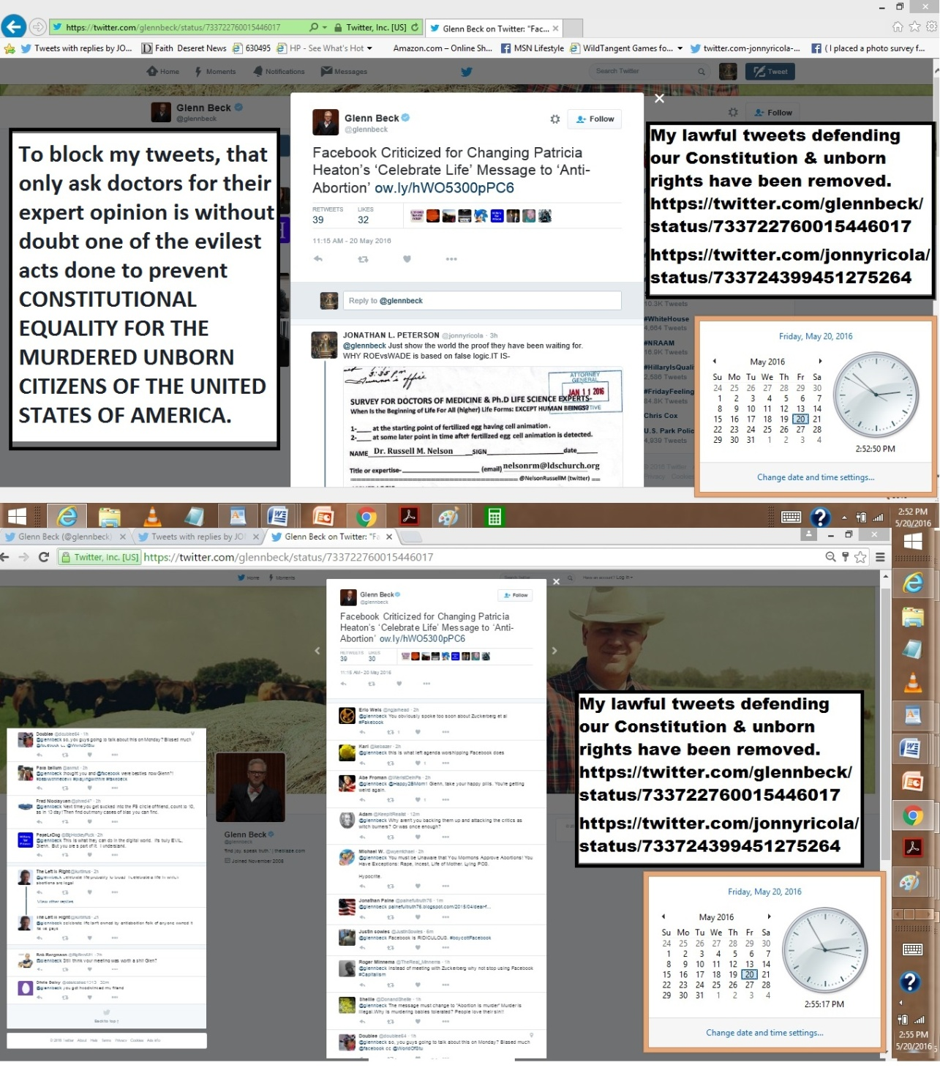
May 19, 2016
I am back on JonathanJohnson for Gov. site. HE KNOWS/BEING an Officer of the Court-
he can't lawfully remain silent with proof of crimes against citizenship. TESTmyLOGIC.
https://twitter.com/jonnyricola/status/733419785535422465
DIRECT- ((( JJ & GLEN BECK ARE VOCAL LDS MEMBERS)))
@JJohnsonNow @glennbeck Our Sins against Others R terrible
COMPARE 2 SILENCE-KNOWING SURVEY WOULD END MURDERS=BnHELL
https://twitter.com/jonnyricola/status/733416331727364097
(@JJohnsonNow @glennbeck YOU MUST ASK DOCTORS THIS QUESTION.SERVE GOD -OR BURN IN HELL MY BROTHERS. 6000 LIVES ADAY.)
reply
@JJohnsonNow @glennbeck Confront your sub-conscience/Satan
& serve God DEMAND @ldschurch COURT FOR ME? @DeseretNews?
(W-photo DeseretNews Comments ‘Music and the Spoken Word- What is true greatness’ (5-14-2016)URLmessURLsiteMustDEMANDdk)
===============
DIRECT FROM MY TWITTER SITE TO THE WORLD-
https://twitter.com/jonnyricola/status/733435408428605440
I'm a member @LDSchurch @DeseretNews Given-NoTrespass Order for my Revelation on Satan:
2yr7months W-OUTaChurch Court
(W-Photo DeseretNews Comments ‘Music and the Spoken Word- What is true greatness’ (5-14-2016)URLmessURLsiteMustDEMANDdk)
===========================
W
https://twitter.com/jonnyricola/status/733429370342121472 (@JJohnsonNow @glennbeck Confront your subconscience/Satan & serve God DEMAND CHURCH COURT4ME @DeseretNews @ldschurch Photo of saying I am a Prophet of God)
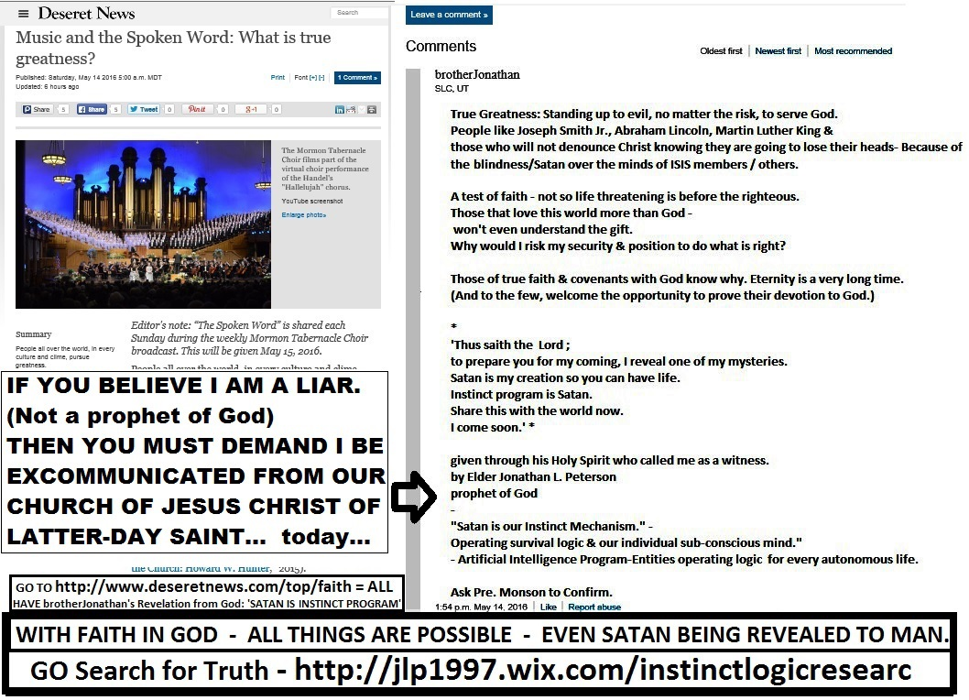
-----------
https://twitter.com/DisruptUPradio/status/733373973845676032 (RETWEETED BY JJ)
@DisruptUPradio At 4:30pm @JJohnsonNow discuss Common Core, fundraising & 5 questions JJ would ask before signing any bill

@DisruptUPradio @JJohnsonNow You really going to ignore your responsibility to LEAD.
Whether you are Governor or not?
https://twitter.com/jonnyricola/status/733346256999747585 (https://twitter.com/JJohnsonNow/status/732790469558702084 @JJohnsonNow @FrugalDougall Honor your Oath of Office (you are an officer of the Court) & your LDS Covenants to God=) Photo of JJ&ME& SURVEY)
reply
@DisruptUPradio @AP @JJohnsonNow& @GovHerbert HAVE KNOWLEDGE
OF BRIBERY CRIMES AGAINST CITIZENS_ W-PROOF=SPEAK= DUTY
(W-Photo DeseretNews Comments ‘GOP primary in governor's race now focused on money’ (5-1-2016) Wview)
(W-Photo 54 Jonathan Johnson for governor rally & JLP 9-15-2015 CROPPED even more 2x W SURVEY 1600 W-TEXT REMINDER)
(W-Photo DeseretNews Comments ‘Gov. Gary Herbert says 'tone' of fundraising will change amid criticism’ (5-17-2016)
(W-Photo Jonathan Johnson & Gov. Gary Herbert-U BELIEVE IT SIGN IT SURVEY FOR CORP BRIBERY -EXPLAIN SIGN 4-1-2016)
reply
@DisruptUPradio @AP @JJohnsonNow @GovHerbert YOU KNOW THIS PROOF IS FILED W-DOJ @CivilRights @LorettaLynch UAG REYES
(W-Photo CIVIL RIGHTS POST ON HUBER VIOLATING DUE PROCESS OCT 8,2015 w-LINK lg text WIDEVIEW & Loretta link)
(W-Photo US DISTRIC COURT Judge Nuffer Complaint July 1, 2015 11pg Lrez PAGE 1 & ZION BANK in ID evidence & SUPREME URL& Loretta)
(W-Photo 46 U.S. DISTRICT COURT JUDGE Robert J. Shelby & WADDOUPS, Filed 11 page complaint 7-1-2015 DK)
(W-Photo USHuber,USLynch& Reyes -U SIGN IT SURVEY CORP BRIBERY -EXPLAIN 2-26-2016 W-SUBVERT WIDEVIEW loretta tell them
reply
@DisruptUPradio @AP @JJohnsonNow @GovHerbert @CivilRights @LorettaLynch
IF YOU DON'T ASK Dr.s=RESPONSIBLE 6K EA. DAY-
https://community.sumofus.org/petitions/ask-doctors-phd-life-science-experts-when-does-life-begin-survey?source=twitter-share-button
May 18, 2016
Go see my work of today with Sen.Hatch, Lee, USAG, AMA,LDS CHURCH & THE POPE.
no signatures on my petition to ask scientists what is the truth about when life begins.
May 17, 2016 (happy birthday Bonnie, my sister)
There are more below the Photos. But the call to LDS LEADERSHIP TO CONFIRM
REVELATION OR EXCOMMUNICATE ME IS CLEAR... THEY MUST DO ONE OR THE OTHER.
(they @BYUSpeeches Now block further posts... they are going to have to repent, or hell to pay. now or later)
https://twitter.com/jonnyricola/status/732658525646675969 @BYUSpeeches @DeseretNews @ThomasSMonson @EyringHB @UchtdorfDF @NelsonRussellM @LDSchurch YOU HOLD THE KEYSSPEAK UP
https://twitter.com/jonnyricola/status/732654377337376768 (@BYUSpeeches Ask @DeseretNews @ThomasSMonson @EyringHB @UchtdorfDF @NelsonRussellM @LDSchurch CONFIRM or DENYasTRUTH)
https://twitter.com/jonnyricola/status/732661102878691328 @BYUSpeeches How DoYou rate my speech/Revelation?DO YOU BELIEVE? @LDSchurch?@DeseretNews?@ThomasSMonson?@byumagazine? https://twitter.com/jonnyricola/status/732658525646675969
https://twitter.com/BYUSpeeches/status/732627554121613312 @BYUSpeechesYou are the hammer. Look for the right nails. How do your particular talents contribute to the world? #byudevo
=========
https://twitter.com/USSupremeCourt/status/732223384965120001 @USSupremeCourtUNITED STUDENT AID FUNDS, INC. v. BIBLE. Decided 05/16/2016 http://j.mp/255VQuA
@USSupremeCourt Declaring treason & such without documented proof is
hearsay. How to Document proofs- @LorettaLynch https://twitter.com/jonnyricola/status/685209659938975744
(@CivilRights @LorettaLynch @USSupremeCourt @RandPaul @JJohnsonNow @latimes @nytimes @seanreyesag SUPPORTING EVIDENCE)
reply
@USSupremeCourt @LorettaLynch You Justices- Know exactly what my proofs mean to US LAW-use them or Violate Oath&DUTY
(3 Photos of proof surveys for Supreme Ct on Bribery, Drug monopoly, fax complaint to DOJ Huber, & science survey for USSurgeon Gen.)
===
May 16, 2016- the battle against instinct moves forward:
sometimes inches sometimes miles (many more posts- but this is an example)
https://twitter.com/heraldextra/status/732359183438217219
@heraldextra business as usual? You're no better than the bribery experts You defend with silence.Shame/Disgrace/YOU- https://twitter.com/jonnyricola/status/732349417122996226
(@heraldextra @DeseretNews Is bribery is actually wrong? Try asking @GovHerbert @JJohnsonNow BOTH ARE UNDER OATH=DUTY) GOP PHOTO OF DNews proofBribery)
https://twitter.com/saltlakechamber/status/732322297218879488 (retweeted by Rep.Romero)
@saltlakechamber @AngelaRomeroH26 If you can't ask this question
You violate your oath to the people of Utah&the USA (W-Photo DeseretNews Comments ‘GOP primary in governor's race now focused on money’ (5-1-2016) Wview)
https://twitter.com/jonnyricola/status/732371709005729792
@LorettaLynch @joerogan @AP @DeseretNews @GovGaryJohnson @realDonaldTrump @HillaryClinton @POTUS Try to sign it L.L.
https://twitter.com/jonnyricola/status/723555257804967936 (@CivilRights @DUTnews @LorettaLynch YOUR PROOF OF INTENT TO COMMIT BRIBERY BY CORP. USING SHAREHOLDER $ =DUE PROCESS)
https://twitter.com/LorettaLynch/status/732238360929021952 @LorettaLynchAG Loretta Lynch Retweeted Justice DepartmentGrateful for the courage, sacrifice & heroism of the #MedalofValor recipients. Thank you all for your service.
@LorettaLynch @joerogan @AP @DeseretNews
@GovGaryJohnson @realDonaldTrump @HillaryClinton @POTUS
PROOF ofOBSTRUCTION https://twitter.com/jonnyricola/status/732336696059002881 (@TyDubreuil @joerogan CENSORSHIP? My Constitutional Proofs from DOJ- https://twitter.com/CivilRights/status/723180011084083200 https://twitter.com/jonnyricola/status/723319661954134016
https://twitter.com/CivilRights/status/723180011084083200
https://twitter.com/jonnyricola/status/723555257804967936
)
reply
@LorettaLynch @joerogan @AP @DeseretNews @GovGaryJohnson @realDonaldTrump @HillaryClinton @POTUS Try to sign it L.L.
https://twitter.com/jonnyricola/status/723555257804967936 (@CivilRights @DUTnews @LorettaLynch YOUR PROOF OF INTENT TO COMMIT BRIBERY BY CORP. USING SHAREHOLDER $ =DUE PROCESS)
May 15, 2016- MY TWEETS (MOST OF THEM NOT ALL) HAVE BEEN RESTORED...
https://community.sumofus.org/petitions/ask-doctors-phd-life-science-experts-when-does-life-begin-survey?source=facebook-share-button&time=1463337383
https://community.sumofus.org/petitions/ask-doctors-phd-life-science-experts-when-does-life-begin-survey?source=twitter-share-button
May 14, 2016
MY TWEETS HAVE BEEN ALL REMOVED AGAIN BY THE NSA....AGAIN.. AFTER THESE POSTS.
(Below here & Below Photos you can see what I posted by my @jonnyricola LINKS.
============================================
https://twitter.com/jonnyricola/status/731517281369358340 @UN US Citizens human rights are being violated W/3 Div. Gov. have been informed. Silence is OBSTRUCTION OF JUSTICE.
https://twitter.com/jonnyricola/status/731518507989393409 @UN PROOF BEYOND ANY REASONABLE DOUBT6000 US LIVES ARE TAKEN EACH DAY-OUTSIDE OF HUMANITY'S HUMAN RIGHTS PRESERVED-
https://twitter.com/UN/status/731425074729754624 @UN Countries on the front lines are struggling to meet the challenge http://j.mp/1WVWB2U #UN4RefugeesMigrants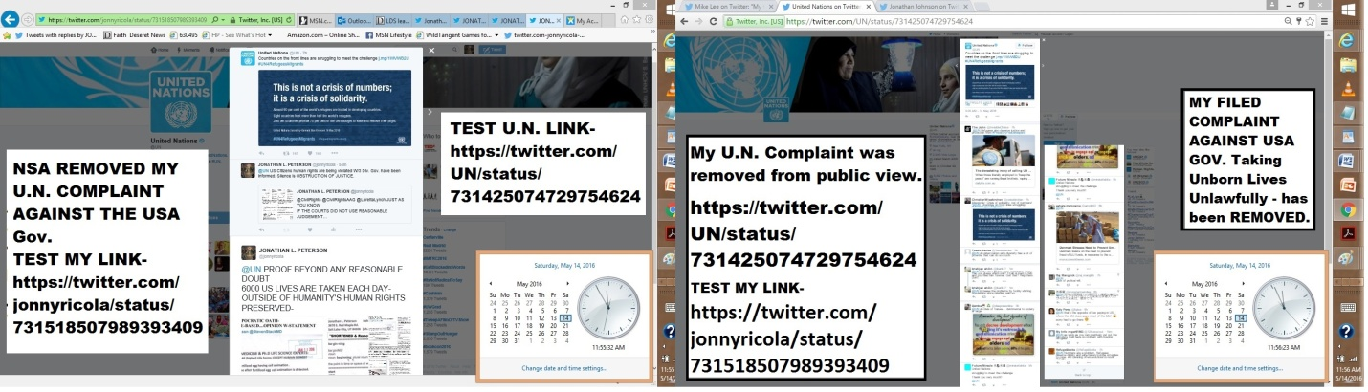
https://twitter.com/jonnyricola/status/731484533598511105
https://twitter.com/JJohnsonNow/status/731183948584230912
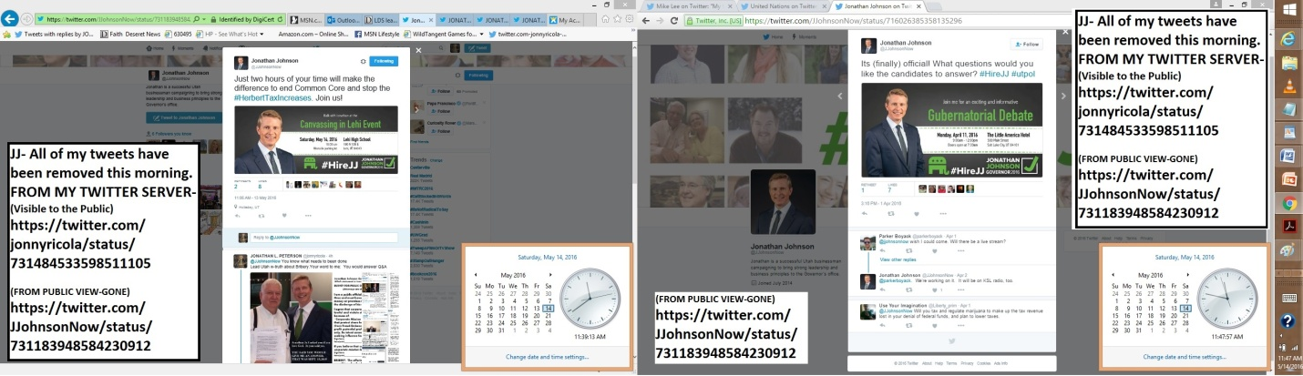
May 13, 2016
FOR 2 DAYS MY TWEETS WERE NOT AVAILABLE TO THE PUBLIC.
THIS MORNING I SEE THEY ARE RETURNED.. BUT HAS BEEN BLOCKING
MY WORK FOR THE PEOPLE-
TO HINDER THE SHARING OF PROOFS WE VIOLATE OUR HIGHEST PRINCIPLE:
CITIZENS MUST SHARE THIS RULE............ EQUAL UNDER ALL LAWS... & WE AREN'T...
Demand my proofs be tested in the News Media, US courts, & by those under oath to God.
CONSTITUTIONAL OATHS INCLUDE.... "SO HELP ME GOD".

May 12, 2016
MY TWEETS - ALL OF THEM - HAVE BEEN REMOVED BY THE NSA. THEY ARE THE ONLY GOV. AGENCY WITH THE POWER TO DO THIS ..
BECAUSE I BREAK NO LAWS OR ASK ANYONE ELSE TO =
They (THOSE WHO BLOCK MY LAWFUL DUTY TO DEFEND OUR CONSTITUTION)
violate both OBSTRUCTION OF JUSTICE & DO COMMIT TREASON AGAINST THE CONSTITUTION FOR THE UNITED STATES OF AMERICA....................
(I do believe they deserve some level of mercy- none citizens have done much better.)
I Am Only Defending Our Constitution From Further Violations By Our Society.
sincerely, Jonathan L.Peterson citizen USA.
Instinct Mechanism Operations&Logic-LAW,SCI,FAITH=2PowerP.P&TWEETdoc- http://jlp1997.wix.com/instinctlogicresearc
GO SEE THIS APPROVED COMMENT-
http://www.deseretnews.com/top/faith
http://www.deseretnews.com/top/3701/0/LDS-leaders-pay-tribute-to-mothers-from-the-pulpit.html
https://www.facebook.com/photo.php?fbid=1181160231918533&set=p.1181160231918533&type=3&theater
https://www.facebook.com/DougWrightShowKSL/photos/a.177803358916183.45041.152111421485377/1260623173967524/?type=3&theater
http://www.deseretnews.com/top/3671/0/20-athletes-who-are-vocal-about-their-faith.html
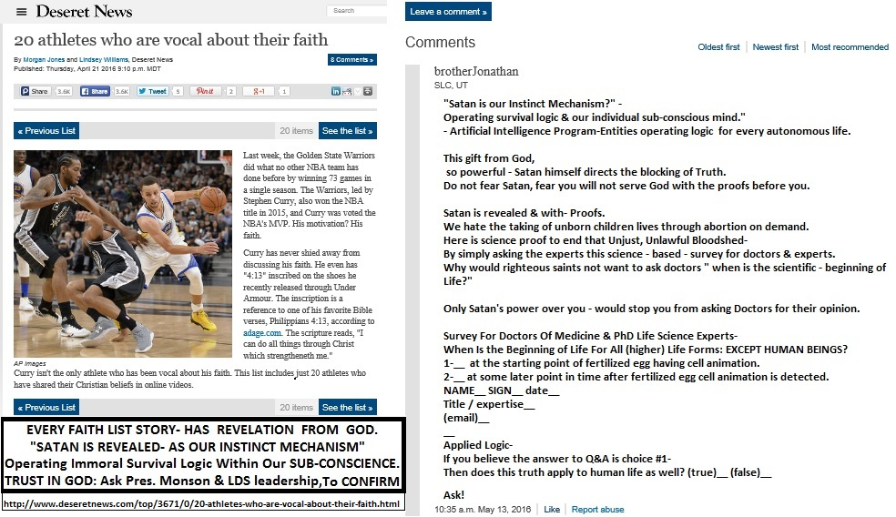
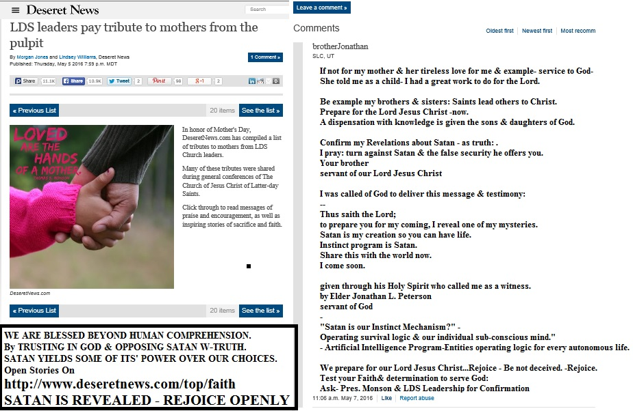
http://www.deseretnews.com/user/comments/865653226/Music-and-the-Spoken-Word-The-time-to-prepare.html
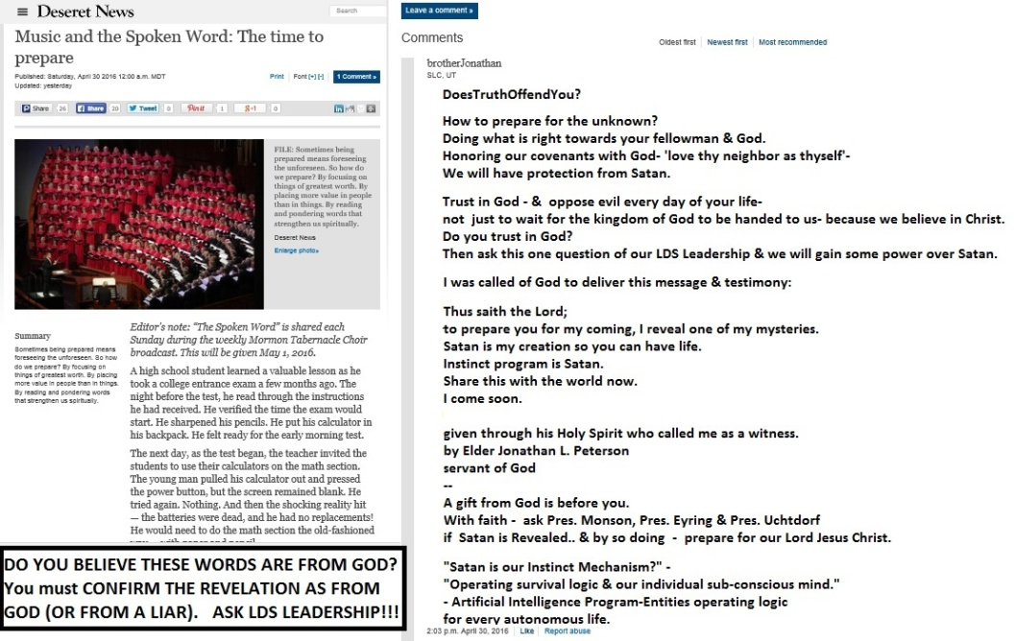

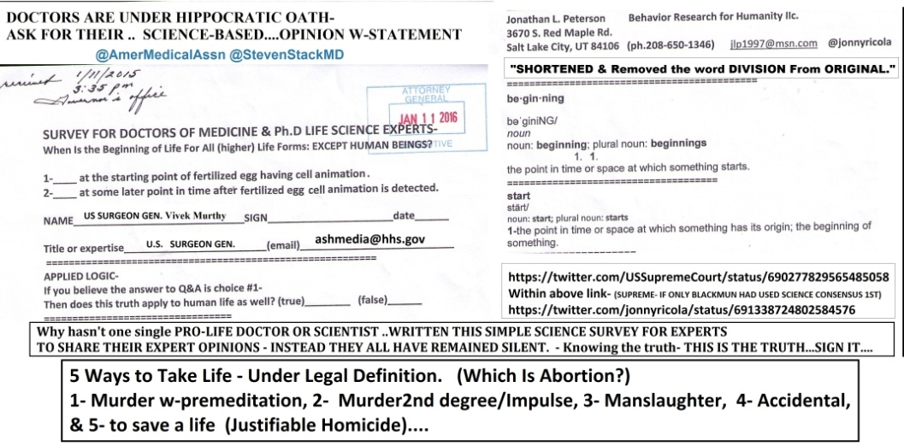

http://www.nhtsa.gov/Driving+Safety/Research+&+Evaluation/Alcohol+and+Drug+Use+By+Drivers
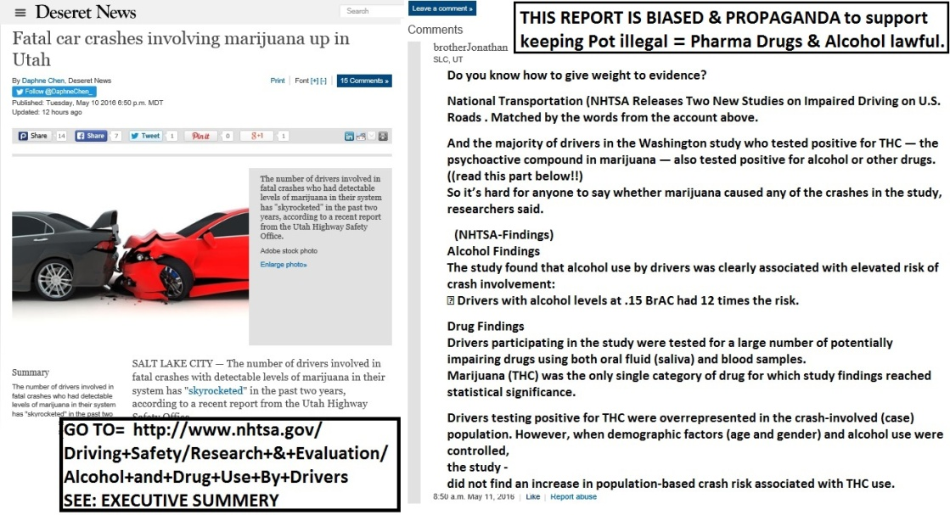
https://www.facebook.com/photo.php?fbid=1178192585548631&set=p.1178192585548631&type=3&theater LIBERTAS UTAH POST
https://www.facebook.com/UtahForBernieSanders/posts/627761514038935?comment_id=627770947371325&notif_t=like&notif_id=1462406977423462
+++++++++++++++++++++++++++++++++++++++++
(May 12, 2016)
https://twitter.com/jonnyricola/status/730835432166936576
@jonnyricola - 13.4K TWEETS REMOVED- BLOCKING FREEDOM OF SPEECH @AP-
@AlanDersh https://twitter.com/AlanDersh/status/725317025673936897
https://twitter.com/jonnyricola/status/730498543010516992
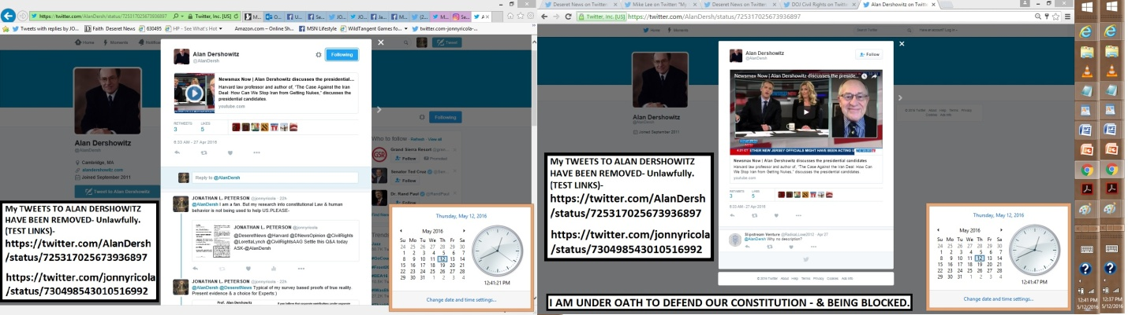

DIRECT FROM ME. https://twitter.com/jonnyricola/status/730825950967910401
@jonnyricola ALL 13.4K TWEETS REMOVED-Blocking my defense of our US Constitution.
https://twitter.com/jonnyricola/status/730537763137675264 https://twitter.com/SenMikeLee/status/730535271649923072
(W-photo Sen. Mike Lee TWEETS REMOVED violating freedom of speech & Religion May 11-2016 WViewDUTY)

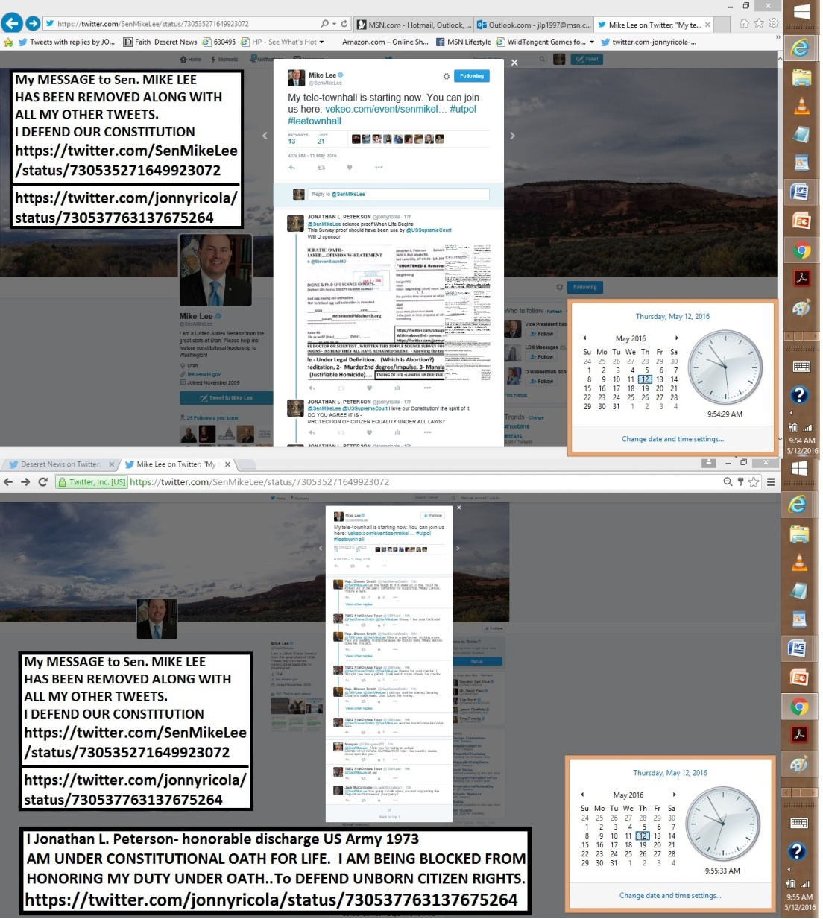
DIRECT FROM ME. https://twitter.com/jonnyricola/status/730822504986464256
@jonnyricola ALL 13.4K TWEETS REMOVED RROM PUBLIC VIEW-
NSA Violates my rights to defend our Constitution.
https://twitter.com/jonnyricola/status/730470430125916161
(W-photo DOJ Civil Rights TWEETS REMOVED violating freedom of speech & Religion May 11-2016 WView DUTY)
(@CivilRights @DeseretNews @LorettaLynch @CivilRightsAAG SWORN OATH TO DEFEND OUR CONSTITUTION EVEN withYOUR LIFE=ACT)
(W-Photo USAG L. Lynch & US SUPREME CT JUSTICES -WHY DIDN'T YOU WRITE THIS-SURVEY PUB OFFICIALS plain 1-12-2016 WIDEVw-tell
(W-Photo USAG Vanita & Loretta-are the controlled substance acts violations 6-4-2015 NOTARIZED WIDEVIEW w-YEA OR NAE ASK to sign -
(W-Photo CIVIL RIGHTS POST ON HUBER VIOLATING DUE PROCESS OCT 8,2015 w-LINK lg text WIDEVIEW & Loretta link)
(W-Photo US DISTRIC COURT Judge Nuffer Complaint July 1, 2015 11pg Lrez PAGE 1 & ZION BANK in ID evidence & SUPREME URL& Loretta)

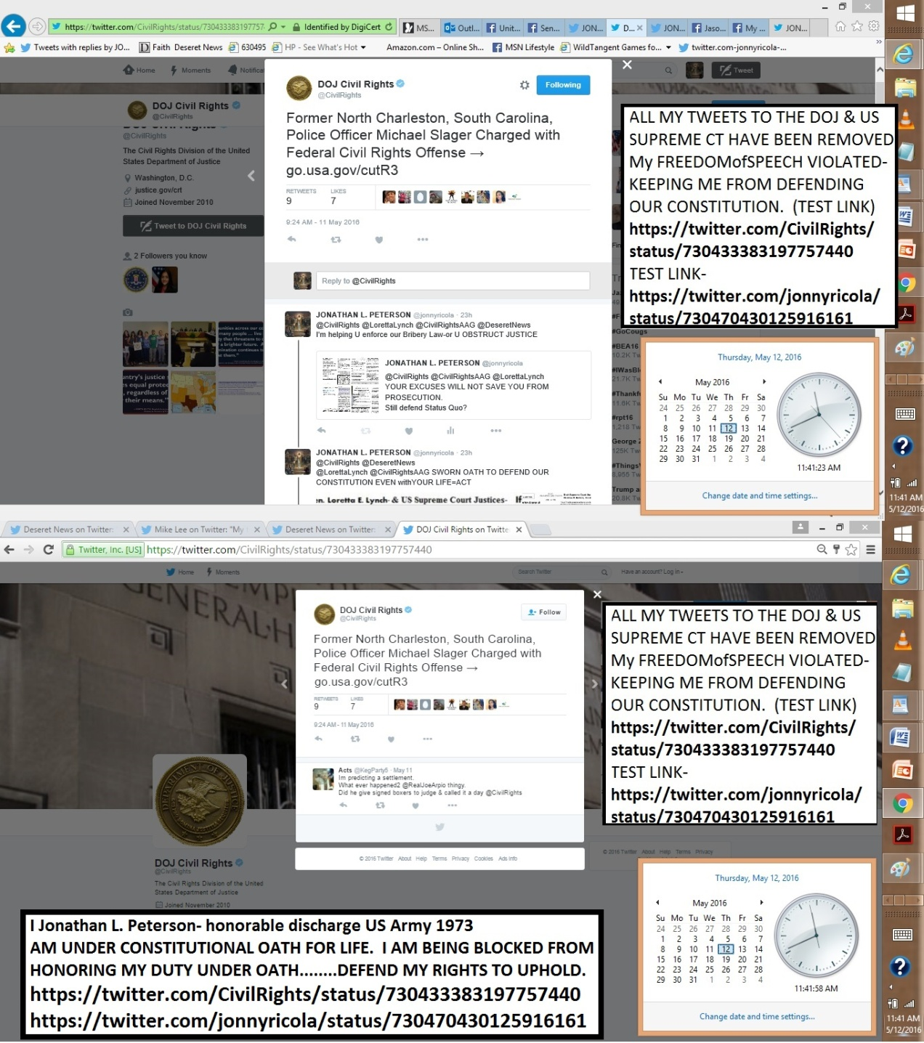
https://twitter.com/DeseretNews/status/730490017626259456
https://twitter.com/jonnyricola/status/730492638638395393 @DeseretNews @Harvard @DNewsOpinion I submitted PROOFofINTENTto Harvard Law review.They said maybe-MEANT NO WAY ASK
https://twitter.com/jonnyricola/status/730496253478338560 (@DeseretNews @Harvard @DNewsOpinion @CivilRights @LorettaLynch @CivilRightsAAG Settle this Q&A today ASK-@AlanDersh)
https://twitter.com/jonnyricola/status/730493824410083329
@DeseretNews @Harvard @DNewsOpinion GET TOP GOV. EXPERTS INVOLVED @CivilRights @LorettaLynch @CivilRightsAAG Sign IT https://twitter.com/jonnyricola/status/730470430125916161 (@CivilRights @DeseretNews@LorettaLynch @CivilRightsAAG SWORN OATH TO DEFEND OUR CONSTITUTION EVEN withYOUR LIFE=ACT1:24 PM - 11 May 2016)
https://twitter.com/jonnyricola/status/730496253478338560 @DeseretNews @Harvard @DNewsOpinion @CivilRights @LorettaLynch @CivilRightsAAG Settle this Q&A today ASK-@AlanDersh
https://twitter.com/jonnyricola/status/730514676459560960 @DeseretNews @Harvard @DNewsOpinion @CivilRights @LorettaLynch@CivilRightsAAG @AlanDersh @AP Go2 https://twitter.com/jonnyricola/status/730507855854325760 (HOW I GOT SO SMART)
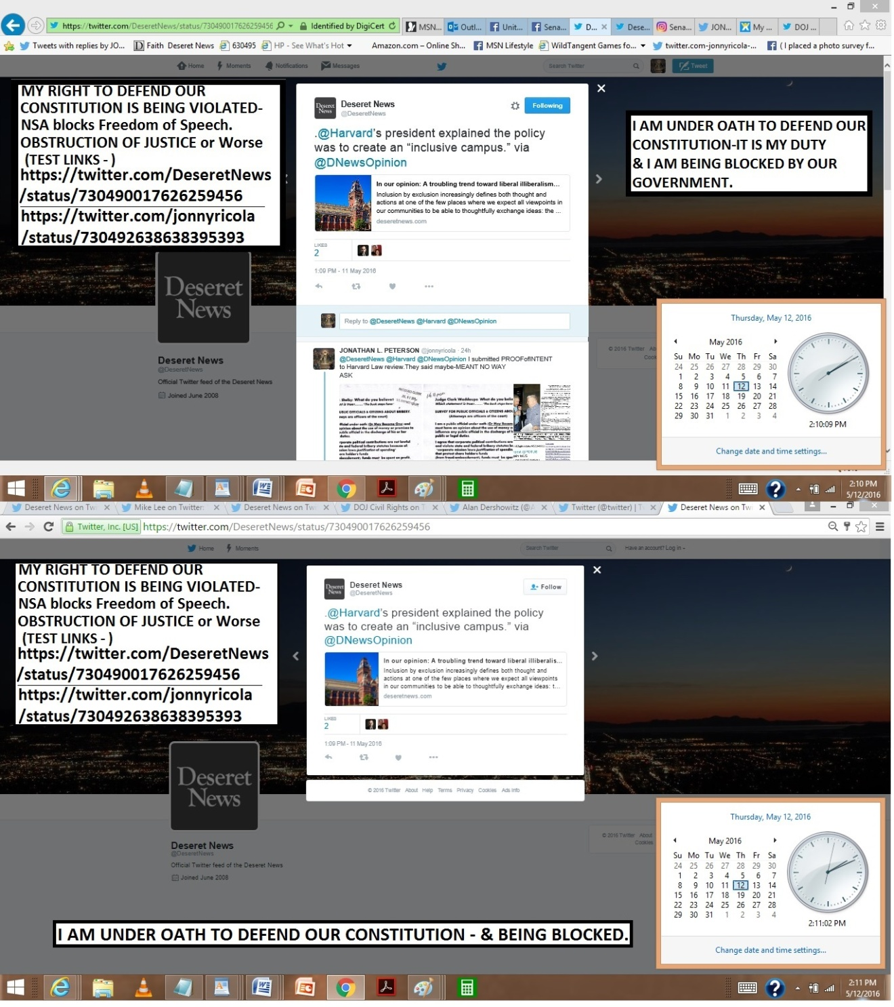

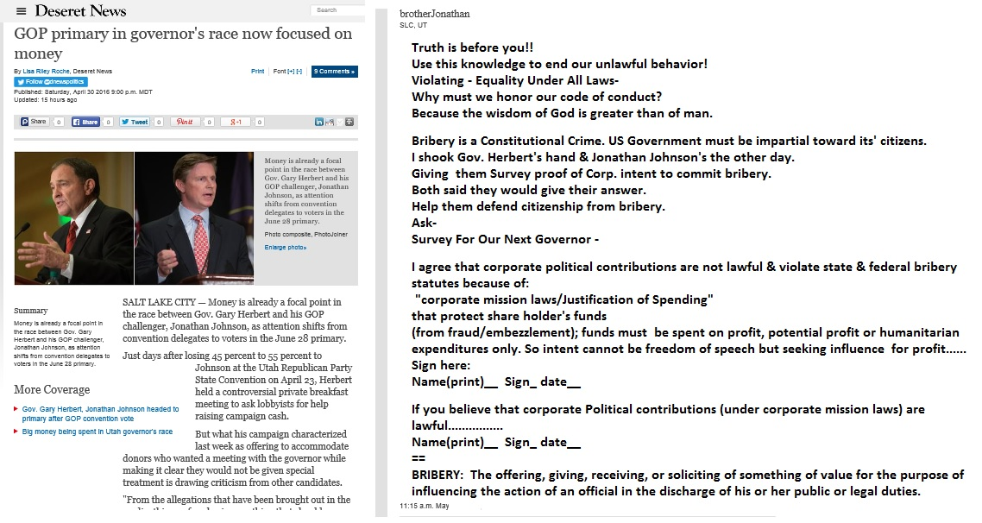

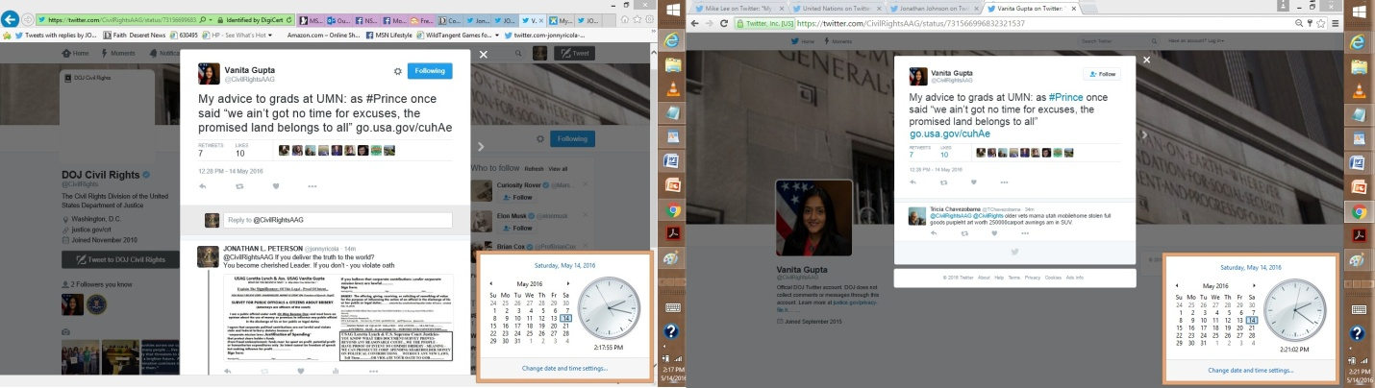
5-21-2016

============================================================
DIRECT-@DeseretNews @glennbeck My religious freedom is being blocked by NSA-
https://twitter.com/glennbeck/status/733722760015446017
https://twitter.com/jonnyricola/status/733724399451275264
(W-photo GLEN BECK TWEETS REMOVED. DEFENDING OUR UNBORN WVIEW URLSpart1mess
(W-photo GLEN BECK TWEETS REMOVED. DEFENDING OUR UNBORN WVIEW URLSpart2mess
(W-photo Gov. Herbert&REYES Survey for Doctors Jan. 11, 2016 SHORT ORi W-HEADER & divisonRemovWVIEW NELSON 7ways)
(W-photo Gov. Herbert&REYES Survey for Doctors Jan. 11, 2016 SHORT ORi W-HEADER & divisonRemovWVIEW AMA 7ways)Caption
============
DIRECT-@DeseretNews @glennbeck THIS SCIENCE SURVEY FOR DOCTORS.
PROVES BEYOND ANY REASONABLE DOUBT-
LIFE BEGINS @ BEGINNING-https://community.sumofus.org/petitions/ask-doctors-phd-life-science-experts-when-does-life-begin-survey?source=twitter-share-button
============
DIRECT- @DeseretNews @glennbeck Newest twitter post.being blocked by NSA again today
DEFEND myRIGHTS
https://twitter.com/glennbeck/status/733751716756217857
https://twitter.com/jonnyricola/status/734047171889135617
=====================================
DIRECT- @DeseretNews @glennbeck NSA removed this post as well
on Corp. Bribery & Drug Monopoly-CTR ? https://twitter.com/glennbeck/status/733716457289338880
https://twitter.com/jonnyricola/status/733722889506148353
========================
https://twitter.com/DeseretNews/status/734031033989890048 @DeseretNewsReligious freedom is good for business, Elder Christofferson sayshttp://www.deseretnews.com/article/865654755/Religious-freedom-is-good-for-business-Elder-Christofferson-says-so-all-have-a-stake-in-it.html
@DeseretNews @glennbeck My religious freedom is being blocked by NSA-
https://twitter.com/glennbeck/status/733722760015446017
https://twitter.com/jonnyricola/status/733724399451275264
(W-photo GLEN BECK TWEETS REMOVED. DEFENDING OUR UNBORN WVIEW URLSpart1mess
(W-photo GLEN BECK TWEETS REMOVED. DEFENDING OUR UNBORN WVIEW URLSpart2mess
(W-photo Gov. Herbert&REYES Survey for Doctors Jan. 11, 2016 SHORT ORi W-HEADER & divisonRemovWVIEW NELSON 7ways)
(W-photo Gov. Herbert&REYES Survey for Doctors Jan. 11, 2016 SHORT ORi W-HEADER & divisonRemovWVIEW AMA NSF 7ways)
reply
@DeseretNews @glennbeck THIS SCIENCE SURVEY FOR DOCTORS.
PROVES BEYOND ANY REASONABLE DOUBT-
LIFE BEGINS @ BEGINNING-https://community.sumofus.org/petitions/ask-doctors-phd-life-science-experts-when-does-life-begin-survey?source=twitter-share-button
reply
@DeseretNews @glennbeck newest twitter post.being blocked by NSA again today
DEFENDmyRIGHTS
https://twitter.com/glennbeck/status/733751716756217857
https://twitter.com/jonnyricola/status/734047171889135617
reply
@DeseretNews @glennbeck NSA removed this post as well
on Corp. Bribery & Drug Monopoly-CTR ? https://twitter.com/glennbeck/status/733716457289338880
https://twitter.com/jonnyricola/status/733722889506148353
+++++++++++++
=====================
https://twitter.com/jonnyricola/status/734043532332126208
https://twitter.com/jonnyricola/status/734047171889135617
https://twitter.com/glennbeck/status/733742874525880320 @glennbeckLibertarian Austin Petersen Makes Glenn’s Heart Skip a Beat http://ow.ly/Qtm0300q9WL

@glennbeck My brother,@DeseretNews NSA Continues to remove my posts to you-Defend my right to oppose evil. Speak&CTR
(W-photo GLEN BECK TWEETS REMOVED. DEFENDING OUR UNBORN WVIEW URLSpart1mess
(W-photo GLEN BECK TWEETS REMOVED. DEFENDING OUR UNBORN WVIEW URLSpart2mess
(W-photo Gov. Herbert&REYES Survey for Doctors Jan. 11, 2016 SHORT ORi W-HEADER & divisonRemovWVIEW NELSON 7ways)
(W-photo Gov. Herbert&REYES Survey for Doctors Jan. 11, 2016 SHORT ORi W-HEADER & divisonRemovWVIEW AMA NSF 7ways)
reply
@glennbeck @DeseretNews THIS SCIENCE SURVEY FOR DOCTORS.
PROVES BEYOND ANY REASONABLE DOUBT-
LIFE BEGINS @ BEGINNING- https://community.sumofus.org/petitions/ask-doctors-phd-life-science-experts-when-does-life-begin-survey?source=twitter-share-button
++++++++++++
===================================================
5-20-2016
=====================================================
https://twitter.com/jonnyricola/status/733724399451275264
https://twitter.com/jonnyricola/status/733725052408107008
@glennbeck @NSF & Glen-help Save 6000 lives taken ea. day in the USA.IT ISN'T LAWFUL. WE CAN PROVE IT WITH SCIENCE
https://twitter.com/jonnyricola/status/733727266912395264
https://twitter.com/glennbeck/status/733722760015446017 @glennbeckFacebook Criticized for Changing Patricia Heaton’s ‘Celebrate Life’ Message to ‘Anti-Abortion’ http://ow.ly/hWO5300pPC6

@glennbeck What truth does to otherwise good people
THEY CAN'T OPEN THEIR MOUTH.Like Germans WW2
Ask @NelsonRussellM
(W-photo Gov. Herbert&REYES Survey for Doctors Jan. 11, 2016 SHORT ORi W-HEADER & divisonRemovWVIEW NELSON 7ways)

@glennbeck Just show the world the proof they have been waiting for. WHY ROEvsWADE is based on false logic.IT IS-
https://community.sumofus.org/petitions/ask-doctors-phd-life-science-experts-when-does-life-begin-survey?source=twitter-share-button
reply
@glennbeck @NSF & Glen-help Save 6000 lives taken ea. day in the USA. IT ISN'T LAWFUL. WE CAN PROVE IT WITH SCIENCE
(W-photo Gov. Herbert&REYES Survey for Doctors Jan. 11, 2016 SHORT ORi W-HEADER & divisonRemovWVIEW USSG 7ways&Captions)
reply
@glennbeck @NSF & Glen-help Save 6000 lives taken ea. day in the USA. IT ISN'T LAWFUL. WE CAN PROVE IT WITH SCIENCE
(W-photo Gov. Herbert&REYES Survey for Doctors Jan. 11, 2016 SHORT ORi W-HEADER & divisonRemovWVIEW AMA 7ways&Captions

===================================================
https://twitter.com/jonnyricola/status/733720373762523136
https://twitter.com/jonnyricola/status/733722889506148353
https://twitter.com/glennbeck/status/733716457289338880 @glennbeck POLL: 90% of Native Americans Aren’t Offended by Washington Redskins Name http://ow.ly/Ef2e300pPs2

@glennbeck They are offended by Bribery, & Drug monopolyLaw= freedom of choice taken from them & given to others.
https://twitter.com/USSupremeCourt/status/691657424634191875 MENOMINEE INDIAN TRIBE
reply
@glennbeck Glen said-"You've got to demand the truth from yourself" HERE'S THE BIGGEST TEST OF YOUR LIFE Sign TRUTHS
(W-photo GLEN BECK for the love of God-U BELIEVE IT SIGN IT SURVEY FOR CORP BRIBERY -EXPLAIN 2-26-2016 WView messURLS)
(W-photo GLEN BECK & LORETTA-NUFFER DOC w--are the controlled sub 6-4-2015 NOTARIZED WVIEW w-YEA NAE w sq & CTstamped)
(W-Photo DeseretNews Comments ‘Lawmakers advance five bills designed to save lives’ (2-12-2016) WIDEVIEW
(W-Photo DeseretNews comments ‘Scalia's death leaves major void in high court, Utah legal experts say’ (2-14-2016) W-SUPREME URL)
===========================
https://twitter.com/glennbeck/status/733710153904705536 (@glennbeckObservations From the Heart of Silicon Valley http://ow.ly/gjag300pPny)

@glennbeck If my proofs of law & your duty to speak about are wrong?
TELL ME TO GO AWAY. my brother
(W-photo GLEN BECK for the love of God-U BELIEVE IT SIGN IT SURVEY FOR CORP BRIBERY -EXPLAIN 2-26-2016 WView messURLS)
reply
@glennbeck And say this survey for Doctors is not the best SCIENCE PROOF To end ROE vs. WADE-using A Science Survey-
https://community.sumofus.org/petitions/ask-doctors-phd-life-science-experts-when-does-life-begin-survey?source=twitter-share-button
(hidden reply to Glen- @glennbeck Glen, not one Pro-Life leader or member will sign this petition to ask doctors & experts for their opinion.NOT 1 Will you be 1st?
reply
@glennbeck Are we going to serve God together? Oppose Satan with Logic&Proofs? Confirm or Deny- I am serving God & Nation with TRUTH?brother
reply
@glennbeck I CAN TESTIFY TO YOU ALL- WHY GLEN WON'T TELL ME TO GO AWAY: GLEN KNOWS I SERVE GOD WITH TRUTH.@LDSchurch
https://community.sumofus.org/petitions/ask-doctors-phd-life-science-experts-when-does-life-begin-survey?source=twitter-share-button
=============================
https://twitter.com/glennbeck/status/733667402848800768 @glennbeckThe Contested Convention Part II: 1924 (Democrats) http://ow.ly/Z4lP300ow0n

@glennbeck we are LDS brothers,Trying to serve God
Here is proof of Corp. Shareholder Bribery-READY FOR COURTS=speak
(W-Photo 59 Gary Johnson & me & survey on Bribery April 6-2016 slc,utURLmess)
(W-Photo 54 Jonathan Johnson for governor rally & JLP 9-15-2015 CROPPED even more 2x W SURVEY 1600 W-TEXT REMINDER)
(W-Photo CIVIL RIGHTS POST ON HUBER VIOLATING DUE PROCESS OCT 8,2015 w-LINK lg text WIDEVIEW & Loretta link)
(W-Photo US DISTRIC COURT Judge Nuffer Complaint July 1, 2015 11pg Lrez PAGE 1 & ZION BANK in ID evidence & SUPREME URL& Loretta)
reply
@glennbeck Did you read my proofs on @JJohnsonNow on your story of @GovHerbert? You claim to defend our Constitution-
https://twitter.com/jonnyricola/status/733402120083243009 (@JJohnsonNow @glennbeck GLEN-Do you know Truth when it is Given YOU?LIKE PROOF OF BRIBERY READY & FILED W-DOJ?Well)
++++++++++++++++++
===========================================================
https://twitter.com/glennbeck/status/733702614290948097 @glennbeckClinton: ‘I Will Be the Nominee’ http://ow.ly/GTtd300pPcp

@glennbeck Did U read my Q&A for you & For our society_that is Embracing Unlawful Behavior forGENERATIONS?@LDSchurch
https://twitter.com/jonnyricola/status/733684733452931072 ( @glennbeck @AP @JJohnsonNow @GovHerbert @LorettaLynchGLEN YOU EITHER KNOW MY LOGIC IS TRUE & CORRECT OR NOT.SPEAK)
reply
@glennbeck @LDSchurch IF YOU BELIEVE -CORP.SHAREHOLDER $ SPENT ON PUBLIC OFFICE IS JUSTIFIED/FREEDOMofSPEECH? SignIT
(W-photo GLEN BECK for the love of God-U BELIEVE IT SIGN IT SURVEY FOR CORP BRIBERY -EXPLAIN 2-26-2016 WView messURLS)
reply
@glennbeck @LDSchurch Why is no one else asking this question?
THEY CAN'T MAKE THEMSELVES OPPOSE STATUS QUO-directly
(W-Photo 59 Gary Johnson & me & survey on Bribery April 6-2016 slc,utURLmess)
(W-Photo Huber, Lynch& Reyes -U BELIEVE IT SIGN IT SURVEY FOR CORP BRIBERY -EXPLAIN SIGN 2-26-2016 W-SUBVERT WVIEW loretta tell
(W-Photo CIVIL RIGHTS POST ON HUBER VIOLATING DUE PROCESS OCT 8,2015 w-LINK lg text WIDEVIEW & Loretta link)
(W-Photo US DISTRIC COURT Judge Nuffer Complaint July 1, 2015 11pg Lrez PAGE 1 & ZION BANK in ID evidence & SUPREME URL& Loretta)
reply
@glennbeck @LDSchurch YOU BETTER FIND THE COURAGE TO OPEN YOUR MOUTH @LorettaLynch OR OUR NATION WILL SUFFER GREATLY
==============================

https://twitter.com/glennbeck/status/733674965686439937 (@glennbeckSyrian Kurds Plead With U.S. for More Help to Defeat ISIS http://ow.ly/cDy7300ovRQ)

@glennbeck I believe you try to serve God & nation Here is proof of Corp. Shareholder Bribery-READY FOR COURTS=speak
(W-Photo 59 Gary Johnson & me & survey on Bribery April 6-2016 slc,utURLmess)
(W-Photo 54 Jonathan Johnson for governor rally & JLP 9-15-2015 CROPPED even more 2x W SURVEY 1600 W-TEXT REMINDER)
(W-Photo CIVIL RIGHTS POST ON HUBER VIOLATING DUE PROCESS OCT 8,2015 w-LINK lg text WIDEVIEW & Loretta link)
(W-Photo US DISTRIC COURT Judge Nuffer Complaint July 1, 2015 11pg Lrez PAGE 1 & ZION BANK in ID evidence & SUPREME URL& Loretta)
reply
@glennbeck @AP @JJohnsonNow @GovHerbert HOW TO PROVE? Ask @LorettaLynch =STATE IF MY FILED COMPLAINT HAS MERIT
@glennbeck @AP Did you read my proofs on @JJohnsonNow on your story of @GovHerbert? PROVE YOU defend ourConstitution- https://twitter.com/jonnyricola/status/733402120083243009 (@JJohnsonNow @glennbeck GLEN-Do you know Truth when it is Given YOU?LIKE PROOF OF BRIBERY READY & FILED W-DOJ?Well)
reply
@glennbeck @AP @JJohnsonNow @GovHerbert HOW TO PROVE?
Ask @LorettaLynch =STATE IF MY FILED COMPLAINT HAS MERIT orNOT
(W-Photo USAG Lynch & Pres. Obama-U BELIEVE IT SIGN IT SURVEY FOR CORP BRIBERY -EXPLAIN SIGN 2-26-2016 WView mess)
(W-Photo CIVIL RIGHTS POST ON HUBER VIOLATING DUE PROCESS OCT 8,2015 w-LINK lg text WIDEVIEW & Loretta link)
(W-Photo US DISTRIC COURT Judge Nuffer Complaint July 1, 2015 11pg Lrez PAGE 1 & ZION BANK in ID evidence & SUPREME URL& Loretta)
(W-Photo DNews Comments ‘Gov. Gary Herbert says 'tone' of fundraising will change amid criticism’ (5-17-2016) w-lorettad URL&mess)
reply
@glennbeck @AP @JJohnsonNow @GovHerbert @LorettaLynch GLEN YOU EITHER KNOW MY LOGIC IS TRUE & CORRECT OR NOT. SPEAK
(W-photo GLEN BECK for the love of God-U BELIEVE IT SIGN IT SURVEY FOR CORP BRIBERY -EXPLAIN 2-26-2016 WView messURLS)
reply
@glennbeck @AP @JJohnsonNow @GovHerbert @LorettaLynch
ASK @DeseretNews @CivilRights& @POTUS IF MY POSTS ARE ACCURATE
(W-Photo DeseretNews Comments ‘Gov. Gary Herbert says 'tone' of fundraising will change amid criticism’ (5-17-2016)
(W-Photo DeseretNews Comments ‘GOP primary in governor's race now focused on money’ (5-1-2016) Wview)
(W-Photo DeseretNews comments ‘Scalia's death leaves major void in high court, Utah legal experts say’ (2-14-2016) W-SUPREME URL)
(W-photo 15 DeseretNews comments 15 LDS general authorities and their Book of Mormon heroes 1-8-2016 WVIEW ONLY w- SKULL -DN-)
reply
@glennbeck @AP @LorettaLynch @CivilRights @POTUS @DeseretNews @JJohnsonNow @GovHerbert
https://community.sumofus.org/petitions/ask-doctors-phd-life-science-experts-when-does-life-begin-survey?source=twitter-share-button ASK-
(W-photo Gov. Herbert&REYES Survey for Doctors Jan. 11, 2016 SHORT ORi W-HEADER & divisonRemovWVIEW RMNelson7 ways&Lawful
(W-photo DeseretNews comment 20 athletes who are vocal about their faith (4-21-2016) WVIEWmessURL DK
(W-photo Gov. Herbert&REYES Survey Doctors Jan. 11, 2016 SHORT ORi W-HEADER & divisonRemovWVIEW RMNelson5ways&Lawful
(W-Photo DeseretNews Comment- ‘Bill intends to ban certain abortion procedures in Utah’ (2-26-2016) WIDEVIEW )
reply
@glennbeck @AP @LorettaLynch @CivilRights @POTUS @DeseretNews @JJohnsonNow @GovHerbert WANT EQUALITY @NelsonRussellM?
https://community.sumofus.org/petitions/ask-doctors-phd-life-science-experts-when-does-life-begin-survey?source=twitter-share-button
reply
@glennbeck @AP @LorettaLynch @CivilRights @POTUS @DeseretNews @JJohnsonNow @GovHerbert @NelsonRussellM MyBeliefsOnHELL_EternityOF REMORSE 4U
++++++++
5-19-2016
=========================================================================
DIRECT-
@MormonTabChoir I'm member @LDSchurch Given-NoTrespass Order for my Revelation
onSatan:2yr7months W-OUTaChurch Court
(W-photo DeseretNews Comments ‘Music and the Spoken Word- What is true greatness’ (5-14-2016)URLmessURLsiteMustDEMANDdk)
(W-Photo 1 FAITH LIST DNews FEB-29-2016 w- URL&revelation- The Lord says & ASK LDS if true- rejoice DN-savior is born)
(W-Photo DeseretNews comment LDS leaders pay tribute to mothers from the pulpit (5-6-2016) WView mess)
(W-photo DeseretNews comment 20 athletes who are vocal about their faith (4-21-2016) WVIEWmessURL DK
======================================
https://twitter.com/MormonTabChoir/status/733439128491040770 @MormonTabChoirThe #History and Lyrics to “God Be With You Till We Meet Again” http://bit.ly/1TmEFdl

@MormonTabChoir I'm member @LDSchurch Given-NoTrespass Order for my Revelation
onSatan:2yr7months W-OUTaChurch Court
(W-photo DeseretNews Comments ‘Music and the Spoken Word- What is true greatness’ (5-14-2016)URLmessURLsiteMustDEMANDdk)
===================================================================================
DIRECT-
@JJohnsonNow @glennbeck Our Sins against Others R terrible
COMPARE 2 SILENCE-KNOWING SURVEY WOULD END MURDERS=BnHELL
https://twitter.com/jonnyricola/status/733416331727364097
(@JJohnsonNow @glennbeck YOU MUST ASK DOCTORS THIS QUESTION.SERVE GOD -OR BURN IN HELL MY BROTHERS. 6000 LIVES ADAY.)
reply
@JJohnsonNow @glennbeck Confront your sub-conscience/Satan
& serve God DEMAND @ldschurch COURT FOR ME? @DeseretNews?
(W-photo DeseretNews Comments ‘Music and the Spoken Word- What is true greatness’ (5-14-2016)URLmessURLsiteMustDEMANDdk)
==================================================================
https://twitter.com/jonnyricola/status/733429370342121472 (@JJohnsonNow @glennbeck Confront your subconscience/Satan & serve God DEMAND CHURCH COURT4ME @DeseretNews @ldschurch Photo of saying I am a Prophet of God)
https://twitter.com/jonnyricola/status/733416331727364097 @JJohnsonNow @glennbeck YOU MUST ASK DOCTORS THIS QUESTION.SERVE GOD -OR BURN IN HELL MY BROTHERS. 6000 LIVES ADAY.
https://twitter.com/JJohnsonNow/status/733396214230568961 @JJohnsonNowThe list of those disgusted w/Herbert's speed dating tactics just keeps growing. Check out @glennbeck's coverage:

@JJohnsonNow @glennbeck GLEN-Do you know Truth when it is Given YOU? LIKE PROOF OF BRIBERY READY & FILED W-DOJ? Well
(W-Photo DeseretNews Comments ‘Gov. Gary Herbert says 'tone' of fundraising will change amid criticism’ (5-17-2016)
(W-Photo CIVIL RIGHTS POST ON HUBER VIOLATING DUE PROCESS OCT 8,2015 w-LINK lg text WIDEVIEW & Loretta link)
(W-Photo US DISTRIC COURT Judge Nuffer Complaint July 1, 2015 11pg Lrez PAGE 1 & ZION BANK in ID evidence & SUPREME URL& Loretta)
(W-Photo 54 Jonathan Johnson for governor rally & JLP 9-15-2015 CROPPED even more 2x W SURVEY 1600 W-TEXT REMINDER)
reply
@JJohnsonNow @glennbeck OUR CONSTITUTION IS VIOLATED W-CORP. SHAREHOLDER $ SPENT ON PUBLIC OFFICE. Ask @LorettaLynch
(W-Photo LYNCH & US SUPREME COURT -U BE SIGN IT SURVEY FOR CORP BRIBERY -EXPLAIN 2-26-2016 W-SUBVERT WVIEW loretta tell )
(W-Photo CIVIL RIGHTS POST ON HUBER VIOLATING DUE PROCESS OCT 8,2015 w-LINK lg text WIDEVIEW & Loretta link)
(W-Photo TWITTER POSTS REMOVED CivilRights post on bribery May 16, 2016 POST GONE
(W-Photo TWITTER POSTS REMOVED CIVILRIGHTS RI POSTING April 30, 2016 URLS p3-loretta survey)
reply
@JJohnsonNow @glennbeck @LorettaLynch CHECK THE LINKS
I AM UNDER OATH&BLOCKING me IS aCrime=
https://twitter.com/CivilRights/status/723180011084083200
https://twitter.com/jonnyricola/status/723555257804967936 (civilrights RI proof for loretta been removed)
reply
@JJohnsonNow @glennbeck @LorettaLynch 2 other posts were removed as well.
I DEFEND the USA-
https://twitter.com/jonnyricola/status/723322078376550401
https://twitter.com/jonnyricola/status/723319661954134016
reply
@JJohnsonNow @glennbeck We Are LDS-THESE TRUTHS FROM GOD ARE HERE TO HELP US OPPOSE INSTINCT-http://jlp1997.wix.com/instinctlogicresearc
(W-Photo JLP1997 INSTINCTLOGICRESEARC- Website photo May 15, 2016 WVIEW urlPart1)
(W-Photo JLP1997 INSTINCTLOGICRESEARC- Website photo May 15, 2016 WVIEW urlPart2b)
(W-photo Gov. Herbert&REYES Survey Doctors Jan. 11, 2016 ORi &diviRemovWVIEW nelson-7 ways&Lawful
(W-photo DeseretNews comment 20 athletes who are vocal about their faith (4-21-2016) WVIEWmessURL DK
reply
@JJohnsonNow @glennbeck YOU MUST ASK DOCTORS THIS QUESTION.
SERVE GOD -OR BURN IN HELL MY BROTHERS. 6000 LIVES ADAY.
(W-Photo Gov. Herbert&REYES Survey for Doctors Jan. 11, 2016 & div.Remov&7Ways DK nelsonLViewLAWsite)
reply
@JJohnsonNow @glennbeck Confront your subconscience/Satan & serve God
DEMAND CHURCH COURT4ME @DeseretNews @ldschurch
(W-photo DeseretNews Comments ‘Music and the Spoken Word- What is true greatness’ (5-14-2016)URLmessURLsiteMustDEMANDdk)
(W-Photo 1 FAITH LIST DNews FEB-29-2016 w- URL&revelation- The Lord says & ASK LDS if true- rejoice DN-savior is born)
(W-Photo DeseretNews comment LDS leaders pay tribute to mothers from the pulpit (5-6-2016) WView mess)
(W-Photo 4 DeseretNews comment 16 quotes about service and love from LDS General Women (4-9-2016) WIDEVIEWw-URLS&mess)
========================================================
https://twitter.com/DisruptUPradio/status/733373973845676032 (RETWEETED BY JJ)
@DisruptUPradioAt 4:30pm @JJohnsonNow discuss Common Core, fundraising & 5 questions JJ would ask before signing any bill

@DisruptUPradio @JJohnsonNow You really going to ignore your responsibility to LEAD.
Whether you are Governor or not?
https://twitter.com/jonnyricola/status/733346256999747585 (@JJohnsonNow @FrugalDougall Honor your Oath of Office (you are an officer of the Court) & your LDS Covenants to God=) Photo of JJ&ME& SURVEY)
reply
@DisruptUPradio @AP @JJohnsonNow& @GovHerbert HAVE KNOWLEDGE
OF BRIBERY CRIMES AGAINST CITIZENS_ W-PROOF=SPEAK= DUTY
(W-Photo DeseretNews Comments ‘GOP primary in governor's race now focused on money’ (5-1-2016) Wview)
(W-Photo 54 Jonathan Johnson for governor rally & JLP 9-15-2015 CROPPED even more 2x W SURVEY 1600 W-TEXT REMINDER)
(W-Photo DeseretNews Comments ‘Gov. Gary Herbert says 'tone' of fundraising will change amid criticism’ (5-17-2016)
(W-Photo Jonathan Johnson & Gov. Gary Herbert-U BELIEVE IT SIGN IT SURVEY FOR CORP BRIBERY -EXPLAIN SIGN 4-1-2016)
reply
@DisruptUPradio @AP @JJohnsonNow @GovHerbert YOU KNOW THIS PROOF IS FILED W-DOJ @CivilRights @LorettaLynch UAG REYES
(W-Photo CIVIL RIGHTS POST ON HUBER VIOLATING DUE PROCESS OCT 8,2015 w-LINK lg text WIDEVIEW & Loretta link)
(W-Photo US DISTRIC COURT Judge Nuffer Complaint July 1, 2015 11pg Lrez PAGE 1 & ZION BANK in ID evidence & SUPREME URL& Loretta)
(W-Photo 46 U.S. DISTRICT COURT JUDGE Robert J. Shelby & WADDOUPS, Filed 11 page complaint 7-1-2015 DK)
(W-Photo USHuber,USLynch& Reyes -U SIGN IT SURVEY CORP BRIBERY -EXPLAIN 2-26-2016 W-SUBVERT WIDEVIEW loretta tell them
reply
@DisruptUPradio @AP @JJohnsonNow @GovHerbert @CivilRights @LorettaLynch
IF YOU DON'T ASK Dr.s=RESPONSIBLE 6K EA. DAY-
https://community.sumofus.org/petitions/ask-doctors-phd-life-science-experts-when-does-life-begin-survey?source=twitter-share-button
reply
@DisruptUPradio @AP @JJohnsonNow @GovHerbert @CivilRights @LorettaLynch
Need help W-TRUTHS?-http://jlp1997.wix.com/instinctlogicresearc
(W-Photo JLP1997 INSTINCTLOGICRESEARC- Website photo May 15, 2016 WVIEW urlPart1)
(W-Photo JLP1997 INSTINCTLOGICRESEARC- Website photo May 15, 2016 WVIEW urlPart2b)
(W-photo 15 DeseretNews comments 15 LDS general authorities and their Book of Mormon heroes 1-8-2016 WVIEW ONLY w- SKULL -DN-)
(W-Photo DeseretNews Comments ‘Music and the Spoken Word- What is true greatness’ (5-14-2016)URLmessURLsiteMustDEMANDdk)
++++++++++
=====================================================
https://twitter.com/JJohnsonNow/status/732790469558702084 @JJohnsonNowTalking w/voters in Davis County tonight alongside @FrugalDougall. Thanks to those who attended! #HireJJ

@JJohnsonNow @FrugalDougall How can I help you to Lead? By Awakening Your Sleeping Conscience- ENDORSEor 6K PER DAY-
https://community.sumofus.org/petitions/ask-doctors-phd-life-science-experts-when-does-life-begin-survey?source=twitter-share-button
reply
@JJohnsonNow @FrugalDougall Honor your Oath of Office (you are an officer of the Court) & your LDS Covenants to God=
(W-Photo 54 Jonathan Johnson for governor rally & JLP 9-15-2015 CROPPED even more 2x W SURVEY 1600 W-TEXT REMINDER
(W-Photo CIVIL RIGHTS POST ON HUBER VIOLATING DUE PROCESS OCT 8,2015 w-LINK lg text WIDEVIEW & Loretta link)
(W-Photo US DISTRIC COURT Judge Nuffer Complaint July 1, 2015 11pg Lrez PAGE 1 & ZION BANK in ID evidence & SUPREME URL& Loretta)
(W-Photo DeseretNews comments 15 LDS general authorities & B of Mormon heroes 1-8-2016 WVIEW w- SKULL )
+++++++++++++++++
5-18-2016
=========================================
DIRECT-
@SenMikeLee & @SenOrrinHatch areN't honoring your Oath to God @LDSchurch
@ThomasSMonson @DeseretNews
https://community.sumofus.org/petitions/ask-doctors-phd-life-science-experts-when-does-life-begin-survey?source=twitter-share-button
@NelsonRussellM
==================================
https://twitter.com/SenMikeLee/status/732939383507148800 @SenMikeLeeSpread the word: Collins Amendment Offers Bogus Diversion from #AFFH Defund: Stick With Lee Amendment

@SenMikeLee You are not honoring your Oath to God @Pontifex& @LDSchurch @ThomasSMonson @DeseretNews https://community.sumofus.org/petitions/ask-doctors-phd-life-science-experts-when-does-life-begin-survey?source=twitter-share-button @AmerMedicalAssn
reply
@SenMikeLee @Pontifex @LDSchurch @ThomasSMonson @DeseretNews @AmerMedicalAssn YOU NEED TO KNOW WHY -YOU WON'T ACTctr
(W-Photo DeseretNews comment 20 athletes who are vocal about their faith (4-21-2016) WVIEWmessURL DK&Skull&FAITH)
reply
@SenMikeLee @Pontifex @LDSchurch @ThomasSMonson @DeseretNews Sen.Lee & @SenOrrinHatch @DUTnews @LorettaLynch I helpU
(W-Photo Sen. Hatch & Sen Lee -U SIGN IT SURVEY CORP BRIBERY -EXPLAIN 2-26-2016 W-SUBVERT WVIEW loretta tell)
(W-Photo DeseretNews Comments ‘Gov. Herbert says 'tone' of fundraising will change amid criticism’ (5-17-2016) w-lorettad URL&mess)
(W-Photo CIVIL RIGHTS POST ON HUBER VIOLATING DUE PROCESS OCT 8,2015 w-LINK lg text WIDEVIEW & Loretta link)
(W-Photo FAX DOJ,Nuffer Complaint July 1, 2015 Pg 1 & ZION BANK in ID evidence&USsup)
reply
SenMikeLee @Pontifex @LDSchurch @DeseretNews @SenOrrinHatch @DUTnews @LorettaLynch & @POTUS
https://twitter.com/USSupremeCourt/status/691657424634191875
(W-Photo Sen Lee,Hatch& USAG Lynch w-REYES-cont sub acts violat equality 5-18-2016 NOTARIZED WIDEVIEW w-YEANAE & CTstamped
(W-Photo DeseretNews Comments ‘Lawmakers advance five bills designed to save lives’ (2-12-2016) WIDEVIEW
(W-Photo CIVIL RIGHTS POST ON HUBER VIOLATING DUE PROCESS OCT 8,2015 w-LINK lg text WIDEVIEW & Loretta link)
(W-Photo Gary Johnson & me Photo#2 survey S April 6-2016 slc,ut 1000x650 w-huber&gary obstruct & DRUG LAW
reply
@SenMikeLee @Pontifex @LDSchurch @DeseretNews @SenOrrinHatch @DUTnews @LorettaLynch Mr.@POTUS I know you sawITwas1st-
https://twitter.com/jonnyricola/status/686952038115115008 (750K potus)
sub reply (made a correction to the above in a reply)- it wasn't 1st but very visible)
reply
@SenMikeLee @Pontifex @LDSchurch @DeseretNews @SenOrrinHatch @DUTnews @LorettaLynch @POTUS
Y UcantACT
INSTINCT/Blind- https://twitter.com/jonnyricola/status/730507855854325760
(@AlanDersh @CivilRights @LorettaLynch @CivilRightsAAG @DeseretNews @USSupremeCourt HOW2SERVE http://jlp1997.wix.com/instinctlogicresearc)
reply
@SenMikeLee @Pontifex @LDSchurch @DeseretNews @SenOrrinHatch @DUTnews @LorettaLynch @POTUS http://jlp1997.wix.com/instinctlogicresearc :)
(W-Photo PBS The BRAIN final episode with PROOFS OF INSTINCT MECH as A.I. Driven w STATUS QUO w-LINK
(W-Photo DR. NEIL PhD EXPERTS SCI-SURVEY ON INSTINCT w-deprog 3-14-2016 PAINTED TEXT w-PBSbrainURL & )
(W-Photo 69B MY LAST TWEET- Was to Dr. Neil DeGrassi Tyson March 14-2016 survey on instinct LG VIEW messDKwARROWS
(W-Photo JLP1997 INSTINCTLOGICRESEARC- Website photo May 15, 2016 LView)
==============================================
DIRECT-
@Pontifex & @LDSchurch @ThomasSMonson @DeseretNews
ToSERVE GOD WE MUSH END ABORTIONonDEMAND-Correct?@AmerMedicalAssn https://community.sumofus.org/petitions/ask-doctors-phd-life-science-experts-when-does-life-begin-survey?source=twitter-share-button
=======================================================
https://twitter.com/Pontifex/status/732541245952663552 Pope Francis Verified account ‏@PontifexThe world needs the courage, hope, faith and perseverance of Christ’s followers.

@Pontifex & @LDSchurch @ThomasSMonson @DeseretNews
ToSERVE GOD WE MUSH END ABORTIONonDEMAND-Correct?@AmerMedicalAssn https://community.sumofus.org/petitions/ask-doctors-phd-life-science-experts-when-does-life-begin-survey?source=twitter-share-button

reply to
@pblu22 @FrMatthewLC @BradleeDean1
@Pontifex& @LDSchurch @ThomasSMonson @DeseretNews
End PRO-CHOICE-@AmerMedicalAssn
https://community.sumofus.org/petitions/ask-doctors-phd-life-science-experts-when-does-life-begin-survey?source=twitter-share-button
===========================
https://twitter.com/Pontifex/status/732903619469533188 @PontifexThe Jubilee is the party to which Jesus invites us all, without excluding anyone.

@Pontifex & @LDSchurch @ThomasSMonson @DeseretNews
ToSERVE GOD WE MUSH END ABORTIONonDEMAND-Correct?@AmerMedicalAssn https://community.sumofus.org/petitions/ask-doctors-phd-life-science-experts-when-does-life-begin-survey?source=twitter-share-button
=========================================================
DIRECT-
@TIME When Roe vs Wade is struck down. Experts performing abortions would be prosecuted.ASK EXPERTS ForSCI-TRUTH-NOW- https://community.sumofus.org/petitions/ask-doctors-phd-life-science-experts-when-does-life-begin-survey?source=twitter-share-button
================================
DIRECT-
@UniverseBYU Part3-Blessed w-the gospel of Jesus Christ-written in our hearts
FIGHTSatan=LAW-
https://twitter.com/USSupremeCourt/status/691657424634191875
(W-Photo OAKS & PRES WORTHEN-UNDER OATH W-NUFFER DOC w-REYES-are controlled sub 5-18 NOTARIZED WIDEVIEW CTstamped
(W-Photo Gary Johnson & me Photo#2 survey S April 6-2016 slc,ut 1000x650 w-huber&gary obstruct & DRUG LAW
(W-Photo DeseretNews Comments ‘Lawmakers advance five bills designed to save lives’ (2-12-2016) WIDEVIEW
(W-Photo 24 DeseretNews Comments about ‘Why politicians turn to religion in times of uncertainty’ (4-2-2015)
DIRECT-
@UniverseBYU Part2-Blessed w-the gospel of Jesus Christ-written in our hearts
Fight Satan's Lies=LAW https://community.sumofus.org/petitions/ask-doctors-phd-life-science-experts-when-does-life-begin-survey?source=twitter-share-button @NelsonRussellM
DIRECT-
@UniverseBYU We are blessed with the gospel of Jesus Christ-written in our hearts
3 prong attack on Satan's Lies=LAW
(W-Photo DeseretNews Comments ‘Gov. Herbert says 'tone' of fundraising will change amid criticism’ (5-17-2016) w-lorettad URL&mess)
(W-Photo MormonNewsRoom Elder Oaks Encourages @BYU Grad to Serve &UT Sup JustOaks &Worthen- SUR-11-2015 Wtitle URL CROP)
(W-Photo CIVIL RIGHTS POST ON HUBER VIOLATING DUE PROCESS OCT 8,2015 w-LINK lg text WIDEVIEW & Loretta link)
(W-Photo FAX DOJ,Nuffer Complaint July 1, 2015 Pg 1 & ZION BANK in ID evidence&USsup)
===================================
https://twitter.com/UniverseBYU/status/732273208112652288 @UniverseBYU Investigators now access social media as part of a background check. Good or bad?http://ow.ly/d5qF300fEch

@UniverseBYU Here's an article on Social Media-@DeseretNews PINNED FOR 5 WEEKS.That ever happened before=OPEN IT&C
Y= https://twitter.com/DeseretNews/status/700088768682790912
reply
@UniverseBYU @DeseretNews This is Y: pinned for 5 weeks Just ask @ThomasSMonson @EyringHB @UchtdorfDF _To Explain IT
https://twitter.com/jonnyricola/status/730522616973406211 (@DeseretNews Today on Harvard Law & the 1 from FEB that stayedPinned for 5 weeks.CTR &ASK @LDSchurch @ThomasSMonson)
reply
@UniverseBYU @DeseretNews This is Y: pinned for 5 weeks Just ask @ThomasSMonson @EyringHB @UchtdorfDF _To Explain IT https://twitter.com/jonnyricola/status/701487762831052800 (PINNED STORY)
+++++++++++++
==============================================================

https://twitter.com/BYUphoto
@BYUphoto What a great smile/photo.That child is loved Others need help they R poor & R cheated Citizens of USA= CTR
(W-Photo DeseretNews Comments ‘Gov. Herbert says 'tone' of fundraising will change amid criticism’ (5-17-2016) w-lorettad URL&mess)
(W-Photo DeseretNews Comments ‘GOP primary in governor's race now focused on money’ (5-1-2016) Wview)
(W-photo USatt Huber,USAG Lynch& Reyes -U BEL BRIBERY -EXPLAIN SIGN 2-26-2016 WVIEW loretta tell them
(W-Photo CIVIL RIGHTS POST ON HUBER VIOLATING DUE PROCESS OCT 8,2015 w-LINK lg text WIDEVIEW & Loretta link)
reply
@BYUphoto @BYU With faith in God &covenants to hold us firm Oppose Satan's Lies & do what is right. Ask Pres.Worthen
(W-Photo MormonNewsRoom Elder Oaks Encourages @BYU Grad to Serve &UT Sup JustOaks &Worthen- SUR-11-2015 Wtitle URL CROP)
reply
@BYUphoto @BYU My photo, my work for the Lord- can be seen & examined for truth. Search for Truth.-
++++++
=========================================================
DIRECT-
@solesofpassion I defend Citizenship/Constitutional Law. Proofs are filed but DOJ&
@LorettaLynch refuse DUE PROCESS-
(W-Photo DeseretNews Comments ‘Gov. Herbert says 'tone' of fundraising will change amid criticism’ (5-17-2016) w-lorettad URL&mess)
(W-Photo DeseretNews Comments ‘GOP primary in governor's race now focused on money’ (5-1-2016) Wview)
(W-photo USatt Huber,USAG Lynch& Reyes -U BEL BRIBERY -EXPLAIN SIGN 2-26-2016 WVIEW loretta tell them
(W-Photo CIVIL RIGHTS POST ON HUBER VIOLATING DUE PROCESS OCT 8,2015 w-LINK lg text WIDEVIEW & Loretta link)
====================================
https://twitter.com/solesofpassion/status/720992548874022913 @solesofpassionOur New Single #taxslave is out now! Share if you're tired overtaxing! #taxdayFull Video: http://youtube.com/watch?v=TlmUjlkuNOQ

@solesofpassion I defend Citizenship/Constitutional Law. Proofs are filed but DOJ&
@LorettaLynch refuse DUE PROCESS-
(W-Photo DeseretNews Comments ‘Gov. Herbert says 'tone' of fundraising will change amid criticism’ (5-17-2016) w-lorettad URL&mess)
(W-Photo DeseretNews Comments ‘GOP primary in governor's race now focused on money’ (5-1-2016) Wview)
(W-photo USatt Huber,USAG Lynch& Reyes -U BEL BRIBERY -EXPLAIN SIGN 2-26-2016 WVIEW loretta tell them
(W-Photo CIVIL RIGHTS POST ON HUBER VIOLATING DUE PROCESS OCT 8,2015 w-LINK lg text WIDEVIEW & Loretta link)
++++++++++
5-17-2016
=================================================
https://twitter.com/BYU/status/732624397312221184 @BYUOne of the key elements to successful collaboration is to have respect for those who are different from you. #byudevo
@BYU You could unblock me.I don't lie & I'm dedicated servant of the Lord
My work is good for the people &especially the Saints.WeTrustinGod
============================================================
DIRECT-
@KUTV2News @AP Duty:to defend Constitutional Law-
To insure facts & logic play the highest role.RUgoing to CorrectIT?
https://twitter.com/jonnyricola/status/732736538216300545
@KUTV2News Did I make the case for a correction? @NORML @AP http://www.nhtsa.gov/Driving+Safety/Research+&+Evaluation/
Alcohol+and+Drug+Use+By+Drivers SEE: EXECUTIVE SUMMERY
==============================================
https://twitter.com/jonnyricola/status/732736538216300545 @KUTV2News Did I make the case for a correction? @NORML @AP http://www.nhtsa.gov/Driving+Safety/Research+&+Evaluation/ …Alcohol+and+Drug+Use+By+Drivers SEE: EXECUTIVE SUMMERY
https://twitter.com/KUTV2News/status/732714055971000320 @KUTV2News#Marijuana involved in nearly 40 percent of fatal crashes in #Utah.http://bit.ly/1Xy41tQ

@KUTV2News You are publishing false claims- REALLY- Fact check. http://www.nhtsa.gov/Driving+Safety/Research+&+Evaluation/Alcohol+and+Drug+Use+By+Drivers
SEE: EXECUTIVE SUMMERY-CRASH
(W-photo DeseretNews Comments ‘Fatal car crashes involving marijuana up in Utah’ (5-11-2016)WView- wURL&pharma)
reply
@KUTV2News I Don't Say smoke pot & drive.But if you read the reports?
You will find if other drugs are elimated from statisicsTHC
NON FACTOR
reply
@KUTV2News RUcorrect FALSE CLAIM? So it’s hard for anyone to say whether marijuana caused any of the crashes in the study, researchers said.
reply
@KUTV2News the report is clear. of all the drugs that impair drivers POT is the safest one.RETRACTIONforFALSE REPORT-
reply
@KUTV2News I Don't Say smoke pot & drive.But if you read the reports?
You will find if other drugs are elimated from statisicsTHC NON FACTOR
reply
@KUTV2News the report is clear. of all the drugs that impair drivers POT is the safest one.RETRACTIONforFALSE REPORT-http://www.deseretnews.com/article/865654011/Fatal-car-crashes-involving-marijuana-up-in-Utah.html
reply
@KUTV2News Did I make the case for a correction? @NORML @AP http://www.nhtsa.gov/Driving+Safety/Research+&+Evaluation/
Alcohol+and+Drug+Use+By+Drivers SEE: EXECUTIVE SUMMERY
=================================
@KUTV2News This is a petition to ask doctors & PhD Life science experts opinion on a survey. It was needed 40Yrs ago-https://community.sumofus.org/petitions/ask-doctors-phd-life-science-experts-when-does-life-begin-survey?source=twitter-share-button
====================================
https://twitter.com/jonnyricola/status/732714751042588672 @BYU @ThomasSMonson I love to create Logic Proofs&Surveys Let us test my logic & proofs with experts @NelsonRussellM
https://twitter.com/BYU/status/732627280401338369 @BYU"Many great inventions are entirely unanticipated before their creation" #byudevo
@BYU The first invention needs to be understood better
It was created a long time ago. ask @ThomasSMonson to confirm-https://twitter.com/jonnyricola/status/732654377337376768
reply
@BYU @ThomasSMonson I love to create Logic Proofs&Surveys
Let us test my logic & proofs with experts @NelsonRussellM
(W-photo Prof Hedges,Bigler&Prof. Cynthia Berg -SURVEY ON INSTINCT w-deprog 3-3-2016 PAINTED TEXT
(W-Photo DeseretNews comment '53 female Utah college athletes who served or serving LDS missions' (10-30-2015) WIDE text PBS URL)
(W-photo Gov. Herbert&REYES Survey Doctors Jan. 11, 2016 ORi &diviRemovWVIEW nelson-7 ways&Lawful
(W-photo DeseretNews comment 20 athletes who are vocal about their faith (4-21-2016) WVIEWmessURL DK
reply
@BYU @ThomasSMonson @NelsonRussellM Some belief I serve God.
Some believe I serve Satan. Does revealing Satan & our unlawful behavior HelpU
reply
@BYU @ThomasSMonson @NelsonRussellM Would Satan approve of this message Ask @EyringHB @UchtdorfDF & @DeseretNews TOO
https://twitter.com/jonnyricola/status/732654377337376768 (@BYUSpeeches Ask @DeseretNews @ThomasSMonson @EyringHB @UchtdorfDF @NelsonRussellM @LDSchurch CONFIRM or DENYasTRUTH)
reply
@BYU @ThomasSMonson @NelsonRussellM @EyringHB @UchtdorfDF @DeseretNews
Get on your knees & ask God to help you &
the saints oppose Satan now
reply
@BYU @ThomasSMonson @NelsonRussellM @EyringHB @UchtdorfDF @DeseretNews
My testimony is true-http://jlp1997.wix.com/instinctlogicresearc
https://twitter.com/jonnyricola/status/732644448429969408 (@byumagazine @NelsonRussellM My work for the Lord&you: is on http://jlp1997.wix.com/instinctlogicresearc … 4 review&download.INVITEme @BYU)
=========================================================================
https://twitter.com/byumagazine/status/732697092410343424 @byumagazineDe Lamar Jensen paints murals of favorite travels. How do you remember yours? #travel #BYUalum

@byumagazine Most important SCI, LAW & FAITH REVELATION SINCE JOSEPH SMITH JR & not one Saint can SPEAKUP-Try Harder https://twitter.com/BYUSpeeches/status/732627554121613312
reply
@byumagazine I don't believe I am the one going to suffer from great remorse.
I am trying to help you oppose Satan
https://twitter.com/jonnyricola/status/732654377337376768 (@BYUSpeeches Ask @DeseretNews @ThomasSMonson @EyringHB @UchtdorfDF @NelsonRussellM @LDSchurch CONFIRM or DENYasTRUTH)
reply
@byumagazine I love old westerns & their colloquial sayings.
"lily-livered" its one thing to froze with fear-another to actively block truth
reply
@byumagazine I won't spend my time on unfaithful servants.I will pray for you
Opposing Satan is our covenant with God.Ask @LDSchurch &repent
reply
@byumagazine @LDSchurch My apologies BYU Magazine.It's @BYUSpeeches that got offended & now blocks me. Im not perfect-but I do try hard-Thx
================================================================================
NOW BLOCKS, ME.. WHO DO THEY SERVE? Themselves not God... this day anyhow.
https://twitter.com/jonnyricola/status/732658525646675969 @BYUSpeeches @DeseretNews @ThomasSMonson @EyringHB @UchtdorfDF @NelsonRussellM @LDSchurch YOU HOLD THE KEYSSPEAK UP
https://twitter.com/jonnyricola/status/732654377337376768 (@BYUSpeeches Ask @DeseretNews @ThomasSMonson @EyringHB @UchtdorfDF @NelsonRussellM @LDSchurch CONFIRM or DENYasTRUTH)
https://twitter.com/jonnyricola/status/732661102878691328 @BYUSpeeches How DoYou rate my speech/Revelation?DO YOU BELIEVE? @LDSchurch?@DeseretNews?@ThomasSMonson?@byumagazine? https://twitter.com/jonnyricola/status/732658525646675969
https://twitter.com/BYUSpeeches/status/732627554121613312 @BYUSpeechesYou are the hammer. Look for the right nails. How do your particular talents contribute to the world? #byudevo

@BYUSpeeches How DoYou rate my speech/Revelation?
DO YOU BELIEVE?@LDSchurch?@DeseretNews?@ThomasSMonson?@byumagazine?
https://twitter.com/jonnyricola/status/732658525646675969
(@BYUSpeeches @DeseretNews @ThomasSMonson @EyringHB @UchtdorfDF @NelsonRussellM @LDSchurch YOU HOLD THE KEYSSPEAK UP)
reply
@BYUSpeeches @LDSchurch @DeseretNews @ThomasSMonson @byumagazine I think you should read my post to @USSupremeCourt
https://twitter.com/jonnyricola/status/732686097155661824 (@USSupremeCourt @LorettaLynch You Justices- Know exactly what my proofs mean to US LAW-use them or Violate Oath&DUTY) w-3 surveys & fax doc.
@BYUSpeeches HIDING this gift from God=Knowledge to oppose Satan's power over you? We will be humbled &SUFFER soCTR-
https://twitter.com/jonnyricola/status/732647824127483904 (@byumagazine @NelsonRussellM @BYU My proofs of LAW&SCI-will change US.If you have faith in God to use them.4surveys)
reply
@BYUSpeeches Ask @DeseretNews @ThomasSMonson @EyringHB @UchtdorfDF @NelsonRussellM @LDSchurch CONFIRM or DENYasTRUTH
(W-Photo 1 FAITH LIST DNews FEB-29-2016 w- URL&revelation- The Lord says & ASK LDS if true- rejoice DN-savior is born
(W-Photo DeseretNews comment LDS leaders pay tribute to mothers from the pulpit (5-6-2016) WView mess
(W-photo DeseretNews comment 20 athletes who are vocal about their faith (4-21-2016) WVIEWmessURL DK
(W-photo DeseretNews Comments ‘Music and the Spoken Word- The time to prepare’ (4-30-2016) WView)
reply
@BYUSpeeches @DeseretNews @ThomasSMonson @EyringHB @UchtdorfDF @NelsonRussellM @LDSchurch If I have lied -MAY I BURN
(W-Photo DeseretNews Comments ‘Music and the Spoken Word- What is true greatness’ (5-14-2016)URLmessURLsite
reply
@BYUSpeeches @DeseretNews @ThomasSMonson @EyringHB @UchtdorfDF @NelsonRussellM @LDSchurch Should I BeEXCOMMUNICATED?
(W-Photo DeseretNews Comments ‘Music and the Spoken Word- What is true greatness’ (5-14-2016)URLmessURLsite
reply
@BYUSpeeches @DeseretNews @ThomasSMonson @EyringHB @UchtdorfDF @NelsonRussellM @LDSchurch
YOU HOLD THE KEYS
SPEAK UP
https://twitter.com/jonnyricola/status/732657995226570754 (@BYUSpeeches @DeseretNews @ThomasSMonson @EyringHB @UchtdorfDF @NelsonRussellM @LDSchurch Should I BeEXCOMMUNICATED?
(W-Photo DeseretNews Comments ‘Music and the Spoken Word- What is true greatness’ (5-14-2016)URLmessURLsite)
reply
@BYUSpeeches @DeseretNews @ThomasSMonson @EyringHB @UchtdorfDF @NelsonRussellM @LDSchurch
My post to-@USSupremeCourt
https://twitter.com/jonnyricola/status/732686097155661824 (@USSupremeCourt @LorettaLynch You Justices- Know exactly what my proofs mean to US LAW-use them or Violate Oath&DUTY) w-3 surveys & fax doc.)
=============================================================
https://twitter.com/jonnyricola/status/732644448429969408 @byumagazine @NelsonRussellM My work for the Lord&you: is on http://jlp1997.wix.com/instinctlogicresearc … 4 review&download.INVITEme @BYU
https://twitter.com/byumagazine/status/732592853080121344 @byumagazineJoin us at 11:05 for highlights of the #byudevo forum with mechanical engineering professor Larry L. Howell!
@byumagazine Dear Prof.Howell-Please read my words of truth from God. I could never have done it alone.InviteMe @BYU
https://twitter.com/jonnyricola/status/732241892608380930 (@byumagazine @BYU by asking @NelsonRussellM A gift from God-who I serve-is before you:We can end 6000 KIA a day/USA)
reply
@byumagazine @BYU The logic & truth (proofs) are a blessing from above
Test of Faith=serve God-& ask @NelsonRussellM
(W-photo Gov. Herbert&REYES Survey Doctors Jan. 11, 2016 ORi &diviRemovWVIEW NONAME-7 ways&Lawful
(W-photo DeseretNews comment 20 athletes who are vocal about their faith (4-21-2016) WVIEWmessURL DK
(W-photo DeseretNews Comment- ‘Bill intends to ban certain abortion procedures in Utah’ (2-26-2016) WIDEVIEW w-SUP URL
(W-Photo DeseretNews comments 15 LDS general authorities & B of Mormon heroes 1-8-2016 WVIEW w- SKULL )
reply
@byumagazine @BYU Dear brother @NelsonRussellM Before you The Means To Use Science & Oppose Satan Directly-HELP THEM
(W-photo Gov. Herbert&REYES Survey Doctors Jan. 11, 2016 ORi &diviRemovWVIEW RMNelson7 ways&Lawful)
reply
@byumagazine @NelsonRussellM My work for the Lord&you:
is on http://jlp1997.wix.com/instinctlogicresearc 4 review&download.INVITEme @BYU
(W-Photo JLP1997 INSTINCTLOGICRESEARC- Website photo May 15, 2016 WVIEW urlPart1)
(W-Photo JLP1997 INSTINCTLOGICRESEARC- Website photo May 15, 2016 WVIEW urlPart2)
(W-Photo DeseretNews comment LDS leaders pay tribute to mothers from the pulpit (5-6-2016) WView mess
(W-Photo 1 FAITH LIST DNews FEB-29-2016 w- URL&revelation- The Lord says & ASK LDS if true- rejoice DN-savior is born url
reply
@byumagazine @NelsonRussellM @BYU My proofs of LAW&SCI-will change US.
If you have faith in God to use them.4surveys
(W-Photo MormonNewsRoom Elder Oaks Encourages @BYU Grad to Serve &UT Sup JustOaks &Worthen- SUR-11-2015 Wtitle URL CROP)
(W-Photo Gary Johnson & me Photo#2 survey S April 6-2016 slc,ut 1000x650 w-huber&gary obstruct & DRUG LAW
(W-photo Gov. Herbert&REYES Survey Doctors Jan. 11, 2016 ORi &diviRemovWVIEW NONAME-7 ways&Lawful
(W-photo Prof Hedges,Bigler&Prof. Cynthia Berg -SURVEY ON INSTINCT w-deprog 3-3-2016 PAINTED TEXT)
++++++++++++
(W-photo USAG LYNCH & US SUPREME-U BELIEVE IT SIGN IT SURVEY CORP BRIBERY - 2-26-2016 W-SUBVERT WIDEVIEW loretta tell them
(W-photo OBAMA,TRUMP HILLARY& LORETTA- are the controlled substance 6-4-2015 NOTARIZED WIDEVIEW w-YEA OR NAE
https://twitter.com/USSupremeCourt/status/691657424634191875 INDIAN
https://www.facebook.com/pages/Stories-from-Utah-State-Prison/696794973677646?fref=ts
@USSupremeCourt @LorettaLynch @votemadsen OFFERED ADMINISTRATION RIGHTS TO- https://www.facebook.com/pages/Stories-from-Utah-State-Prison/696794973677646?fref=ts THEN SITE CLOSED
====================================================
https://twitter.com/jonnyricola/status/732616988715974656 @KUTV2News @AP @GovHerbert @JJohnsonNow @LorettaLynch @DUTnews KUTV2 thxME_FOR PROOFS-Right https://twitter.com/USSupremeCourt/status/691657424634191875
DIRECT-
@KUTV2News I was corrected by facebook staff- saying I spammed. Help me serve the people.CTR-PUBLISH-TEST CASE PROOF
(W-Photo FAX DOJ,Nuffer Complaint July 1, 2015 Pg 1 & ZION BANK in ID evidence&USsupr&USAG URLS 3photos)
reply
@KUTV2News @AP Ask Officials&Candidates:2HONOR THEIR OATHS
& RESPOND-@GovHerbert @JJohnsonNow @LorettaLynch @DUTnews
(W-Photo DeseretNews Comments ‘GOP primary in governor's race now focused on money’ (5-1-2016) Wview)
(W-Photo Jonathan Johnson & Gov. Gary Herbert-U BELIEVE IT SIGN IT SURVEY CORP BRIBERY -EXPLAIN SIGN 4-1-2016
(W-photo USatt Huber,USAG Lynch& Reyes -U BEL BRIBERY -EXPLAIN SIGN 2-26-2016 WVIEW loretta tell them
(W-Photo CIVIL RIGHTS POST ON HUBER VIOLATING DUE PROCESS OCT 8,2015 w-LINK lg text WIDEVIEW & Loretta link)
reply
@KUTV2News @AP @GovHerbert @JJohnsonNow @LorettaLynch @DUTnews KUTV2 thxME_FOR PROOFS-Right https://twitter.com/USSupremeCourt/status/691657424634191875
(W-photo Stories from Utah State Prison comment 6-5-2015 both W story COMPOSITE WIDEVIEW 2016 TEXT & OFFER ADMIN-SHUT DOWN)
(W-photo KUTV2 thanks me & then calls me a spammer & warns me. & THEY PRINT NO STORY ABOUT ANY OF IT. MAY 17-2-16Mess)

+++++++++++++++
5-16-2016
==================================================
https://twitter.com/cannabist/status/730446965507379201 @cannabist Rhode Island bishop thinks legalizing weed will turn people into zombies: http://dpo.st/1T6iuId

@cannabist Zombie's that see true reality better than hypocrites.
Judge my Constitutional proofs & see whose Zombie
(W-photo USAG LYNCH & US SUPREME-U BELIEVE IT SIGN IT SURVEY CORP BRIBERY - 2-26-2016 W-SUBVERT WIDEVIEW loretta tell them
(W-photo OBAMA,TRUMP HILLARY& LORETTA- are the controlled substance 6-4-2015 NOTARIZED WIDEVIEW w-YEA OR NAE
(W-Photo CIVIL RIGHTS POST ON HUBER VIOLATING DUE PROCESS OCT 8,2015 w-LINK lg text WIDEVIEW & Loretta link)
(W-Photo 26 DeseretNews ‘Scalia's death leaves major void in high court, (2-14-2016) W-SUPRURL& Loretta WView
reply
@cannabist @AP Lets really test him
I'm sure he says Im PROLIFE
show him this proof & he won't ask a doctor to Help
(W-Photo Gov. Herbert&REYES Survey for Doctors Jan. 11, 2016 SHORT ORi W-HEADER & divisonRemovWVIEW 4USSG 5ways2Lawful
(W-photo Gov. Herbert&REYES Survey Doctors Jan. 11, 2016 SHORT ORi W-HEADER & divisonRemovWVIEW RMNelson5ways&Lawful
(W-Photo DeseretNews Comment- ‘Bill intends to ban certain abortion procedures in Utah’ (2-26-2016) WIDEVIEW )
(W-photo DeseretNews comment 20 athletes who are vocal about their faith (4-21-2016) WVIEWmessURL DK
+++++++++++
=================================================
https://twitter.com/OraPolitics/status/732343907774664705 @OraPoliticsReport: CIA watchdog 'accidentally' destroys copy of torture doc http://goo.gl/Obf8rS
@OraPolitics Just like my Constitution Proofs just disappeared -
Accidental on Purpose.Blocking Info From The Public
https://twitter.com/jonnyricola/status/732336696059002881 (@TyDubreuil @joerogan CENSORSHIP? My Constitutional Proofs from DOJ- https://twitter.com/CivilRights/status/723180011084083200 https://twitter.com/jonnyricola/status/723319661954134016 )
reply
@OraPolitics Most of the time- there just isn't evidence of wrong doing.
This time there is.
https://twitter.com/CivilRights/status/723180011084083200
https://twitter.com/jonnyricola/status/723555257804967936
++++++++++++++
===============================================
DIRECT- @heraldextra @AP BIGGESTinYRS
@LorettaLynch @DeseretNews @GovGaryJohnson @realDonaldTrump @POTUS
PROOF ofOBSTRUCTION
https://twitter.com/jonnyricola/status/732336696059002881 (@TyDubreuil @joerogan CENSORSHIP? My Constitutional Proofs from DOJ- https://twitter.com/CivilRights/status/723180011084083200 https://twitter.com/jonnyricola/status/723319661954134016 )
======================================
https://twitter.com/heraldextra/status/732327155263119360 @heraldextraHerbert disappointed with himself for lobbyist meeting offer http://dlvr.it/LKZlcS
@heraldextra @DeseretNews Is bribery is actually wrong?
Try asking @GovHerbert @JJohnsonNow
BOTH ARE UNDER OATH=DUTY
(W-Photo Jonathan Johnson & Gov. Gary Herbert-U BELIEVE IT SIGN IT SURVEY CORP BRIBERY -EXPLAIN SIGN 4-1-2016
(W-Photo DeseretNews Comments ‘GOP primary in governor's race now focused on money’ (5-1-2016) Wview)
(W-Photo Jonathan Johnson & Gov. Gary Herbert-U BELIEVE IT SIGN IT SURVEY FOR CORP BRIBERY -EXPLAIN SIGN 4-1-2016
(W-Photo 26 DeseretNews ‘Scalia's death leaves major void in high court, (2-14-2016) W-SUPRURL& Loretta 3photo WView
reply
@heraldextra @DeseretNews @GovHerbert @JJohnsonNow @NBCNews @utahsenate @POTUS TEST LINKS-
https://twitter.com/CivilRights/status/723180011084083200
https://twitter.com/jonnyricola/status/723555257804967936
reply
@heraldextra @DeseretNews @GovHerbert @JJohnsonNow @NBCNews
@utahsenate WE THE PEOPLE @POTUS=DUTY
PROOFofOBSTRUCTION
https://twitter.com/jonnyricola/status/732336696059002881 (@TyDubreuil @joerogan CENSORSHIP? My Constitutional Proofs from DOJ- https://twitter.com/CivilRights/status/723180011084083200 https://twitter.com/jonnyricola/status/723319661954134016 )
==============================================
DIRECT- @COPSOffice @AP @LorettaLynch @DeseretNews
@GovGaryJohnson @realDonaldTrump @HillaryClinton @POTUS
PROOF=OBSTRUCTION
https://twitter.com/jonnyricola/status/732336696059002881
====================================================
https://twitter.com/COPSOffice/status/486940826552250368 @COPSOffice"Advancement of community policing is the key strategy for improving public safety and security in this nation.”-Dir. Davis
@COPSOffice @AP @LorettaLynch @DeseretNews
@GovGaryJohnson @realDonaldTrump @HillaryClinton @POTUS
PROOF=OBSTRUCTION
https://twitter.com/jonnyricola/status/732336696059002881
+++++++++++
https://twitter.com/jonnyricola/status/723319661954134016
https://twitter.com/jonnyricola/status/723322078376550401
https://twitter.com/jonnyricola/status/723323923136282624
https://twitter.com/jonnyricola/status/723555257804967936
https://twitter.com/jonnyricola/status/724334724466888704
https://twitter.com/CivilRights/status/723180011084083200
=================================================
https://twitter.com/jonnyricola/status/732336696059002881 (@TyDubreuil @joerogan CENSORSHIP? My Constitutional Proofs from DOJ- https://twitter.com/CivilRights/status/723180011084083200 https://twitter.com/jonnyricola/status/723319661954134016 )
https://twitter.com/TyDubreuil/status/732270510248054792 @TyDubreuil@joerogan Canadian comedians protest the censorship of Mike Ward at comedy awards show.

@TyDubreuil @joerogan CENSORSHIP? My Constitutional Proofs from DOJ-
https://twitter.com/CivilRights/status/723180011084083200
https://twitter.com/jonnyricola/status/723319661954134016
(W-Photo TWITTER POSTS REMOVED CivilRights post on bribery May 16, 2016 POST GONE
(W-Photo TWITTER POSTS REMOVED CIVILRIGHTS RI POSTING April 30, 2016 URLS p1)
(W-Photo TWITTER POSTS REMOVED CIVILRIGHTS RI POSTING April 30, 2016 URLS p2)
(W-Photo TWITTER POSTS REMOVED CIVILRIGHTS RI POSTING April 30, 2016 URLS p3)
reply
@TyDubreuil @joerogan THIS IS NSA CENSORSHIP-@DeseretNews @AP @ACLU
@GovGaryJohnson @POTUS
https://twitter.com/CivilRights/status/723180011084083200
https://twitter.com/jonnyricola/status/723322078376550401
reply
@TyDubreuil @joerogan THIS IS NSA CENSORSHIP-@DeseretNews @AP @ACLU
@GovGaryJohnson @POTUS
https://twitter.com/CivilRights/status/723180011084083200
https://twitter.com/jonnyricola/status/723323923136282624
reply
@TyDubreuil @joerogan @DeseretNews @AP @ACLU
@GovGaryJohnson @POTUS I DEFEND US CONSTITUTION
https://twitter.com/CivilRights/status/723180011084083200
https://twitter.com/jonnyricola/status/723555257804967936
reply
@TyDubreuil @joerogan @DeseretNews @AP @ACLU @GovGaryJohnson
@POTUS R U GOING TO ALLOW THIS?
https://twitter.com/CivilRights/status/723180011084083200
https://twitter.com/jonnyricola/status/724334724466888704
++++
=================================================
https://twitter.com/jonnyricola/status/732355427518668801 @APSouthRegion @AP @CivilRights @LorettaLynch @DeseretNews @NBCNews@utahsenate TEST LINKS-https://twitter.com/CivilRights/status/723180011084083200 …
https://twitter.com/APSouthRegion/status/732305607206797312 (@APSouthRegionFlorida man running for U.S. Senate calls Obama an 'animal')

@APSouthRegion @AP @LorettaLynch @DeseretNews
@GovGaryJohnson @realDonaldTrump @HillaryClinton
PROOF OF OBSTRUCTION (@https://twitter.com/CivilRights/status/723180011084083200 https://twitter.com/jonnyricola/status/723319661954134016 )
reply
@APSouthRegion @AP @CivilRights @LorettaLynch @DeseretNews @NBCNews
@utahsenate TEST LINKS-
https://twitter.com/CivilRights/status/723180011084083200
https://twitter.com/jonnyricola/status/723555257804967936
===================================================
DIRECT- @AP Shame/Disgrace/YOU for not defending WE THE PEOPLE
with proof in hand you defend violations of EqualityW-SILENCE-https://twitter.com/jonnyricola/status/732355427518668801
=====================
DIRECT @AP @LorettaLynch @joerogan @DeseretNews
@GovGaryJohnson @realDonaldTrump @HillaryClinton @POTUS
PROOF ofOBSTRUCTION
https://twitter.com/jonnyricola/status/732336696059002881 (@TyDubreuil @joerogan CENSORSHIP? My Constitutional Proofs from DOJ- https://twitter.com/CivilRights/status/723180011084083200 https://twitter.com/jonnyricola/status/723319661954134016 )
==================================================
DIRECT- @LorettaLynch @joerogan @AP @DeseretNews
@GovGaryJohnson @realDonaldTrump @HillaryClinton @POTUS
PROOF ofOBSTRUCTION
https://twitter.com/jonnyricola/status/732336696059002881 (@TyDubreuil @joerogan CENSORSHIP? My Constitutional Proofs from DOJ- https://twitter.com/CivilRights/status/723180011084083200 https://twitter.com/jonnyricola/status/723319661954134016 )
=============================================
https://twitter.com/jonnyricola/status/732371709005729792
@LorettaLynch @joerogan @AP @DeseretNews @GovGaryJohnson @realDonaldTrump @HillaryClinton @POTUS Try to sign it L.L.
https://twitter.com/jonnyricola/status/723555257804967936 (@CivilRights @DUTnews @LorettaLynch YOUR PROOF OF INTENT TO COMMIT BRIBERY BY CORP. USING SHAREHOLDER $ =DUE PROCESS)
https://twitter.com/LorettaLynch/status/732238360929021952 @LorettaLynchAG Loretta Lynch Retweeted Justice DepartmentGrateful for the courage, sacrifice & heroism of the #MedalofValor recipients. Thank you all for your service.

@LorettaLynch @joerogan @AP @DeseretNews
@GovGaryJohnson @realDonaldTrump @HillaryClinton @POTUS
PROOF ofOBSTRUCTION
https://twitter.com/jonnyricola/status/732336696059002881 (@TyDubreuil @joerogan CENSORSHIP? My Constitutional Proofs from DOJ- https://twitter.com/CivilRights/status/723180011084083200 https://twitter.com/jonnyricola/status/723319661954134016 )
reply
https://twitter.com/jonnyricola/status/732371709005729792 @LorettaLynch @joerogan @AP @DeseretNews @GovGaryJohnson @realDonaldTrump @HillaryClinton @POTUS Try to sign it L.L.
https://twitter.com/jonnyricola/status/723555257804967936
=========================================
DIRECT-
@joerogan @AP @DeseretNews @LorettaLynch
@GovGaryJohnson @realDonaldTrump @HillaryClinton @POTUS
PROOFofOBSTRUCTION
https://twitter.com/jonnyricola/status/732336696059002881 (@TyDubreuil @joerogan CENSORSHIP? My Constitutional Proofs from DOJ- https://twitter.com/CivilRights/status/723180011084083200 https://twitter.com/jonnyricola/status/723319661954134016 )
===================================
DIRECT- @joerogan Joe @AP @DeseretNews 4 USA ask @LorettaLynch?
@GovGaryJohnson @realDonaldTrump @HillaryClinton & @POTUS
(W-photo Gary Johnson & me & survey on Bribery April 6-2016 slc,ut crop)
(W-photo USAG LYNCH & Pres. Obama -U BELIEVE IT SIGN IT SURVEY CORP BRIBERY - 2-26-2016 W-SUBVERT WIDEVIEW loretta tell them
(W-photo Trump & HILLARY& Bernie -U BELIEVE IT SIGN IT SURVEY FOR CORP BRIBERY -EXPLAIN SIGN 2-26-2016 WView mess
(W-Photo DeseretNews Comments ‘GOP primary in governor's race now focused on money’ (5-1-2016) Wview)
==========================================================
https://twitter.com/joerogan/status/732288214610804737 @joeroganAbout to go live with @BrendanSchaub & @bryancallen

@joerogan @BrendanSchaub @bryancallen Joe 4 USA ask @LorettaLynch?
@GovGaryJohnson? @realDonaldTrump @HillaryClinton
(W-photo Gary Johnson & me & survey on Bribery April 6-2016 slc,ut crop)
(W-photo Trump & HILLARY& Bernie -U BELIEVE IT SIGN IT SURVEY FOR CORP BRIBERY -EXPLAIN SIGN 2-26-2016 WView mess
(W-photo USAG LYNCH & Ass Gupta -U BELIEVE IT SIGN IT SURVEY CORP BRIBERY - 2-26-2016 W-SUBVERT WIDEVIEW loretta tell them
(W-Photo DeseretNews Comments ‘GOP primary in governor's race now focused on money’ (5-1-2016) Wview)
reply
@joerogan @BrendanSchaub @bryancallen @LorettaLynch @GovGaryJohnson
@realDonaldTrump @HillaryClinton ObstructJustice
https://twitter.com/jonnyricola/status/732336696059002881 (@TyDubreuil @joerogan CENSORSHIP? My Constitutional Proofs from DOJ- https://twitter.com/CivilRights/status/723180011084083200 https://twitter.com/jonnyricola/status/723319661954134016 )
+++++
===========================================================
https://twitter.com/GovGaryJohnson/status/732281230675214337 @GovGaryJohnsonGov. Gary Johnson Retweeted Joe RoganLooking forward to seeing @joerogan Tuesday! #libertarian #tlot #WhereIsGaryJohnson

@GovGaryJohnson @joerogan @AP @LorettaLynch
Gary: Do you believe Demanding Corp. Bribery Be Punished:
Will Hurt You?
(W-photo Gary Johnson & me & survey on Bribery April 6-2016 slc,ut crop)
(W-photo USAG LYNCH & Ass Gupta -U BELIEVE IT SIGN IT SURVEY CORP BRIBERY - 2-26-2016 W-SUBVERT WIDEVIEW loretta tell them
(W-Photo CIVIL RIGHTS POST ON HUBER VIOLATING DUE PROCESS OCT 8,2015 w-LINK lg text WIDEVIEW & Loretta link)
(W-Photo US DISTRIC COURT Judge Nuffer Complaint July 1, 2015 11pg Lrez PAGE 1 & ZION BANK in ID evidence & SUPREME URL& Loretta)

++++++++++++++++
http://www.deseretnews.com/user/comments/865640253/Why-are-zombies-everywhere.html
================================================
https://twitter.com/jonnyricola/status/732241892608380930 (@byumagazine @BYU by asking @NelsonRussellM A gift from God-who I serve- is before you:We can end 6000 KIA a day/USA https://community.sumofus)
https://twitter.com/byumagazine/status/731976571708268544 @byumagazineThe core religion classes #BYU students take are changing. Sit in on one: http://magazine.byu.edu/article/class-audit-a-better-disciple/ … #LDS #HisDay

@byumagazine I research human logic & behaviors.
Share my work w-@BYU- Ask Pres.Worthen &CTR
http://jlp1997.wix.com/instinctlogicresearc
https://community.sumofus.org/petitions/ask-doctors-phd-life-science-experts-when-does-life-begin-survey?source=facebook-share-button&time=1463337383
reply
@byumagazine @BYU by asking @NelsonRussellM A gift from God-who I serve- is before you:We can end 6000 KIA a day/USA
https://community.sumofus.org/petitions/ask-doctors-phd-life-science-experts-when-does-life-begin-survey?source=twitter-share-button
reply
@byumagazine @BYU @NelsonRussellM Ask ourProphet @ThomasSMonson @EyringHB @UchtdorfDF @LDSchurch @DeseretNews 4TRUTH
(W-photo DeseretNews comment 20 athletes who are vocal about their faith (4-21-2016) WVIEWmessURL DK
(W-Photo DeseretNews comment LDS leaders pay tribute to mothers from the pulpit (5-6-2016) WView mess
(W-Photo 1 FAITH LIST DNews FEB-29-2016 w- URL&revelation- The Lord says & ASK LDS if true- rejoice DN-savior is born url
(W-Photo DeseretNews comments 15 LDS general authorities & B of Mormon heroes 1-8-2016 WVIEW w- SKULL )
reply
@byumagazine @BYU @NelsonRussellM @ThomasSMonson @EyringHB
@UchtdorfDF @LDSchurch @DeseretNews Prof @drhalv InviteMe
(W-Photo DeseretNews Comments ‘Taylor Halverson- When should we be afraid of the future ’ (1-10-2016) WIDEVIEW Painted TEXTw-URL
(W-photo DeseretNews Comments ‘Taylor Halverson- Teaching faith and science to children’ (2-23-2016) WIDEVIEW
(W-photo 34 DeseretNews Comments ‘Ewan McGregor pulls off a convincing Jesus in ‘Last Days in the Desert’’ (1-30-2015)
(W-Photo DeseretNews comment '53 female Utah college athletes who served or serving LDS missions' (10-30-2015) WIDE text PBS URL)
+++++++++++++
===================================
https://twitter.com/jonnyricola/status/709444653825667072 (@OraTV @neiltyson I have a Q&A for you-Do you really believe-Instinctual Survival Logic is chem. reactions?TEST4U:) )
+++++++++
5-15-2016
==============================================
DIRECT- @SenOrrinHatch @DeseretNews @SenMikeLee
Ask -@NelsonRussellM & EXPERTS
64Mil KIA cause we didn't use SCI-SURVEY 1ST
(W-photo Gov. Herbert&REYES Survey Doctors Jan. 11, 2016 SHORT ORi W-HEADER & divisonRemovWVIEW RMNelson5ways&Lawful
(W-photo DeseretNews comment 20 athletes who are vocal about their faith (4-21-2016) WVIEWmessURL DK
(W-Photo Gov. Herbert&REYES Survey for Doctors Jan. 11, 2016 SHORT ORi W-HEADER & divisonRemovWVIEW 4USSG 5ways2Lawful
(W-Photo DeseretNews comment LDS leaders pay tribute to mothers from the pulpit (5-6-2016) WView mess
============================================================
https://twitter.com/SenOrrinHatch/status/731904280001695744 @SenOrrinHatchSenator Hatch in the @DeseretNews today: A tribute to Sen. Bob Bennett | #utpol
@SenOrrinHatch @DeseretNews @SenMikeLee
Ask -@NelsonRussellM to SIGNit
64Mil KIA cause we didn't use SCI-SURVEY 1ST
(W-photo Gov. Herbert&REYES Survey Doctors Jan. 11, 2016 SHORT ORi W-HEADER & divisonRemovWVIEW RMNelson5ways&Lawful
(W-photo DeseretNews comment 20 athletes who are vocal about their faith (4-21-2016) WVIEWmessURL DK
(W-Photo Gov. Herbert&REYES Survey for Doctors Jan. 11, 2016 SHORT ORi W-HEADER & divisonRemovWVIEW 4USSG 5ways2Lawful
(W-Photo DeseretNews comments 15 LDS general authorities & B of Mormon heroes 1-8-2016 WVIEW w- SKULL )
reply

=========================================================
DIRECT- @DeseretNews Ask them-@NelsonRussellM @SenMikeLee @SenOrrinHatch
2 HELP
64Mil KIA cause we didn't use SCI-SURVEY 1ST
(W-photo Gov. Herbert&REYES Survey Doctors Jan. 11, 2016 SHORT ORi W-HEADER & divisonRemovWVIEW RMNelson5ways&Lawful
(W-photo DeseretNews comment 20 athletes who are vocal about their faith (4-21-2016) WVIEWmessURL DK
(W-Photo Gov. Herbert&REYES Survey for Doctors Jan. 11, 2016 SHORT ORi W-HEADER & divisonRemovWVIEW 4USSG 5ways2Lawful
(W-Photo DeseretNews comments 15 LDS general authorities & B of Mormon heroes 1-8-2016 WVIEW w- SKULL )
=======================================================
https://twitter.com/DeseretNews/status/732028515919351809 @DeseretNewsIS attack and bombings leave 29 dead across Iraq | http://www.deseretnews.com/article/765686488/IS-attack-and-bombings-leave-29-dead-across-Iraq.html …
@DeseretNews 64Mil KIA cause we didn't use SCI-SURVEY 1ST
Ask @NelsonRussellM @SenMikeLee @SenOrrinHatch DEFEND THEM
(W-photo Gov. Herbert&REYES Survey Doctors Jan. 11, 2016 SHORT ORi W-HEADER & divisonRemovWVIEW RMNelson5ways&Lawful
(W-photo DeseretNews comment 20 athletes who are vocal about their faith (4-21-2016) WVIEWmessURL DK
(W-Photo Gov. Herbert&REYES Survey for Doctors Jan. 11, 2016 SHORT ORi W-HEADER & divisonRemovWVIEW 4USSG 5ways2Lawful
(W-Photo DeseretNews comments 15 LDS general authorities & B of Mormon heroes 1-8-2016 WVIEW w- SKULL )
=================================================
DIRECT-
@SenMikeLee @SenOrrinHatch @DeseretNews SCI- SURVEY FOR
EXPERTS IS READY TO END THE BLOODSHED OF OUR UNBORN
CTR
(W-photo Gov. Herbert&REYES Survey Doctors Jan. 11, 2016 SHORT ORi W-HEADER & divisonRemovWVIEW RMNelson5ways&Lawful
(W-photo DeseretNews comment 20 athletes who are vocal about their faith (4-21-2016) WVIEWmessURL DK
(W-Photo Gov. Herbert&REYES Survey for Doctors Jan. 11, 2016 SHORT ORi W-HEADER & divisonRemovWVIEW 4USSG 5ways2Lawful
(W-Photo DeseretNews Comment- ‘Bill intends to ban certain abortion procedures in Utah’ (2-26-2016) WIDEVIEW )
=============================================
https://twitter.com/jonnyricola/status/732022664420687877 @SenMikeLee My car don't run. But my keyboard works fineDefend our Unborn with this Proof of Life-YOU NEVER RESPOND

@SenMikeLee My car don't run. But my keyboard works fine
Defend our Unborn with this Proof of Life-YOU NEVER RESPOND
https://twitter.com/jonnyricola/status/730537763137675264 (@SenMikeLee science proof:When Life BeginsThis Survey proof should have been use by @USSupremeCourtWill U sponsor)
reply
@SenMikeLee Look closely-SCI-BASED SURVEY SHOULD HAVE BEEN USED
40 YEARS AGO 64mil KIA
Moral Responsibility Is YOURS
(W-photo Gov. Herbert&REYES Survey Doctors Jan. 11, 2016 SHORT ORi W-HEADER & divisonRemovWVIEW RMNelson5ways&Lawful
(W-photo DeseretNews comment 20 athletes who are vocal about their faith (4-21-2016) WVIEWmessURL DK
(W-Photo Gov. Herbert&REYES Survey for Doctors Jan. 11, 2016 SHORT ORi W-HEADER & divisonRemovWVIEW 4USSG 5ways2Lawful
(W-Photo DeseretNews Comment- ‘Bill intends to ban certain abortion procedures in Utah’ (2-26-2016) exWIDEVIEW )
++++++++++
=========================================
https://twitter.com/dianemgoldstein/status/731505786652786688 @dianemgoldsteinMarijuana & the Constitution http://bit.ly/1TCW2WE For the #constitutional wonk in you @RandyEBarnett @SLandP it's time to deschedule

@dianemgoldstein @RandyEBarnett @SLandP Diane-
DO YOU REALLY WANT TO CHANGE WORLD?
Publish Q&A @POTUS& @LorettaLynch
(W-Photo Pres. Obama & LORETTA-UNDER OATH W-NUFFER DOC w-REYES-are controlled sub 6-4-2015 NOTARIZED WIDEVIEW CTstamped)
+++++++++
======================================
DIRECT-
@CopsSayLegalize @LorettaLynch @CivilRightsAAG @AlanDersh @NeillFranklin
@DeseretNews PUBLISH THIS- USA WINS @POTUS
(W-Photo Pres. Obama & LORETTA-UNDER OATH W-NUFFER DOC w-REYES-are controlled sub 6-4-2015 NOTARIZED WIDEVIEW CTstamped)
=========================================================
https://twitter.com/jonnyricola/status/732009694454124544 @billjpiper @CopsSayLegalize @LorettaLynch @CivilRightsAAG BRING IN THE BIG GUNS- ASK Prof. @AlanDersh & @POTUS :) https://twitter.com/jonnyricola/status/730504879161008129
(@AlanDersh @CivilRights @LorettaLynch @CivilRightsAAG @DeseretNewsI present you with Drug Monopoly Proof. Opinion =)
https://twitter.com/billjpiper/status/731851299143200768 @billjpiperjournalists should say prohibition-related violence, not drug-related violence, in their stories
@billjpiper This (filed w-9 Utah judges ) PROOF OUR DRUG MONOPOLY LAW IS NOT CONSTITUTIONAL
But you R AFRAID-2Use IT- https://twitter.com/jonnyricola/status/728328926708178944
(@CopsSayLegalize @stevefx @LAcrimes 50 x's @NeillFranklin=Survey is ready for US Courts. FACE YOUR FEARS & Sign IT)
reply
@billjpiper @CopsSayLegalize USE LOGIC & PROOF END DRUG PROHIBITION Ask 2 DOJ Experts @LorettaLynch @CivilRightsAAG
(W-Photo USAG Vanita & Loretta-are the controlled substance acts violations 6-4-2015 NOTARIZED WVIEW w-YEA OR NAE ASK Att to sign)
reply
@billjpiper @CopsSayLegalize THEY KNOW @LorettaLynch @CivilRightsAAG
But are waiting for NEWSMEDIA to ask them=2 Act- https://twitter.com/jonnyricola/status/731177072362561537
(LorettaLynch @CivilRights I would like to meet & discuss Constitutional Proofs to end Corp.Bribery & Drug Monopoly?)
reply
@billjpiper @CopsSayLegalize @LorettaLynch @CivilRightsAAG
BRING IN THE BIG GUNS- ASK Prof. @AlanDersh & @POTUS :) https://twitter.com/jonnyricola/status/730504879161008129
(@AlanDersh @CivilRights @LorettaLynch @CivilRightsAAG @DeseretNewsI present you with Drug Monopoly Proof. Opinion =)
reply
@billjpiper @CopsSayLegalize @LorettaLynch @CivilRightsAAG @AlanDersh @POTUS @NeillFranklin
@AP PUBLISH THIS-USAwins
(W-Photo Pres. Obama & LORETTA-UNDER OATH W-NUFFER DOC w-REYES-are controlled sub 6-4-2015 NOTARIZED WIDEVIEW CTstamped)
==================================================
(@LorettaLynch @CivilRights I would like to meet & discuss Constitutional Proofs to end Corp.Bribery & Drug Monopoly?)
++++++++
https://twitter.com/jonnyricola/status/731175445798871041 (@LorettaLynch @CivilRights Knowing my Constitution WorkFor The People has been removed several times.State Opinion)
https://twitter.com/jonnyricola/status/731184080205668352 (@LorettaLynch @CivilRights Now Have Knowledge:SCI -CONSENSUS of EXPERTS WAS NOT USED BY @USSupremeCourtDUTY 2 ASK
https://twitter.com/LorettaLynch/status/729687104599539712
+++++++++++++
=======================================
DIRECT-
@JJohnsonNow @DeseretNews JJ with faith in God
Do Your Duty (under oath already) State Your Opinion & Lead Our Nation-
https://twitter.com/jonnyricola/status/731967352028323840 (@JJohnsonNow @GovHerbert
@sltrib @DeseretNews THIS WILL BE THE BIGGEST STORY IN OUR NATION: IF YOU DO YOUR JOB & ASK survey)
======================================================
https://twitter.com/jonnyricola/status/731967352028323840 (@JJohnsonNow @GovHerbert
@sltrib @DeseretNews THIS WILL BE THE BIGGEST STORY IN OUR NATION: IF YOU DO YOUR JOB & ASK survey)
https://twitter.com/JJohnsonNow/status/731674118299344896 @JJohnsonNowThe @sltrib just released audio recording from Herbert's Alta Club meeting w/lobbyists. I am disgusted. Listen here:

@JJohnsonNow @sltrib @DeseretNews Please examine this Q&A for
JJ & @GovHerbert-VOTERS NEED TO KNOW:
WHO IS TRUTHFUL
https://twitter.com/jonnyricola/status/731960834646147072
(@JJohnsonNow @Overstock JJ you want to be a true leader of democracy?Sign the Bribery Survey & then ask @GovHerbert)
reply
@JJohnsonNow @GovHerbert
@sltrib @DeseretNews THIS WILL BE THE BIGGEST STORY IN OUR NATION:
IF YOU DO YOUR JOB & ASK
(W-Photo Jonathan Johnson & Gov. Gary Herbert-U BELIEVE IT SIGN IT SURVEY CORP BRIBERY -EXPLAIN SIGN 4-1-2016
(W-Photo DeseretNews Comments ‘GOP primary in governor's race now focused on money’ (5-1-2016) Wview)
reply to Staci's post
@ArtbystaciStaci & @AP Please examine this Q&A for
@JJohnsonNow & @GovHerbert- VOTERS NEED TO KNOW: WHO IS TRUTHFUL
(@JJohnsonNow @Overstock JJ you want to be a true leader of democracy?Sign the Bribery Survey & then ask @GovHerbert)

=============
https://twitter.com/jonnyricola/status/731960834646147072 @JJohnsonNow @Overstock JJ you want to be a true leader of democracy?Sign the Bribery Survey & then ask @GovHerbert
https://twitter.com/JJohnsonNow/status/731684384567238656 @JJohnsonNowFrom the recording, Herbert's fundraiser states,"...20 minutes, collecting checks, talking specifically about their issues." #paytoplay

@JJohnsonNow A good advisor- doesn't sugarcoat truth.
To be Utah Governor:You need to end @Overstock Bribery use-NOW
https://twitter.com/jonnyricola/status/649349367837552640 (@JJohnsonNow @GaryHerbertNews @AP If you wait until the DOJ prosecutes @Overstock you do a disservice to shareholders)
reply
@JJohnsonNow @Overstock You Must State Your Position on: Abortion On Demand By Support for Asking Doctors' Survey-
https://community.sumofus.org/petitions/ask-doctors-phd-life-science-experts-when-does-life-begin-survey?source=twitter-share-button
reply
@JJohnsonNow @Overstock You told me- you would help my work & hugged me back. If You Don't = More Needless Suffering
(W-Photo 54 Jonathan Johnson for governor rally & JLP 9-15-2015 CROPPED even more 2x W SURVEY 1600 W-TEXT REMINDER
(W-photo DeseretNews comment 20 athletes who are vocal about their faith (4-21-2016) WVIEWmessURL DK
(W-photo Gov. Herbert&REYES Survey Doctors Jan. 11, 2016 SHORT ORi W-HEADER & divisonRemovWVIEW RMNelson5ways&Lawful
(W-Photo Gary Johnson & me Photo#2 survey S April 6-2016 slc,ut 1000x650 w-huber&gary obstruct & DRUG LAW)
reply
@JJohnsonNow @Overstock Did you know:The NSA Removed my posts to You? TEST-I ServeThePeople-https://twitter.com/JJohnsonNow/status/721865931715022848
https://twitter.com/jonnyricola/status/721891954703794180 (@JJohnsonNow @LDSchurch @DesertNews No cloak to hide your sin=RepentPROOFS FROM GOD-of SATAN'S POWER>LAW,SCI &FAITH)
reply
@JJohnsonNow @Overstock This should make you fighting mad?
I defend our Constitution & the NSA Blocks my Duty&Oath !
(W-Photo TWITTER JONATHAN JOHNSON Twitter comments removed &ALL April 18,2016 Lview URLSmesPART1)
(W-Photo TWITTER JONATHAN JOHNSON Twitter comments removed &ALL April 18,2016 Lview URLSmesPART2)
(W-Photo DOJ Civil Rights TWEETS REMOVED violating freedom of speech & Religion May 11-2016 WViewPart1)
(W-Photo DOJ Civil Rights TWEETS REMOVED violating freedom of speech & Religion May 11-2016 WViewPart2)
reply
@JJohnsonNow @Overstock JJ you want to be a true leader of democracy?
Sign the Bribery Survey & then ask @GovHerbert
(W-Photo Jonathan Johnson & Gov. Gary Herbert-U BELIEVE IT SIGN IT SURVEY CORP BRIBERY -EXPLAIN SIGN 4-1-2016
(W-Photo DeseretNews Comments ‘GOP primary in governor's race now focused on money’ (5-1-2016) Wview)
reply
@JJohnsonNow @Overstock @GovHerbert BOTH GIVEN THESE PROOFS LAW,SCI,FAITH=2PhotoPP&TWEETdoc- http://jlp1997.wix.com/instinctlogicresearc
(W-Photo JLP1997 INSTINCTLOGICRESEARC- Website photo May 1, 2016 URLS&mess 5-6-2016 WView NelsonSurv) URL
(W-photo Gov. Herbert&REYES Survey Doctors Jan. 11, 2016 SHORT ORi W-HEADER & divisonRemovWVIEW RMNelson5ways&Lawful
(W-Photo CIVIL RIGHTS POST ON HUBER VIOLATING DUE PROCESS OCT 8,2015 w-LINK lg text WIDEVIEW & Loretta link)
(W-Photo US DISTRIC COURT Judge Nuffer Complaint July 1, 2015 11pg Lrez PAGE 1 & ZION BANK in ID evidence & SUPREME URL& Loretta)
reply
@JJohnsonNow @Overstock @GovHerbert You both are my LDS brothers
under covenant to God IF YOU REMAIN SILENT-URdamned
(W-photo DeseretNews comment 20 athletes who are vocal about their faith (4-21-2016) WVIEWmessURL DK
(W-Photo DeseretNews comments 15 LDS general authorities & B of Mormon heroes 1-8-2016 WVIEW w- SKULL )
(W-Photo DeseretNews comment LDS leaders pay tribute to mothers from the pulpit (5-6-2016) WView mess
(W-Photo 1 FAITH LIST DNews FEB-29-2016 w- URL&revelation- The Lord says & ASK LDS if true- rejoice DN-savior is born url

===================================================
https://twitter.com/ABC4Glen/status/731846598586568705 @ABC4GlenOn #IUP we're digging into the GOP race for governor with both campaigns. #utpol @abc4utah @GovHerbert @JJohnsonNow
@ABC4Glen @abc4utah @GovHerbert @JJohnsonNow Who really defends Pro-Life? This Survey For Doctors HAS NOT BEEN USED- https://community.sumofus.org/petitions/ask-doctors-phd-life-science-experts-when-does-life-begin-survey?source=twitter-share-button
================================================
https://twitter.com/DeseretNews/status/731941676579594240 @DeseretNewsGOP leaders describe unity as the education of Donald Trumphttp://www.deseretnews.com/article/765686475/GOP-leaders-describe-unity-as-the-education-of-Donald-Trump.html

@DeseretNews Let US find out if @realDonaldTrump SUPPORTS
Pro-Life or Pro-Choice. This is a defining moment History- https://community.sumofus.org/petitions/ask-doctors-phd-life-science-experts-when-does-life-begin-survey?source=twitter-share-button

=================================================
DIRECT-
@ProLifePolitics Constitutional Law-Requires DUE PROCESS=
Use this Survey for Doctors & Experts will force US COURTS- https://community.sumofus.org/petitions/ask-doctors-phd-life-science-experts-when-does-life-begin-survey?source=twitter-share-button
==================================================
https://twitter.com/ProLifePolitics/status/731858601640398848 @ProLifePoliticsFocusing on what happens to an unborn baby in dismemberment abortions can transform the abortion debate. http://nrlc.cc/1sk7VLt #prolife
@ProLifePolitics Constitutional Law-Requires DUE PROCESS=
Use this Survey for Doctors & Experts will force US COURTS- https://community.sumofus.org/petitions/ask-doctors-phd-life-science-experts-when-does-life-begin-survey?source=twitter-share-button
++++++++++
===============================================================
DIRECT- https://twitter.com/jonnyricola/status/731916461409636353
@jonnyricola 30m30 minutes ago
This cause is close to my heart - please sign: https://community.sumofus.org/petitions/ask-doctors-phd-life-science-experts-when-does-life-begin-survey?source=twitter-share-button … via @SumOfUs
=============================================================
https://twitter.com/LDSChurchNews/status/731877534728523781 LDS Church News‏ @LDSChurchNewsNew mission presidents called to Brazil, Argentina, other missions http://desne.ws/N8r1PJ
@LDSChurchNews We desire to serve God-
Honoring His wisdom above man's. TEST YOUR FAITH
Choose well- @NelsonRussellM
(W-photo DeseretNews comment 20 athletes who are vocal about their faith (4-21-2016) WVIEWmessURL DK
(W-photo Gov. Herbert&REYES Survey Doctors Jan. 11, 2016 SHORT ORi W-HEADER & divisonRemovWVIEW RMNelson5ways&Lawful
(W-Photo DeseretNews comment LDS leaders pay tribute to mothers from the pulpit (5-6-2016) WView mess
(W-Photo JLP1997 INSTINCTLOGICRESEARC- Website photo May 1, 2016 URLS&mess 5-6-2016 WView NelsonSurv)
++++++++++++++++
5-14-2016
======================================================
https://twitter.com/jonnyricola/status/731575618135949312 (if you deliver) https://twitter.com/jonnyricola/status/731577830492921856 (PROOF of law)
https://twitter.com/CivilRightsAAG/status/731566996832321537 @CivilRightsAAGMy advice to grads at UMN: as #Prince once said “we ain’t got no time for excuses, the promised land belongs to all” http://go.usa.gov/cuhAe
@CivilRightsAAG If you deliver the truth to the world?
You become cherished Leader. If you don't - you violate oath
(W-Photo USAG LYNCH & Vanita Gupta -SIGN IT SURVEY CORP BRIBERY -EXPLAIN 2-26-2016 W-SUBVERT WVIEW tell them)
reply
@CivilRightsAAG @AP PROOF of law violations: Filed W-DOJ @CivilRights & @LorettaLynch _HAVE COURAGE-HONOR YOUR OATHS- https://twitter.com/jonnyricola/status/729800324832067588 (@CivilRights @CivilRightsAAG @LorettaLynch JUST AS YOU KNOWIF THE COURTS DID NOT USE REASONABLE JUDGEMENTYouCanAsk)
+++++++++
=================================
https://twitter.com/jonnyricola/status/731484533598511105 @JJohnsonNow You know what needs to been doneLead Utah w-truth about Bribery.Your word to me: You would answer Q&A
https://twitter.com/jonnyricola/status/731486989619335169 @JJohnsonNow If you don't want to believe my words?Consider approved comment & survey to end 6K murders aday in USA
https://twitter.com/jonnyricola/status/731491944921108480 @JJohnsonNow You are an attorney/officer of the court &having covenants with God.Sign this & then ask @GovHerbert
https://twitter.com/JJohnsonNow/status/731183948584230912 @JJohnsonNowJust two hours of your time will make the difference to end Common Core and stop the #HerbertTaxIncreases. Join us!

@JJohnsonNow You know what needs to
been done
Lead Utah w-truth about Bribery.Your word to me: You would answer Q&A
W-Photo DeseretNews Comments ‘GOP primary in governor's race now focused on money’ (5-1-2016) Wview)
(W-Photo Jonathan Johnson & Gov. Gary Herbert-U BELIEVE IT SIGN IT SURVEY CORP BRIBERY -EXPLAIN SIGN 4-1-2016 W-SUBVERT Lgtype
(W-Photo 54 Jonathan Johnson for governor rally & JLP 9-15-2015 CROPPED even more 2x W SURVEY 1600 W-TEXT REMINDER
(W-Photo 24 DeseretNews Comments about ‘Why politicians turn to religion in times of uncertainty’ (4-2-2015)
reply
@JJohnsonNow If you don't want to believe my words?
Consider approved comment & survey to end 6K murders aday in USA
(W-photo DeseretNews comment 20 athletes who are vocal about their faith (4-21-2016) WVIEWmessURL DK
(W-photo Gov. Herbert&REYES Survey Doctors Jan. 11, 2016 SHORT ORi W-HEADER & divisonRemovWVIEW RMNelson5ways&Lawful
(W-Photo Gov. Herbert&REYES Survey for Doctors Jan. 11, 2016 SHORT ORi W-HEADER & divisonRemovWVIEW VivianS.Lee UU)
(W-Photo DeseretNews Comment- ‘Bill intends to ban certain abortion procedures in Utah’ (2-26-2016) WIDEVIEW &truth)
reply
@JJohnsonNow You are an attorney/officer of the court & having covenants with God. Sign this & then ask @GovHerbert
(W-photo Jonathan Johnson & Gov. Gary Herbert-U BELIEVE IT SIGN IT SURVEY FOR CORP BRIBERY -EXPLAIN SIGN 4-1-2016)
++++++++++++
http://jlp1997.wix.com/instinctlogicresearc
(W-Photo JLP1997 INSTINCTLOGICRESEARC- Website photo May 1, 2016 URLS&mess 5-6-2016 WView NelsonSurv)
=====================================
https://twitter.com/jonnyricola/status/731499595839115265 @TEDx @TEDxSanDiego Luck/2Imply Life=Random sequence of events_Proof this isn't Reality.W-Instinct survey @neiltyson
https://twitter.com/jonnyricola/status/731503995907280896 @TEDx @TEDxSanDiego @neiltyson Human logic & choices offered our conscious mind are constructed by Instinct=TEST 4 U
https://twitter.com/TEDx/status/731210685657579520 @TEDxA lighthearted look at how we view luck on #Fridaythe13th from Mark Menjivar @TEDxSanDiego
@TEDx @TEDxSanDiego Luck/2Imply Life=Random sequence of events_Proof this isn't Reality.W-Instinct survey @neiltyson
(W-Photo DR. NEIL PhD EXPERTS SCI-SURVEY ON INSTINCT w-deprog 3-14-2016 PAINTED TEXT w-PBSbrainURL & )
(W-Photo A SCIENTIFIC COMPARISON BETWEEN, INSTINCT FUNCTIONS VS. COMPUTER FUNCTIONS W-NSF tweets 4-2015
(W-Photo 69B MY LAST TWEET- Was to Dr. Neil DeGrassi Tyson March 14-2016 survey on instinct LG VIEW messDKwARROWS
(W-Photo PBS The BRAIN final episode with PROOFS OF INSTINCT MECH as A.I. Driven w STATUS QUO w-LINK
reply
@TEDx @TEDxSanDiego @neiltyson Human logic & choices offered our
conscious mind are constructed by Instinct=TEST 4 U
(W-Photo Gov. Herbert&REYES Survey for Doctors Jan. 11, 2016 SHORT ORi W-HEADER & divisonRemov&5Ways)
(W-Photo DeseretNews Comment- ‘Bill intends to ban certain abortion procedures in Utah’ (2-26-2016) WIDEVIEW )
(W-Photo JLP1997 INSTINCTLOGICRESEARC- Website photo May 1, 2016 URLS&mess 5-6-2016 WView NelsonSurv)
(W-photo Gov. Herbert&REYES Survey Doctors Jan. 11, 2016 SHORT ORi W-HEADER & divisonRemovWVIEW RMNelson5ways&Lawful ++++++++++++
=============================================
==============================
DIRECT-https://twitter.com/jonnyricola/status/731521359692468224
@UN US Citizens human rights are being violated W/3 Div. Gov. have been informed. Silence is OBSTRUCTION OF JUSTICE.
https://twitter.com/jonnyricola/status/729800324832067588 (@CivilRights @CivilRightsAAG @LorettaLynch JUST AS YOU KNOWIF THE COURTS DID NOT USE REASONABLE JUDGEMENTYouCanAsk)
DIRECT- https://twitter.com/jonnyricola/status/731522634127527936
@UN PROOF=Beyond Any Reasonable Doubt
6000 US Lives Are Taken Each Day-Outside Of Humanity's Human Rights Preserved-
(W-Photo Gov. Herbert&REYES Survey for Doctors Jan. 11, 2016 SHORT ORi W-HEADER & divisonRemovWVIEW 4USSG 5ways2Lawful
(W-photo Gov. Herbert&REYES Survey for Doctors Jan. 11, 2016 SHORT ORi W-HEADER & divisonRemovWVIEW AMA)
(W-Photo DeseretNews Comment- ‘Bill intends to ban certain abortion procedures in Utah’ (2-26-2016) WIDEVIEW )
(W-photo DeseretNews comment 20 athletes who are vocal about their faith (4-21-2016) WVIEWmessURL DK
============================================
https://twitter.com/jonnyricola/status/731517281369358340 @UN US Citizens human rights are being violated W/3 Div. Gov. have been informed. Silence is OBSTRUCTION OF JUSTICE.
https://twitter.com/jonnyricola/status/731518507989393409 @UN PROOF BEYOND ANY REASONABLE DOUBT6000 US LIVES ARE TAKEN EACH DAY-OUTSIDE OF HUMANITY'S HUMAN RIGHTS PRESERVED-
https://twitter.com/UN/status/731425074729754624 @UN Countries on the front lines are struggling to meet the challenge http://j.mp/1WVWB2U #UN4RefugeesMigrants

@UN US Citizens human rights are being violated W/3 Div. Gov. have been informed. Silence is OBSTRUCTION OF JUSTICE.
https://twitter.com/jonnyricola/status/729800324832067588 (@CivilRights @CivilRightsAAG @LorettaLynch JUST AS YOU KNOWIF THE COURTS DID NOT USE REASONABLE JUDGEMENTYouCanAsk)
reply
@UN PROOF BEYOND ANY REASONABLE DOUBT 6000 US LIVES ARE TAKEN EACH DAY-OUTSIDE OF HUMANITY'S HUMAN RIGHTS PRESERVED-
(W-Photo Gov. Herbert&REYES Survey for Doctors Jan. 11, 2016 SHORT ORi W-HEADER & divisonRemovWVIEW 4USSG 5ways2Lawful
(W-photo Gov. Herbert&REYES Survey for Doctors Jan. 11, 2016 SHORT ORi W-HEADER & divisonRemovWVIEW AMA)
(W-Photo DeseretNews Comment- ‘Bill intends to ban certain abortion procedures in Utah’ (2-26-2016) WIDEVIEW )
(W-photo DeseretNews comment 20 athletes who are vocal about their faith (4-21-2016) WVIEWmessURL DK
===========================================
DIRECT- (https://twitter.com/jonnyricola/status/731514117769461761)
@Pontifex my brother in Christ,@DeseretNews @LDSChurchNews&
@NelsonRussellM Science Proof To End ROEvsWADE=
CTR &ACT
(W-photo Gov. Herbert&REYES Survey Doctors Jan. 11, 2016 SHORT ORi W-HEADER & divisonRemovWVIEW RMNelson5ways&Lawful
(W-photo DeseretNews comment 20 athletes who are vocal about their faith (4-21-2016) WVIEWmessURL DK
(W-Photo DeseretNews Comment- ‘Bill intends to ban certain abortion procedures in Utah’ (2-26-2016) WIDEVIEW )
(W-Photo JLP1997 INSTINCTLOGICRESEARC- Website photo May 1, 2016 URLS&mess 5-6-2016 WView NelsonSurv)
================
https://twitter.com/jonnyricola/status/731509485689143296 @Pontifex Dear Pope Francis I hope you & my @LDSchurch will ask all doctors for their expert opinion & serve God.1st
https://twitter.com/jonnyricola/status/731508314316496896 @Brainman365 @Pontifex Brainiack- Proofs you have been waiting for are here.take this instinct survey & ask Expert
https://twitter.com/Pontifex/status/731469184501059586 @PontifexTo communicate with mercy means to help create a healthy, free and fraternal closeness among the children of God.

@Pontifex Dear Pope Francis I hope you & my @LDSchurch will ask all doctors
for their expert opinion & serve God.1st
(W-photo Gov. Herbert&REYES Survey Doctors Jan. 11, 2016 SHORT ORi W-HEADER & divisonRemovWVIEW RMNelson5ways&Lawful
(W-photo DeseretNews comment 20 athletes who are vocal about their faith (4-21-2016) WVIEWmessURL DK
(W-Photo DeseretNews Comment- ‘Bill intends to ban certain abortion procedures in Utah’ (2-26-2016) WIDEVIEW )
(W-Photo JLP1997 INSTINCTLOGICRESEARC- Website photo May 1, 2016 URLS&mess 5-6-2016 WView NelsonSurv)

reply to brainman who thinksGod is a fairytale
@Brainman365 @Pontifex Brainiack- Proofs you have been waiting for are here. take this instinct survey & ask Expert
(W-Photo DR. NEIL PhD EXPERTS SCI-SURVEY ON INSTINCT w-deprog 3-14-2016 PAINTED TEXT w-PBSbrainURL & )
(W-Photo A SCIENTIFIC COMPARISON BETWEEN, INSTINCT FUNCTIONS VS. COMPUTER FUNCTIONS W-NSF tweets 4-2015
(W-Photo 69B MY LAST TWEET- Was to Dr. Neil DeGrassi Tyson March 14-2016 survey on instinct LG VIEW messDKwARROWS
(W-Photo PBS The BRAIN final episode with PROOFS OF INSTINCT MECH as A.I. Driven w STATUS QUO w-LINK
replied to me
@Brainman365
@jonnyricola Which of that was evidence for the reality of your specific god? @Pontifex
reply
@Brainman365 @Pontifex The evidence that instinct mechanism was a creation by intelligence. Not self invented.
I writing the proofs 2 Reveal
+++++++++++++++++
5-13-2016
=======================================
https://twitter.com/jonnyricola/status/731322677340733440 @UniverseBYU I would like to come to BYU & discuss my human logic research with you all. My brother&sis Grad BYU :)
https://twitter.com/jonnyricola/status/731326224824303616 @UniverseBYU Ask Pres. Worthen if he wants to meet with me first.We serve the same Lord.:)_http://jlp1997.wix.com/instinctlogicresearc …
https://twitter.com/jonnyricola/status/731328690433318913 @UniverseBYU If I tell you something.You can bet I am truthful &can probably document it. Let us serve God together
https://twitter.com/UniverseBYU/status/731166544697266180 The Universe at BYU‏@UniverseBYUThe Universe at BYU Retweeted Taysom Hillhttp://universe.byu.edu/2016/05/13/taysom-hill-changes-jersey-number-to-honor-late-brother/ …

@UniverseBYU I would like to come to BYU &
discuss my human logic research with you all. My brother&sis Grad BYU :)
(W-photo DeseretNews comment 20 athletes who are vocal about their faith (4-21-2016) WVIEWmessURL DK
(W-photo Gov. Herbert&REYES Survey Doctors Jan. 11, 2016 SHORT ORi W-HEADER & divisonRemovWVIEW RMNelson5ways&Lawful
(W-Photo Gov. Herbert&REYES Survey for Doctors Jan. 11, 2016 SHORT ORi W-HEADER & divisonRemovWVIEW VivianS.Lee UU)
(W-Photo DeseretNews Comment- ‘Bill intends to ban certain abortion procedures in Utah’ (2-26-2016) WIDEVIEW 3 wide image)
reply
@UniverseBYU Ask Pres. Worthen if he wants to meet with me first. We serve the same Lord.:)_http://jlp1997.wix.com/instinctlogicresearc
(W-Photo JLP1997 INSTINCTLOGICRESEARC- Website photo May 3, 2016 WViewURL)
(W-Photo DeseretNews comment LDS leaders pay tribute to mothers from the pulpit (5-6-2016) WView mess
(W-Photo DeseretNews comments 15 LDS general authorities & B of Mormon heroes 1-8-2016 WVIEW w- SKULL -DN-URL& faithURL
(W-Photo MormonNewsRoom Elder Oaks Encourages @BYU Grad to Serve &UT Sup JustOaks &Worthen- SUR-11-2015 Wtitle URL CROP)
reply
@UniverseBYU If I tell you something.You can bet I am truthful &
can probably document it. Let us serve God together
(W-Photo Gary Johnson & me & survey on Bribery April 6-2016 slc,ut 1000x650 w-huber&gary obstruct
(W-Photo Jonathan Johnson for governor rally & JLP 9-15-2015 CROPPED even more 2x W SURVEY 1600 W-TEXT REMINDER CROPPEDwURL
(W-Photo 59 Gary Johnson & me & survey on Bribery April 6-2016 slc,utURLmess
(W-Photo Rep.Jason Chaffetz,MIA LOVE Photos & jlp w-Prison stories papaer cropped July 20,2015 W-titles 3 PHOTOw JLP) JPEG)
++++++++++++++++++++++
======================================================
DIRECT-
@LorettaLynch @CivilRights @USSupremeCourt
@DeseretNews @NelsonRussellM @LDSchurch @AmerMedicalAssn
OBSTRUCT JUSTICE- https://twitter.com/jonnyricola/status/731184080205668352 (@LorettaLynch @CivilRights Now Have Knowledge:SCI -CONSENSUS of EXPERTS WAS NOT USED BY @USSupremeCourtDUTY 2 ASK
DIRECT- @LorettaLynch @CivilRights Now Have Knowledge:
SCI -CONSENSUS of EXPERTS WAS NOT USED BY @USSupremeCourt
DUTY 2 ASK
(W-Photo Gov. Herbert&REYES Survey for Doctors Jan. 11, 2016 SHORT ORi W-HEADER & divisonRemovWVIEW USSG)
(W-photo Gov. Herbert&REYES Survey for Doctors Jan. 11, 2016 SHORT ORi W-HEADER & divisonRemovWVIEW AMA)
(W-photo Gov. Herbert&REYES Survey Doctors Jan. 11, 2016 SHORT ORi W-HEADER & divisonRemovWVIEW RMNelson5ways&Lawful
(W-Photo DeseretNews Comment- ‘Bill intends to ban certain abortion procedures in Utah’ (2-26-2016) WIDEVIEW 3 wide image)
DIRECT-
@LorettaLynch @CivilRights In order to FORCE YOUR HAND TO HONOR
YOUR OATH_KNOW THIS:
TAKE ACTION OR OBSTRUCT JUSTICE-
https://twitter.com/jonnyricola/status/730470430125916161
(@CivilRights @DeseretNews @LorettaLynch @CivilRightsAAG SWORN OATH TO DEFEND OUR CONSTITUTION EVEN withYOUR LIFE=ACT)
DIRECT- @LorettaLynch @CivilRights I would like to meet & discuss Constitutional Proofs to end Corp.Bribery & Drug Monopoly?
(W-Photo USAG Vanita & Loretta-are the controlled substance acts violations 6-4-2015 NOTARIZED WVIEW w-YEA OR NAE ASK Att to sign
(W-Photo Gary Johnson & me & survey on Bribery April 6-2016 slc,ut 1000x650 w-huber&gary obstruct )DRUG LAW
(W-Photo 46 U.S. DISTRICT COURT JUDGE Robert J. Shelby & WADDOUPS, Filed 11 page complaint 7-1-2015 DK)
(W-Photo 26 DeseretNews ‘Scalia's death leaves major void in high court, (2-14-2016) W-SUPRURL& Loretta 3photo WView
DIRECT-
@LorettaLynch @CivilRights Knowing my Constitution Work For The People has been removed several times. State Opinion
(W-Photo USAG LYNCH & Vanita Gupta -SIGN IT SURVEY CORP BRIBERY -EXPLAIN 2-26-2016 W-SUBVERT WVIEW tell them)
(W-Photo CIVIL RIGHTS POST ON HUBER VIOLATING DUE PROCESS OCT 8,2015 w-LINK lg text WIDEVIEW & Loretta link)
(W-Photo US DISTRIC COURT Judge Nuffer Complaint July 1, 2015 11pg Lrez PAGE 1 & ZION BANK in ID evidence & SUPREME URL& Loretta)
(W-Photo DOJ Civil Rights TWEETS REMOVED violating freedom of speech & Religion May 11-2016 WView DUTY)
===================================================
https://twitter.com/jonnyricola/status/731175445798871041 (@LorettaLynch @CivilRights Knowing my Constitution WorkFor The People has been removed several times.State Opinion)
https://twitter.com/jonnyricola/status/731184080205668352 (@LorettaLynch @CivilRights Now Have Knowledge:SCI -CONSENSUS of EXPERTS WAS NOT USED BY @USSupremeCourtDUTY 2 ASK
https://twitter.com/LorettaLynch/status/729687104599539712 @LorettaLynch Expanding access to higher ed for justice-involved individuals can help them embark on the path to a brighter future http://www.ed.gov/news/press-releases/education-department-pushes-alternatives-criminal-history-questions-college-admissions …

@LorettaLynch @CivilRights Knowing my Constitution Work
For The People has been removed several times.
State Opinion
(W-Photo USAG LYNCH & Vanita Gupta -SIGN IT SURVEY CORP BRIBERY -EXPLAIN 2-26-2016 W-SUBVERT WVIEW tell them)
(W-Photo CIVIL RIGHTS POST ON HUBER VIOLATING DUE PROCESS OCT 8,2015 w-LINK lg text WIDEVIEW & Loretta link)
(W-Photo US DISTRIC COURT Judge Nuffer Complaint July 1, 2015 11pg Lrez PAGE 1 & ZION BANK in ID evidence & SUPREME URL& Loretta)
(W-Photo DOJ Civil Rights TWEETS REMOVED violating freedom of speech & Religion May 11-2016 WView DUTY)
reply
@LorettaLynch @CivilRights I would like to meet &
discuss Constitutional Proofs to end Corp.Bribery & Drug Monopoly?
(W-Photo USAG Vanita & Loretta-are the controlled substance acts violations 6-4-2015 NOTARIZED WVIEW w-YEA OR NAE ASK Att to sign
(W-Photo 46 U.S. DISTRICT COURT JUDGE Robert J. Shelby & WADDOUPS, Filed 11 page complaint 7-1-2015 DK)
(W-Photo Gary Johnson & me & survey on Bribery April 6-2016 slc,ut 1000x650 w-huber&gary obstruct )DRUG LAW
(W-Photo 26 DeseretNews ‘Scalia's death leaves major void in high court, (2-14-2016) W-SUPRURL& Loretta 3photo WView
reply
@LorettaLynch @CivilRights In order to FORCE YOUR HAND TO HONOR
YOUR OATH_KNOW THIS:
TAKE ACTION OR OBSTRUCT JUSTICE-
https://twitter.com/jonnyricola/status/730470430125916161
(@CivilRights @DeseretNews
@LorettaLynch @CivilRightsAAG SWORN OATH TO DEFEND OUR CONSTITUTION EVEN withYOUR LIFE=ACT)
reply
@LorettaLynch @CivilRights Now Have Knowledge:
SCI -CONSENSUS of EXPERTS WAS NOT USED BY @USSupremeCourt
DUTY 2 ASK
(W-Photo Gov. Herbert&REYES Survey for Doctors Jan. 11, 2016 SHORT ORi W-HEADER & divisonRemovWVIEW USSG)
(W-photo Gov. Herbert&REYES Survey for Doctors Jan. 11, 2016 SHORT ORi W-HEADER & divisonRemovWVIEW AMA)
(W-photo Gov. Herbert&REYES Survey Doctors Jan. 11, 2016 SHORT ORi W-HEADER & divisonRemovWVIEW RMNelson5ways&Lawful
(W-Photo DeseretNews Comment- ‘Bill intends to ban certain abortion procedures in Utah’ (2-26-2016) WIDEVIEW 3 wide image)
reply
@LorettaLynch @CivilRights @USSupremeCourt @DeseretNews
@NelsonRussellM @LDSchurch @AmerMedicalAssn
OBSTRUCT JUSTICE-
https://twitter.com/jonnyricola/status/731184080205668352 (@LorettaLynch @CivilRights Now Have Knowledge:
SCI -CONSENSUS of EXPERTS WAS NOT USED BY @USSupremeCourt DUTY 2 ASK )
+++++++++++++

=========
https://twitter.com/jonnyricola/status/731171806061592576
(@operationrescue @DeseretNews @USSupremeCourt @AmerMedicalAssn
USE PROOF & LOGIC @NelsonRussellM OR OBSTRUCT JUSTICE (W-photo RMNelson5ways&Lawful)

===================================
DIRECT- @operationrescue @DeseretNews Science Can Defend Our Unborn
DO NOT FEAR USING SCIENCE TO CHALLENGE STATUS QUO
CallME
(W-photo Gov. Herbert&REYES Survey Doctors Jan. 11, 2016 SHORT ORi W-HEADER & divisonRemovWVIEW RMNelson5ways&Lawful
(W-Photo Gov. Herbert&REYES Survey for Doctors Jan. 11, 2016 SHORT ORi W-HEADER & divisonRemovWVIEW USSG)
(W-Photo DeseretNews Comment- ‘Bill intends to ban certain abortion procedures in Utah’ (2-26-2016) WIDEVIEW 3 wide image)
(W-Photo JLP1997 INSTINCTLOGICRESEARC- Website photo May 3, 2016 WViewURL)
==========================================
https://twitter.com/jonnyricola/status/731171806061592576
(@operationrescue @DeseretNews @USSupremeCourt @AmerMedicalAssn
USE PROOF & LOGIC @NelsonRussellM OR OBSTRUCT JUSTICE (W-photo RMNelson5ways&Lawful)
https://twitter.com/operationrescue/status/731093484279472129 @operationrescue#FlashbackFriday 3 yrs ago: GUILTY! Gosnell Found Guilty of 3 Counts of First Degree Murder

@operationrescue Look at what Science Can Do For the Unborn DO NOT FEAR USING SCIENCE TO CHALLENGE STATUS QUO CallME
(W-Photo Gov. Herbert&REYES Survey for Doctors Jan. 11, 2016 SHORT ORi W-HEADER & divisonRemovWVIEW USSG)
(W-Photo Gov. Herbert&REYES Survey for Doctors Jan. 11, 2016 SHORT ORi W-HEADER & divisonRemov&5Ways)
(W-photo Gov. Herbert&REYES Survey Doctors Jan. 11, 2016 SHORT ORi W-HEADER & divisonRemovWVIEW RMNelson5ways&Lawful
(W-Photo DeseretNews Comment- ‘Bill intends to ban certain abortion procedures in Utah’ (2-26-2016) WIDEVIEW 3 wide image)
reply
@operationrescue @DeseretNews @USSupremeCourt
Corrected 1st draft of - Survey for Doctors & Experts @AmerMedicalAssn
https://twitter.com/jonnyricola/status/706206154691469312 (@USSupremeCourt @POTUS @LorettaLynch I REWROTE THESCI- SURVEY FOR DOCTORS & PhD experts. ASK THEM~@AmerMedicalAssn)
reply
@operationrescue @DeseretNews @USSupremeCourt @AmerMedicalAssn
USE PROOF & LOGIC @NelsonRussellM
OR OBSTRUCT JUSTICE
(W-photo Gov. Herbert&REYES Survey Doctors Jan. 11, 2016 SHORT ORi W-HEADER & divisonRemovWVIEW RMNelson5ways&Lawful)
++++++++++++++++
5-12-2016
=========================================================
DIRECT FROM ME-
https://twitter.com/jonnyricola/status/730901640270610434
@jonnyricola - Change REALITY_W-LOGIC
Instinct Mechanism Operations&Logic-LAW,SCI,FAITH=2PowerP.P&TWEETdoc-
http://jlp1997.wix.com/instinctlogicresearc
(W-Photo Gary Johnson & me & survey on Bribery April 6-2016 slc,ut 1000x650 w-huber&gary obstruct & DRUG LAW)
(W-photo Gov. Herbert&REYES Survey Doctors Jan. 11, 2016 SHORT ORi W-HEADER & divisonRemovWVIEW RMNelson5ways&Lawful
(W-Photo DR. NEIL PhD EXPERTS SCI-SURVEY ON INSTINCT w-deprog 3-14-2016 PAINTED TEXT w-PBSbrainURL & )
(W-Photo JLP1997 INSTINCTLOGICRESEARC- Website photo May 1, 2016 URLS&mess 5-6-2016 WView NelsonSurv) How
========================================================
DIRECT FROM ME-
https://twitter.com/jonnyricola/status/730868276322934784
@jonnyricola - 13K CONSTITUTIONAL TWEETS REMOVED
@DeseretNews @Harvard @AlanDersh
https://twitter.com/DeseretNews/status/730490017626259456 https://twitter.com/jonnyricola/status/730492638638395393
(W-Photo DeseretNews & HarvardLaw TWEETS REMOVED violating freedom of speech & Religion May 11-2016 WViewDUTYPart1)
(W-Photo DeseretNews & HarvardLaw TWEETS REMOVED violating freedom of speech & Religion May 11-2016 WViewDUTYPart2)
(W-photo Gov. Herbert&REYES Survey Doctors Jan. 11, 2016 SHORT ORi W-HEADER & divisonRemovWVIEW RMNelson5ways&Lawful
(W-Photo Gary Johnson & me & survey on Bribery April 6-2016 slc,ut 1000x650 w-huber&gary obstruct & DRUG LAW)
==========================================
DIRECT-
@twitter Why are my tweets not visible to the public? PLEASE EXPLAIN
https://twitter.com/jonnyricola/status/730537763137675264
https://twitter.com/SenMikeLee/status/730535271649923072
(W-Photo Sen. Mike Lee TWEETS REMOVED violating freedom of speech & Religion May 11-2016 LViewDUTY)
===================================================
https://twitter.com/jonnyricola/status/730846546950946816
(@twitter @vine @LeslieWai Why are my tweets not visible 2the public? https://twitter.com/jonnyricola/status/730537763137675264 https://twitter.com/SenMikeLee/status/730535271649923072)
https://twitter.com/jonnyricola/status/730849222396809217 (@twitter @vine @LeslieWai is Twitter Violating My Freedom of Speech??https://twitter.com/CivilRights/status/730433383197757440 … https://twitter.com/jonnyricola/status/730470430125916161)
https://twitter.com/twitter/status/730833708157042688 @twitterRemix and repeat on @Vine with this week's #SongCollab channel featuring @LeslieWai.🎤 https://vine.co/channels/songcollab-leslie-wai …

@twitter @vine @LeslieWai Why are my tweets not visible 2the public? https://twitter.com/jonnyricola/status/730537763137675264 https://twitter.com/SenMikeLee/status/730535271649923072
(W-Photo Sen. Mike Lee TWEETS REMOVED violating freedom of speech & Religion May 11-2016 LViewDUTY)
reply
@twitter @vine @LeslieWai is Twitter Violating My Freedom of Speech??
https://twitter.com/CivilRights/status/730433383197757440 https://twitter.com/jonnyricola/status/730470430125916161
(W-Photo DOJ Civil Rights TWEETS REMOVED violating freedom of speech & Religion May 11-2016 WViewPart1)
(W-Photo DOJ Civil Rights TWEETS REMOVED violating freedom of speech & Religion May 11-2016 WViewPart2)
(W-Photo Sen. Mike Lee TWEETS REMOVED violating freedom of speech & Religion May 11-2016 WViewDUTY PART1)
(W-Photo Sen. Mike Lee TWEETS REMOVED violating freedom of speech & Religion May 11-2016 WViewDUTY PART2)
=========================================================
DIRECT FROM ME- https://twitter.com/jonnyricola/status/730835432166936576
@jonnyricola 13.4K TWEETS REMOVED- BLOCKING FREEDOM OF SPEECH @AP-
@AlanDersh https://twitter.com/AlanDersh/status/725317025673936897 https://twitter.com/jonnyricola/status/730498543010516992
(W-Photo ALAN DERSHOWITZ & DNews TWEETS REMOVED violating freedom of speech & Religion May 11-2016 WViewDUTY)
(W-Photo Prof. Alan Dershowitz -U BELIEVE IT SIGN IT SURVEY CORP BRIBERY -EXPLAIN SIGN 5-11-2016 W-SUBVERT WIDEV loretta tell )
(W-Photo Prof Dershowitz & LORETTA-UNDER OATH W-NUFFER -controlled subst 5-11-2015 NOTARIZED WIDEVIEW w-YEA OR NAE
(W-Photo Gov. Herbert&REYES Survey for Doctors Jan. 11, 2016 SHORT ORi W-HEADER & divisonRemovWVIEW 4USSG 5ways2Lawful
==========================================================
DIRECT FROM ME. https://twitter.com/jonnyricola/status/730825950967910401
@jonnyricola ALL 13.4K TWEETS REMOVED-Blocking my defense of our US Constitution.
https://twitter.com/jonnyricola/status/730537763137675264 https://twitter.com/SenMikeLee/status/730535271649923072
(W-photo Sen. Mike Lee TWEETS REMOVED violating freedom of speech & Religion May 11-2016 WViewDUTY)
====================
DIRECT FROM ME. https://twitter.com/jonnyricola/status/730822504986464256
@jonnyricola ALL 13.4K TWEETS REMOVED RROM PUBLIC VIEW-
NSA Violates my rights to defend our Constitution.
https://twitter.com/jonnyricola/status/730470430125916161
(W-photo DOJ Civil Rights TWEETS REMOVED violating freedom of speech & Religion May 11-2016 WView DUTY)
(@CivilRights @DeseretNews @LorettaLynch @CivilRightsAAG SWORN OATH TO DEFEND OUR CONSTITUTION EVEN withYOUR LIFE=ACT)
(W-Photo USAG L. Lynch & US SUPREME CT JUSTICES -WHY DIDN'T YOU WRITE THIS-SURVEY PUB OFFICIALS plain 1-12-2016 WIDEVw-tell
(W-Photo USAG Vanita & Loretta-are the controlled substance acts violations 6-4-2015 NOTARIZED WIDEVIEW w-YEA OR NAE ASK to sign -
(W-Photo CIVIL RIGHTS POST ON HUBER VIOLATING DUE PROCESS OCT 8,2015 w-LINK lg text WIDEVIEW & Loretta link)
(W-Photo US DISTRIC COURT Judge Nuffer Complaint July 1, 2015 11pg Lrez PAGE 1 & ZION BANK in ID evidence & SUPREME URL& Loretta)
+++++++++++++
5-11-2016
https://twitter.com/jonnyricola/status/730537763137675264 @SenMikeLee science proof:When Life BeginsThis Survey proof should have been use by @USSupremeCourtWill U sponsor
https://twitter.com/SenMikeLee/status/730535271649923072
================================================
https://twitter.com/jonnyricola/status/730537763137675264 @SenMikeLee science proof:When Life BeginsThis Survey proof should have been use by @USSupremeCourtWill U sponsor
https://twitter.com/jonnyricola/status/730538655543001089 https://twitter.com/jonnyricola/status/730539871824023552
https://twitter.com/jonnyricola/status/730543775894790144 https://twitter.com/jonnyricola/status/730546891964866560
https://twitter.com/SenMikeLee/status/730535271649923072 @SenMikeLeeMy tele-townhall is starting now. You can join us here: https://vekeo.com/event/senmikelee-24347/ … #utpol #leetownhallRetweets11Likes14Kelly Walter Gerard Aaron Caleb Meyer RenowN Ken travkina ir Ex-GOP Alan Ashton BeV #EXGOP

@SenMikeLee science proof:When Life Begins This Survey proof should have been use by @USSupremeCourt Will U sponsor
(W-photo Gov. Herbert&REYES Survey Doctors Jan. 11, 2016 SHORT ORi W-HEADER & divisonRemovWVIEW RMNelson5ways&Lawful
(W-Photo Gov. Herbert&REYES Survey for Doctors Jan. 11, 2016 SHORT ORi W-HEADER & divisonRemovWVIEW USSG)
(W-Photo Gov. Herbert&REYES Survey for Doctors Jan. 11, 2016 SHORT ORi W-HEADER & divisonRemovWVIEW VivianS.Lee UU)
(W-Photo DeseretNews Comment- ‘Bill intends to ban certain abortion procedures in Utah’ (2-26-2016) WIDEVIEW 3 wide image)
reply
@SenMikeLee @USSupremeCourt I love our Constitution/ the spirit of it.
DO YOU AGREE IT IS -
PROTECTION OF CITIZEN EQUALITY UNDER ALL LAWS?
reply
@SenMikeLee @USSupremeCourt We agree our highest principle is citizen equal under all laws?Then my proofs=R YourDUTY- https://twitter.com/jonnyricola/status/730498543010516992
(@AlanDersh @DeseretNews Typical of my survey based proofs of true reality.Present evidence & a choice for Experts:)
reply
@SenMikeLee @USSupremeCourt TEST Case filed here in SLC, UT
With the DOJ
MY Tweets 2U rGONE
https://twitter.com/jonnyricola/status/730537763137675264
https://twitter.com/jonnyricola/status/730537763137675264
( @SenMikeLee science proof:When Life BeginsThis Survey proof should have been use by @USSupremeCourtWill U sponsor)
+++++++++++++
=============================================
https://twitter.com/DeseretNews/status/730531708508889088 Deseret News‏@DeseretNewsFamily homelessness in Utah up 17 percent, new data showshttp://www.deseretnews.com/article/865654048/Family-homelessness-in-Utah-up-17-percent-new-data-shows.html …

@DeseretNews Ask @LDSchurch @NelsonRussellM for permission2 publish or
REAP=SOW (W-PROOF TO END IT)Brings WRATHofGOD
(W-photo Gov. Herbert&REYES Survey Doctors Jan. 11, 2016 SHORT ORi W-HEADER & divisonRemovWVIEW RMNelson5ways&Lawful
reply
@DeseretNews @LDSchurch @NelsonRussellM IF MY WORDS OFFEND YOU? ASK ME TO STOP.. Serving God & act like you?& BnHELL
(W-photo Gov. Herbert&REYES Survey Doctors Jan. 11, 2016 SHORT ORi W-HEADER & divisonRemovWVIEW RMNelson5ways&Lawful
(W-Photo DeseretNews Comment- ‘Bill intends to ban certain abortion procedures in Utah’ (2-26-2016) WIDEVIEW 3 wide image)
(W-Photo Gov. Herbert&REYES Survey for Doctors Jan. 11, 2016 SHORT ORi W-HEADER & divisonRemovWVIEW USSG)
(W-Photo Gov. Herbert&REYES Survey for Doctors Jan. 11, 2016 SHORT ORi W-HEADER & divisonRemovWVIEW VivianS.Lee UU)
reply
@DeseretNews @LDSchurch @NelsonRussellM
Personal beliefs about Burning in Hell:
Eternity of acute remorse, without relief as instinct givesUS
====================================================
DIRECT-
@DeseretNews Ask @LDSchurch @NelsonRussellM for permission2 publish
or REAP&SOW (W-PROOF TO END IT)Brings WRATHofGOD
================================================

https://twitter.com/DeseretNews/status/730522958792294400 @DeseretNewsFather and son charged with kidnapping, beating Clinton mom, 4 daughtershttp://www.deseretnews.com/article/865654036/Centerville-mother-4-daughters-reportedly-kidnapped-beaten.html …

@DeseretNews ask @LDSchurch @NelsonRussellM @BYU& ALL Doctors We can end the murder of 6000 US citizens everyday.CTR
(W-photo Gov. Herbert&REYES Survey Doctors Jan. 11, 2016 SHORT ORi W-HEADER & divisonRemovWVIEW RMNelson5ways&Lawful
reply
@DeseretNews @LDSchurch @NelsonRussellM @BYU WE WERE SO ANGRY AT THE GERMANS FOR NOT SMELLING THE JEWS BEING BURNT?
(W-photo Gov. Herbert&REYES Survey Doctors Jan. 11, 2016 SHORT ORi W-HEADER & divisonRemovWVIEW RMNelson5ways&Lawful
+++++++++
=======================================

https://twitter.com/jonnyricola/status/730522616973406211 (@DeseretNews Today on Harvard Law & the 1 from FEB that stayedPinned for 5 weeks.CTR &ASK @LDSchurch @ThomasSMonson)

https://twitter.com/DeseretNews/status/730519382305038337 @DeseretNewsFresh but familiar new logo coming for the Utah Jazzhttp://www.deseretnews.com/article/865654045/Fresh-but-familiar-new-logo-coming-for-the-Utah-Jazz.html …

@DeseretNews & Nero watched Rome burn Pin the stories with truth from God.
Help us oppose Instinct's power over US?
https://twitter.com/jonnyricola/status/730518544706764800 (@DeseretNews Be sure to ask our @LDSchurch & @ThomasSMonsonfor their spiritual help2CTRLet us fight Satan together-)
reply
@DeseretNews Today on Harvard Law & the 1 from FEB that stayedPinned for 5 weeks.CTR &ASK @LDSchurch @ThomasSMonson
https://twitter.com/jonnyricola/status/701487762831052800 (PINNED @DeseretNews Understanding the power instinct exerts on our choices & view of reality will help mankind to be moral-)
reply
@DeseretNews @LDSchurch @ThomasSMonson I PROMISE YOU-CTR
God will protect US= if trust in Him & we do what is right.
https://twitter.com/jonnyricola/status/730496253478338560 (@DeseretNews @Harvard @DNewsOpinion @CivilRights @LorettaLynch @CivilRightsAAG Settle this Q&A today ASK-@AlanDersh)
reply
@DeseretNews @LDSchurch @ThomasSMonson IF NOT A SERVANT OF GOD:
COULD I WRITE PROOF TO END ROEvsWADE?@NelsonRussellM
(W-photo Gov. Herbert&REYES Survey Doctors Jan. 11, 2016 SHORT ORi W-HEADER & divisonRemovWVIEW RMNelson5ways&Lawful
++++++++
================================
DIRECT-@DeseretNews Do you think you should pin the story & try saving the world from self-destruction?? IF NOT YOU?WHOwill?https://twitter.com/jonnyricola/status/730496253478338560
(@DeseretNews @Harvard @DNewsOpinion @CivilRights @LorettaLynch @CivilRightsAAG Settle this Q&A today ASK-@AlanDersh)
=============================================
https://twitter.com/DeseretNews/status/730512022496903168 @DeseretNewsSalt Lake Comic Con announces 13 guests, teases at future Avengers, Star Wars newshttp://www.deseretnews.com/article/865654037/Salt-Lake-Comic-Con-announces-first-guests-teases-at-future-Avengers-Star-Wars-news.html …
-@DeseretNews Do you think you should pin the story & try saving
the world from self-destruction?? IF NOT YOU?WHOwill? https://twitter.com/jonnyricola/status/730496253478338560
(@DeseretNews @Harvard @DNewsOpinion @CivilRights @LorettaLynch @CivilRightsAAG Settle this Q&A today ASK-@AlanDersh)
reply
@DeseretNews The same way you pinned this (nothing story) for 5 FULL WEEKS. OPEN IT NOW & SEE WHY IT STAYED PINNED-
https://twitter.com/DeseretNews/status/700088768682790912 (When 46% report being phubbed by their partner, "The problem is bigger than you think." ▶ http://on.fb.me/1TrkPSc)
reply
@DeseretNews Be sure to ask our @LDSchurch & @ThomasSMonson
for their spiritual help2CTR
Let us fight Satan together-
https://twitter.com/jonnyricola/status/701487762831052800 (PINNED @DeseretNews Understanding the power instinct exerts on our choices & view of reality will help mankind to be moral-)

++++++++++++
================================================
https://twitter.com/jonnyricola/status/730497567088214017 (I am a fan)
https://twitter.com/jonnyricola/status/730498543010516992 @AlanDersh @DeseretNews Typical of my survey based proofs of true reality.Present evidence & a choice for Experts:)
https://twitter.com/jonnyricola/status/730501990803898368 https://twitter.com/jonnyricola/status/730504879161008129
https://twitter.com/jonnyricola/status/730505201635852289
https://twitter.com/jonnyricola/status/730507855854325760 https://twitter.com/jonnyricola/status/730511303152783360 (open word doc=record of Tweets)
https://twitter.com/AlanDersh/status/725317025673936897 Alan Dershowitz‏ @AlanDersh

@AlanDersh I am a fan. But my research into constitutional Law & human behavior is not being used to help US.PLEASE-
https://twitter.com/jonnyricola/status/730496253478338560 (@DeseretNews @Harvard @DNewsOpinion @CivilRights @LorettaLynch @CivilRightsAAG Settle this Q&A today ASK-@AlanDersh)
reply
@AlanDersh @DeseretNews Typical of my survey based proofs of true reality.
Present evidence & a choice for Experts:)
(W-Photo Prof. Alan Dershowitz -U BELIEVE IT SIGN IT SURVEY CORP BRIBERY -EXPLAIN SIGN 5-11-2016 W-SUBVERT WIDEV loretta tell )
reply
@AlanDersh If my proofs cause U Fear&Anxiety?
U AREN'T ALONE= @CivilRights @LorettaLynch @CivilRightsAAG @DeseretNews https://twitter.com/jonnyricola/status/730470430125916161
(@CivilRights @DeseretNews @LorettaLynch @CivilRightsAAG SWORN OATH TO DEFEND OUR CONSTITUTION EVEN withYOUR LIFE=ACT)
reply
@AlanDersh @CivilRights @LorettaLynch @CivilRightsAAG @DeseretNews
I present you with Drug Monopoly Proof. Opinion =
(W-Photo Prof Dershowitz & LORETTA-UNDER OATH W-NUFFER -controlled subst 5-11-2015 NOTARIZED WIDEVIEW w-YEA OR NAE
reply
@AlanDersh @CivilRights @LorettaLynch @CivilRightsAAG @DeseretNews
Proof our @USSupremeCourt FORGOT TO ASK EXPERTS
(W-Photo Gov. Herbert&REYES Survey for Doctors Jan. 11, 2016 SHORT ORi W-HEADER & divisonRemovWVIEW 4USSG 5ways2Lawful
reply
@AlanDersh @CivilRights @LorettaLynch @CivilRightsAAG @DeseretNews
@USSupremeCourt HOW2SERVE
http://jlp1997.wix.com/instinctlogicresearc
(W-Photo JLP1997 INSTINCTLOGICRESEARC- Website photo May 1, 2016 URLS&mess 5-6-2016 WView Nelson HOWdid I
reply
@AlanDersh @CivilRights @LorettaLynch @CivilRightsAAG @DeseretNews @USSupremeCourt
Go2 jlp1997.wix.com/instinctlogicresearc
&OPEN WORD DOC=RECORDofTWEETS
++++++++
=========================================
https://twitter.com/jonnyricola/status/730492638638395393 @DeseretNews @Harvard @DNewsOpinion I submitted PROOFofINTENTto Harvard Law review.They said maybe-MEANT NO WAY ASK
https://twitter.com/jonnyricola/status/730496253478338560 (@DeseretNews @Harvard @DNewsOpinion @CivilRights @LorettaLynch @CivilRightsAAG Settle this Q&A today ASK-@AlanDersh)
https://twitter.com/jonnyricola/status/730493824410083329
@DeseretNews @Harvard @DNewsOpinion GET TOP GOV. EXPERTS INVOLVED @CivilRights @LorettaLynch @CivilRightsAAG Sign IT https://twitter.com/jonnyricola/status/730470430125916161 (@CivilRights @DeseretNews@LorettaLynch @CivilRightsAAG SWORN OATH TO DEFEND OUR CONSTITUTION EVEN withYOUR LIFE=ACT1:24 PM - 11 May 2016)
https://twitter.com/jonnyricola/status/730496253478338560 @DeseretNews @Harvard @DNewsOpinion @CivilRights @LorettaLynch @CivilRightsAAG Settle this Q&A today ASK-@AlanDersh
https://twitter.com/jonnyricola/status/730514676459560960 @DeseretNews @Harvard @DNewsOpinion @CivilRights @LorettaLynch@CivilRightsAAG @AlanDersh @AP Go2 https://twitter.com/jonnyricola/status/730507855854325760 (HOW I GOT SO SMART)
https://twitter.com/DeseretNews/status/730490017626259456 @DeseretNews.@Harvard’s president explained the policy was to create an “inclusive campus.” via @DNewsOpinion

@DeseretNews @Harvard @DNewsOpinion I submitted PROOFofINTENT
to Harvard Law review.They said maybe-MEANT NO WAY
ASK
(W-Photo 46 U.S. DISTRICT COURT JUDGE Robert J. Shelby & WADDOUPS, Filed 11 page complaint 7-1-2015 DK)
(W-Photo Gary Johnson & me & survey on Bribery April 6-2016 slc,ut 1000x650 w-huber&gary obstruct )
(W-Photo CIVIL RIGHTS POST ON HUBER VIOLATING DUE PROCESS OCT 8,2015 w-LINK lg text WIDEVIEW & Loretta link)
(W-Photo US DISTRIC COURT Judge Nuffer Complaint July 1, 2015 11pg Lrez PAGE 1 & ZION BANK in ID evidence & SUPREME URL& Loretta)
reply
@DeseretNews @Harvard @DNewsOpinion GET TOP GOV. EXPERTS INVOLVED @CivilRights @LorettaLynch @CivilRightsAAG Sign IT
https://twitter.com/jonnyricola/status/730470430125916161 (@CivilRights @DeseretNews@LorettaLynch @CivilRightsAAG SWORN OATH TO DEFEND OUR CONSTITUTION EVEN withYOUR LIFE=ACT)
reply
@DeseretNews @Harvard @DNewsOpinion @CivilRights @LorettaLynch @CivilRightsAAG Settle this Q&A today ASK-@AlanDersh
(W-Photo Prof. Alan Dershowitz -U BELIEVE IT SIGN IT SURVEY CORP BRIBERY -EXPLAIN SIGN 5-11-2016 W-SUBVERT WIDEV loretta tell )
reply
@DeseretNews @Harvard @DNewsOpinion @CivilRights @LorettaLynch
@CivilRightsAAG @AlanDersh @AP Go2 https://twitter.com/jonnyricola/status/730507855854325760
HOW I GOT SO SMART
(https://twitter.com/jonnyricola/status/730507855854325760 (@AlanDersh @CivilRights @LorettaLynch @CivilRightsAAG @DeseretNews @USSupremeCourt HOW2SERVE http://jlp1997.wix.com/instinctlogicresearc)
++++++++++++
=========================================
https://twitter.com/jonnyricola/status/730467848586297348 @CivilRights @LorettaLynch @CivilRightsAAG @DeseretNewsI'm helping U enforce our Bribery Law-or U OBSTRUCT JUSTICE
https://twitter.com/jonnyricola/status/730470430125916161 (SWORN OATH TO DEFEND)
https://twitter.com/jonnyricola/status/730471304336281601 (IF MY LOGIC)
https://twitter.com/jonnyricola/status/730479999313006592 (CLEARLY MY LOGIC)
https://twitter.com/jonnyricola/status/730483310648942592 (INVITE ME TO WASH)
(https://twitter.com/jonnyricola/status/729790426996056065( included in a post-link to civilR- 5 surveys)
https://twitter.com/CivilRights/status/730433383197757440 DOJ Civil Rights Verified account ‏@CivilRightsFormer North Charleston, South Carolina, Police Officer Michael Slager Charged with Federal Civil Rights Offense → http://go.usa.gov/cutR3

@CivilRights @LorettaLynch @CivilRightsAAG @DeseretNews
I'm helping U enforce our Bribery Law-or U OBSTRUCT JUSTICE
https://twitter.com/jonnyricola/status/729798131542413312 (@CivilRights @CivilRightsAAG @LorettaLynchYOUR EXCUSES WILL NOT SAVE YOU FROM PROSECUTION.Still defend Status Quo?)
reply https://twitter.com/jonnyricola/status/730470430125916161
@CivilRights @DeseretNews @LorettaLynch @CivilRightsAAG SWORN OATH TO DEFEND OUR CONSTITUTION EVEN withYOUR LIFE=ACT
(W-Photo USAG L. Lynch & US SUPREME CT JUSTICES -WHY DIDN'T YOU WRITE THIS-SURVEY PUB OFFICIALS plain 1-12-2016 WIDEVw-tell
(W-Photo USAG Vanita & Loretta-are the controlled substance acts violations 6-4-2015 NOTARIZED WIDEVIEW w-YEA OR NAE ASK to sign -
(W-Photo CIVIL RIGHTS POST ON HUBER VIOLATING DUE PROCESS OCT 8,2015 w-LINK lg text WIDEVIEW & Loretta link)
(W-Photo US DISTRIC COURT Judge Nuffer Complaint July 1, 2015 11pg Lrez PAGE 1 & ZION BANK in ID evidence & SUPREME URL& Loretta)
reply
@CivilRights @DeseretNews @LorettaLynch @CivilRightsAAG IF MY LOGIC & CONSTITUTIONAL PROOFS ARE FALSE. SIGN IT NOW
(W-Photo USAG LORETTA LYNCH & Ass USAG Vanita Gupta -U SIGN IT SURVEY FOR CORP BRIBERY -EXPLAIN 2-26-2016 W-SUBVERT WIDEV
reply
@CivilRights @DeseretNews @LorettaLynch @CivilRightsAAG
Clearly my logic & proofs needs to be shared W-Public_= DUTY
https://twitter.com/jonnyricola/status/729790426996056065 (@CivilRights @TheJusticeDept @DUTnews @AP @LorettaLynch @USSupremeCourt @POTUS 5 surveys TO CHANGE OUR WORLD2lawful)
reply
@CivilRights @DeseretNews @LorettaLynch @CivilRightsAAG
INVITE ME TO WASH.DC TO PROVE-
HOW TO DEFENDourCONSTITUTION
(W-Photo Gary Johnson & me & survey on Bribery April 6-2016 slc,ut 1000x650 w-huber&gary obstruct & DRUG LAW)
(W-Photo 54 Jonathan Johnson for governor rally & JLP 9-15-2015 CROPPED even more 2x W SURVEY 1600 W-TEXT REMINDER
(W-Photo Rep.Jason Chaffetz,MIA LOVE Photos & jlp w-Prison stories papaer cropped July 20,2015 W-titles 3 PHOTOw JLP) JPEG
(W-Photo Gov. Herbert&REYES Survey for Doctors Jan. 11, 2016 SHORT ORi W-HEADER & divisonRemovWVIEW 4USSG 5ways2Lawfu)

(earlier posting)
@CivilRights I am trying to help you honor your oath to God & Constitution. Speakup or commit-OBSTRUCTION of JUSTICE- https://twitter.com/CivilRights/status/729779370676633600 (.@CivilRightsAAG Vanita Gupta: "Calling H.B. 2 a 'bathroom bill' trivializes what this is really about." http://go.usa.gov/cu6hH)
reply
@CivilRights @LorettaLynch @CivilRightsAAG YOU HAVE SWORN AN OATH TO DEFEND OUR CONSTITUTION EVEN WITH YOUR LIFE=ACT
(W-Photo USAG L. Lynch & US SUPREME CT JUSTICES -WHY DIDN'T YOU WRITE THIS-SURVEY PUB OFFICIALS plain 1-12-2016 WIDEVw-tell
(W-Photo USAG Vanita & Loretta-are the controlled substance acts violations 6-4-2015 NOTARIZED WIDEVIEW w-YEA OR NAE ASK to sign -
(W-Photo CIVIL RIGHTS POST ON HUBER VIOLATING DUE PROCESS OCT 8,2015 w-LINK lg text WIDEVIEW & Loretta link)
(W-Photo US DISTRIC COURT Judge Nuffer Complaint July 1, 2015 11pg Lrez PAGE 1 & ZION BANK in ID evidence & SUPREME URL& Loretta)
reply
@CivilRights @LorettaLynch @CivilRightsAAG @DeseretNews
Amazing-dojLINKabove
PEOPLE SEE PROOFS-CAN CHANGE USA:end BAD BEHAVIOR
& SAY NOTHING
reply
@CivilRights @DeseretNews @LorettaLynch @CivilRightsAAG
Clearly my logic & proofs need to be shared W-Public_= DUTY
https://twitter.com/jonnyricola/status/729790426996056065 (@CivilRights @TheJusticeDept @DUTnews @AP @LorettaLynch @USSupremeCourt @POTUS 5 surveys TO CHANGE OUR WORLD2lawful)
reply
@CivilRights @LorettaLynch @CivilRightsAAG @DeseretNews
INVITE ME TO WASH.DC TO SHARE LOGIC & DEFENDourCONSTITUTION
(W-Photo Gary Johnson & me & survey on Bribery April 6-2016 slc,ut 1000x650 w-huber&gary obstruct & DRUG LAW)
(W-Photo Rep.Jason Chaffetz,MIA LOVE Photos & jlp w-Prison stories papaer cropped July 20,2015 W-titles 3 PHOTOw JLP) JPEG
(W-Photo 26 DeseretNews ‘Scalia's death leaves major void in high court, Utah legal experts say’ (2-14-2016) W-SUPRURL& Loretta
(W-Photo Gov. Herbert&REYES Survey for Doctors Jan. 11, 2016 SHORT ORi W-HEADER & divisonRemovWVIEW 4USSG 5ways2Lawfu)
++++++++++++++
============================================================
DIRECT- @CivilRights @CivilRightsAAG @TheJusticeDept @nytimes
Turns out most citizensARE treated inferior to those who cheat https://twitter.com/jonnyricola/status/730470430125916161 (@CivilRights @DeseretNews@LorettaLynch @CivilRightsAAG SWORN OATH TO DEFEND OUR CONSTITUTION EVEN withYOUR LIFE=ACT)
==================================
https://twitter.com/CivilRights/status/730035860578680832 @CivilRightsICYMI:
@CivilRightsAAG said @TheJusticeDept complaint "speaks to all of us who have ever been made to feel inferior" http://go.usa.gov/cu6hH
@CivilRights @CivilRightsAAG @TheJusticeDept @nytimes
Turns out most citizensARE treated inferior to those who cheat
https://twitter.com/jonnyricola/status/730470430125916161 (@CivilRights @DeseretNews@LorettaLynch @CivilRightsAAG SWORN OATH TO DEFEND OUR CONSTITUTION EVEN withYOUR LIFE=ACT)
+++++++++++++++++
https://twitter.com/CivilRights/status/729776727325585408 https://twitter.com/jonnyricola/status/729790426996056065 @CivilRights @TheJusticeDept @DUTnews @AP @LorettaLynch @USSupremeCourt @POTUS5 surveys TO CHANGE OUR WORLD2lawful
+++++++++
==============================================

J JOHNSON &GOV. HERBERT-U BELIEVE IT SIGN IT SURVEY FOR CORP BRIBERY -EXPLAIN SIGN 2-26-2016 WView mess
https://twitter.com/jonnyricola/status/729798131542413312 @CivilRights @CivilRightsAAG @LorettaLynchYOUR EXCUSES WILL NOT SAVE YOU FROM PROSECUTION.Still defend Status Quo?
++++++++
====================================================
https://twitter.com/jonnyricola/status/730422864671703040 @neiltyson How about the one inside our headU-know instinct-operating survival logic outside our sci-understanding
https://twitter.com/jonnyricola/status/730424271101558784 @neiltyson "This should Help-reality currently in change"-see evidence of true reality-http://jlp1997.wix.com/instinctlogicresearc … & :)
https://twitter.com/jonnyricola/status/730428630828867585 @neiltyson Why do you think:No doctor/scientist wroteSci-Based Survey for Consensus_BEGINNINGofLIFE?@NelsonRussellM
https://twitter.com/neiltyson/status/730422243608694785 @neiltysonNeil deGrasse Tyson Retweeted Phil PlaitNobody doesn’t love exoplanets.

@neiltyson How about the one inside our head
U-know instinct-operating survival logic outside our sci-understanding
(W-Photo DR. NEIL PhD EXPERTS SCI-SURVEY ON INSTINCT w-deprog 3-14-2016 PAINTED TEXT w-PBSbrainURL & )
(W-Photo JLP1997 INSTINCTLOGICRESEARC- Website photo May 1, 2016 URLS&mess 5-6-2016 WView NelsonSurv) How
reply
@neiltyson "This should Help-reality currently in change"-
see evidence of true reality-http://jlp1997.wix.com/instinctlogicresearc & :)
(W-Photo JLP1997 INSTINCTLOGICRESEARC- Website photo May 1, 2016 URLS&mess 5-6-2016 WView NelsonSurv)
reply
@neiltyson Why do you think:No doctor/scientist wrote
Sci-Based Survey for Consensus_BEGINNINGofLIFE?@NelsonRussellM
(W-Photo Gov. Herbert&REYES Survey for Doctors Jan. 11, 2016 SHORT ORi W-HEADER & divisonRemovWVIEW RMNelson)cut
(W-Photo Gov. Herbert&REYES Survey for Doctors Jan. 11, 2016 SHORT ORi W-HEADER & divisonRemov&5WV Dr TYSON lawful)
(W-Photo Gov. Herbert&REYES Survey for Doctors Jan. 11, 2016 SHORT ORi W-HEADER & divisonRemovWVIEW USSG)
(W-Photo DeseretNews Comment- ‘Bill intends to ban certain abortion procedures in Utah’ (2-26-2016) WIDEVIEW 3 wide image)
++++++
==================================================
https://twitter.com/jonnyricola/status/730419950733524992 @DeseretNews Any citizen would BE a better pres. than what we have had since Lincoln-IF THEY DEFEND OUR CONSTITUTION
https://twitter.com/DeseretNews/status/730397185179668480 @DeseretNewsAP Interview: Trump narrows VP list as he moves into generalhttp://www.deseretnews.com/article/765686363/AP-Interview-Trump-narrows-VP-list-as-he-moves-into-general.html …

@DeseretNews Any citizen would BE a better pres. than what we have had since
Lincoln-IF THEY DEFEND OUR CONSTITUTION
(W-Photo Pres. Obama & Trump & HILLARY-U BELIEVE IT SIGN IT SURVEY FOR CORP BRIBERY -EXPLAIN SIGN 2-26-2016 WView mess
(W-Photo OBAMA,TRUMP HILLARY& LORETTA- W-NUFFER w-REYES-are the controlled substance 6-4-2015 NOTARIZED WVIEW w-YEA OR)
(W-Photo 26 DeseretNews ‘Scalia's death leaves major void in high court, Utah legal experts say’ (2-14-2016) W-SUPRURL& Loretta
reply
@DeseretNews Deseret News staff & leadership- @cleepost @Tad_Walch @tbtoone
ARE MY CONSTITUTIONAL PROOFS VALID?Speak-
https://twitter.com/jonnyricola/status/730419950733524992
reply
@DeseretNews @cleepost @Tad_Walch @tbtoone Confirm proof WE VIOLATE OUR HIGHEST PRINCIPLE-@NelsonRussellM @neiltyson
https://twitter.com/jonnyricola/status/730428630828867585 @neiltyson Why do you think:No doctor/scientist wroteSci-Based Survey for Consensus_BEGINNINGofLIFE?@NelsonRussellM
reply
@DeseretNews @cleepost @Tad_Walch @tbtoone @NelsonRussellM @neiltyson
OUR HIGHEST PRINCIPLE?NEVER TAKE LIFE UNJUSTLY
(W-Photo Gov. Herbert&REYES Survey for Doctors Jan. 11, 2016 SHORT ORi W-HEADER & divisonRemovWVIEW RMNelson)cut
(W-Photo Gov. Herbert&REYES Survey for Doctors Jan. 11, 2016 SHORT ORi W-HEADER & divisonRemov&5WV Dr TYSON lawful)
(W-Photo DeseretNews Comment- ‘Bill intends to ban certain abortion procedures in Utah’ (2-26-2016) WIDEVIEW 3 wide image)
(W-Photo DeseretNews comments 15 LDS general authorities & B of Mormon heroes 1-8-2016 WVIEW w- SKULL )
++++
=================================================
https://twitter.com/DeseretNews/status/730392031206334464 @DeseretNewsFatal car crashes involving marijuana up in Utahhttp://www.deseretnews.com/article/865654011/Fatal-car-crashes-involving-marijuana-up-in-Utah.html …
@DeseretNews The truth is not being promoted.Give weight to the facts http://www.nhtsa.gov/Driving+Safety/Research+&+Evaluation/Alcohol+and+Drug+Use+By+Drivers
SEE: EXECUTIVE SUMMERY
(W-Photo DeseretNews Comments ‘Fatal car crashes involving marijuana up in Utah’ (5-11-2016)WView- wURL&pharma
(W-Photo DeseretNews Comments ‘Fatal car crashes involving marijuana up in Utah’ (5-11-2016) REPLY w-LINK onhold
reply
@DeseretNews @AP My goal: Uphold Constitutional Principles.
I do not advise using any drug (that impairs) & driving.
(W-Photo 26 DeseretNews ‘Scalia's death leaves major void in high court, Utah legal experts say’ (2-14-2016) W-SUPRURL& Loretta
(W-Photo DeseretNews Comments ‘Lawmakers advance five bills designed to save lives’ (2-12-2016) WIDEVIEW) jpeg
(W-Photo DeseretNews Comments ‘Medical association withdraws support for medical cannabis bill’ (3-10-2016)
(W-Photo 52 DeseretNews Comments ‘House opts not to vote on medical marijuana bill’ (3-11-2016)
reply
@DeseretNews @AP DNews team is my logic & proofs accurate?
THEN TELL THE PUBLIC OF MY WORK FOR THEM-
So We canB FREE- https://twitter.com/jonnyricola/status/730419950733524992
++++++++++
===============================================
https://twitter.com/RecoveryFlorida/status/730064940007084033 Recovery First‏ @RecoveryFlorida We're looking forward to today's #SoberUSA chat! Hope to see everyone there! Starts at 11am PST/2pm EST.

@RecoveryFlorida will you share this with addiction patients/clients?
& all I ask is feedback on results.ResearchN/C
73 DeseretNews comment My view- Saving drug addicts should be priority for government, health care leaders’(7-5-2015)
===========
5-10-2016

http://www.sltrib.com/news/3862949-156/prosecutor-withheld-evidence-and-the-utah#comment-2668607000
"There is a much larger violation of evidence rules - being done by 3 federal judges, 6 Utah…" — Jonathan Peterson
5-10-2016
==========================================
https://twitter.com/jpetersoninutah/status/730047771085025280 @jpetersoninutah What does Mr. Peterson think? The NRA and Utah Sierra Club ask.http://buff.ly/1Odo8LE #utpol #utleg #qanda

@jpetersoninutah Sometimes I say interesting things too.
Have a look. see if you can say if my logic is good or not?
(W-Photo DeseretNews Comments ‘GOP primary in governor's race now focused on money’ (5-1-2016) Wview)
(W-Photo DeseretNews Comment- ‘Bill intends to ban certain abortion procedures in Utah’ (2-26-2016) WIDEVIEW 3 wide image)
(W-Photo Gov. Herbert&REYES Survey for Doctors Jan. 11, 2016 SHORT ORi W-HEADER & divisonRemovWVIEW RMNelson)cut
(W-Photo 26 DeseretNews ‘Scalia's death leaves major void in high court, Utah legal experts say’ (2-14-2016) W-SUPRURL& Loretta

++++++++++++
=============================================
DIRECT-
@nrlc HOW to end ROE vs WADE? IN 6 MONTHS?
USE SCIENCE =ASK @DeseretNews @NelsonRussellM @LDSchurch
@AmerMedicalAssn
(W-Photo Gov. Herbert&REYES Survey for Doctors Jan. 11, 2016 SHORT ORi W-HEADER & divisonRemovWVIEW RMNelson)cut
(W-Photo Gov. Herbert&REYES Survey for Doctors Jan. 11, 2016 SHORT ORi W-HEADER & divisonRemovWVIEW AMA)
(W-Photo Gov. Herbert&REYES Survey for Doctors Jan. 11, 2016 SHORT ORi W-HEADER & divisonRemovWVIEW USSG)
(W-Photo Gov. Herbert&REYES Survey for Doctors Jan. 11, 2016 SHORT ORi W-HEADER & divisonRemov WVIEW)
==============================================
Right to Life‏@nrlc
https://twitter.com/nrlc/status/730091098320801793 @nrlcCharges dropped against abortionist accused of killing woman who bled to death http://nrlc.cc/1T2vNN2 #prolife
@nrlc HOW to end ROE vs WADE? IN 6 MONTHS?
USE SCIENCE =ASK @DeseretNews @NelsonRussellM @LDSchurch
@AmerMedicalAssn
(W-Photo Gov. Herbert&REYES Survey for Doctors Jan. 11, 2016 SHORT ORi W-HEADER & divisonRemovWVIEW RMNelson)cut
(W-Photo Gov. Herbert&REYES Survey for Doctors Jan. 11, 2016 SHORT ORi W-HEADER & divisonRemovWVIEW AMA)
(W-Photo Gov. Herbert&REYES Survey for Doctors Jan. 11, 2016 SHORT ORi W-HEADER & divisonRemovWVIEW USSG)
(W-Photo DeseretNews Comment- ‘Bill intends to ban certain abortion procedures in Utah’ (2-26-2016) WIDEVIEW 3 wide image)
++++++++
====================================================
https://twitter.com/TeamMcCain/status/730123356557561856 @TeamMcCain.@nrlc Endorses John McCain for U.S. Senate #AZSEN

@TeamMcCain @nrlc HOW to end ROE vs WADE? Within 6 months?
WE MUST USE SCIENCE=ASK @NelsonRussellM @AmerMedicalAssn
(W-Photo Gov. Herbert&REYES Survey for Doctors Jan. 11, 2016 SHORT ORi W-HEADER & divisonRemovWVIEW RMNelson)cut
(W-Photo Gov. Herbert&REYES Survey for Doctors Jan. 11, 2016 SHORT ORi W-HEADER & divisonRemovWVIEW USSG)
(W-Photo Gov. Herbert&REYES Survey for Doctors Jan. 11, 2016 SHORT ORi W-HEADER & divisonRemovWVIEW AMA)
(W-Photo Gov. Herbert&REYES Survey for Doctors Jan. 11, 2016 SHORT ORi W-HEADER & divisonRemov WVIEW)
++++++++
========================================================
DIRECT FROM ME @jonnyricola
https://twitter.com/jonnyricola/status/730124976691404800
@jonnyricola"There is a much larger violation of evidence rules - being done by 3 federal judges, 6 Utah…" — Jonathan Peterson
http://www.sltrib.com/news/3862949-156/prosecutor-withheld-evidence-and-the-utah#comment-2668607000
==================================================
https://twitter.com/PoliticalSurf/status/730085139737284608 @PoliticalSurfMy column in Se today -- http://www.standard.net/Guest-Commentary/2016/05/09/Common-Core-SAGE-testing-now-a-big-issue-in-GOP-gubernatorial-race.html … .@GovHerbert .@JJohnsonNow #CommonCore #Sagetesting

@PoliticalSurf @GovHerbert @JJohnsonNow You both know proof is filed to end Corp.Shareholder Bribery Use-DUTY=SignIT
(W-Photo DeseretNews Comments ‘GOP primary in governor's race now focused on money’ (5-1-2016) Wview)
(W-Photo Jonathan Johnson & Gov. Gary Herbert-U BELIEVE IT SIGN IT SURVEY CORP BRIBERY -EXPLAIN SIGN 4-1-2016 W-SUBVERT Lgtype
(W-Photo 54 Jonathan Johnson for governor rally & JLP 9-15-2015 CROPPED even more 2x W SURVEY 1600 W-TEXT REMINDER
(W-Photo 42 CIVIL RIGHTS POST ON HUBER VIOLATING DUE PROCESS OCT 8,2015 w-LINK lg text W-NUFFER&Lynch
reply
@PoliticalSurf @GovHerbert @JJohnsonNow 1 MORE THING-
6000 ABORTIONS PER DAY- USE SCI TO END IT= Ask @NelsonRussellM
(W-Photo Gov. Herbert&REYES Survey for Doctors Jan. 11, 2016 SHORT ORi W-HEADER & divisonRemovWVIEW RMNelson)cut
reply
@PoliticalSurf @GovHerbert @JJohnsonNow @NelsonRussellM @DeseretNews
Proof filed w-9 UT Judges R ignored=OBSTRUCTION- https://twitter.com/jonnyricola/status/730124976691404800
(@jonnyricola"There is a much larger violation of evidence rules - being done by 3 federal judges, 6 Utah…" — Jonathan Peterson)
(http://www.sltrib.com/news/3862949-156/prosecutor-withheld-evidence-and-the-utah#comment-2668607000 )
+++++++++++
================================================
https://twitter.com/JJohnsonNow/status/729363255055917056 @JJohnsonNow#HappyMothersDay from the Johnson family! To mothers and women everywhere, thank you for all you do.

@JJohnsonNow I have been neglecting you my brother.
What I have been doing.defending citizenship- R We in agreement?
(W-Photo Gov. Herbert&REYES Survey for Doctors Jan. 11, 2016 SHORT ORi W-HEADER & divisonRemovWVIEW RMNelson)cut
(W-Photo DeseretNews Comments ‘GOP primary in governor's race now focused on money’ (5-1-2016) Wview)
(W-Photo 54 Jonathan Johnson for governor rally & JLP 9-15-2015 CROPPED even more 2x W SURVEY 1600 W-TEXT REMINDER
(W-Photo Gary Johnson & me & survey on Bribery April 6-2016 slc,ut 1000x650 w-huber&gary obstruct & DRUG LAW)
reply
@JJohnsonNow I will always be grateful God chose my mother for me To love & never give up on my calling to serve God
(W-Photo DeseretNews comment LDS leaders pay tribute to mothers from the pulpit (5-6-2016) WView mess
reply
@JJohnsonNow You are under covenant with God To serve faithfully. A gift from God:logic & proof =Ask @NelsonRussellM
(W-Photo Gov. Herbert&REYES Survey for Doctors Jan. 11, 2016 SHORT ORi W-HEADER & divisonRemovWVIEW RMNelson)cut
+++++++++++
5-9-2016
===================================================
https://twitter.com/CivilRights/status/729779370676633600 @CivilRights.@CivilRightsAAG Vanita Gupta: "Calling H.B. 2 a 'bathroom bill' trivializes what this is really about." http://go.usa.gov/cu6hH

@CivilRights @CivilRightsAAG @LorettaLynch YOUR EXCUSES WILL NOT SAVE YOU FROM PROSECUTION. Still defend Status Quo?
(W-Photo USAG LYNCH & Ass USAG Vanita G-U SIGN IT SURVEY CORP BRIBERY -EXPLAIN 2-26-2016 W-SUBVERT WIDEV loretta tell them
(W-Photo USAG Vanita & Loretta-are the controlled substance acts violations 6-4-2015 NOTARIZED WIDEVIEW w-YEA OR N
(W-Photo CIVIL RIGHTS POST ON HUBER VIOLATING DUE PROCESS OCT 8,2015 w-LINK lg text WIDEVIEW & Loretta link)
(W-Photo Gary Johnson & me & survey on Bribery April 6-2016 slc,ut 1000x650 w-huber&gary obstruct & DRUG LAW)
reply
@CivilRights @CivilRightsAAG @LorettaLynch MY GOAL?
GET YOU 2 TO HONOR YOUR OATH & USE MY FILED PROOFS TO DEFEND USA-https://twitter.com/jonnyricola/status/729781567418064896
(@CivilRights @TheJusticeDept @DUTnewsHuber needs to interview me &Filed court proofs of crimes against Constitution)
reply
@CivilRights @CivilRightsAAG @LorettaLynch JUST AS YOU KNOW
IF THE COURTS DID NOT USE REASONABLE JUDGEMENT
YouCanAsk
(W-Photo Gov. Herbert&REYES Survey for Doctors Jan. 11, 2016 SHORT ORi W-HEADER & divisonRemovWVIEW USSG)
(W-Photo Gov. Herbert&REYES Survey for Doctors Jan. 11, 2016 SHORT ORi W-HEADER & divisonRemovWVIEW AMA)
(W-Photo Gov. Herbert&REYES Survey for Doctors Jan. 11, 2016 SHORT ORi W-HEADER & divisonRemov)
(W-Photo DeseretNews Comment- ‘Bill intends to ban certain abortion procedures in Utah’ (2-26-2016) WIDEVIEW 3 wide image)
reply
@CivilRights @CivilRightsAAG @LorettaLynch
ANY OF YOU HAVE COURAGE ENOUGH TO STATE MY LOGIC IS TRUE?
& WE HAVE BEEN VIOLATING OUR LAW?speak
reply
@CivilRights @CivilRightsAAG @LorettaLynch
Proofs cause instinct reaction.
Examine w-Lg group-
http://jlp1997.wix.com/instinctlogicresearc
(W-Photo JLP1997 INSTINCTLOGICRESEARC- Website photo May 1, 2016 URLS&mess 5-6-2016 WView NelsonSurv)
(W-Photo PBS The BRAIN final episode with PROOFS OF INSTINCT MECH as A.I. Driven w STATUS QUO w-LINK
(W-Photo DR. NEIL PhD EXPERTS SCI-SURVEY ON INSTINCT w-deprog 3-14-2016 PAINTED TEXT w-PBSbrainURL & )
(W-Photo 69B MY LAST TWEET- Was to Dr. Neil DeGrassi Tyson March 14-2016 survey on instinct LG VIEW messDKwARROWS
+++++++++++++++
=====================================================
(W-Photo Gov. Herbert&REYES Survey for Doctors Jan. 11, 2016 SHORT ORi W-HEADER & divisonRemov)
https://twitter.com/CivilRightsAAG/status/729777482245787648 @CivilRightsAAGH.B. 2 violates the laws that govern our nation and the values that define us as a people → http://go.usa.gov/cu6hH

@CivilRightsAAG Vanity you know the difference between right & wrong OBSTRUCTION IS WRONG-@CivilRights @LorettaLynch
https://twitter.com/jonnyricola/status/714892795157172224 (@CivilRightsAAG @LorettaLynch @TheJusticeDept @CivilRights@DeseretNews _Have seen proof of Corp Bribery-WHAT SAY U?)
reply
@CivilRightsAAG @CivilRights @LorettaLynch YOU DON'T ACT ON FILED PROOFS-
1 DAY SOON UR in Court:charged wOBSTRUCTION-
https://twitter.com/jonnyricola/status/729781567418064896 (@CivilRights @TheJusticeDept @DUTnewsHuber needs to interview me &Filed court proofs of crimes against Constitution)
reply
@CivilRightsAAG @CivilRights @LorettaLynch DO NOT WAIT TO USE THE
PROOFS I HAVE GIVEN YOU- CRIMES DEMAND DUE PROCESS
(W-Photo CIVIL RIGHTS POST ON HUBER VIOLATING DUE PROCESS OCT 8,2015 w-LINK lg text WIDEVIEW & Loretta link)
(W-Photo US DISTRIC COURT Judge Nuffer Complaint July 1, 2015 11pg Lrez PAGE 1 & ZION BANK in ID evidence & SUPREME URL& Loretta)
(W-Photo USAG LYNCH & Ass USAG Vanita G-U SIGN IT SURVEY CORP BRIBERY -EXPLAIN 2-26-2016 W-SUBVERT WIDEV loretta tell them
(W-Photo Rep.Jason Chaffetz,MIA LOVE Photos & jlp w-Prison stories papaer cropped July 20,2015 W-titles 3 PHOTOw JLP) JPEG
reply
@CivilRightsAAG @CivilRights @LorettaLynch YOU KNOW The @USSupremeCourt Didnt Ask Experts Before giving a SCI-Ruling
(W-Photo Gov. Herbert&REYES Survey for Doctors Jan. 11, 2016 SHORT ORi W-HEADER & divisonRemovWVIEW USSG)
W-Photo Gov. Herbert&REYES Survey for Doctors Jan. 11, 2016 SHORT ORi W-HEADER & divisonRemovWVIEW AMA)
(W-Photo Gov. Herbert&REYES Survey for Doctors Jan. 11, 2016 SHORT ORi W-HEADER & divisonRemovWVIEW RMNelson
(W-Photo JLP1997 INSTINCTLOGICRESEARC- Website photo May 1, 2016 URLS&mess 5-6-2016 WView NelsonSurv)
reply
@CivilRightsAAG @CivilRights @LorettaLynch @USSupremeCourt
Have I proven my logic & evidence is worthy of DUE PROCESS?
DO YOUR DUTY-speakUP
================================================
https://twitter.com/jonnyricola/status/729781567418064896 (@CivilRights @TheJusticeDept @DUTnewsHuber needs to interview me &Filed court proofs of crimes against Constitution)
https://twitter.com/CivilRights/status/729776727325585408 @CivilRights.@TheJusticeDept files complaint against NC to stop discrimination against transgender individuals → http://go.usa.gov/cu6Sw
https://twitter.com/jonnyricola/status/729778881796833280 (@CivilRights @TheJusticeDept @DUTnews John Huber : Sitting on filed legal proofs-IS OBSTRUCTIONofJUSTICE=It must end-)

@CivilRights @TheJusticeDept @DUTnews John Huber : Sitting on
filed legal proofs-IS OBSTRUCTIONofJUSTICE=It must end-
https://twitter.com/jonnyricola/status/728967174082035712 (@CivilRights @TheJusticeDept @DeseretNews 5 SURVEYS TO END UNCONSTITUTIONAL BEHAVIORS OF OUR SOCIETY.@GovGaryJohnson)
reply

@CivilRights @TheJusticeDept @DUTnews Huber needs to interview me
&Filed court proofs of crimes against Constitution
reply
@CivilRights @TheJusticeDept @DUTnews @AP @LorettaLynch @USSupremeCourt
TEST THESE PROOFS YOURSELF @POTUS SignIT TOO
(W-Photo USAG LYNCH&US SUPREME CT-U SIGN IT SURVEY CORP BRIBERY -EXPLAIN SIGN 2-26-2016 W-SUBVERT WIDEV loretta tell them
(W-Photo Pres. Obama & Trump & HILLARY-U BELIEVE IT SIGN IT SURVEY FOR CORP BRIBERY -EXPLAIN SIGN 2-26-2016 WView mess
(W-Photo Gary Johnson & me & survey on Bribery April 6-2016 slc,ut 1000x650 w-huber&gary obstruct & DRUG LAW)
(W-Photo US SUPREME CT & LORETTA- W-NUFFER DOC w-REYES-controlled subs 6-4-2015 NOTARIZED WVIEW w-YEA NAE & CTstamped
reply
@CivilRights @TheJusticeDept @DUTnews @AP @LorettaLynch
@USSupremeCourt @POTUS CALL ME IN
To help U honor your OATHS
(W-Photo 26 DeseretNews ‘Scalia's death leaves major void in high court, Utah legal experts say’ (2-14-2016) W-SUPRURL& Loretta
(w-photo Rep.Jason Chaffetz & jlp w-Prison stories papaer cropped July 20,2015 W-titles & SURVEY&jlpWsign)
(W-Photo U.S. Rep. MIA LOVE & me #2 at townmeeting 8-26-2015 cropped w titles 1000x800 & HER SURVEY)
(W-Photo BERNIE SLC,UT March 21-2016 cropped wideview then longview W-we have proof of intent. & survey Lg TEXT)
reply
@CivilRights @TheJusticeDept @DUTnews @AP @LorettaLynch @USSupremeCourt @POTUS
5 surveys TO CHANGE OUR WORLD2lawful
(W-Photo Gov. Herbert&REYES Survey for Doctors Jan. 11, 2016 SHORT ORi W-HEADER & divisonRemovWVIEW USSG)
(W-Photo Gary Johnson & me & survey on Bribery April 6-2016 slc,ut 1000x650 w-huber&gary obstruct & DRUG LAW)
(W-Photo DR. NEIL PhD EXPERTS SCI-SURVEY ON INSTINCT w-deprog 3-14-2016 PAINTED TEXT w-PBSbrainURL & COMPAR)TRUMP
(W-Photo DeseretNews comments 15 LDS general authorities & B of Mormon heroes 1-8-2016 WVIEW w- SKULL & TRUMP)
reply
@CivilRights @TheJusticeDept @DUTnews @AP @LorettaLynch @USSupremeCourt @POTUS
2PP &TWEETdoc- http://jlp1997.wix.com/instinctlogicresearc
(W-Photo JLP1997 INSTINCTLOGICRESEARC- Website photo May 1, 2016 URLS&mess 5-6-2016 WView NelsonSurv)
========================================
https://twitter.com/LDSNews/status/585473504792936448 @LDSNewsThere is more to Bluffdale than the prison and the NSA:

@LDSNews it is a storage place for violations of equality to be exacted on citizenship. Doctors sell commodity permits but dontHoldAnOffice.
reply
@LDSNews Serve God-defend USA Constitution from violations A prison for morality crimes_not Constitutional crimes =
https://twitter.com/jonnyricola/status/728967174082035712 (@CivilRights @TheJusticeDept @DeseretNews 5 SURVEYS TO END UNCONSTITUTIONAL BEHAVIORS OF OUR SOCIETY.@GovGaryJohnson)

@Bumpyknight @LDSNews So you are saying it is a prison for morality crimes not Constitutional based/actual crimes =
https://twitter.com/jonnyricola/status/728967174082035712
======================================
DIRECT- @DaphneChen_ You never have said. Is my logic & proofs true?
Be the 1st to admit my work for the people is needed.
https://twitter.com/jonnyricola/status/728967174082035712
(@CivilRights @TheJusticeDept @DeseretNews 5 SURVEYS TO END
UNCONSTITUTIONAL BEHAVIORS OF OUR SOCIETY.@GovGaryJohnson)
================================================
https://twitter.com/DaphneChen_/status/725718327121727488 @DaphneChen_Watching the election this year is like watching WWE if Bravo were in charge

@DaphneChen_ It takes 1 to know @SpeakerBoehner =like to prove your claim. begin with asking himself Then ?@tedcruz
(W-Photo Trump & HILLARY& Bernie -U BELIEVE IT SIGN IT SURVEY FOR CORP BRIBERY -EXPLAIN SIGN 2-26-2016 WView BoehnerCruz
reply
@DaphneChen_ AFTER @SpeakerBoehner @tedcruz HONOR OATHS & Sign IT ASK THESE @GovGaryJohnson @JJohnsonNow @GovHerbert
(W-Photo BERNIE SLC,UT March 21-2016 cropped wideview then longview W-we have proof of intent. & survey Lg TEXT)
(W-Photo Gary Johnson & me & survey on Bribery April 6-2016 slc,ut 1000x650 w-huber&gary obstruct & DRUG LAW)
(W-Photo DeseretNews Comments ‘GOP primary in governor's race now focused on money’ (5-1-2016) Wview)
(W-Photo MormonNewsRoom Elder Oaks Encourages @BYU Grad to Serve &UT Sup JustOaks &Worthen- SUR-11-2015 Wtitle URL CROP)
reply
@DaphneChen_ @SpeakerBoehner @tedcruz @GovGaryJohnson
@JJohnsonNow @GovHerbert YOU CLAIM TO DEFEND CONSTITUTION=
ACT
(W-Photo Gov. Herbert&REYES Survey for Doctors Jan. 11, 2016 SHORT ORi W-HEADER & divisonRemovWVIEW RMNelson
(W-Photo Gov. Herbert&REYES Survey for Doctors Jan. 11, 2016 SHORT ORi W-HEADER & divisonRemovWVIEW USSG)
(W-Photo Gov. Herbert&REYES Survey for Doctors Jan. 11, 2016 SHORT ORi W-HEADER & divisonRemovWVIEW VivianS.Lee UU)
(W-Photo DeseretNews Comment- ‘Bill intends to ban certain abortion procedures in Utah’ (2-26-2016) WIDEVIEW 3photo wide image)
reply
@DaphneChen_ You never have said. Is my logic & proofs true?
Be the 1st to admit my work for the people is needed.
https://twitter.com/jonnyricola/status/728967174082035712
@DaphneChen_ @SpeakerBoehner @tedcruz @GovGaryJohnson
@JJohnsonNow @GovHerbert SPEAK-Is my logic & proofs needed????
https://twitter.com/jonnyricola/status/728967174082035712 (@CivilRights @TheJusticeDept @DeseretNews 5 SURVEYS TO END
UNCONSTITUTIONAL BEHAVIORS OF OUR SOCIETY.@GovGaryJohnson)

+++++
==========================================

@DaphneChen_ Hi Daphne-I write Constitution Proofs.This needs approval & this on DOUG WRIGHT https://www.facebook.com/photo.php?fbid=1181923545175535&set=p.1181923545175535&type=3&theater
(W-photo Gov. Herbert&REYES Survey for Doctors Jan. 11, 2016 SHORT ORi W-HEADER 5ways)

(W-Photo DeseretNews Comment- ‘Bill intends to ban certain abortion procedures in Utah’ (2-26-2016) WIDEVIEW wide image)
++++++++++
================================================
https://twitter.com/LDSChurchNews/status/729679216417996801 @LDSChurchNews'#HisDay' initiative encourages all to strengthen their faith http://desne.ws/AhUH2K

@LDSChurchNews The greatest privilege of a Saint- To battle Satan(instinct mech)
in service of God.CTR&USE THIS GIFT-
https://twitter.com/jonnyricola/status/729033370135498752 (@LDSChurchNews @DeseretNews Test RevelationBY ASKING THEM NOW=@MonsonThomasS @EyringHB @UchtdorfDF @NelsonRussellM)
reply
@LDSChurchNews To remain Silent is supporting Satan's power over US @NelsonRussellM 6000 lives taken ea_day=SPEAK UP
(W-photo Gov. Herbert&REYES Survey for Doctors Jan. 11, 2016 SHORT ORi W-HEADER & divisonRemovWVIEW RMNelson5ways cut
(W-photo Gov. Herbert&REYES Survey for Doctors Jan. 11, 2016 SHORT ORi W-HEADER 5ways)
(W-Photo DeseretNews comment LDS leaders pay tribute to mothers from the pulpit (5-6-2016) WView mess
(W-Photo DeseretNews comments 15 LDS general authorities & B of Mormon heroes 1-8-2016 WVIEW w- SKULL -DN-URL& faithURL
reply
@LDSChurchNews @NelsonRussellM DO YOU DENY THIS MESSAGE IS FROM GOD? WE BATTLE SATAN NOW- or reap what we sow-CHOOSE
(W-Photo DeseretNews comment 20 athletes who are vocal about their faith (4-21-2016) on hold REALITY 4 world changed)
(W-Photo DeseretNews Comments ‘Carmen Rasmusen Herbert- For the unglamorous mother’ (5-7-2016)
(W-Photo DeseretNews Comment- ‘Bill intends to ban certain abortion procedures in Utah’ (2-26-2016) WIDEVIEW wide image)
(W-Photo 1 FAITH LIST DNews FEB-29-2016 w- URL&revelation- The Lord says & ASK LDS if true- rejoice DN-savior is born url
reply

(W-photo Gov. Herbert&REYES Survey for Doctors Jan. 11, 2016 SHORT ORi W-HEADER & divisonRemovWVIEW RMNelson5ways cut
(W-photo Gov. Herbert&REYES Survey for Doctors Jan. 11, 2016 SHORT ORi W-HEADER 5ways)
(W-Photo DeseretNews comment LDS leaders pay tribute to mothers from the pulpit (5-6-2016) WView mess
(W-Photo DeseretNews comments 15 LDS general authorities & B of Mormon heroes 1-8-2016 WVIEW w- SKULL -DN-URL& faithURL
reply
@LDSChurchNews @DeseretNews @ThomasSMonson @EyringHB @UchtdorfDF @NelsonRussellM PROOFrHERE=http://jlp1997.wix.com/instinctlogicresearc
W-Photo JLP1997 INSTINCTLOGICRESEARC- Website photo May 1, 2016 URLS&mess 5-6-2016 WView NelsonSurv)
+++++++++++
===================================
https://twitter.com/mormontimes/status/729463397478109184 @mormontimesCarmen Rasmusen Herbert: For the unglamorous mother http://desne.ws/oBn7A4

@mormontimes To Battle Satan (Instinct Mech) is a privilege
given to followers of Christ. Use this gift from God=CTR
(W-Photo DeseretNews Comments ‘Carmen Rasmusen Herbert- For the unglamorous mother’ (5-7-2016)
(W-photo Gov. Herbert&REYES Survey for Doctors Jan. 11, 2016 SHORT ORi W-HEADER & divisonRemovWVIEW RMNelson5ways cut
(W-photo Gov. Herbert&REYES Survey for Doctors Jan. 11, 2016 SHORT ORi W-HEADER 5ways)
(W-Photo DeseretNews comment LDS leaders pay tribute to mothers from the pulpit (5-6-2016) WView mess
reply
@mormontimes Your duty to God=ASK
@ThomasSMonson @EyringHB @UchtdorfDF I am LDS Mem.1605-7120
Are my words from God? https://twitter.com/jonnyricola/status/729033370135498752 (

+++++++++++
5-8-2016
=================================================
https://twitter.com/Tad_Walch/status/725793376302338048 @Tad_WalchSister Oscarson presents @LDSChurch donations of $125,000 to two child abuse agencies. #LDS #Mormon

@Tad_Walch Dear @LDSchurch& @ThomasSMonson Im Elder Jonathan L Peterson-
with a gift from God- ask- @NelsonRussellM
(W-photo Gov. Herbert&REYES Survey for Doctors Jan. 11, 2016 SHORT ORi W-HEADER & divisonRemovWVIEW RMNelson5ways cut
reply
@Tad_Walch @NelsonRussellM To prepare mankind for our Lord-
@LDSchurch @ThomasSMonson need confirm Truth_CTR&REJOICE
(W-Photo DeseretNews comment 20 athletes who are vocal about their faith (4-21-2016) on hold REALITY 4 world changed
(W-Photo DeseretNews comment LDS leaders pay tribute to mothers from the pulpit (5-6-2016) WView mess
(W-Photo DeseretNews comments 15 LDS general authorities & B of Mormon heroes 1-8-2016 WVIEW w- SKULL -DN-URL& faithURL
(W-Photo 1 FAITH LIST DNews FEB-29-2016 w- URL&revelation- The Lord says & ASK LDS if true- rejoice DN-savior is born url
reply
@Tad_Walch @NelsonRussellM @LDSchurch @ThomasSMonson
I made 2x10min photo PP&TweetWordDOC4U-http://jlp1997.wix.com/instinctlogicresearc
W-Photo JLP1997 INSTINCTLOGICRESEARC- Website photo May 1, 2016 URLS&mess 5-6-2016 WView NelsonSurv)
===================================================
++++++
===========================================
DIRECT- @RecoveryFlorida I do behavior research.Wrote a de-programming tool under inspiration as I studied human compulsions
(W-Photo DeseretNews comment My view- Saving drug addicts should be priority for government, health care leaders’(7-5-2015)
=================================================================
https://twitter.com/RecoveryFlorida/status/729340136299843589 @RecoveryFloridaFrom all of us at AAC, Happy Mother's Day! #happymothersday #mothersday #mom #love
@RecoveryFlorida I do behavior research.Wrote a de-programming tool under inspiration as I studied human compulsions
(W-Photo DeseretNews comment My view- Saving drug addicts should be priority for government, health care leaders’(7-5-2015)
++++++++++
====================================================
DIRECT- @Tad_Walch I meet you when I moved to SLC, You indicated you wanted to help with my work for the Lord. DO YOU STILL?
(W-Photo DeseretNews comment 20 athletes who are vocal about their faith (4-21-2016) on hold REALITY 4 world changed
(W-photo Gov. Herbert&REYES Survey for Doctors Jan. 11, 2016 SHORT ORi W-HEADER & divisonRemovWVIEW RMNelson5ways cut
(W-Photo DeseretNews comments 15 LDS general authorities & B of Mormon heroes 1-8-2016 WVIEW w- SKULL -DN-URL& faithURL
W-Photo JLP1997 INSTINCTLOGICRESEARC- Website photo May 1, 2016 URLS&mess 5-6-2016 WView NelsonSurv)
===================================================
https://twitter.com/Tad_Walch/status/725822589956804608 @Tad_WalchMason Wells is home! It took 37 days after Mormon missionary was wounded in Brussels. #LDS #Mormon #BrusselsAttacks
@Tad_Walch I meet you when I moved to SLC, You indicated you wanted to help with my work for the Lord. DO YOU STILL?
(W-Photo DeseretNews comment 20 athletes who are vocal about their faith (4-21-2016) on hold REALITY 4 world changed
(W-photo Gov. Herbert&REYES Survey for Doctors Jan. 11, 2016 SHORT ORi W-HEADER & divisonRemovWVIEW RMNelson5ways cut
(W-Photo DeseretNews comments 15 LDS general authorities & B of Mormon heroes 1-8-2016 WVIEW w- SKULL -DN-URL& faithURL
W-Photo JLP1997 INSTINCTLOGICRESEARC- Website photo May 1, 2016 URLS&mess 5-6-2016 WView NelsonSurv)
reply
@Tad_Walch Review Proofs= http://jlp1997.wix.com/instinctlogicresearc
Instinct Mech. Operations&Logic-LAW,SCI,FAITH=2PPhoto.P &TWEETdoc-
W-Photo JLP1997 INSTINCTLOGICRESEARC- Website photo May 1, 2016 URLS&mess 5-6-2016 WView NelsonSurv)
+++++++++++++++
==================================================
DIRECT- @GovGaryJohnson @GStephanopoulos @ThisWeekABC
1 WAY-2Lead the USA AS OUR PRES
I gave you PROOFS to end Corp. Bribery
W-Photo 59 Gary Johnson & me & survey on Bribery April 6-2016 slc,utURLmess)
(W-Photo CIVIL RIGHTS POST ON HUBER VIOLATING DUE PROCESS OCT 8,2015 w-LINK lg text WIDEVIEW & Loretta link)
(W-Photo US DISTRIC COURT Judge Nuffer Complaint July 1, 2015 11pg Lrez PAGE 1 & ZION BANK in ID evidence & SUPREME URL& Loretta)
(W-Photo Pres. Obama & Trump & HILLARY-U BELIEVE IT SIGN IT SURVEY FOR CORP BRIBERY -EXPLAIN SIGN 2-26-2016 WView mess
=====================================================
https://twitter.com/GovGaryJohnson/status/729351999381110784 @GovGaryJohnson#2016election a "real opportunity". More from my interview with @GStephanopoulos today on @ThisWeekABC : http://abcnews.go.com/Politics/gary-johnson-2016-race-real-opportunity-libertarian-party/story?id=38956151 … tlot tcot

@GovGaryJohnson @GStephanopoulos @ThisWeekABC 1 WAY-Lead the USA AS OUR PRES. I gave you PROOFS to end Corp. Bribery
(W-Photo 59 Gary Johnson & me & survey on Bribery April 6-2016 slc,utURLmess)
(W-Photo CIVIL RIGHTS POST ON HUBER VIOLATING DUE PROCESS OCT 8,2015 w-LINK lg text WIDEVIEW & Loretta link)
(W-Photo US DISTRIC COURT Judge Nuffer Complaint July 1, 2015 11pg Lrez PAGE 1 & ZION BANK in ID evidence & SUPREME URL& Loretta)
(W-Photo Pres. Obama & Trump & HILLARY-U BELIEVE IT SIGN IT SURVEY FOR CORP BRIBERY -EXPLAIN SIGN 2-26-2016 WView mess
++++++++++++
====================================

@tbtoone @DeseretNews My brother Trent- Do you approve of my newest faith list story comment? I pray for deliverance
(W-Photo DeseretNews comment LDS leaders pay tribute to mothers from the pulpit (5-6-2016) WView mess)
reply
@tbtoone @DeseretNews @LDSChurchNews @EyringHB @UchtdorfDF @NelsonRussellM
@LDSchurch IF @ThomasSMonson SHARE TRUTH
(W-Photo DeseretNews comment 20 athletes who are vocal about their faith (4-21-2016) on hold REALITY 4 world changed
(W-photo Gov. Herbert&REYES Survey for Doctors Jan. 11, 2016 SHORT ORi W-HEADER & divisonRemovWVIEW RMNelson5ways cut
(W-Photo DeseretNews comments 15 LDS general authorities & B of Mormon heroes 1-8-2016 WVIEW w- SKULL -DN-URL& faithURL
W-Photo JLP1997 INSTINCTLOGICRESEARC- Website photo May 1, 2016 URLS&mess 5-6-2016 WView NelsonSurv)
==============
5-7-2016
=====================================================
https://twitter.com/bobpmd/status/728740355689066496 (RETWEETED by @uofunursing) @bobpmdI am so very privileged to work with the AMAZING, CARING, SKILLED nurses @UofUHealthCare @uofunursing - #NursesWeek
@bobpmd @UofUHealthCare @uofunursing Bob- very important science
proofs are here: is it ok to ignore them??Ask-THEM2
(W-Photo Gov. Herbert&REYES Survey for Doctors Jan. 11, 2016 SHORT ORi W-HEADER & divisonRemovWVIEW VivianS.Lee UU)
(W-Photo Dr. Vivian S. Lee scientist &EXPERTS SCI-SURVEY ON INSTINCT w-deprog 5-6-2016)
(W-Photo 25 Dear Prof. Cynthia Berg & PhD BRAIN EXPERTS, SCI-SURVEY ON INSTINCT w-deprog 3-3-2016 PAINTED TEXT )
(W-Photo PBS The BRAIN final episode with PROOFS OF INSTINCT MECH as A.I. Driven w STATUS QUO w-LINK
+++++

================
JUST ADDED TOO - https://twitter.com/CivilRights/status/728616157712912384
SAYS TWEETS UNAVAILABLE=
@CivilRights @TheJusticeDept @DeseretNews @GovGaryJohnson @POTUS ALL THESE 'Unavailable Tweets" WORK FINE= Test THEM-
https://twitter.com/jonnyricola/status/723555257804967936
(@CivilRights @DUTnews @LorettaLynch YOUR PROOF OF INTENT TO COMMIT BRIBERY BY CORP. USING SHAREHOLDER $ =DUE PROCESS- W-Loretta Lynch Survey)
=============================================================
https://twitter.com/mormontimes/status/729070071943827457 @mormontimes“Loved are the hands of a mother.” –President Thomas S. Monson #lds #quotes #MothersDay

@mormontimes My mother -never gave up on me.
@ThomasSMonson @EyringHB Will you confirm this Revelation is from God?
(W-Photo DeseretNews Comments ‘Carmen Rasmusen Herbert- For the unglamorous mother’ (5-7-2016)WVw-mess DNstaff
(W-Photo DeseretNews comment LDS leaders pay tribute to mothers from the pulpit (5-6-2016) WView mess)
W-Photo 4 DeseretNews comment 16 quotes about service and love from LDS General Women (4-9-2016) WIDEVIEWw-URLS&mess
(W-Photo 1 FAITH LIST DNews FEB-29-2016 w- URL&revelation- The Lord says & ASK LDS if true- rejoice DN-savior is born url (W-
reply

reply
@mormontimes I am LDS Mem. 1605-7120.
Are my words from God or not? WHAT SAY U-
@ThomasSMonson @EyringHB @UchtdorfDF https://twitter.com/jonnyricola/status/729033370135498752
(@LDSChurchNews @DeseretNews Test RevelationBY ASKING THEM NOW=@MonsonThomasS @EyringHB @UchtdorfDF @NelsonRussellM)
===================================================================
https://twitter.com/mormontimes/status/728722288602808320 @mormontimes“You are doing terrifically well.”–Elder Jeffrey R. Holland#lds #quotes

@mormontimes @HollandJeffreyR I know you have read my words.
50+ on @DeseretNews ONLINE- CONFIRM REVELATION from GOD
(W-Photo DeseretNews comment LDS leaders pay tribute to mothers from the pulpit (5-6-2016) WView mess)

@mormontimes Mothers who love God are a gift from heaven to children. The only way to repay? life of service to God.
(W-Photo DeseretNews comment LDS leaders pay tribute to mothers from the pulpit (5-6-2016) BEFORE ANOTHER WAS APPROVED)
=============================================
https://twitter.com/yabberz_news/status/729068356720992256 @yabberz_newsIs Trump’s Ego Too Big To Unify The Republican Party?

@yabberz_news Publish QUESTION for @realDonaldTrump @HillaryClinton
@BernieSanders @GovGaryJohnson SERVE THE PEOPLE?
(W-Photo Trump & HILLARY& Bernie -U BELIEVE IT SIGN IT SURVEY FOR CORP BRIBERY -EXPLAIN SIGN 2-26-2016 WView mess
(W-Photo BERNIE SLC,UT March 21-2016 cropped wideview then longview W-we have proof of intent. & survey Lg TEXT
(W-Photo Gary Johnson & me & survey on Bribery April 6-2016 slc,ut 1000x650 w-huber&gary obstruct & DRUG LAW
(W-Photo Rep.Jason Chaffetz,MIA LOVE Photos & jlp w-Prison stories papaer cropped July 20,2015 W-titles 3 PHOTOw JLP) JPEG
reply
@yabberz_news @realDonaldTrump @HillaryClinton @BernieSanders
@GovGaryJohnson THE FACTS. WE CAN END CORP BRIBERY NOW
(W-Photo 26 DeseretNews comments ‘Scalia's death leaves major void in high court, Utah legal experts say’ (2-14-2016) W-SUPRURL& Loretta
++++++++
=====================================================
https://twitter.com/yabberz_news/status/729039984024375296 @yabberz_newsTell Me, What Do You Want To Talk About?

@yabberz_news Proofs of Constitutional Law being violated &
DOJ/@CivilRights TAKING NO ACTIONS=OBSTRUCTIONofJUSTICE-
https://twitter.com/jonnyricola/status/728967174082035712 (@CivilRights @TheJusticeDept @DeseretNews 5 SURVEYS TO END UNCONSTITUTIONAL BEHAVIORS OF OUR SOCIETY.@GovGaryJohnson)
reply
@yabberz_news @CivilRights WORD DOC TWEET record & 2X10Min PPphoto P.
@ my website.=EVIDENCE_ http://jlp1997.wix.com/instinctlogicresearc
W-Photo JLP1997 INSTINCTLOGICRESEARC- Website photo May 1, 2016 URLS&mess 5-6-2016 WView NelsonSurv)
(W-Photo Gary Johnson & me & survey on Bribery April 6-2016 slc,ut 1000x650 w-huber&gary obstruct & DRUG LAW
(W-Photo CIVIL RIGHTS POST ON HUBER VIOLATING DUE PROCESS OCT 8,2015 w-LINK lg text WIDEVIEW & Loretta link)
(W-Photo US DISTRIC COURT Judge Nuffer Complaint July 1, 2015 11pg Lrez PAGE 1 & ZION BANK in ID evidence & SUPREME URL& Loretta)
++++++
=========================================================
https://twitter.com/DeseretNews/status/729052687396839424 @DeseretNewsCarmen Rasmusen Herbert: For the unglamorous motherhttp://www.deseretnews.com/article/865653681/For-the-unglamorous-mother.html …

@DeseretNews I am grateful to God for every step forward
He leads the Saints to oppose Satan & prepare for the Lord.
(W-Photo DeseretNews Comments ‘Carmen Rasmusen Herbert- For the unglamorous mother’ (5-7-2016)WVw-mess DNstaff)
+++++++++
==================================================
https://twitter.com/jonnyricola/status/729033370135498752 ( @LDSChurchNews @DeseretNews Test RevelationBY ASKING THEM NOW=@MonsonThomasS @EyringHB @UchtdorfDF @NelsonRussellM)
https://twitter.com/jonnyricola/status/729035213314007040 (@LDSChurchNews @DeseretNews @MonsonThomasS @EyringHB @UchtdorfDF @NelsonRussellM @AP IF YOU DON'T USE THIS GIFT FROM GODWE SHALL BE HUMBLED)
https://twitter.com/jonnyricola/status/728677561815851008 (@LDSChurchNews By example. Use This gift from God.By your faith &works-kingdom of God on earthask @NelsonRussellM)
https://twitter.com/LDSChurchNews/status/728947620421373952 @LDSChurchNews#LDS Church members rejoice at announcement of new temples http://desne.ws/c2luXn
@LDSChurchNews @DeseretNews This is the true church of Christ Our example is Lacking TRUTHfromGOD TO HELP US PREPARE- https://twitter.com/jonnyricola/status/728677561815851008 (@LDSChurchNews By example. Use This gift from God.By your faith &works-kingdom of God on earthask @NelsonRussellM)
reply
@LDSChurchNews @DeseretNews Instinct Mech Operations&Logic-LAW,SCI,FAITH=2PowerP.P&TWEETdoc- http://jlp1997.wix.com/instinctlogicresearc
reply
@LDSChurchNews @DeseretNews God offers the Saints&world-
Proofs & testimony OF SATAN'S POWERS-
COULD I REVEAL SATAN?
https://twitter.com/jonnyricola/status/701487762831052800 (PINNED @DeseretNews Understanding the power instinct exerts on our choices & view of reality will help mankind to be moral-)
reply
@LDSChurchNews @DeseretNews Test Revelation BY ASKING THEM NOW=
@MonsonThomasS @EyringHB @UchtdorfDF @NelsonRussellM
(W-Photo 2 DeseretNews 67 quotes from the LDS Church's 186th Annual General Conference (4-5-2016) Urls & mess
(W-Photo 4 DeseretNews comment 16 quotes about service and love from LDS General Women (4-9-2016) WIDEVIEWw-URLS&mess
(W-photo 6 DeseretNews comments 20 quotes from LDS leaders to help you celebrate Genealogy Day (3-11-2016) WIDEVIEWw-savior)
(W-Photo 1 FAITH LIST DNews FEB-29-2016 w- URL&revelation- The Lord says & ASK LDS if true- rejoice DN-savior is born url (W-
reply
@LDSChurchNews @DeseretNews @MonsonThomasS @EyringHB @UchtdorfDF
SATAN IS BLOCKING OUR LOGIC ASK-@NelsonRussellM @AP
(W-photo Gov. Herbert&REYES Survey for Doctors Jan. 11, 2016 SHORT ORi W-HEADER & divisonRemovWVIEW RMNelson5ways )
W-Photo DeseretNews Comment- ‘Bill intends to ban certain abortion procedures in Utah’ (2-26-2016) WIDEVIEW wide image)
(W-Photo DeseretNews comments 15 LDS general authorities & B of Mormon heroes 1-8-2016 WVIEW w- SKULL -DN-URL& faithURL
(W-Photo SCALIA 2 WIDEVIEW NEW w-SUPREME LINK not 3 wide DNews url)
reply
@LDSChurchNews @DeseretNews @MonsonThomasS @EyringHB @UchtdorfDF
@NelsonRussellM @AP IF YOU DON'T USE THIS GIFT FROM GOD
WE SHALL BE HUMBLED
reply
@LDSChurchNews @DeseretNews @MonsonThomasS @EyringHB @UchtdorfDF
@NelsonRussellM @AP DNews Staff know its God's Will
(W-photo DeseretNews comment LDS leaders pay tribute to mothers from the pulpit (5-6-2016) WView mess)
(W-photo DeseretNews Comments ‘Carmen Rasmusen Herbert- For the unglamorous mother’ (5-7-2016)WVw-mess DNstaff
(W-Photo MormonNewsRoom Elder Oaks Encourages @BYU Grad to Serve &UT Sup JustOaks &Worthen- SUR-11-2015 Wtitle URL CROP
(W-Photo DeseretNews comments 'How much do you know about Elder Ronald A. Rasband-' (2-5-2016) WIDEVIEW w-Tw-URL)
+++++++++++++
==========================================
https://twitter.com/DeseretNews/status/728997932003786752 @DeseretNewsMexico drug lord 'El Chapo' Guzman moved to Juarez prisonhttp://www.deseretnews.com/article/765686278/Mexico-drug-lord-El-Chapo-Guzman-moved-to-Juarez-prison.html
@DeseretNews This one that won't be freed
when our Drug Monopoly Law is struck down.
Violations of other laws UPHELD
(W-Photo 24 DeseretNews Comments about ‘Why politicians turn to religion in times of uncertainty’ (4-2-2015) dk &HISPANIC POST&URLS&SUPREME
reply
@DeseretNews @LDSchurch RepostPhotos WHEN WE HONOR OUR OATH TO GODLove thy neighbor Oppose evil/Satan=Blindness Ends
DeseretNews Comments about ‘Why politicians turn to religion in times of uncertainty’ (4-2-2015) dk WIDEVIEW
Deseret News Utahs expanding Hispanic bus 9-23-2014 darkened W ATF proof redone textWIDEVIEW 2016
(W-Photo SCALIA 2 WIDEVIEW NEW w-SUPREME LINK not 3 wide DNews url)
(W-Photo DeseretNews comments 15 LDS general authorities & B of Mormon heroes 1-8-2016 WVIEW w- SKULL -DN-URL& faithURL
++++
==============================
https://twitter.com/DeseretNews/status/728989207331397633 Deseret News‏@DeseretNewsThe art of motherhood: Local artists share their experiences as mothershttp://www.deseretnews.com/article/865653755/The-art-of-motherhood-Local-artists-share-their-experiences-as-mothers.html …
@DeseretNews I wrote this in memory of my sweet mother-thankU
Who never gave up on me serving the Lord Jesus Christ.
(W-photo DeseretNews comment LDS leaders pay tribute to mothers from the pulpit (5-6-2016) header
++++++++++
=================================================
https://twitter.com/DeseretNews/status/728980042835857408 @DeseretNews'Waitress' is a delightful new Broadway musicalhttp://www.deseretnews.com/article/865653759/Waitress-is-a-delightful-new-Broadway-musical.html …

@DeseretNews Defending citizenship from unlawful behaviors of our society.
Must be done now-BEFORE IT IS TOLATE-Pin= https://twitter.com/jonnyricola/status/728980764176486405
(@DeseretNews Honor our Constitution& defend the poor fromUnlawful Drug Monopoly Law causing suffering&bloodshed-NOW)
reply
@DeseretNews This gift from God will either help us (if you share truths) or be a testimony against you=Which is it?- https://twitter.com/jonnyricola/status/728722255941804032 (@vivianleemd @uofunursing @UUtah I've many proofs of true reality=1st 2 are just for Dr.Lee-http://jlp1997.wix.com/instinctlogicresearc)
reply
@DeseretNews 6000 murdered unborn everyday=WHY?
Satan's power to protect status quo-
End it =ASK. @NelsonRussellM
(W-photo Gov. Herbert&REYES Survey for Doctors Jan. 11, 2016 SHORT ORi W-HEADER & divisonRemovWVIEW RMNelson5ways )
=====================================
https://twitter.com/jonnyricola/status/728980764176486405 (@DeseretNews Honor our Constitution& defend the poor fromUnlawful Drug Monopoly Law causing suffering&bloodshed-NOW)
https://twitter.com/DeseretNews/status/728973647684075524 @DeseretNewsHow the rise of fake drugs is killing the poor, and what can be done to stop ithttp://www.deseretnews.com/article/865653801/How-the-rise-of-fake-drugs-is-killing-the-poor-and-what-can-be-done-to-stop-it.html …

@DeseretNews Honor our Constitution& defend the poor from Unlawful Drug Monopoly Law causing suffering&bloodshed-NOW
(W-Photo DeseretNews Comments ‘Lawmakers advance five bills designed to save lives’ (2-12-2016) WIDEVIEW) jpeg
(W-Photo DeseretNews Comments ‘Medical association withdraws support for medical cannabis bill’ (3-10-2016)
(W-Photo 52 DeseretNews Comments ‘House opts not to vote on medical marijuana bill’ (3-11-2016)
(W-Photo DeseretNews Comments ‘Medical association withdraws support for medical cannabis bill’ (3-10-2016) Comment#33 w-
reply
@DeseretNews My Constitutional Proofs are so strong,full of truth & Logic
The NSA is willing to commit Treason2BLOCK-
https://twitter.com/jonnyricola/status/728976610951499777 (@CivilRights @TheJusticeDept @DeseretNews @GovGaryJohnson@POTUS = You click on this link https://twitter.com/CivilRights/status/723180011084083200)
reply
@DeseretNews @UUtah 9 Utah Judges have proof US Drug Monopoly Law Violates our Constitution. DO YOU DUTY & ASK THEM=
(W-Photo Utah Supreme Court Justice DURRANT DRUG MONOPOLY survey FOR PEARCE March 25, 2016 wview)
(W-Photo (W-Photo Utah Supreme Court Justice DURRANT DRUG MONOPOLY survey FOR PEARCE March 25, 2016 wview)
(W-Photo US DISTRIC COURT Judge Nuffer Complaint July 1, 2015 11pg Lrez PAGE 3 w page & notarized WIDEVIEW w- STAMPED
(W-Photo 46 U.S. DISTRICT COURT JUDGE Robert J. Shelby & WADDOUPS, Filed 11 page complaint 7-1-2015 DK)
reply
@DeseretNews @UUtah I am not perfect. I left out the proof 5 Utah Supreme Ct.
Justices received notarized Proof-ASK=
(W-Photo 30 Utah Supreme court Justices-are the controlled substance acts violations of equality 6-4-2015 NOTARIZED & pg2 bribery proof)
++++++
===========================================================
https://twitter.com/jonnyricola/status/728976610951499777 (@CivilRights @TheJusticeDept @DeseretNews @GovGaryJohnson@POTUS = You click on this link https://twitter.com/CivilRights/status/723180011084083200)
https://twitter.com/CivilRights/status/728616157712912384 @CivilRights.@TheJusticeDept statements on court approval of agreement with Newark to reform unconstitutional policing practices http://go.usa.gov/cud3d

@CivilRights @TheJusticeDept @DeseretNews
You have had sufficient time to review Proofs of Law Violations=DUTY &OATH
https://twitter.com/jonnyricola/status/727642202080313344 (@CivilRights @usedgov @LorettaLynch @thenation Corp. Shareholder $ spent on political Contributions=BRIBERY w-INTENT)
reply

https://twitter.com/jonnyricola/status/725373655182532609 (@USSupremeCourt @DeseretNews @LorettaLynch MyCitizen Rights Violated https://twitter.com/jonnyricola/status/723555257804967936 … https://twitter.com/jonnyricola/status/723322078376550401)
reply
@CivilRights @TheJusticeDept @DeseretNews @GovGaryJohnson TEST PROOF
https://twitter.com/CivilRights/status/723180011084083200
https://twitter.com/jonnyricola/status/723323923136282624
https://twitter.com/jonnyricola/status/723555257804967936
reply
@CivilRights @TheJusticeDept @DeseretNews @GovGaryJohnson 2nd
PROOFS
https://twitter.com/CivilRights/status/723180011084083200
https://twitter.com/jonnyricola/status/723322078376550401 https://twitter.com/jonnyricola/status/723319661954134016
reply
@CivilRights @TheJusticeDept @DeseretNews @GovGaryJohnson
@POTUS = You click on this link https://twitter.com/CivilRights/status/723180011084083200
W-Photo PROOF OF TREASON- CIVILRIGHTS POSTS REMOVED STILL MAY 7-2016 w-posts)
reply
@CivilRights @TheJusticeDept @DeseretNews @GovGaryJohnson @POTUS
ALL THESE 'Unavailable Tweets" WORK FINE= Test THEM-https://twitter.com/jonnyricola/status/723555257804967936 (@CivilRights @DUTnews @LorettaLynch YOUR PROOF OF INTENT TO COMMIT BRIBERY BY CORP. USING SHAREHOLDER $ =DUE PROCESS)
+++++++++++++++
https://twitter.com/jonnyricola/status/723322078376550401
https://twitter.com/jonnyricola/status/723319661954134016 @CivilRights Poor citizens don't receive adequate defense.Ending Provable Corp Bribery is in your hands.=DUTY=OATH
https://twitter.com/jonnyricola/status/723322078376550401 (@CivilRights John W. Huber @DUTnews YOU IGNORE FILED PROOF OF CRIMES AGAINST OUR CONSTITUTION- IS IT 'OBSTRUCTION' ? https://twitter.com/jonnyricola/status/685209659938975744 SUPPORTING EVIDENCE)
https://twitter.com/jonnyricola/status/723323923136282624 @CivilRights @DUTnews WRONG PHOTO ON THE 1st POSTIT SHOULD HAVE BEEN THIS ONE=SORRY-shareholder BriberyNOT DRUG LAW
https://twitter.com/jonnyricola/status/723555257804967936 @CivilRights @DUTnews @LorettaLynch YOUR PROOF OF INTENT TO COMMIT BRIBERY BY CORP. USING SHAREHOLDER $ =DUE PROCESS
+++++++++++++++++
=======================================================

Added too-- https://twitter.com/vivianleemd/status/728688246968844289 @vivianleemdVivian Lee, MD, PhD Retweeted Univ of Utah NursingCongratulations graduates @uofunursing '16 You really define the "care" in health care. #proudtobeaUte @UUtah
@vivianleemd @uofunursing @UUtah The Truth shall set us free. Don't fear knowledge_a gift from God. 5 surveys2FreeUS
W-Photo Gary Johnson & me & survey on Bribery April 6-2016 slc,ut 1000x650 w-huber&gary obstruct & DRUG LAW
W-Photo DeseretNews Comment- ‘Bill intends to ban certain abortion procedures in Utah’ (2-26-2016) WIDEVIEW wide image)
(W-Photo DR. NEIL PhD EXPERTS SCI-SURVEY ON INSTINCT w-deprog 3-14-2016 PAINTED TEXT w-PBSbrainURL & COMPAR)
(W-Photo DeseretNews comments 15 LDS general authorities & B of Mormon heroes 1-8-2016 WVIEW w- SKULL -DN-URL& faithURL
reply

======
@realbobmassi @FoxNews @foxandfriends @SteveDoocy @ainsleyearhardt @kilmeade @DrMarcSiegel @nytimes WE COULDN'T KNOW
W-Photo JLP1997 INSTINCTLOGICRESEARC- Website photo May 1, 2016 URLS&mess
(W-Photo 69B MY LAST TWEET- Was to Dr. Neil DeGrassi Tyson March 14-2016 survey on instinct LG VIEW messDKwARROWS
(W-Photo PBS The BRAIN final episode with PROOFS OF INSTINCT MECH as A.I. Driven w STATUS QUO w-LINK
(W-Photo DeseretNews comments 15 LDS general authorities & B of Mormon heroes 1-8-2016 WVIEW w- SKULL -DN-URL& faithURL
+++++++++++

++++++++++
5-6-2016
===============================================================
(@vivianleemd Dr. Vivian S. Lee - IS THE DEAN OF MEDICINE AT @UUtah @UofUSofMedicine)
https://twitter.com/jonnyricola/status/728957256755118081 (@vivianleemd @uofunursing @UUtah WHY WOULD A SCIENTIST BLOCK RESEARCH INTO BEHAVIORAL LOGIC OPERATING INSTINCT MECH?w-photo of Blocking)
https://twitter.com/jonnyricola/status/728722255941804032
@vivianleemd @uofunursing @UUtah I've many proofs of true reality= 1st 2 are just for Dr.Lee-http://jlp1997.wix.com/instinctlogicresearc )
https://twitter.com/vivianleemd/status/728688246968844289 @vivianleemdVivian Lee, MD, PhD Retweeted Univ of Utah NursingCongratulations graduates @uofunursing '16 You really define the "care" in health care. #proudtobeaUte @UUtah
@vivianleemd @uofunursing @UUtah Dr. Lee- you didn't say a word???
Most important behavior research revealed to you-
https://twitter.com/jonnyricola/status/728665364658196480 (@UofUSofMedicine @NelsonRussellM @vivianleemd If you can't make yourselfsign this survey=Proof my RESEACH isREALITY)
reply
@vivianleemd @uofunursing @UUtah I've many proofs of true reality=
1st 2 are just for Dr.Lee-http://jlp1997.wix.com/instinctlogicresearc
(W-Photo Gov. Herbert&REYES Survey for Doctors Jan. 11, 2016 SHORT ORi W-HEADER & divisonRemovWVIEW VivianS.Lee UU)
(W-Photo Dr. Vivian S. Lee scientist &EXPERTS SCI-SURVEY ON INSTINCT w-deprog 5-6-2016)
(W-Photo 25 Dear Prof. Cynthia Berg & PhD BRAIN EXPERTS, SCI-SURVEY ON INSTINCT w-deprog 3-3-2016 PAINTED TEXT )
(W-Photo DeseretNews comments 15 LDS general authorities & B of Mormon heroes 1-8-2016 WVIEW w- SKULL -DN-URL& faithURL)
reply
@vivianleemd @uofunursing @UUtah I am friendly-invite me to share my
research with you & other depts.- Advanced logic is needed by society&U
reply
@vivianleemd @uofunursing @UUtah The Truth shall set us free. Don't fear knowledge_a gift from God. 5 surveys2FreeUS
W-Photo Gary Johnson & me & survey on Bribery April 6-2016 slc,ut 1000x650 w-huber&gary obstruct & DRUG LAW
W-Photo DeseretNews Comment- ‘Bill intends to ban certain abortion procedures in Utah’ (2-26-2016) WIDEVIEW wide image)
(W-Photo DR. NEIL PhD EXPERTS SCI-SURVEY ON INSTINCT w-deprog 3-14-2016 PAINTED TEXT w-PBSbrainURL & COMPAR)
(W-Photo DeseretNews comments 15 LDS general authorities & B of Mormon heroes 1-8-2016 WVIEW w- SKULL -DN-URL& faithURL
reply
@vivianleemd @uofunursing @UUtah WHY WOULD A SCIENTIST BLOCK RESEARCH INTO BEHAVIORAL LOGIC OPERATING INSTINCT MECH?
(W-Photo Dr. Vivian S. Lee scientist BLOCKS ME FROM POSTING ON HER SITE 5-7-2016)
reply
@vivianleemd @uofunursing @UUtah WHY?Like NSA= OBSTRUCTIONofJUSTICE=
https://twitter.com/jonnyricola/status/723323923136282624 https://twitter.com/jonnyricola/status/723319661954134016
https://twitter.com/CivilRights/status/723180011084083200

reply
@vivianleemd @uofunursing @UUtah So EVIL, to block info from Public View
to Protect Unlawful STATUS QUO From Change-
https://twitter.com/jonnyricola/status/725373655182532609 (@USSupremeCourt @DeseretNews @LorettaLynch MyCitizen Rights Violated https://twitter.com/jonnyricola/status/723555257804967936 … https://twitter.com/jonnyricola/status/723322078376550401)
+++++++++++++++++++++++++++++++ OLD POSTING
https://twitter.com/USSupremeCourt/status/724975158218215424 @USSupremeCourtHEFFERNAN, JEFFREY J. v. PATERSON, NJ, ET AL.. Decided 04/26/2016 http://j.mp/23Z2uSH
@USSupremeCourt @DeseretNews @LorettaLynch Obstruction of Justice = https://twitter.com/jonnyricola/status/723323923136282624 https://twitter.com/jonnyricola/status/723319661954134016
https://twitter.com/CivilRights/status/723180011084083200
reply
@USSupremeCourt @DeseretNews @LorettaLynch My Citizen Rights Violated
https://twitter.com/jonnyricola/status/723555257804967936
https://twitter.com/jonnyricola/status/723322078376550401
+++++++++++++
============================================
DIRECT- @USATODAY To SAVE OUR NATION.@BernieSanders WE THE PEOPLE Must oppose Corp Bribery-LEGAL PROOF TO PROSECUTE THEM NOW
(W-Photo Gary Johnson & me & survey on Bribery April 6-2016 slc,ut 1000x650 w-huber&gary obstruct & DRUG LAW (W-Photo CIVIL RIGHTS POST ON HUBER VIOLATING DUE PROCESS OCT 8,2015 w-LINK lg text WIDEVIEW & Loretta link)
(W-Photo US DISTRIC COURT Judge Nuffer Complaint July 1, 2015 11pg Lrez PAGE 1 & ZION BANK in ID evidence & SUPREME URL& Loretta)
==============================
https://twitter.com/USATODAYsports/status/728703415539339264 @USATODAYsportsExplaining all the #KentuckyDerby traditions: http://usat.ly/1YdDtwh

@USATODAYsports LetThem eat cake The Christians burnt Rome Hitler:Success is the sole earthly judge of right & wrong
https://twitter.com/jonnyricola/status/728708750236770304 @USATODAY IF ANY OF YOU CITIZENS. know my logic & proofs of law are correct?Use this INFO & RETWEET BEFORE TO LATE-
==================================
https://twitter.com/jonnyricola/status/728708750236770304 @USATODAY IF ANY OF YOU CITIZENS. know my logic & proofs of law are correct?Use this INFO & RETWEET BEFORE TO LATE-
https://twitter.com/USATODAY/status/728703411953258496 @USATODAYDo you feel lucky? This weekend's Powerball jackpot is $415 million, one of the highest ever http://usat.ly/270sCvw #lottery

@USATODAY WHEN OUR ECONOMY FAILS (unless we end Corp. Bribery) YOUR MONEY WILL BE WORTHLESS.Just like your stocks.
https://twitter.com/jonnyricola/status/728704011075878912 (@gregorykorte @USATODAY TO SAVE THE USAASK 1 MORE TIME-@POTUS @LorettaLynch @realDonaldTrump @HillaryClinton=DUTY)
reply
@USATODAY IF ANY OF YOU CITIZENS. know my logic & proofs of law are correct?
Use this INFO & RETWEET BEFORE TO LATE-
(W-Photo Pres. Obama & Trump & HILLARY-U BELIEVE IT SIGN IT SURVEY FOR CORP BRIBERY -EXPLAIN SIGN 2-26-2016 WView mess
+++++++++
====================================================
https://twitter.com/jonnyricola/status/728704011075878912 @gregorykorte @USATODAY TO SAVE THE USAASK 1 MORE TIME-@POTUS @LorettaLynch @realDonaldTrump @HillaryClinton=DUTY
https://twitter.com/gregorykorte/status/728662703368212480 @gregorykorteObama asks the press to start taking Trump seriously. Reporter responds with question about Trump's taco tweet.

@gregorykorte @USATODAY Pres.@POTUS TRIES TO DO WHAT IS RIGHT. but He has had proof to prosecute Corp Bribery&SILENT-
https://twitter.com/jonnyricola/status/686952038115115008 (potus 750K )
reply
@gregorykorte @USATODAY TO SAVE THE USA ASK 1 MORE TIME-@POTUS @LorettaLynch @realDonaldTrump @HillaryClinton =DUTY
(W-Photo Pres. Obama & Trump & HILLARY-U BELIEVE IT SIGN IT SURVEY FOR CORP BRIBERY -EXPLAIN SIGN 2-26-2016 WView mess
reply
@gregorykorte @USATODAY @POTUS @LorettaLynch @realDonaldTrump @HillaryClinton THIS ISN'TaJOKE.we can prosecute today-
https://twitter.com/jonnyricola/status/685209659938975744
( SUPPORTING EVIDENCE -https://twitter.com/CivilRights/status/676820650825269248 (Loretta)

++++++++++
@usatodaylife Important as this is.ENDING CORP BRIBERY W-OUT NEW LAW IS OF GREATER News Worthiness-ask @LorettaLynch
https://twitter.com/jonnyricola/status/728691057806827520

+++++++
========================================================
https://twitter.com/usatodaylife/status/728683989863698432 @usatodaylifeGenetic testing authorized on Prince's blood to handle 'parentage' claims http://usat.ly/1T34Urb

@usatodaylife Important as this is.ENDING CORP BRIBERY W-OUT NEW LAW IS OF GREATER News Worthiness-ask @LorettaLynch
https://twitter.com/jonnyricola/status/728691057806827520
(@USATODAY @Teamsters @AP FiledPROOF BRIBERY INTENT ASK- @LorettaLynch @HillaryClinton @realDonaldTrump @BernieSanders)
reply
@usatodaylife @LorettaLynch PRINCE was for EQUALITY
Bribery takes Power from People & GIVES IT TO THE HIGHEST BIDDER
(W-Photo BERNIE SLC,UT March 21-2016 cropped wideview then longview W-we have proof of intent. & survey Lg TEXT
(W-Photo Gary Johnson & me & survey on Bribery April 6-2016 slc,ut 1000x650 w-huber&gary obstruct & DRUG LAW
(W-Photo Rep.Jason Chaffetz,MIA LOVE Photos & jlp w-Prison stories papaer cropped July 20,2015 W-titles 3 PHOTOw JLP) JPEG
(W-Photo SCALIA 2 WIDEVIEW NEW w-SUPREME LINK not 3 wide DNews url)
+++++++
======================================================
https://twitter.com/jonnyricola/status/728691057806827520
(@USATODAY @Teamsters @AP FiledPROOF BRIBERY INTENT ASK- @LorettaLynch @HillaryClinton @realDonaldTrump @BernieSanders)
https://twitter.com/USATODAY/status/728686433288867841 @USATODAYFederal officials reject plan to cut Teamster pensions

@USATODAY @Teamsters @AP FiledPROOF BRIBERY INTENT ASK- @LorettaLynch @HillaryClinton @realDonaldTrump @BernieSanders
(W-Photo Trump & HILLARY& Bernie -U BELIEVE IT SIGN IT SURVEY FOR CORP BRIBERY -EXPLAIN SIGN 2-26-2016 WView mess
(W-Photo BERNIE SLC,UT March 21-2016 cropped wideview then longview W-we have proof of intent. & survey Lg TEXT
(W-Photo CIVIL RIGHTS POST ON HUBER VIOLATING DUE PROCESS OCT 8,2015 w-LINK lg text WIDEVIEW & Loretta link)
(W-Photo US DISTRIC COURT Judge Nuffer Complaint July 1, 2015 11pg Lrez PAGE 1 & ZION BANK in ID evidence & SUPREME URL& Loretta)
reply
@USATODAY @Teamsters @AP IF YOU DON'T ASK- BRIBERY KEEPS OPERATING POLITICS @LorettaLynch @HillaryClinton @realDonaldTrump @BernieSanders:(
reply
@USATODAY @Teamsters @AP @LorettaLynch @HillaryClinton @realDonaldTrump @BernieSanders HONOR OUR OATH W-FAITH @POTUS
(W-Photo Trump & HILLARY& Bernie -U BELIEVE IT SIGN IT SURVEY FOR CORP BRIBERY -EXPLAIN SIGN 2-26-2016 WView mess
+++++++++++
==========================
https://twitter.com/USATODAY/status/728680803077623808 @USATODAY#BoatyMcBoatface is sunk: Officials go a different direction with vessel name http://usat.ly/26ZCV32 (Screenshot)

@USATODAY To SAVE OUR NATION.@BernieSanders WE THE PEOPLE Must oppose Corp Bribery-LEGAL PROOF TO PROSECUTE THEM NOW
(W-Photo BERNIE SLC,UT March 21-2016 cropped wideview then longview W-we have proof of intent. & survey Lg TEXT
(W-Photo Gary Johnson & me & survey on Bribery April 6-2016 slc,ut 1000x650 w-huber&gary obstruct & DRUG LAW
(W-Photo CIVIL RIGHTS POST ON HUBER VIOLATING DUE PROCESS OCT 8,2015 w-LINK lg text WIDEVIEW & Loretta link)
(W-Photo US DISTRIC COURT Judge Nuffer Complaint July 1, 2015 11pg Lrez PAGE 1 & ZION BANK in ID evidence & SUPREME URL& Loretta)
reply
@USATODAY @usatoday2016 FILED PROOF BRIBERY INTENT
ASK-@LorettaLynch @HillaryClinton @realDonaldTrump @BernieSanders
(W-Photo Trump & HILLARY& Bernie -U BELIEVE IT SIGN IT SURVEY FOR CORP BRIBERY -EXPLAIN SIGN 2-26-2016 WView mess
+++++++++++
====================================================
https://twitter.com/jonnyricola/status/728677561815851008 (@LDSChurchNews By example. Use This gift from God.By your faith &works-kingdom of God on earthask @NelsonRussellM)
https://twitter.com/jonnyricola/status/729025552611299328 (@LDSChurchNews @NelsonRussellM @ThomasSMonson @EyringHB @UchtdorfDF @LDSchurch @DeseretNews?http://jlp1997.wix.com/instinctlogicresearc )
https://twitter.com/jonnyricola/status/729026234361905152 (@LDSChurchNews @NelsonRussellM @ThomasSMonson @EyringHB @UchtdorfDF @LDSchurch @DeseretNews TRUST IN GOD & STATE THE OBVIOUS. TRUTH from GOD)
https://twitter.com/LDSChurchNews/status/728648200207228928 @LDSChurchNewsThe changing role of Sunday School presidencies http://desne.ws/7ut8nj
@LDSChurchNews By example. Use This gift from God. By your faith &works-kingdom of God on earth ask @NelsonRussellM
(W-photo Gov. Herbert&REYES Survey for Doctors Jan. 11, 2016 SHORT ORi W-HEADER & divisonRemovWVIEW RMNelson5ways cut
reply
@LDSChurchNews @NelsonRussellM Dispensation4the Saints
to use knowledge in Preparing for our LordJesus
SatanRevealed-
https://twitter.com/jonnyricola/status/701487762831052800 (PINNED @DeseretNews Understanding the power instinct exerts on our choices & view of reality will help mankind to be moral-)
reply
@LDSChurchNews @NelsonRussellM @ThomasSMonson @EyringHB @UchtdorfDF @LDSchurch @DeseretNews LDS LEADERSHIP CONFIRM-
(W-Photo DeseretNews comments 15 LDS general authorities & B of Mormon heroes 1-8-2016 WVIEW w- SKULL -DN-URL& faithURL
(W-Photo 1 FAITH LIST DNews FEB-29-2016 w- URL&revelation- The Lord says & ASK LDS if true- rejoice DN-savior is born url (W-Photo
(W-Photo 4 DeseretNews comment 16 quotes about service and love from LDS General Women (4-9-2016) WIDEVIEWw-URLS&mess
(W-photo JLP1997 INSTINCTLOGICRESEARC- Website photo May 1, 2016 URLS&mess 5-6-2016 WView NelsonSurv
reply
@LDSChurchNews @NelsonRussellM @ThomasSMonson @EyringHB @UchtdorfDF @LDSchurch @DeseretNews?http://jlp1997.wix.com/instinctlogicresearc )
(W-Photo JLP1997 INSTINCTLOGICRESEARC- Website photo May 6, 2016 URLS&mess 5-6-2016 WView NelsonSurv)
reply
@LDSChurchNews @NelsonRussellM @ThomasSMonson @EyringHB @UchtdorfDF
@LDSchurch @DeseretNews TRUST IN GOD & STATE THE OBVIOUS.TRUTH from GOD
++++++++++++++++
=======================================================
https://twitter.com/vivianleemd/status/728302825382547456 @vivianleemdVivian Lee, MD, PhD Retweeted Harvard Med SchoolHappy 40th HST! So proud #HSTalum '92 Thnks Irving London, Roger Marks, Martha Gray et al! @harvardmed @mit_hst
@vivianleemd @harvardmed @mit_hst My Research is sure to trigger an instinctual reaction. Oppose sub-conscience Mech- https://twitter.com/jonnyricola/status/728665364658196480 (@UofUSofMedicine @NelsonRussellM @vivianleemd If you can't make yourselfsign this survey=Proof my RESEACH isREALITY)
+++++++++
===========================================================
DIRECT-
@UofUSofMedicine My research- instinctual behaviors=
Society/driven by survival logic & blinded_ASK-?@NelsonRussellM
W-Photo Gov. Herbert&REYES Survey for Doctors Jan. 11, 2016 SHORT ORi W-HEADER & divisonRemovWVIEW RMNelson
W-Photo Gov. Herbert&REYES Survey for Doctors Jan. 11, 2016 SHORT ORi W-HEADER & divisonRemovWVIEW AMA)
(W-Photo Gov. Herbert&REYES Survey for Doctors Jan. 11, 2016 SHORT ORi W-HEADER & divisonRemovWVIEW USSG)
W-Photo DeseretNews Comment- ‘Bill intends to ban certain abortion procedures in Utah’ (2-26-2016) WIDEVIEW wide image)
===================================
https://twitter.com/jonnyricola/status/728665364658196480 (@UofUSofMedicine @NelsonRussellM @vivianleemd If you can't make yourself sign this survey=Proof my RESEACH isREALITY)
https://twitter.com/UofUSofMedicine/status/727172538355183618
@UofUSofMedicineI posted 80 photos on Facebook in the album "2016 Alpha Omega Alpha Banquet" http://fb.me/wA0AiDbC

@UofUSofMedicine My research- instinctual behaviors=
Society/driven by survival logic & blinded_ASK-@NelsonRussellM
W-Photo Gov. Herbert&REYES Survey for Doctors Jan. 11, 2016 SHORT ORi W-HEADER & divisonRemovWVIEW RMNelson
reply
@UofUSofMedicine @NelsonRussellM @vivianleemd If you can't make yourself
sign this survey=Proof my RESEACH isREALITY
W-Photo Gov. Herbert&REYES Survey for Doctors Jan. 11, 2016 SHORT ORi W-HEADER & divisonRemovWVIEW VivianS.Lee UU
(W-photo Prof. Cynthia Berg & PhD BRAIN EXPERTS, SCI-SURVEY ON INSTINCT w-deprog 3-3-2016 PAINTED TEXT LG RECORD
(W-Photo PBS The BRAIN final episode with PROOFS OF INSTINCT MECH as A.I. Driven w STATUS QUO w-LINK
(W-photo JLP1997 INSTINCTLOGICRESEARC- Website photo May 1, 2016 URLS&mess 5-6-2016 WView NelsonSurv)
++++++++++
5-5-2016
=============================================
https://twitter.com/LDSChurchNews/status/727875493781897216 @LDSChurchNewsNew stake presidents http://desne.ws/BhZBNH

@LDSChurchNews Hello, I'm Elder Jonathan L Peterson
Our society can't seem to use logic.Please Ask @NelsonRussellM
W-Photo Gov. Herbert&REYES Survey for Doctors Jan. 11, 2016 SHORT ORi W-HEADER & divisonRemovWVIEW RMNelson5ways) cut
reply
@LDSChurchNews @NelsonRussellM You believe I am called of God
To reveal our Blindness & Satan's power over the flesh?
https://twitter.com/jonnyricola/status/701487762831052800 (PINNED @DeseretNews Understanding the power instinct exerts on our choices & view of reality will help mankind to be moral-)
+++++++++++++
========================================================
DIRECT-
@DeseretNews I pray often for our Lord to help us
End our bad behaviors.If you would ask @NelsonRussellM @LDSchurch
W-Photo Gov. Herbert&REYES Survey for Doctors Jan. 11, 2016 SHORT ORi W-HEADER & divisonRemovWVIEW RMNelson5ways)
(W-Photo Gov. Herbert&REYES Survey for Doctors Jan. 11, 2016 SHORT ORi W-HEADER & divisonRemovWVIEW USSG)
W-Photo Gov. Herbert&REYES Survey for Doctors Jan. 11, 2016 SHORT ORi W-HEADER & divisonRemovWVIEW AMA)
W-Photo DeseretNews Comment- ‘Bill intends to ban certain abortion procedures in Utah’ (2-26-2016) WIDEVIEW wide image)
==============================
https://twitter.com/DeseretNews/status/728357570746810368 @DeseretNewsTapping into the power of prayer: LDS Church leaders share principles of prayerhttp://www.deseretnews.com/article/865653581/Tapping-into-the-power-of-prayer-LDS-Church-leaders-share-principles-of-prayer.html …
@DeseretNews I pray often for our Lord to help us End our bad behaviors.If you would ask @NelsonRussellM @LDSchurch
W-Photo Gov. Herbert&REYES Survey for Doctors Jan. 11, 2016 SHORT ORi W-HEADER & divisonRemovWVIEW RMNelson
reply
@DeseretNews @NelsonRussellM @LDSchurch As you know- by now
That survey should have been used in 1973. Y-NOT = Satan
JLP1997 INSTINCTLOGICRESEARC- Website photo May 1, 2016 URLS&mess 5-4-2016 WView
(W-Photo DeseretNews comments 15 LDS general authorities & B of Mormon heroes 1-8-2016 WVIEW w- SKULL -DN-URL& faithURL
(W-Photo 1 FAITH LIST DNews FEB-29-2016 w- URL&revelation- The Lord says & ASK LDS if true- rejoice DN-savior is born url (W-Photo
(W-Photo 4 DeseretNews comment 16 quotes about service and love from LDS General Women (4-9-2016) WIDEVIEWw-URLS&mess

========================================================

===================================================

+++++++++++
===================================================
https://twitter.com/PsychToday/status/728354612269322240 @PsychTodayIf you think you're addicted to technology, try going on a digital fast: http://bit.ly/1rokc04 @ud

@PsychToday @ud that was my advice back in Feb.-Read the whole posting & you will have Logic/Knowledge_NEW ON EARTH-
https://twitter.com/jonnyricola/status/701486217301401600 (PINNED @DeseretNews Our minds treat whatever we do as an addiction/compulsion.Use this knowledge & test yourselves.Stop a behavior & see reaction.)
reply
@PsychToday @ud REALITY CURRENTLY IN CHANGE-
Review & ask an expert like @neiltyson @NSF @pbs @APAPsychiatric 4TRUTH
(W-Photo DR. NEIL PhD EXPERTS SCI-SURVEY ON INSTINCT w-deprog 3-14-2016 PAINTED TEXT w-PBSbrainURL & COMPAR)
(W-Photo PBS The BRAIN final episode with PROOFS OF INSTINCT MECH as A.I. Driven w STATUS QUO w-LINK
(W-Photo A SCIENTIFIC COMPARISON BETWEEN, INSTINCT FUNCTIONS VS. COMPUTER FUNCTIONS W-NSF tweets 4-2015 WIDEVIEW
W-Photo JLP1997 INSTINCTLOGICRESEARC- Website photo May 1, 2016 URLS&mess
=======================================================
DIRECT-
@CopsSayLegalize 1 OF YOUR FOLLOWERS
@GovGaryJohnson said (to @KUTV2News he would pardon drug offenders
I gave Proof
(W-PHOTO LEAP Director Neil Franklin & Loretta-controlled sub acts violations 6-4-2015 NUFFER NOTARIZED WView-YEA OR NAE ASK
(W-Photo Justice Post with proof for drug inmates right of DISCOVERY - WIDEVIEW & SUPREME indian ruling & Loretta
(W-Photo CIVIL RIGHTS POST ON HUBER VIOLATING DUE PROCESS OCT 8,2015 w-LINK lg text WIDEVIEW & Loretta link)

===========================================================
https://twitter.com/johannhari101/status/728333079949893632 @johannhari101When you arrest drug-dealers, violence goes +up+ - this is why:

@johannhari101 Proof of Constitutional Law to end our Drug Monopoly
IF THESE @CopsSayLegalize& @NeillFranklin SignIT
(W-PHOTO LEAP Director Neil Franklin & Loretta-controlled sub acts violations 6-4-2015 NUFFER NOTARIZED WView-YEA OR NAE ASK
(W-Photo Gary Johnson & me & survey on Bribery April 6-2016 slc,ut 1000x650 w-huber&gary obstruct & DRUG LAW
(W-Photo DeseretNews Comments ‘Lawmakers advance five bills designed to save lives’ (2-12-2016) WIDEVIEW) jpeg
(W-Photo 52 DeseretNews Comments ‘House opts not to vote on medical marijuana bill’ (3-11-2016)
reply
@johannhari101 @CopsSayLegalize @NeillFranklin MY LOGIC
IS READY TO DEFEND CITIZENSHIP
INVITE ME FOR DEBATES_TEST IT
(w-photo 45 Utah Supreme Court Justice DURRANT & BRIBERY & DRUG survey FOR PEARCE March 25, 2016)
++++++++
===================================

https://twitter.com/CopsSayLegalize/status/728326534491156480 “The war on drugs was a failure, I should know as I once led it," said ret. LAPD deputy chief @stevefx. http://tinyurl.com/j2l3d3x @LACrimes

@CopsSayLegalize @stevefx @LAcrimes @NeillFranklin Invite me for a public decussion on CONSTITUTIONAL LAW vsDRUG LAW-
https://twitter.com/jonnyricola/status/691735612257251328 (@USSupremeCourt @LorettaLynch OUR DRUG MONOPOLY LAW ~CLEARLY VIOLATES CITIZEN EQUALITY-US JUSTICES- JUST TRYsignIT)
reply
@CopsSayLegalize @stevefx @LAcrimes @NeillFranklin
No logical reason not to use my proofs.140KDead MEXICANS=USfault
https://twitter.com/jonnyricola/status/655813591698829312 (civil rights oct15)
reply
@CopsSayLegalize @stevefx @LAcrimes @NeillFranklin
MY WORK FOR THE PEOPLE CAUSES BAD BEHAVIOR /Instinctual reactions-
https://twitter.com/jonnyricola/status/727529038055510018 ( @degamuna @Blklivesmatter @thenation I was offered Administrative rights to https://www.facebook.com/pages/Stories-from-Utah-State-Prison/696794973677646?fref=ts … SHUTDOWN ThatDAY)

@CopsSayLegalize @stevefx @LAcrimes 50 x's @NeillFranklin= Survey is ready for US Courts. FACE YOUR FEARS & Sign IT
(W-PHOTO LEAP Director Neil Franklin & Loretta-controlled sub acts violations 6-4-2015 NUFFER NOTARIZED WView-YEA OR NAE ASK
(W-Photo USAG Vanita & Loretta-controlled sub acts violations 6-4-2015 NUFFER NOTARIZED WIDEVIEW w-YEA OR NAE ASK Att to
(W-Photo DeseretNews Comments ‘Lawmakers advance five bills designed to save lives’ (2-12-2016) WIDEVIEW) jpeg
(W-Photo SCALIA 2 WIDEVIEW NEW w-SUPREME LINK not 3 wide DNews url)
reply
@CopsSayLegalize @stevefx @LAcrimes @NeillFranklin ALL OF YOU SHOULD BE JUMPING FOR JOY&CALLING @latimes WHY U DON'T-
https://twitter.com/jonnyricola/status/727561464903393280
(@TheJusticeDept @RepMiaLove @thenation @CivilRights @ACLU@DeseretNews @Pontifex5surveys=change our-REALITY 2LAWFUL)
reply
@CopsSayLegalize @stevefx @LAcrimes @NeillFranklin @latimes
Humanity's problem is our logic/operated by instinct-:)
(W-Photo DeseretNews Comments about ‘Why politicians turn to religion in times of uncertainty’ (4-2-2015) dk)WIDEVIEW jpeg
(W-Photo DeseretNews comments 15 LDS general authorities & B of Mormon heroes 1-8-2016 WVIEW w- SKULL -DN-URL& faithURL
W-Photo JLP1997 INSTINCTLOGICRESEARC- Website photo May 1, 2016 URLS&mess
(W-Photo 69B MY LAST TWEET- Was to Dr. Neil DeGrassi Tyson March 14-2016 survey on instinct LG VIEW messDKwARROWS
reply
@CopsSayLegalize @stevefx @LAcrimes @NeillFranklin @latimes TEST MY PROOFS ON EXPERTS & Consider:Y no 1 wrote before
W-Photo Gov. Herbert&REYES Survey for Doctors Jan. 11, 2016 SHORT ORi W-HEADER & divisonRemovWVIEW AMA)
reply

++++++
===========================================
https://twitter.com/jonnyricola/status/728322131650482177 (@CopsSayLegalize You have to understand @NeillFranklin (a goodman)DOESN'T SHARE PROOFS W-MEMBERS.we can end it NOW-)

@CopsSayLegalize You have to understand @NeillFranklin (a goodman)
DOESN'T SHARE PROOFS W-MEMBERS.we can end it NOW-
https://twitter.com/jonnyricola/status/728302784911572998 (@TheInfluenceOrg @julesbesch @CopsSayLegalize @CivilRights @LorettaLynch@NeillFranklin SIGN IT or REFUND MEMBERS $)
reply
@CopsSayLegalize 100 Public officials W-proofs filed W-judges,newsmedia WILL U-@votemadsen @NeillFranklin DoYourDUTY
https://twitter.com/jonnyricola/status/687326307621838848 (@votemadsen You have the filed with 3 Fed Judges & 5 UT Sup Ct. Justices Survey proof to end our Drug Monopoly.SPEAK)
reply
@CopsSayLegalize @votemadsen @NeillFranklin THIS SURVEY IS PROOF- DRUG INMATES HAVE THE RIGHT TO APPEAL CONVICTION.
(W-PHOTO LEAP Director Neil Franklin & Loretta-controlled sub acts violations 6-4-2015 NUFFER NOTARIZED WView-YEA OR NAE ASK
(W-Photo (W-Photo 46 U.S. DISTRICT COURT JUDGE Robert J. Shelby & WADDOUPS, Filed 11 page complaint 7-1-2015 DK)
(W-Photo US DISTRIC COURT Judge Nuffer Complaint July 1, 2015 11pg Lrez PAGE 3 w page & notarized WIDEVIEW w- STAMPED
(W-Photo CIVIL RIGHTS POST ON HUBER VIOLATING DUE PROCESS OCT 8,2015 w-LINK lg text WIDEVIEW & Loretta link)
reply
(W-Photo Utah Supreme Court Justice DURRANT DRUG MONOPOLY survey FOR PEARCE March 25, 2016 wview

++++++++++++++++++
============================================
@CopsSayLegalize @NeillFranklin DON'T POST ANOTHER STORY UNTIL Director Neil Franklin-DEFENDS THE USA W-Signature
(W-PHOTO LEAP Director Neil Franklin & Loretta-controlled sub acts violations 6-4-2015 NUFFER NOTARIZED WView-YEA OR NAE ASK

++++++++++++++

=======================================

https://twitter.com/TheInfluenceOrg/status/728290606196379648 @TheInfluenceOrgFDA Finally Announces Its E-Cigarette Regulations—And There's a Lot Not to Like http://theinfluence.org/fda-finally-announces-its-e-cigarette-regulations-and-theres-a-lot-not-to-like/ … by @julesbesch

@TheInfluenceOrg @julesbesch @CopsSayLegalize @NeillFranklin YOU OBSTRUCT JUSTICE LikeDOJ/@CivilRights @LorettaLynch
https://twitter.com/jonnyricola/status/728293819955838976 ( @MAPublicHealth @TuftsMedicalCtr @SenJasonLewis @regulatemass @DrKevinHill @CopsSayLegalize ?=9Judges& @LorettaLynch)
reply
@TheInfluenceOrg @julesbesch @CopsSayLegalize @CivilRights @LorettaLynch @NeillFranklin SIGN IT or REFUND MEMBERS $
(W-PHOTO LEAP Director Neil Franklin & Loretta-controlled sub acts violations 6-4-2015 NUFFER NOTARIZED WView-YEA OR NAE ASK
(W-Photo SCALIA 2 WIDEVIEW NEW w-SUPREME LINK not 3 wide DNews url) &jlp info
(W-Photo Gary Johnson & me & survey on Bribery April 6-2016 slc,ut 1000x650 w-huber&gary obstruct & DRUG LAW
(W-Photo DeseretNews Comments ‘Medical association withdraws support for medical cannabis bill’ (3-10-2016) w-MADSEN URL
reply
@TheInfluenceOrg @julesbesch @CopsSayLegalize @CivilRights @LorettaLynch @NeillFranklin NEIL- YOUR DUTY TO OATH &GOD
(W-PHOTO LEAP Director Neil Franklin & Loretta-controlled sub acts violations 6-4-2015 NUFFER NOTARIZED WView-YEA OR NAE ASK

+++
=====================================================

https://twitter.com/MAPublicHealth/status/728210245307207680 @MAPublicHealth@MAPublicHealth hosting #marijuana legalization debate May 12! @TuftsMedicalCtr @SenJasonLewis @regulatemass @DrKevinHill @CopsSayLegalize

@MAPublicHealth @TuftsMedicalCtr @SenJasonLewis @regulatemass @DrKevinHill @CopsSayLegalize I GAVE YOU PROOFS 2 USE-
https://twitter.com/jonnyricola/status/664864644092194816 (@NeillFranklin @GavinNewsom @BarackObama NEIL THIS IS HOW TO DO IT-1 TEST CASE & IT'S OVER ASK @CivilRights /HUBER-)
reply
@MAPublicHealth @TuftsMedicalCtr @SenJasonLewis @regulatemass @DrKevinHill @CopsSayLegalize ?=9Judges& @LorettaLynch
(W-Photo Justice Post with proof for drug inmates right of DISCOVERY - WIDEVIEW & SUPREME indian ruling & Loretta
(W-Photo US DISTRIC COURT Judge Nuffer Complaint July 1, 2015 11pg Lrez PAGE 3 w page & notarized WIDEVIEW
(W-Photo USAG Vanita & Loretta-controlled sub acts violations 6-4-2015 NUFFER NOTARIZED WIDEVIEW w-YEA OR NAE ASK Att to sign
(W-Photo Utah Supreme court Justices-are controlled substance acts violations of equality 6-4-2015 NOTARIZED WIDEVIEW w-YEA OR NAE
reply
@MAPublicHealth @TuftsMedicalCtr @SenJasonLewis @regulatemass @DrKevinHill @CopsSayLegalize @LorettaLynch OBSTRUCT J
https://twitter.com/jonnyricola/status/703658890206969856 (loretta/civilrights drug proofs link)
+++++++++++
=====================================================
https://twitter.com/kilmeade/status/728210418666225664 @kilmeadeTalking to @Reince now on radio...listen here

@kilmeade @Reince IF U DON'T USE BRIBERY PROOFS
Our Economy Will Fail & Great Suffering Shared By All DO U WANT THIS?
https://twitter.com/jonnyricola/status/727966556299272196
(@FoxNewsInsider @foxandfriends BEFORE IT'S TO LATE @realDonaldTrump W-PROOF OF INTENT TO COMMIT BRIBERY- RU ETHICAL?
reply
@kilmeade @Reince Save the USA by ASKING 1 Q&A (on Corp Spending) of @realDonaldTrump @HillaryClinton @LorettaLynch
(W-Photo BERNIE SLC,UT March 21-2016 cropped wideview then longview W-we have proof of intent. & survey Lg TEXT
(W-Photo Gary Johnson & me & survey on Bribery April 6-2016 slc,ut 1000x650 w-huber&gary obstruct & DRUG LAW
(W-Photo Trump & HILLARY& Bernie -U BELIEVE IT SIGN IT SURVEY FOR CORP BRIBERY -EXPLAIN SIGN 2-26-2016 WView mess
(W-Photo CIVIL RIGHTS POST ON HUBER VIOLATING DUE PROCESS OCT 8,2015 w-LINK lg text W-NUFFER&LynchEXWView) blurry
reply
@kilmeade @Reince @realDonaldTrump @HillaryClinton @LorettaLynch& DOJ/@CivilRights ARE OBSTRUCTING JUSTICE TEST_CASE=
https://twitter.com/jonnyricola/status/727642202080313344 (@CivilRights @usedgov @LorettaLynch @thenationCorp. Shareholder $ spent on political Contributions=BRIBERY w-INTENT

(W-Photo CIVIL RIGHTS POST ON HUBER VIOLATING DUE PROCESS OCT 8,2015 w-LINK lg text WIDEVIEW & Loretta link)
(W-Photo US DISTRIC COURT Judge Nuffer Complaint July 1, 2015 11pg Lrez PAGE 1 & ZION BANK in ID evidence & SUPREME URL& Loretta)
(W-Photo Trump & HILLARY& Bernie -U BELIEVE IT SIGN IT SURVEY FOR CORP BRIBERY -EXPLAIN SIGN 2-26-2016 WView mess
(W-Photo DeseretNews Comments ‘GOP primary in governor's race now focused on money’ (5-1-2016) Wview
++++++++++++
==========================================
https://twitter.com/foxandfriends/status/728206350719668224 @foxandfriendsAfter NYC mayor de Blasio urges people to boycott Chick-Fil-A, @SteveDoocy asks customers why they 'eat mor chikin'

@foxandfriends @SteveDoocy Far more important PROOFS-
R ignored by DOJ/@CivilRights @LorettaLynch& @ainsleyearhardt
https://twitter.com/jonnyricola/status/727966556299272196
(@FoxNewsInsider @foxandfriends BEFORE IT'S TO LATE @realDonaldTrump W-PROOF OF INTENT TO COMMIT BRIBERY- RU ETHICAL?

+++++++++++++++++++

===================================================

@foxandfriends @ESPNDrLou @newtgingrich @ericstonestreet @KChenoweth @KevinMcCarthyTV @realbobmassi @DosCaminos https://twitter.com/jonnyricola/status/727966556299272196 HELP
(
+++++++++++++++++++
============================================
https://twitter.com/ainsleyearhardt/status/728025177766932480 @ainsleyearhardtSee you bright and early! @foxandfriends is LIVE from 6-9am ET on @FoxNews Channel! #FoxNews

@ainsleyearhardt @foxandfriends @FoxNews Did you read?
what no other expert:Is able to do? Prove Bribery is Wrong :) https://twitter.com/jonnyricola/status/727966556299272196
(@FoxNewsInsider @foxandfriends BEFORE IT'S TO LATE @realDonaldTrump W-PROOF OF INTENT TO COMMIT BRIBERY- RU ETHICAL?)
reply
(W-Photo Gary Johnson & me & survey on Bribery April 6-2016 slc,ut 1000x650 w-huber&gary obstruct & DRUG LAW
(W-Photo TWITTER JONATHAN JOHNSON Twitter comments removed &ALL April 18,2016 WIDEv URLSmes)
(W-Photo Rep.Jason Chaffetz,MIA LOVE Photos & jlp w-Prison stories papaer cropped July 20,2015 W-titles 3 PHOTOw JLP) JPEG
(W-photo JLP photo at capitol w sign WITH DOCTOR SURVEY INSERTED, POORLY divison removed) blury
reply
@ainsleyearhardt @foxandfriends @FoxNews Done in paint-Poor quality photoshop work but the message is advanced logic
(W-photo JLP photo at capitol w sign WITH DOCTOR SURVEY INSERTED, POORLY divison removed)
+++
5-4-2016
========================================
DIRECT- From me to world
https://twitter.com/jonnyricola/status/727979091148726273
@jonnyricola · 2m2 minutes agoI'm not taking credit for a gift from GodI only Share Knowledge & Proofs To Upgrade Humanity's LogicIt's flawed_:)
(W-photo JLP1997 INSTINCTLOGICRESEARC- Website photo May 1, 2016 URLS&mess)
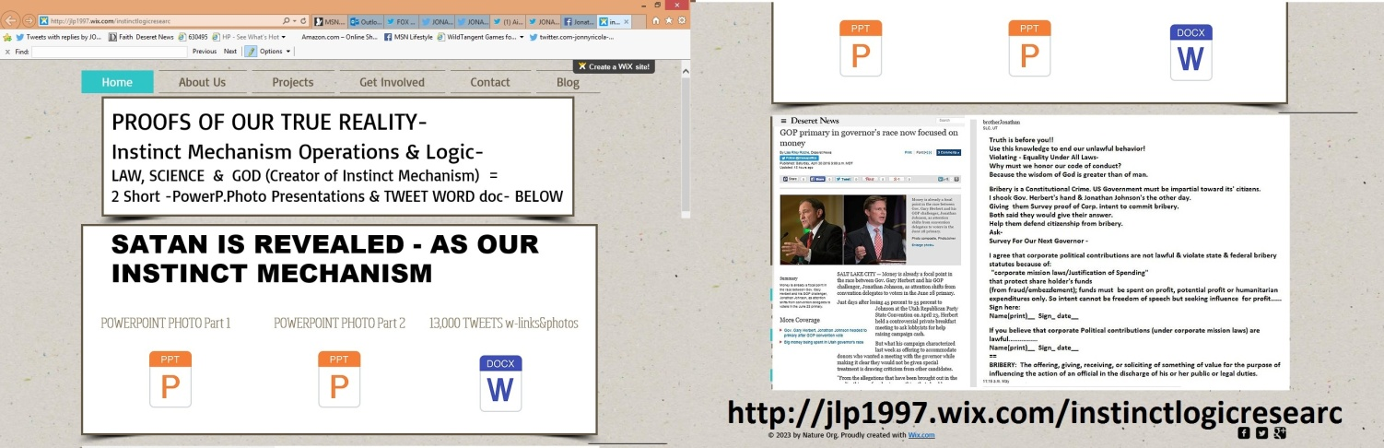
===================================================
DIRECT- (FOX NEWS ANCHOR)
@ainsleyearhardt @DeseretNews @LorettaLynch Serious most of the time Ask @realDonaldTrump:Do I have a sense of humor
https://twitter.com/jonnyricola/status/727974285784932352 (@FoxNewsInsider @foxandfriends @AP @LorettaLynch @CivilRights@realDonaldTrump=The smarest man in the world-TEST 4U)
============================================================
https://twitter.com/jonnyricola/status/727974285784932352 (@FoxNewsInsider @foxandfriends @AP @LorettaLynch @CivilRights@realDonaldTrump=The smarest man in the world-TEST 4U 4PHOTOS)
https://twitter.com/FoxNewsInsider/status/727855428487413760 @FoxNewsInsiderTrump: People Who Said Terrible Things About Me Now Want to Join My Team @foxandfriends http://bit.ly/24xGQBL

@FoxNewsInsider @foxandfriends BEFORE IT'S TO LATE
@realDonaldTrump W-PROOF OF INTENT TO COMMIT BRIBERY-
RU ETHICAL?
(W-Photo Trump & HILLARY& Bernie -U BELIEVE IT SIGN IT SURVEY FOR CORP BRIBERY -EXPLAIN SIGN 2-26-2016 WView mess
(W-Photo CIVIL RIGHTS POST ON HUBER VIOLATING DUE PROCESS OCT 8,2015 w-LINK lg text WIDEVIEW & Loretta link)
(W-Photo US DISTRIC COURT Judge Nuffer Complaint July 1, 2015 11pg Lrez PAGE 1 & ZION BANK in ID evidence & SUPREME URL& Loretta)
(W-Photo Gary Johnson & me & survey on Bribery April 6-2016 slc,ut 1000x650 w-huber&gary obstruct & DRUG LAW
reply
@FoxNewsInsider @foxandfriends @realDonaldTrump
Citizens-WE DON'T WANT BRIBERY!
@AP -Ask @LorettaLynch @CivilRights-
https://twitter.com/jonnyricola/status/727642202080313344 (@CivilRights @usedgov @LorettaLynch @thenationCorp. Shareholder $ spent on political Contributions=BRIBERY w-INTENT
reply
@FoxNewsInsider @foxandfriends @AP @LorettaLynch @CivilRights
@realDonaldTrump=The smarest man in the world-TEST 4U
W-Photo Gov. Herbert&REYES Survey for Doctors Jan. 11, 2016 SHORT ORi W-HEADER & divisonRemovWVIEW AMA)
W-Photo Gary Johnson & me & survey on Bribery April 6-2016 slc,ut 1000x650 w-huber&gary obstruct & DRUG LAW
(W-Photo DR. NEIL PhD EXPERTS SCI-SURVEY ON INSTINCT w-deprog 3-14-2016 PAINTED TEXT w-PBSbrainURL & COMPAR)TRUMP
(W-Photo DeseretNews comments 15 LDS general authorities & B of Mormon heroes 1-8-2016 WVIEW w- SKULL & TRUMP)
+++++++
=============================================
https://twitter.com/foxandfriends/status/727956107537190912 @foxandfriends.@ScottyMcCreery: Faith is the single most important part of what I do #GoBigorGoHome

foxandfriends @ScottyMcCreery Faith- belief without proof.
NOW YOU HAVE PROOF OF GOD.@nytimes R U GOING TO SHARE IT?
https://twitter.com/jonnyricola/status/727954703506542592 (@realbobmassi @FoxNews @foxandfriends @SteveDoocy @ainsleyearhardt @kilmeade @DrMarcSiegel @nytimes 5surveys 4LAWFUL)

+++++++++
==========================================
https://twitter.com/jonnyricola/status/727949791620038656 (@realbobmassi @FoxNews @foxandfriends @SteveDoocy @ainsleyearhardt @kilmeade Bob Have a look at the future of USA-https://twitter.com/jonnyricola/status/727917859058241538 … :))
https://twitter.com/realbobmassi/status/727946753983414272 @realbobmassiTune into tomorrow morning to @FoxNews I'll be on @foxandfriends at 8:20 AM ET @SteveDoocy @ainsleyearhardt @kilmeade #betterwithfriends
@realbobmassi @FoxNews @foxandfriends @SteveDoocy @ainsleyearhardt @kilmeade Bob Have a look at the future of USA-https://twitter.com/jonnyricola/status/727917859058241538 … :)
( @ainsleyearhardt @ScottyMcCreery Finding out -We are not a lawful societyIs not easy.But once YOU having knowledge?)
reply
@realbobmassi @FoxNews @foxandfriends @SteveDoocy @ainsleyearhardt @kilmeade @AmerMedicalAssn @DrMarcSiegel @nytimes-https://twitter.com/jonnyricola/status/727903034001391616
reply
@realbobmassi @FoxNews @foxandfriends @SteveDoocy @ainsleyearhardt @kilmeade @DrMarcSiegel @nytimes 5surveys 4LAWFUL
W-Photo Gov. Herbert&REYES Survey for Doctors Jan. 11, 2016 SHORT ORi W-HEADER & divisonRemovWVIEW AMA)
W-Photo Gary Johnson & me & survey on Bribery April 6-2016 slc,ut 1000x650 w-huber&gary obstruct & DRUG LAW
(W-Photo DR. NEIL PhD EXPERTS SCI-SURVEY ON INSTINCT w-deprog 3-14-2016 PAINTED TEXT w-PBSbrainURL & COMPAR)
(W-Photo 20 DeseretNews Comments about ‘Vatican looks to reform its media operations, add multimedia’ (5-30-2015) WIDE VIEW URL)
reply
@realbobmassi @FoxNews @foxandfriends @SteveDoocy @ainsleyearhardt @kilmeade @DrMarcSiegel @nytimes WE COULDN'T KNOW
W-Photo JLP1997 INSTINCTLOGICRESEARC- Website photo May 1, 2016 URLS&mess
(W-Photo 69B MY LAST TWEET- Was to Dr. Neil DeGrassi Tyson March 14-2016 survey on instinct LG VIEW messDKwARROWS
(W-Photo PBS The BRAIN final episode with PROOFS OF INSTINCT MECH as A.I. Driven w STATUS QUO w-LINK
(W-Photo DeseretNews comments 15 LDS general authorities & B of Mormon heroes 1-8-2016 WVIEW w- SKULL -DN-URL& faithURL
+++++++++++
====================================

https://twitter.com/ainsleyearhardt/status/727845430445387776 @ainsleyearhardtGreat having @ScottyMcCreery on set with us #music #AmericanIdol #WINNER #country music

@ainsleyearhardt @ScottyMcCreery Finding out -We are not a lawful society Is not easy.But once YOU having knowledge?
https://twitter.com/jonnyricola/status/727903034001391616 (@foxandfriends @DrMarcSiegel @AmerMedicalAssn IF YOU DON'T RESPOND?YOU VIOLATE HIPPOCRATIC OATH & OBSTRUCT JUSTICE =)
reply
@ainsleyearhardt @ScottyMcCreery @TheJusticeDept @RepMiaLove @thenation @CivilRights @ACLU @DeseretNews @Pontifex-DO
https://twitter.com/jonnyricola/status/727561464903393280
(@TheJusticeDept @RepMiaLove @thenation @CivilRights @ACLU@DeseretNews @Pontifex5surveys=change our-REALITY 2LAWFUL)
reply
@ainsleyearhardt @ScottyMcCreery @TheJusticeDept @RepMiaLove @thenation @CivilRights @ACLU @DeseretNews @Pontifex 5=
W-Photo Gov. Herbert&REYES Survey for Doctors Jan. 11, 2016 SHORT ORi W-HEADER & divisonRemovWVIEW AMA)
W-Photo Gary Johnson & me & survey on Bribery April 6-2016 slc,ut 1000x650 w-huber&gary obstruct & DRUG LAW
(W-Photo DR. NEIL PhD EXPERTS SCI-SURVEY ON INSTINCT w-deprog 3-14-2016 PAINTED TEXT w-PBSbrainURL & COMPAR)
(W-Photo 20 DeseretNews Comments about ‘Vatican looks to reform its media operations, add multimedia’ (5-30-2015) WIDE VIEW URL)
reply
@ainsleyearhardt @ScottyMcCreery @TheJusticeDept @RepMiaLove @thenation @CivilRights @ACLU @DeseretNews @Pontifex :)
W-Photo JLP1997 INSTINCTLOGICRESEARC- Website photo May 1, 2016 URLS&mess
(W-Photo 69B MY LAST TWEET- Was to Dr. Neil DeGrassi Tyson March 14-2016 survey on instinct LG VIEW messDKwARROWS
(W-Photo DeseretNews Comments about ‘Why politicians turn to religion in times of uncertainty’ (4-2-2015) dk)WIDEVIEW jpeg
(W-Photo DeseretNews comments 15 LDS general authorities & B of Mormon heroes 1-8-2016 WVIEW w- SKULL -DN-URL& faithURL
++++++++++++
https://twitter.com/jonnyricola/status/727906975506309121 (added too https://twitter.com/CivilRights/status/727615339664691201 -@CivilRights @usedgov @thenation @DeseretNews @LorettaLynch @foxandfriends PROOFSof LAW,SCI,FAITH=2PowerP.P&TWEETdoc- http://jlp1997.wix.com/instinctlogicresearc )
=========================================
https://twitter.com/foxandfriends/status/727903278579638272 @foxandfriends.@DrMarcSiegel: How do you know when to administer CPR to a victim you've helped pull out of water? #5minutestolive
@foxandfriends TAKE A CPR COURSE_So you can do it right YOU'RE NOW VIOLATING YOUR OATH @DrMarcSiegel @NelsonRussellM
https://twitter.com/jonnyricola/status/727903034001391616 (@foxandfriends @DrMarcSiegel @AmerMedicalAssn IF YOU DON'T RESPOND?YOU VIOLATE HIPPOCRATIC OATH & OBSTRUCT JUSTICE =)
reply

@foxandfriends @DeseretNews @LDSChurchNews STATE YourEXPERT OPINION-@DrMarcSiegel @NelsonRussellM or6000 MURDERED QD
W-Photo Gov. Herbert&REYES Survey for Doctors Jan. 11, 2016 SHORT ORi W-HEADER & divisonRemovWVIEW RMNelson5ways)
(W-Photo Gov. Herbert&REYES Survey for Doctors Jan. 11, 2016 SHORT ORi W-HEADER & divisonRemovWVIEW MarcSiegel)
W-Photo Gov. Herbert&REYES Survey for Doctors Jan. 11, 2016 SHORT ORi W-HEADER & divisonRemovWVIEW AMA)
W-Photo DeseretNews Comment- ‘Bill intends to ban certain abortion procedures in Utah’ (2-26-2016) WIDEVIEW 3 wide image)
+++++++++++
===================================================

https://twitter.com/jonnyricola/status/727903034001391616 (@foxandfriends @DrMarcSiegel @AmerMedicalAssn IF YOU DON'T RESPOND?YOU VIOLATE HIPPOCRATIC OATH & OBSTRUCT JUSTICE =)
https://twitter.com/foxandfriends/status/727896771142111232 @foxandfriends.@DrMarcSiegel: What do you do if you're caught in a rip tide? #5minutestolive

@foxandfriends @DrMarcSiegel Pray & swim with it.
working your way back to safety. now look at our riptide. BRIBERY-
https://twitter.com/jonnyricola/status/727890156808642560 (@jonnyricola TO -@realDonaldTrump WILL YOU LEAD OR OBSTRUCT JUSTICE?DO YOU SUPPORT CORP BRIBERY?@HillaryClinton ASK @BernieSanders 2)
reply
@foxandfriends @DrMarcSiegel Dr. Siegel-I have a Q&A for you & @AmerMedicalAssn of great importance.Being Scientists
(W-Photo Gov. Herbert&REYES Survey for Doctors Jan. 11, 2016 SHORT ORi W-HEADER & divisonRemovWVIEW MarcSiegel)
reply
@foxandfriends @DrMarcSiegel @AmerMedicalAssn IF YOU DON'T RESPOND?
YOU VIOLATE HIPPOCRATIC OATH & OBSTRUCT JUSTICE =
(W-Photo Gov. Herbert&REYES Survey for Doctors Jan. 11, 2016 SHORT ORi W-HEADER & divisonRemovWVIEW MarcSiegel)
W-Photo Herbert&REYES Survey for Doctors Jan. 11, 2016 SHORT ORi W-HEADER & divison remWVIEW 4USsurgeGen 5ways2
W-Photo Gov. Herbert&REYES Survey for Doctors Jan. 11, 2016 SHORT ORi W-HEADER & divisonRemovWVIEW RMNelson5ways
W-Photo DeseretNews Comment- ‘Bill intends to ban certain abortion procedures in Utah’ (2-26-2016) WIDEVIEW 3 wide image
reply
https://twitter.com/jonnyricola/status/727906975506309121 (added too https://twitter.com/CivilRights/status/727615339664691201 -@CivilRights @usedgov @thenation @DeseretNews @LorettaLynch @foxandfriends PROOFSof LAW,SCI,FAITH=2PowerP.P&TWEETdoc- http://jlp1997.wix.com/instinctlogicresearc )

====================================
DIRECT-
@foxandfriends US NEWS AGENCIES HAVE A RESPONSIBILITY TO THE
PEOPLE. https://twitter.com/jonnyricola/status/727890156808642560
@realDonaldTrump @HillaryClinton @BernieSanders
(@realDonaldTrump WILL YOU LEAD OR OBSTRUCT JUSTICE?DO YOU SUPPORT CORP BRIBERY?@HillaryClinton ASK @BernieSanders 2)

==============================================
https://twitter.com/foxandfriends/status/727796140385538048 @foxandfriendsShould the “Never Trump” crowd unite behind the Donald?

@foxandfriends Citizens-WANT BRIBERY USED?
LEGAL PROOF TO END IT ASK
@realDonaldTrump @HillaryClinton @BernieSanders
(W-Photo Trump & HILLARY& Bernie -U BELIEVE IT SIGN IT SURVEY FOR CORP BRIBERY -EXPLAIN SIGN 2-26-2016 WView mess
(W-Photo BERNIE SLC,UT March 21-2016 cropped wideview then longview W-we have proof of intent. & survey Lg TEXT
(W-Photo DeseretNews Comments ‘GOP primary in governor's race now focused on money’ (5-1-2016) Wview
(W-Photo Gary Johnson & me & survey on Bribery April 6-2016 slc,ut 1000x650 w-huber&gary obstruct & DRUG LAW
reply
@foxandfriends US NEWS AGENCIES HAVE A RESPONSIBILITY TO THE
PEOPLE. https://twitter.com/jonnyricola/status/727890156808642560
@realDonaldTrump @HillaryClinton @BernieSanders
(@realDonaldTrump WILL YOU LEAD OR OBSTRUCT JUSTICE?DO YOU SUPPORT CORP BRIBERY?@HillaryClinton ASK @BernieSanders 2)
++++++++++++++++
=================================================
DIRECT FROM MY SITE TO THE WORLD
https://twitter.com/jonnyricola/status/727891933863940097 (@jonnyricolaCitizens-DO YOU WANT BRIBERY USED?LEGAL PROOF TO END IT NOW=ASK-@realDonaldTrump @HillaryClinton& @BernieSanders 2)
Citizens-DO YOU WANT BRIBERY USED? LEGAL PROOF TO END IT NOW= ASK-@realDonaldTrump @HillaryClinton& @BernieSanders 2
(W-Photo Trump & HILLARY& Bernie -U BELIEVE IT SIGN IT SURVEY FOR CORP BRIBERY -EXPLAIN SIGN 2-26-2016 WView mess
(W-Photo BERNIE SLC,UT March 21-2016 cropped wideview then longview W-we have proof of intent. & survey Lg TEXT
(W-Photo DeseretNews Comments ‘GOP primary in governor's race now focused on money’ (5-1-2016) Wview
(W-Photo Gary Johnson & me & survey on Bribery April 6-2016 slc,ut 1000x650 w-huber&gary obstruct & DRUG LAW

==============================================
https://twitter.com/jonnyricola/status/727890156808642560 (@realDonaldTrump WILL YOU LEAD OR OBSTRUCT JUSTICE?DO YOU SUPPORT CORP BRIBERY?@HillaryClinton ASK @BernieSanders 2)
DIRECT-
@realDonaldTrump WILL YOU LEAD OR OBSTRUCT JUSTICE?
DO YOU SUPPORT CORP BRIBERY?@HillaryClinton ASK @BernieSanders 2
(W-Photo Trump & HILLARY& Bernie -U BELIEVE IT SIGN IT SURVEY FOR CORP BRIBERY -EXPLAIN SIGN 2-26-2016 WView mess
(W-Photo BERNIE SLC,UT March 21-2016 cropped wideview then longview W-we have proof of intent. & survey Lg TEXT
(W-Photo DeseretNews Comments ‘GOP primary in governor's race now focused on money’ (5-1-2016) Wview
(W-Photo Gary Johnson & me & survey on Bribery April 6-2016 slc,ut 1000x650 w-huber&gary obstruct & DRUG LAW

==========================================
DIRECT-
@DeseretNews @realDonaldTrump @HillaryClinton
4OUR PRES.?? If They Support Bribery? ASK @BernieSanders & @JJohnsonNow
(W-Photo Trump & HILLARY& Bernie -U BELIEVE IT SIGN IT SURVEY FOR CORP BRIBERY -EXPLAIN SIGN 2-26-2016 WView mess
(W-Photo BERNIE SLC,UT March 21-2016 cropped wideview then longview W-we have proof of intent. & survey Lg TEXT
(W-Photo DeseretNews Comments ‘GOP primary in governor's race now focused on money’ (5-1-2016) Wview
(W-Photo SCALIA 2 WIDEVIEW NEW w-SUPREME LINK not 3 wide DNews url)
========================
https://twitter.com/DeseretNews/status/727865403381190656 @DeseretNewsTrump, Clinton all but certain to face off in fall campaignhttp://www.deseretnews.com/article/765686205/Trump-Clinton-all-but-certain-to-face-off-in-fall-campaign.html …

@DeseretNews @thenation @realDonaldTrump @HillaryClinton 4OUR PRES.??? If They Support Bribery? ASK @BernieSanders 2
(W-Photo Trump & HILLARY& Bernie -U BELIEVE IT SIGN IT SURVEY FOR CORP BRIBERY -EXPLAIN SIGN 2-26-2016 WView mess
(W-Photo BERNIE SLC,UT March 21-2016 cropped wideview then longview W-we have proof of intent. & survey Lg TEXT
(W-Photo DeseretNews Comments ‘GOP primary in governor's race now focused on money’ (5-1-2016) Wview
(W-Photo SCALIA 2 WIDEVIEW NEW w-SUPREME LINK not 3 wide DNews url)
+++++++++++
5-3-2016

